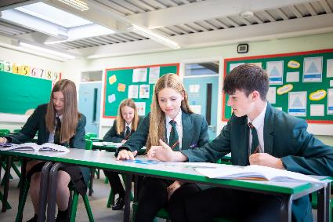
Informal enquiries, further details and application forms can be accessed by requesting these from recruitment@bwh.staffs.sch.uk or via https://www.bwh.staffs.sch.uk/Jobs/. This school is committed to safeguarding and promoting the welfare of children and young people/vulnerable adults and expects all staff and volunteers to share this commitment. This position is subject to appropriate vetting procedures including a criminal record check from the Disclosure and Barring Service (formerly CRB), which will require you to disclose details of all unspent and unfiltered spent reprimands, formal warnings, cautions and convictions as part of the recruitment process.

Blessed William Howard is proud to part of St Gabriel the Archangel Catholic Multi – Academy Trust. A company limited by guarantee registered in England & Wales with company number 08146661. Registered Office Address: Station Road, Cheadle, Staffordshire ST10 1LH. Telephone: 01538 493777
Email: sa@bwh.staffs.sch.uk Web: www.bwh.staffs.sch.uk

About the role:

A vacancy has arisen in our Art & Design department which would suit either a
Main Scale teacher or an unqualified teacher with a background in creative subjects.
The successful candidate would teach a mixture of Art and Graphics for Key Stage 3 and 4.
This post will commence in January 2026

The successful candidate will;

- be inspirational – able to engage with our students and create an
atmosphere of enthusiasm for creative subjects.
- an enthusiastic member of a growing department who will enable students
to creatively flourish.
- have experience using Adobe software including Photoshop and Illustrator.
Find out more on our jobs page – www.bwh.staffs.sch.uk

APPLICATION DEADLINE – Wednesday 10 December 2025 at 8am

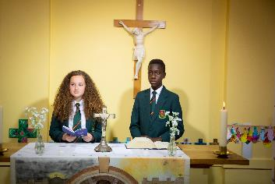

Teacher of Art
UNQ/MS
Maternity leave cover (January 2026 – March 2026)

Are you looking for a new opportunity in an innovative and supportive 11-18 Catholic school? Now part of the St Gabriel the Archangel Catholic Multi – Academy Trust, the largest multi-academy in the Archdiocese of Birmingham. Blessed William Howard is looking to recruit dynamic, forward-thinking and inspirational staff to join us on our journey to success. With a strong Catholic ethos that puts ‘love’ at the heart of its community, the school provides a haven where all can flourish. Situated just outside the town centre and easily accessed by train, bus or the M6, Blessed William Howard is proud of its strong community links and its beautiful grounds.

Why Blessed William Howard?

- A Christian community with a caring, secure and
disciplined environment.
- A wide range of extra-curricular activities.
- High academic standards.
- A commitment to success for all.
- Ongoing CPD for all staff.

“There is a warm atmosphere and the quality of relationships between all members of the school community are a particular strength. Pupils and staff are friendly, helpful, polite and welcoming to visitors.” Diocesan Section 48 Report

Blessed William Howard
Catholic High School, Stafford ST17 9AB
Part of the St Gabriel the Archangel Catholic
Multi – Academy Trust

