
Fairfield Park Lower School

Nursery Room Leader

Recruitment information pack

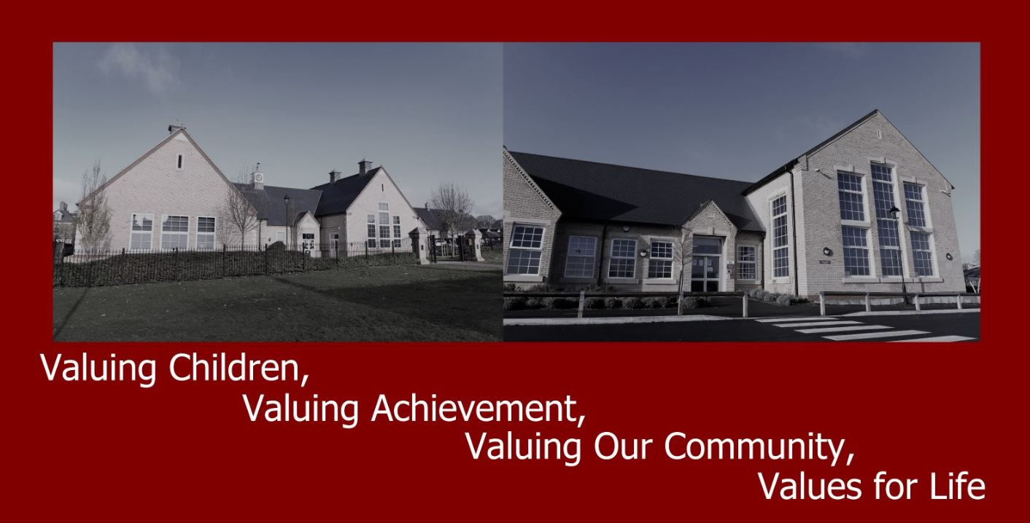

Contents

Letter from our Chair of Governors

Candidate Information

Application and Selection Process

Job Description

Person Specification

About Fairfield Park Lower School

Letter from Chair of Governors

Thank you for your interest in the position of Nursery Room Leader at Fairfield Park Lower School. We are looking to appoint an outstanding candidate to support the learning and development of pupils, and we warmly welcome your application.

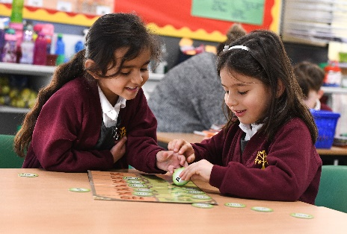
This is a very exciting opportunity to join a forward-thinking school with excellent staff led successfully by an exceptionally strong School Leadership Team. The governing body are experienced and supportive with a very close working relationship to the school.

Fairfield Park Lower School opened its doors in 2007 as a one-form entry lower school and through several expansions has now become two-form entry with nursery provision included for over 400 pupils. In 2018, a further expansion onto a second site across has grown our school even further to three-form entry.

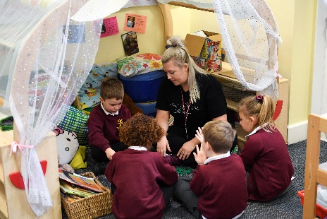
We are looking to appoint a Nursery Room Leader who has forward thinking skills that will help drive the school forward whilst we continue to grow onto our second site.
This is a very exciting opportunity, and we look forward to welcoming you here at Fairfield Park.

We have carefully prepared this information pack for you, but if there is anything else you wish to know or discuss, please visit our website www.fairfield.beds.sch.uk or contact myself or our Headteacher Mrs Jenny Stone on 01462 830000.

We look forward to receiving your application

Fairfield Park Lower School,
Dickens Boulevard
Fairfield
Beds, SG5 4FD
&
Ruskin Drive
Fairfield
Beds, SG5 4SG

01462 830000
office@fairfieldparklower.uk

Yours sincerely

Sue Howley
Chair of Governors

Candidate Information

Vacancy: Nursery Room Leader
School: Fairfield Park Lower School
Address: Fairfield Park, Beds SG5 4SG
Responsible to: Assistant Headteacher for Early Years

Actual Salary: £20,103 pro rata (£26,403)
Hours of Work: 7.45am – 3.15pm (term time only) (1 hour unpaid lunch break)

Fairfield Park School has expanded onto a 2nd site in the local community and is currently 3FE. The school will be facing ongoing changes in the next few years as we transition from a Lower school to a Primary school on both sites. We aspire to continue as an outstanding school in all aspects, and we seek an enthusiastic, caring and creative Nursery Room Leader to help us achieve that goal and for all children to be supported on a 1:1 basis or in a group to enable them to achieve their full potential. All staff at Fairfield Park Lower School are part of one team and as such may be required to work on the Ruskin Drive site and the Dickens Boulevard site at any time to ensure that all children are supported and receive the best education opportunities.

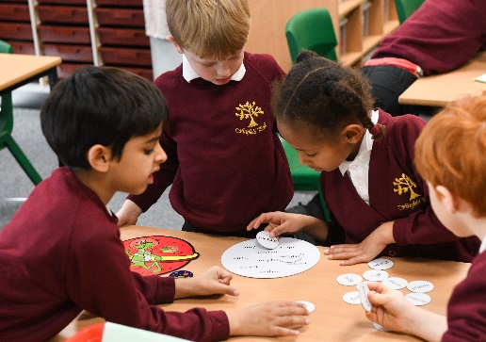

The Application and Selection process

The vacancy is for a Nursery Room Leader to start September 2026.

During the interview candidates will be given activities to assess performance against the person specification. Shortlisted candidates will be provided with further details of the interview process and arrangements.

Please submit your application using the My New Term website. The selection panel will also take into consideration the qualifications and skills of each applicant as well as experience and personal attributes.

Please return your applications electronically to the Headteacher via: the My New Term website

We encourage you to visit our school. To arrange a visit or if you have any questions, please email office@fairfieldparklower.uk

The Governing Body and Central Bedfordshire Council are committed to safeguarding and promoting the welfare of children and young people.

All staff must ensure that the highest priority is given to following guidance and regulations to safeguard children and young people.

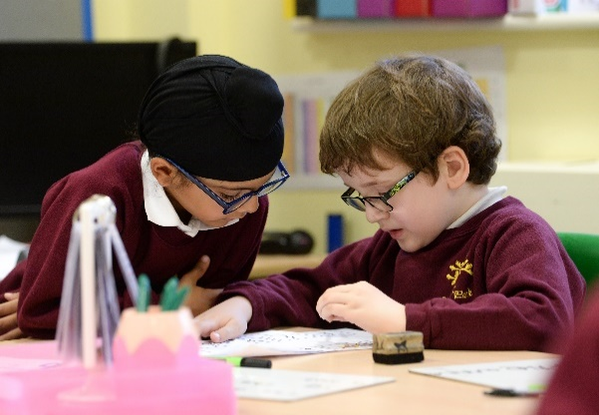
This position requires an enhanced DBS check, references and medical clearance.

About our School

Welcome to Fairfield Park Lower School, where staff, pupils, parents and carers are nurtured and supported through our strong pastoral ethos. We care passionately about our community and the welfare of all stakeholders; this is embedded into all our practices. We have a thriving PTA, and parent helper group, we are a ‘People Place’ where we learn and grow together; we are proud that we are an emotionally intelligent school. We have excellent facilities for staff, pupils and our local community; we have a thriving extended community involving a range of lettings and provision including breakfast and after school club.

Fairfield Park school was a new school in 2007 and has constantly involved and expanded over the years and is used to managing change. We have had staff stability in that process and have grown staff each year as we have expanded. We have a history of coaching, supporting and offering high quality CPD to enable all to achieve their very best. Many staff have pursued their own qualifications further and continued their lifelong learning pathway through working with us. We are passionate about promoting a very happy and skilled staff population, with wellbeing built into our school year. Creative, fun, secure staff create enthusiastic, happy and well-rounded learners.

Our ethos
We are committed to providing children with a high-quality education in a secure and nurturing setting. Our inspiring curriculum and dedicated staff provide quality engaging learning environments and a range of enrichment opportunities. High expectations enable pupils to achieve quality learning outcomes ensuring all pupils have a solid foundation block and love of learning. At the heart of everything we do is achievement, progress, challenge, inspiration, engagement, enjoyment and innovation. We aim to prepare our young pupils for life in a rapidly changing technologically driven global society. Everyone at Fairfield Park is respected and valued and there is equal opportunity for all. Discipline is based upon care for each other and positive reinforcement. Pupils contribute to shaping the school ethos through the School Council and achievements are shared and celebrated. Fairfield Park is a very reflective school, building in annual reviews and professional dialogues to always further enhance pupil outcomes. All staff are part of this culture and have a voice to develop and evolve the school; these are embedded in regular team meetings throughout the year. Fairfield Park enjoys support and effective challenge from an engaged, committed and outstanding Governing Body and there are strong links with the local learning community.

Expansion
Fairfield Park Lower School is currently a three-form entry lower school across two sites, providing education for children in Year Groups: Nursery – Year 4. In addition, we have an established independent pre-school (age 2+) on one school site. We are based in two locations, reflecting the same ethos and mirroring the excellent provision for which Fairfield Park is known. Ultimately, pupil numbers will be 600+ across the school with a full range of extended services.

Curriculum
Excellence is achieved through high expectations, innovation and challenge for all. We are passionate about our age-appropriate inclusive engaging curriculum, embedded into whole school project weeks where pupils have the opportunity to apply their skills further through teamwork, problem solving, risk taking, reflecting and celebrating. A flavour of our project weeks delivered are Engineering week; Health and Fitness week; Culture week through The Arts (Contemporary, The Tate, sculpture, spiritual art); Road Safety week; International week. Our results are consistently above national and local standards, and our curriculum is further enriched in a variety of ways including PE, Music and the Arts.



Play and lunch times are well resourced and supported by quality staff including
Structured sport activities and Play Leaders. We believe that learning should be enjoyed by all and the moment you step through the doors of our caring and happy school we believe you will experience this for yourself.

Pre-school
Poppyfields is an independent preschool on the Dickens Boulevard site and operates from The Pavilion bungalow, the access is from the Community Centre pathway. The provision provides a happy, stimulating, high quality and secure nursery setting for all children aged 2 years to 5 years and ‘out of school hours’ club for children aged 2 years to 7 years. The pre-school was rated as ‘Outstanding’ by Ofsted in October 2015 stating that the “physical environment is highly stimulating and supports learning well” and “Children are excited about coming into the nursery and being able to choose their favourite toy. The relationships between children and adults are warm and caring”. The full report can be found on our website.

Breakfast and after school clubs
There is a range of provisions on our school sites to suit parents’ needs and children’s interests. We can provide facilities and care for children between 8.00an to 6.00pm and some holiday provision and this is much valued by our working parents. Poppyfields offer breakfast club to the full age range of the school and after school for reception to year 2 on the Dickens Boulevard site. Junior Adventure Group offers breakfast club for reception to year 4 on the Ruskin Drive site and after school club for reception to year 2. The school manages after school club for children in years 3 & 4 in friendly, homely environments on both sites. All after school provisions use our extensive outside facilities to mix play and learning together.

Extra-curricular Clubs
A wide range of clubs are also available before and after the school day to extend our childcare service where they can learn key sporting techniques and skills. The clubs are run by a range of competent staff in a warm, friendly and caring environment. Our children enjoy a wide range of clubs before, after and during the school day including French, Spanish,
Tri-golf, Fitness, Dodgeball, Fun & Games, Multi-skills, Netball, Athletics, Cricket, Rounders and Tennis. For more information, please speak to the School Office.

Job Description

Job purpose:
Under the direction of the Headteacher and under the guidance of the Assistant
Headteacher to provide and develop appropriate learning experiences, working with
individual and groups of pupils and with the whole class.

Main duties and responsibilities:

Support for Pupils
1. To provide general welfare and care to pupils.

2. To participate in and foster the learning experiences provided for pupils.

3. To participate in and help maintain behavioural programmes as appropriate.

4. To support individual pupils with specific programmes as identified by the team.

5. To be aware of and to value pupils’ language/communication styles and promote the effective use of verbal and non-verbal language.

6. To ease the pupils’ transition from home to school and to recognise the importance of creating positive links with parents in line with established school policy.

7. To assist with the pupils’ independence programmes e.g. toileting, personal hygiene, safety etc.

8. To contribute to the physical, social, emotional and intellectual well-being of all pupils.

Support for Teachers

1. To participate in forward planning relating to general policy, organisation and management.

2. To contribute in a team situation to the orderly maintenance of the established daily routine.

3. To support special needs pupils with specific programmes, to assist in the integration policy and to contribute to the well-being of these pupils.

4. To assist in recreational activities, e.g. swimming, which may be necessary as part of the care and education of pupils.

Support for the Curriculum

1. To contribute to all areas of curriculum development.

2. To participate in all systems of pupil appraisal and record keeping.

Support for the School

1. To develop and maintain professional relationships with pupils, colleagues, families and other approved agencies where appropriate.

2. To share responsibility for the preparation and presentation of displays.

3. To assist with the training of NNEB/CACHE and work experience students and to liase with training college tutors where appropriate.

4. To maintain confidentiality at all times in respect of school-related matters and to prevent disclosure of confidential or sensitive information.

5. To undertake tasks of a similar nature and level as directed by the headteacher/line manager.

Safeguarding

- To be responsible for promoting and safeguarding the welfare of pupils and for raising any concerns in line with school procedures

Equality and Diversity

- To be responsible for promoting equality and diversity in line with school policies and procedures

Health and Safety

- To be responsible for following health and safety requirements in line with school policies and procedures

Training and Development

- To participate proactively in training and development including qualification development required for the job role

Other responsibilities

- To undertake as required other duties and responsibilities relevant to the job as directed by the Senior Leadership Team



Person Specification - Nursery Room Leader

This acts as selection criteria and gives an outline of the type of person and the characteristic required to do the job.

Attributes | Essential | Desirable
Education/Qualifications | NNEB or equivalent level 3 | Pediatric First aid  Other relevant Early Years courses
Experience | Previous experience of working with 2-5 year olds  Experience of working collaboratively within a team | Previous experience of working in an educational setting  Previous experience of leading a team
Skills/Knowledge/ Aptitude | Understanding of the social and educational needs of 2-5 year olds including those with specific needs  Ability to lead planning of appropriate educational experiences for 2-5 year olds  Ability to apply the EYFS curriculum effectively  Good knowledge of EYFS environment  Knowledge of health & safety requirements for the environment in which children aged 2-5yrs are cared for  Good communication and interpersonal skills  Good organisational and time management skills  Ability to take responsibility and work within set boundaries
Attributes | Motivated with high energy levels and stamina  Positive outlook  Caring and friendly personality  Reliable and responsible  Flexible and adaptable
Physical | Ability to meet needs of pupils
Other | Must be fluent in the English language in accordance with the Immigration Act 2016

About Fairfield Park

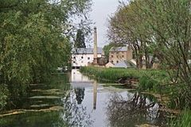
Fairfield Park is a village and civil parish located in the Central Bedfordshire district of Bedfordshire, England. It is in the civil parish of Stotfold.

The village was established in the early 2,000s in the buildings and grounds of Fairfield Hospital, which closed in 1999. The village consists of some 900 dwellings of different housing types and about 100 apartments in the former hospital building.

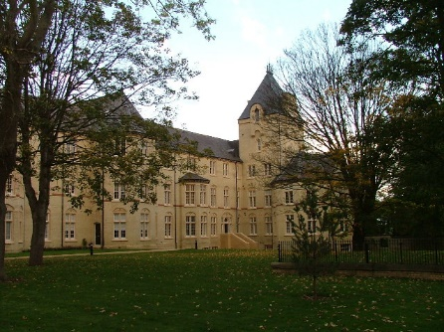
Fairfield Park was originally intended to become a new village in its own right but was designated by planners as part of Stotfold civil parish. However, on 1st April 2013 the village became a separate civil parish and elected its own parish council in May 2013.

Amenities in the village include a community centre, gym and Fairfield Park Lower School.

Transport Links
Fairfield Park is within easy commute of Luton, Milton Keynes, and other areas of Bedfordshire, Hertfordshire and Northamptonshire and is close to the M1 motorway and the A1. We also have good commuter links with regular trains to London (Kings Cross) taking approximately 30 minutes.
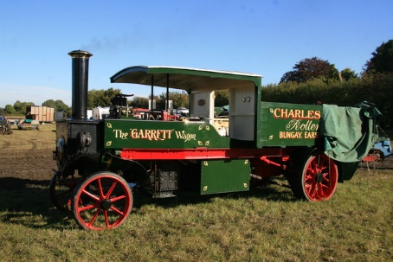

Our Location

Fairfield Park Lower School is located on Dickens Boulevard and Ruskin Drive just off the A507.

