

Candidate Pack
Teaching Assistant
ACE Tiverton School
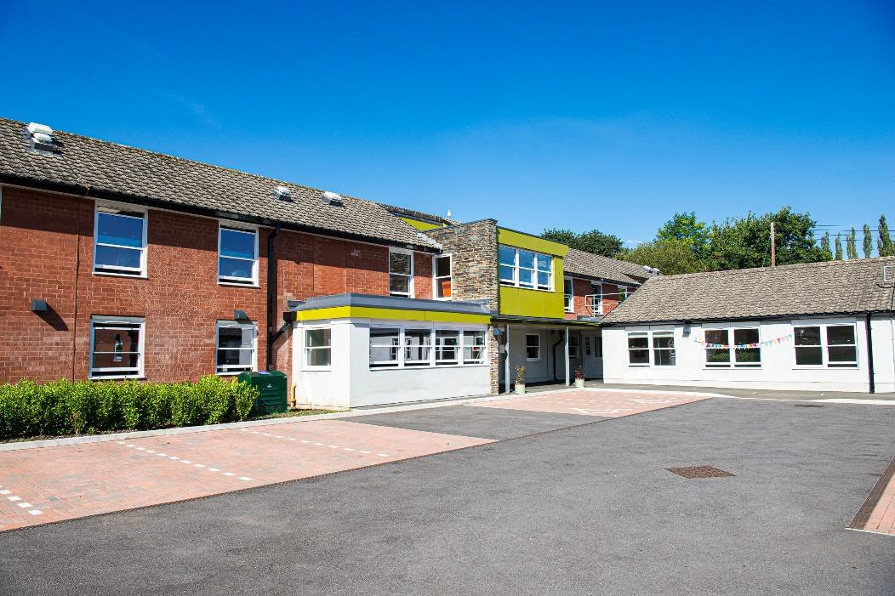



Headteacher’s Welcome

Dear Candidate,

ACE Tiverton is an 11-16 special school. We opened in September 2019 with 35 students across Years 7-11. This year we have expanded to 117 students. We are a Free School Academy with a designation focused on education and supporting students with a diagnosis of Autistic Spectrum Condition and related Social, Emotional and Mental Health needs.

All our students have an EHCP (Education, Health and Care Plan) and are supported in their tutor and teaching groups by teachers and teaching assistants. We aim to keep our groups small, allowing us to deliver the personalised, differentiated learning that enables our students to succeed.

Our school is a welcoming, inclusive and safe learning environment in which vulnerable students are valued, cherished and nurtured. Our priority is engagement and strong relationships. Our students are all bright, humorous and interesting young people with their own backgrounds, stories and contexts. Many have been out of full-time education for significant periods before coming to us. They thrive in an environment built on mutual respect, genuine interest and transparency. ‘Unconditional positive regard’ is our mantra, and we firmly believe that every day is a new start in the common mission we share to ensure every student, and colleague, experiences and delivers everyday excellence.

Our talented, experienced team of staff take pride in working relentlessly to ensure that every individual leaves us as a confident young adult who is well prepared for their life after Year 11, whether they go into employment or take up further education opportunities. At times, such as when meeting new staff for the first time, out students can be challenging and seek to test out boundaries and expectations. If you are motivated to create excellent educational experiences, have inspirational interactions and rewarding relationships with students who deserve amazing adults who care, are curious and driven by a desire to enable them to be the very best they can be, then we are the school family for you.

If, after reading this pack, you are interested in being part of our fantastic team, please contact us to arrange a tour of our school building – visits are warmly encouraged. Thank you for your interest and good luck with your application!

Hannah Smart
Executive Headteacher

About the role

Job Title: Teaching Assistant
Grade: C (NJC), Spinal Point 5 or D (NJC), Spinal Point 8 Depending on level of qualification
Salary From: Salary NJC Grade C5 £19,997.77 Grade D8 £20,967.66 Actual.
Contract Type: Full Time, Permanent
Closing Date: Ongoing
Interview Date: TBC
Start Date: ASAP – pending pre-employment checks and notice periods.

Job Title | Teaching Assistant
Reporting To | HLTA
Line Manger | Head of School
DBS Check Required | Enhanced

Role Summary
We are excited to seek a committed and enthusiastic Teaching Assistant to join our Orchard site, working across a range of class groups and diverse student needs. This is a dynamic, rewarding role where no two days are the same. As a Class Teaching Assistant, you will play a vital role in enabling students to access learning, working in close partnership with subject specialist teachers. You will be linked to a subject area to support and facilitate learning alongside expert teaching colleagues as you collaborate in a personalised, student-centred approach.
Our team of specialist TAs brings together a rich mix of experience and backgrounds, united by a shared passion for helping young people succeed. While experience in SEN/ASC is welcomed, we are most interested in individuals who bring empathy, resilience, adaptability and a genuine commitment to making a difference. Full training will be provided, making this an excellent opportunity for those looking to develop specialist skills in a supportive and forward-thinking environment. In this role, you will:
- Work collaboratively with teachers and support staff to deliver engaging learning experiences
- Act as a key adult for individual students, building trust and promoting independence
- Help develop students’ personal, social, emotional and academic skills, preparing them for life beyond school
We are proud to be building a strong reputation for delivering innovative, highly personalised education that challenges and inspires every student to achieve their full potential. With 115 students on roll, all with EHCPs, our provision is truly bespoke and deeply impactful. If you are proactive, flexible and passionate about transforming young lives—and want to be part of a supportive, skilled and ambitious team—we would love to hear from you.
For more information or an informal discussion please contact Sarah Dunn on 01884 763140 or
email sarah.dunn@transformingfutures.org.uk Apply via My New Term Ace Tiverton Special School, Tiverton, Devon | Teaching Jobs & Education Jobs | MyNewTerm
Please note we are unable to accept CV’s or applications submitted in a PDF format.
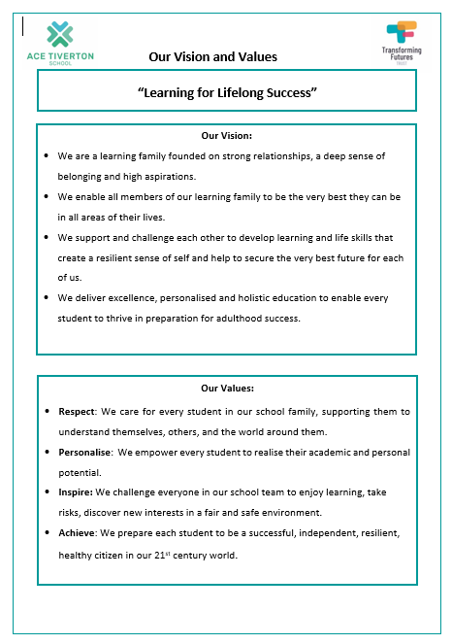

What we can offer you

As a new school, there are many exciting benefits to working at ACE Tiverton. Not only are we located in the centre of Devon with excellent transport links, we can also offer you:

- The chance to be part of a growing school community and to influence how we evolve over the coming years.
- A brand-new £4.5 million building with state-of-the-art facilities and resources, including laptops for all students and teachers, and Wi-Fi enabled mobile devices for support staff.
- A strong, happy, experienced and supportive team of staff.
- Access to high quality CPD, including Team Teach physical intervention training.
- The opportunity to be involved in developing a new curriculum from scratch.
- A school day running from 8am-2pm with an early finish of 1:30pm on Fridays.
- Freshly prepared hot meals provided by our own school chef.
- The opportunity to work alongside a multi-disciplinary team to provide support for students.
- A Wellbeing hub & Vivup app that provides our employees with a range of benefits including health & wellbeing support.

Job Description

The main purpose of the job is to:
- To plan, prepare and deliver a range of for lessons to KS3, KS4 and Nurture Classes, with guidance/instruction from the lesson Lead and support from assistants as appropriate.
- To Assist with the provision of Lesson activities and, through the process of training and involvement, facilitate the effective and efficient delivery of lessons across the curriculum.
- Under the direction/instruction of Senior Staff, provide general support to students and staff, including preparation, routine maintenance of resources/equipment and facilitate student progress academically, socially and personally.

Responsibilities

Support for students in accessing learning activities in a variety of settings, including vocational placements and Learning Outside the Classroom, as directed by Teacher/Senior Staff to include:-

- To create and maintain an engaging, fun and supportive environment, demonstrating flexibility in planning and running sessions in response to varying/changing needs of children.
- To assist in the selection, procurement and proper application of a range of specialist outdoor learning equipment, including maintenance of Personal Protective Equipment to a safe working level in accordance with manufactures guidelines and national standards, and reporting any equipment which needs repair or replacement.
- To undertake clerical tasks associated with student logbooks or outdoor equipment, for example, record keeping (both manual and computerised), filing, photocopying, message taking, as required.
- Model excellent social and communication skills and relationships. Support and encourage students to engage in learning activities, and promote Good Behaviour
- Assist with the supervision of students during off-site activities, including Training Placements
- Be knowledgeable of, and comply with Policies and Procedures relating to: - Child Protection; Health & Safety; Security; and Confidentiality – reporting all concerns to the Designated Person/s
- Be aware of, and support difference, and ensure all students have equal access to opportunities to learn and develop.
- Provide support for the preparation of and undertaking of examinations.
- Be an Excellent and effective role model for the standards of behaviour expected of students.
- To support in the development, monitoring and evaluation of EHCPs and related student paperwork linked to academic, social and personal progression.
- To carry out any other reasonable duties and responsibilities within the overall function, commensurate with the grading and level of responsibility of the post.

Support for the School to include: -
- Contribute to the overall ethos, vision, values and mission of the school and Trust.
- Appreciate and support the role of other professionals and maintain positive working relationships.
- Attend relevant meetings as required; participate in training, learning activities, performance development, and maintain record of own professional development.

General Duties
- Enabling independence in life skills, learning and navigating the social and academic world.
- Employing a range of strategies to recognise and reward achievement of self-reliance for students
- Using specialist (curricular/learning) skills/training/experience to support students
- Assist with the development and implementation of EHCPs and Individual Education Plans (I .E.Ps)
- You will be responsible for keeping and updating records and for the marking of students’ work
recording achievement/progress encouraging students to interact and work co-operatively with others and engage all students in activities.
- Undertake activities to assist teachers in the delivery of the curriculum.
- Promote and ensure the health, safety and appropriate behaviour of students at all times
- Support the teacher by assisting in the production of lesson/work plans, worksheets etc. within an agreed system of supervision.
- Liaise with parents/carers as agreed with the teacher.
- Provide objective feedback and reports, as required, to the teacher on student achievement, progress and other matters.
- Prepare and maintain curriculum equipment/resources as directed by the teacher to meet lesson plans/relevant learning activities.
- Some lifting, stretching and physical effort required for the preparation of the classroom for lessons and clearing away afterwards.
- There may be occasional emotional stress experienced through exposure to difficult child protection/welfare issues which may cause the child to become angry or upset.
- Post holder will be subject to occasional exposure to pupils exhibiting difficult and challenging behaviour and who are angry or upset.
- May be required to assist in the handling of small amounts of money related to various school events, which are then handed over to school office staff for processing.
- Operate office equipment in the provision of clerical and administrative support e.g. photocopier.
- Provide short term cover for the absence of the teacher.
- Support the intimate care and administering medicines to identified individuals within an agreed safeguarding structure.
- The post holder will be expected to work within a Trauma Informed framework, using attachment friendly strategies to connect and build relationships with individual and groups of students.
- Ensuring maintenance of a clean, safe, and orderly working environment
- Timely and accurate preparation of routine equipment, resources, materials, as instructed, ensuring quality/safety.
- Undertake record keeping as directed.
- To ensure that safe working practices are followed in respect of all areas within the provisions of The Health and Safety st Work Act 1974
- To comply with Trust Policies and Procedures.
- Monitoring and arranging orderly and secure storage of learning resources.

Experience & Job Knowledge
Essential
- Ability to plan and deliver environmental education-based activities to a wide age range of children.
- Experience of supporting young people with Autistic Spectrum conditions, including but not limited to social, emotional and mental health, speech, language and communication needs.

Desirable
- Experience of supporting with the supervision of young people during off-site activities
- Evidence of supporting the writing and mentoring of IEP’s and Pastoral Support Plans
- Evidence of involvement in extracurricular activities
- Evidence of supporting in developing / delivering differentiated programmes of work
- Knowledge of SEN and statutory assessment procedures, and the SEN Code of Practice
- Experience of working with young people who suffer from social communication and mental health complications.

Skills
Essential
- Understanding of how children and young people learn in a practical context.
- The ability to carry out risk management procedures in an outdoor context.
- Can organise own workload and that of support staff.
- Excellent communication and interpersonal skills
- Ability to work within school community teams, and wider community teams.
- Ability to produce clear and accurate reports.
- Ability to follow instructions, and to use initiative to work with young people in a variety of settings, in and outside of the school e.g., including but not limited to after school clubs, Food & Nutrition, P.E./Outdoor Education, and Vocational placements.
- Ability to work within corporate policies.
- Awareness of Equal Opportunities and Health & Safety, Child Protection Procedures and Safeguarding & Welfare
- Ability to maintain good discipline and challenge negative behaviour.
- Support in the development of Individual Learning Plans, One Page Profiles and Five Point Scales.

Desirable
- Ability to anticipate likely actions and outcomes of students in outdoor activities and react accordingly. (Dynamic Risk Assessment)
- Experience of using Evolve.
- Evidence of communicating & cooperating with a range of Children’s and Young People’s Services
- Training and experience of communication strategies, assessment of young people’s needs and successful working with families.
- Keyboarding skills required to support the use of ICT in learning activities. Post holder may be required to use specialist equipment/resources and aids to support individual students.

Qualifications
Essential
- GCSE English and Maths (5-9/A*-C) or Adult Literacy & Numeracy Level 2 equivalent
- SEN experience in an education environment. Autism ADHD

Desirable
- Experience of supporting with the supervision of young people during off-site activities
- Other Outdoor specific NGB award(s)
- Two-day NGB Specific Emergency First Aid
- Teaching assistant related qualification.
- Youth work related qualification.
- Other equivalent qualification relevant to children/young people
- Completion or willingness to complete DFE Teacher Assistant Induction Programme within 12 months of appointment.

Physical Requirements
Essential
- Ability and willingness to work outside in sometimes cold, wet and uncomfortable conditions all day, and possibly overnight.
- Participate in off-site and in-house extra-curricular programmes.
- Full driving licence

Desirable
- Mini-bus driving certificate
- Ability to visit and provide support in a variety of setting including, but not limited to all TFT settings, in-home support and community-based learning.

Professional Expectations: -
- Contribute to the overall ethos/work/aims of the school.
- Appreciate and support the role of other professionals and maintain positive working relationships.
- Attend relevant meetings as required.
- Participate in training, learning activities, performance development, and maintain record of own professional development.
- Undertake other duties appropriate to the grade of the post and as required by the student, in line with their Education, Health and Care Plan. Act at all times in accordance with appropriate legislation and regulations, codes of practice, the provisions of the Trust’s constitution and its’ policies and procedures.
- Undertake all duties with due regard to the equalities policy and relevant legislation.
- Work within the requirements of the Trust’s Health and Safety policy, GDPR performance standards, safe systems of work and procedures.

Reach South Academy Trust


Welcome to Reach South Academy Trust, each of our schools is unique, but we are stronger together as a family. Our mission is to transform the lives of young people by providing them with a high-quality inclusive education.
The Trust is made up of 16 academies across the South West of England, in Bournemouth, Gloucestershire, Plymouth, Devon and Wiltshire. We serve children aged from age 3 to 19, in ten primary academies; an all-through 4–16 academy; a secondary academy; the University Technical College in Plymouth; and three special academies. This diverse portfolio provides us with a comprehensive understanding of the needs of a wide range of learners.
Our core values are aspiration, resilience, excellence, integrity and service and our aspiration is for every young person to fulfil their potential. Social mobility and social justice are important to us at Reach South. We equip our leaders to make sure their schools are at the centre of their communities, and provide pathways to success for each pupil.
Reach South schools are encouraged to innovate and demonstrate a pioneering spirit. Engaging with high-impact teaching methods, evidence-based interventions, and research-led approaches are all recommended to drive continuous improvement.
Reach South Academy Trust is on a pioneering journey. We want to work in partnership with more schools who share our vision, so that together, we can have a transformative impact on the education of more young people.
Tom Leverage, CEO
Reach South Academy Trust - Home

