
CLIMB TEACHER RECRUITMENT

Welcome to Our School

We are an all-age, 2-19, generic special school dedicated to nurturing learners with moderate, severe, profound and multiple learning difficulties, autism, communication challenges, sensory processing differences, and SEMH needs on their learning journey. Our provision is based on specialist sites and mainstream partnerships in the West of Leeds.
Each cohort of learners is primarily based within one specialist pathway, where they access a unique, expertly tailored curriculum built around their individual needs, interests and aspirations. As learners grow and progress, they can move flexibly between pathways - ensuring their journey always matches their evolving strengths and goals.

Our school is a place where every learner is seen, heard, and valued – and where every staff member is part of something truly meaningful.
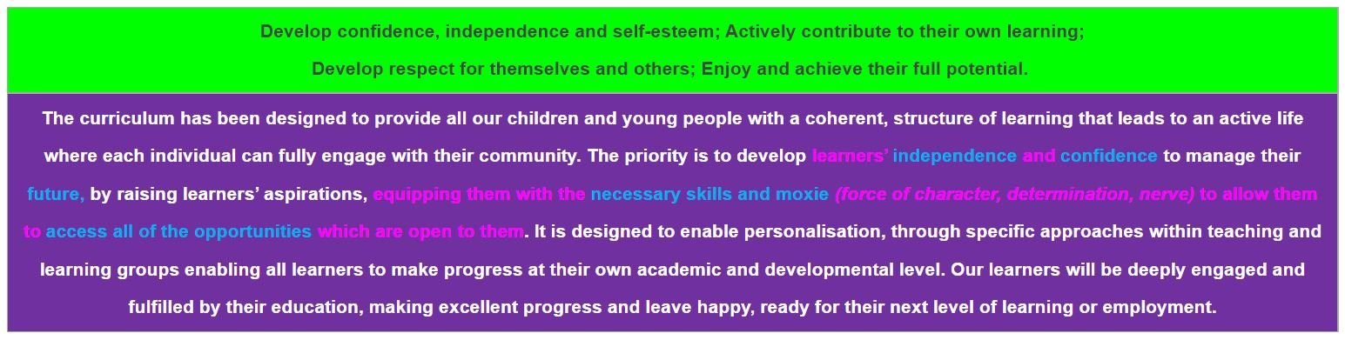
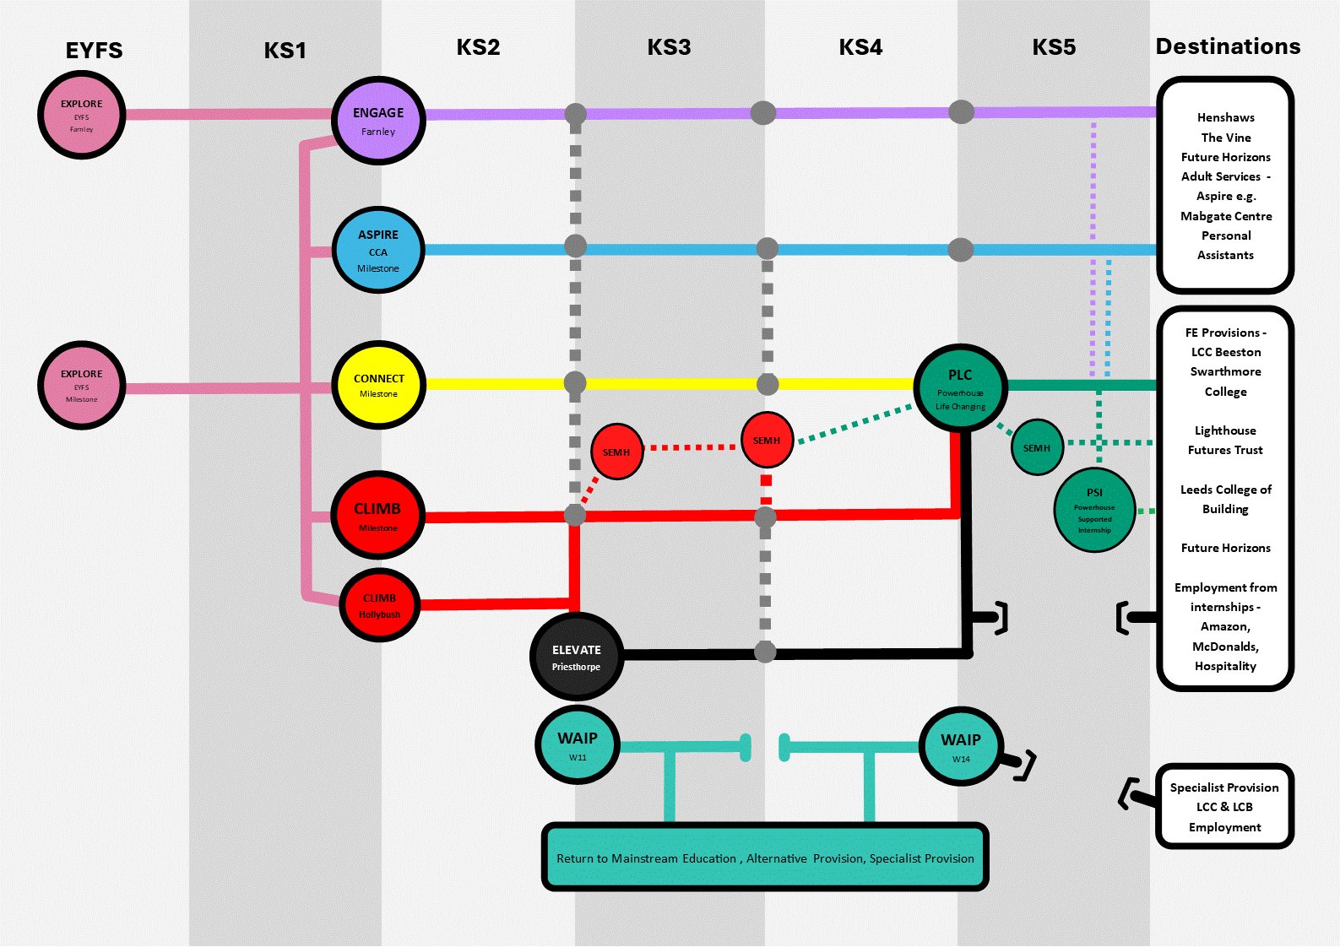

Come Climb with Us:
Where Every Learner Reaches New Heights

In our Climb Pathway (Red pathway), we don’t just teach – we unlock potential, one learner at a time. Spanning Key Stages 1 to 4, our Climb classes support learners with moderate to severe learning difficulties, often alongside additional communication, sensory, physical or social, emotional and mental health (SEMH) needs. It's an extraordinary place where flexibility meets ambition, and where learners are celebrated for their strengths while being supported through their challenges.
At the heart of Climb is our Semi-Formal Curriculum – rich in hands-on, meaningful learning that blends the best of academic opportunity with essential life skills and independence. Every timetable is carefully balanced to make sure learners thrive both in National Curriculum subjects and in achieving the personal outcomes detailed in their EHCPs. We don’t just follow a plan – we tailor every moment to suit our learners’ interests, needs and communication styles, supported by Pupil Passports that map their journey step by step.
From English and Maths to Art, PE and Humanities, our subject offer is wide-ranging and exciting. We use trusted schemes like Talk for Writing, White Rose Maths, Read Write Inc, and Zones of Regulation, but adapt them creatively to ensure our learners remain engaged and challenged at every stage. All subjects are brought to life through multi-sensory, highly visual and practical approaches, including the use of Makaton, assistive technology, and interactive displays. Many learners also benefit from sensory circuits, access to our sensory integration room, or therapies such as LEGO therapy and Art therapy.
We believe progress isn’t just about levels – it’s about confidence, curiosity, and independence. That’s why our learners are assessed using our Strides learning journeys via Evidence for Learning, and why we focus on small-step progress that leads to big, life-changing outcomes. EHCP targets are reviewed and refined termly in partnership with families, and every achievement is recognised, celebrated and used to propel the next step forward.
Climb learners have access to Discovery Clubs, where they choose what to explore – from board games and film clubs to sport and creativity. We also run daily snack cafés, where learners practice real-life maths, communication and decision-making in a way that’s practical and fun. Out in the community, our Life Skills and ‘Every Child Should’ programme opens the door to unforgettable experiences – whether that’s catching a bus, shopping for ingredients, or going on a residential.
Above all, Climb is a place of belonging – for learners and staff alike. You’ll be joining a passionate, expert team who are committed to making a genuine difference. No two days are ever the same, but every day is rewarding. You’ll laugh, learn, and lead – supported by a school that values innovation, creativity and care.
So, if you’re ready to teach in a place where relationships come first, where barriers are broken, and where the joy of learning is everywhere – come climb with us. Your next adventure starts here.

This role is a maternity leave post, temporary for two terms (Easter to Dec 31st initially) to teach in the Climb pathway. The post should be 4 days (but we may be flexible between 3 and 5 days for the right candidate). We are able to offer this post as a flexible opportunity, depending on your interests, experience and skills. The successful candidate will either work in our class where students have a primary need of significant social, emotional and mental health needs and learning difficulties or across several classes in the department where SEMH is less significant.

Information regarding our approach to SEMH: (if interested in working in the SEMH class)
We create a place where lives are transformed through tailored education, therapeutic support, and real human connection for our secondary SEMH students (key stage 3). As a SEMH teacher at our school, you’ll be joining a specialist team working with learners who have significant social, emotional, and mental health needs, alongside additional learning difficulties, and often autism, or sensory differences.

We deal with the entire person including their home, their past and their future. The experience is always nurturing and restorative. Our curriculum is varied and rich and is always adapted to the needs of the pupil to ensure they can succeed in life! We respond to pupils’ individual requirements by actively adapting the offer for each pupil. It is essential that our pupils develop a growth mind set, which is why we aim to expose our pupils to new and challenging experiences with the knowledge that they will always have our full support. We value relationships and directly challenge anything that may harm them. Everyone has a voice and the expectation is, it will be listened to. We continue to use the circle format to empower individuals to express their concerns and find solutions to their problems. We aim for all students to gain a better understanding of their behaviour, take responsibility for their actions and manage the consequences.

Our approach has improved pupils’ self-confidence and awareness. All staff are wholeheartedly committed to raising our pupils’ aspirations. From day one we strive to effectively prepare our pupils for adulthood.

All pupils are accustomed to the following certainties where we:
- Cultivate a restorative environment
- Develop pupils’ independence and employability
- Demonstrate the belief we have in our pupils
- Motivate and engage our pupils.
- Ensure accessible learning, recognising our pupils’ needs

What is the Climb Pathway?
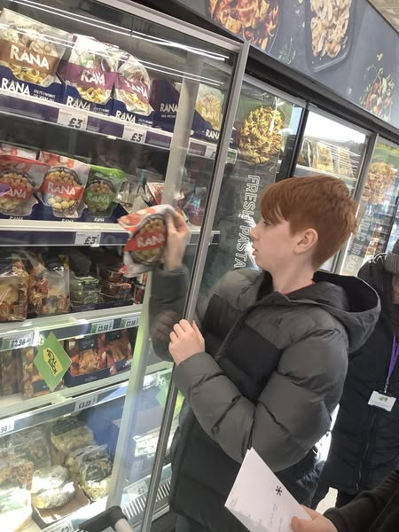
Climb is a vibrant pathway for learners who need a structured, relational and highly personalised approach to education, with moderate to severe learning difficulties.

In Climb we focus on:
- Semi-formal, flexible curriculum delivery

- High staff-to-learner ratios
- Therapeutic-multi sensory teaching
- Life skills: independence, and personal progress as well as academic
- Supporting emotional regulation ­ using tools like Zones of Regulation
Whether teaching English, Maths, Art, or PSHE, Climb teachers are empowered to adapt, inspire, and guide learners through small steps that lead to big changes.

Your Role as a Climb Teacher
As a teacher in Climb, you will:
- Lead a small, nurturing class with high support
- Deliver a wide range of subjects, adapted to learner needs
- Work closely with support staff, therapists and families
- Use tools like Makaton, visual timetables and sensory strategies
- Track progress through Evidence for Learning and EHCP outcomes
- Support emotional regulation using tools like Zones of Regulation
- You’ll be part of a passionate, collaborative team who champion creativity, inclusion and compassion.

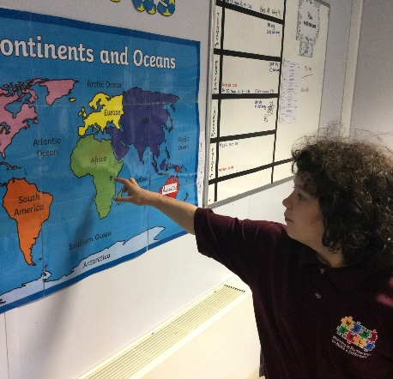

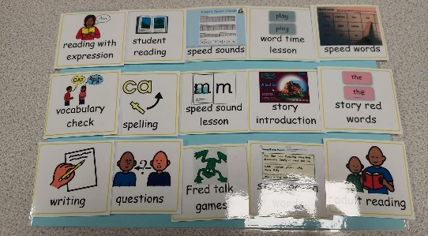
What We Offer

- A warm, welcoming and skilled staff team
- Bespoke induction and CPD tailored to SEND.
- Access to therapeutic and sensory resources.
- Opportunities to shape and develop the curriculum
- A culture values wellbeing, collaboration and humor
- Real opportunities to make a difference - every single day

Who We're Looking For
- A qualified teacher (or about to qualify)
- Passionate about inclusive education
- Flexible, nurturing and reflective
- Excited to teach on creative, sensory rich ways
- Eager to learn and grow in a specialist setting

Whether you’ve worked in mainstream, PRUs, APs or other SEND settings – your experience is welcome here.

West SILC – Working in Partnership to Make a Difference
We aim for all our students, irrespective of social class, age, gender, ability, religion, race or creed to:
    - Develop confidence, independence and self-esteem.
    - Actively contribute to their own learning.
    - Develop respect for themselves and others.
    - Enjoy and achieve their full potential.

Job Description – Class Teacher
Job Title: Class Teacher
Salary: M1 – UPR3, Minimum SEN Allowance
Contract Type: Permanent
Reporting to: Pathway Leader / SLT
Location: West SILC
Core Purpose:
To deliver outstanding, engaging, and meaningful teaching to learners, ensuring their academic, personal, social and emotional development in line with their EHCPs.
Key Responsibilities:

- Teach a broad and balanced curriculum across a range of subjects, adapted creatively to the needs, interests and abilities of learners on your pathway – including contextualised, sensory, therapeutic and visual approaches.
- Facilitate learning that empowers and engages, enabling learners to make meaningful progress across both academic and personal outcomes.
- Plan and deliver high-quality, personalised lessons, ensuring sessions are purposeful, inclusive and rooted in each learner’s EHCP, strengths and communication style.
- Build positive, trusting relationships that promote learner wellbeing, emotional regulation and independence – using tools like Zones of Regulation, Makaton and structured visual supports.
- Inspire curiosity, motivation and joy through consistent routines, multi-sensory experiences, and meaningful enrichment, both inside and outside the classroom.
- Track and celebrate progress using Evidence for Learning, documenting every small step on our Learning Journeys and EHCP small steps.
- Work collaboratively with support staff, therapists and families, building strong partnerships to support holistic learner development.
- Champion the values and aspirations of the Pathway and West SILC, contributing to a culture of inclusion, respect and high expectations.
- Take the lead on an area of curriculum, developing engaging plans with clear goals and success criteria that support independence, life skills, and preparation for adulthood.
- Support the wider school vision by contributing to whole-school improvement, planning, and the development of inclusive policies and practices.
- Reflect on your practice and grow professionally, using feedback, performance management and CPD to continually refine and improve your impact.
- Support learners across the SILC, being flexible to teach on any site as needed, and always committed to making a difference wherever you’re based.

What this means in more detail:

Planning, Teaching and Class Management
You will:
- Plan engaging, progressive lessons that are tailored to each learner’s strengths, needs and next steps – always with high expectations and meaningful outcomes in mind.
- Set clear, ambitious teaching objectives, and choose exciting, relevant ways to teach and assess them.
- Use time effectively and plan tasks that challenge, motivate and support each learner to succeed.
- Stay responsive to learners’ profiles – including communication styles, EHCP targets and sensory needs – and adapt your teaching accordingly.
Your teaching will:
- Blend structure with creativity, using practical, sensory and therapeutic approaches that bring key ideas to life.
- Embrace a wide variety of resources – including ICT, assistive tech, and visual tools – to maximise accessibility and interest.
- Encourage participation, independence and joy in learning.
- Help every learner move closer to their personal potential, no matter their starting point.
In your classroom:
- You’ll create a calm, consistent and respectful learning environment.
- You’ll support learners to regulate their emotions and make positive behaviour choices.
- You’ll celebrate progress – not just in levels, but in confidence, engagement and relationships.
- You’ll ensure all learners are seen, supported and safe, and that their achievements compare positively with those in similar settings.

Monitoring, Assessment and Reporting
You will:
- Use assessment to drive learning – identifying what’s working, what’s next, and how to get there.
- Mark, monitor and reflect on work to inform planning and celebrate success.
- Set personalised targets and track progress through Evidence for Learning and our Strides assessment.
- Keep clear, purposeful records that highlight growth, inform interventions and shape next steps.
- Share progress meaningfully with learners, families, and the wider team – building trust and collaboration through transparency and care.

Pastoral Responsibilities
You will:
- Be a form tutor, providing structured pastoral support and a consistent point of contact to help learners feel secure, understood and ready to engage.
- Promote attendance, engagement, and participation in all areas of school life.
- Be responsible for reviewing and developing each child’s EHCPs, behaviour plans, risk assessments and personal profiles in your class.
- Be proactive in spotting and supporting learners’ challenges – working with colleagues and families to find solutions.
- Build positive, respectful relationships with families, carers and external professionals – always putting the learner’s wellbeing first.

Curriculum Leadership (Area to be Agreed)
As a curriculum lead, you will:
- Coordinate planning, resources and activities within your subject or focus area.
- Support colleagues in delivering exciting, relevant and inclusive learning experiences.
- Review and evolve the curriculum collaboratively, keeping learners’ needs and strengths at the heart of your decisions.
- Stay current with national and sector developments in your area, bringing fresh ideas to the team.

Professional Responsibilities
You will:
- Understand and fulfil your professional and legal duties – including those related to KCSIE, safeguarding and child protection.
- Model the school’s values in everything you do – from your appearance and conduct to your relationships with learners and staff.
- Engage fully with the life of the school – contributing to meetings, reviews, school events and working parties as needed.
- Stay committed to your own growth, seeking out CPD and using what you learn to enhance your impact.
- Positively contribute to school priorities – including wellbeing, equity and Every Child Matters agenda.
- Build positive relationships with families and governors, sharing your passion for what’s possible for our learners.
- Take on additional responsibilities in line with the evolving needs of the school – always with the goal of making a real difference.

General Duties:
- Safeguard and promote the welfare of all learners.
- Contribute to whole-school improvement, staff training, and the positive ethos of the Climb department.
- Fulfil professional duties outlined in the Teachers’ Standards.

Person Specification – Class Teacher (Climb Pathway)
NB. Essential criteria are the qualities that candidates must have to do the job. Desirable criteria are the extra qualities that will enhance a candidate’s job performance and aid short listing. Ensure that your written application and your performance through the selection process demonstrates these.

Criteria | Essential | Desirable
Qualifications | - Qualified Teacher Status | - Additional qualifications in SEND, autism, or SEMH education  - Evidence of ongoing professional development in SEND or related fields
Experience | - Good or outstanding teaching experience in any setting (mainstream / SEND / PRU/AP)  - Ability to deliver engaging, multi-sensory, personalised lessons  - Able to track progress through formative and summative methods; assessing progress through small steps  - Experience of refining the National Curriculum and developing inclusive, adaptive teaching approaches to SEND learners  - Confidence in supporting emotional regulation and learner wellbeing  - Able to create appropriate EHCP outcomes and breaking down into smaller steps  - Successful strategies for supporting young people with social, emotional and mental health needs  - An understanding of the needs of parent/carers of children with SEND. | - Able to adapt teaching to outcomes from - Early Years to year 3 ARE  - Experience teaching learners with moderate to severe learning difficulties and additional needs  - Experience using Read Write Inc, White Rose Maths, or Talk for Writing, Colourful Semantics  - Delivering speech and language programmes, use of visuals, task plans, Makaton etc.  - Experience using Evidence for Learning assessment (or similar)  - Training in Zones of Regulation or similar approaches  - Knowledge of sensory integration, and therapeutic interventions  - Experience in holding annual reviews and associated paperwork  - An understanding of the needs of parent/carers whose children are at risk of disaffection/exclusion or developing mental health problems
Personal Qualities | - Passion for meeting the needs of neurodiverse learners and building positive relationships  - Strong team working and communication with professionals and families  - Reflective, creative, nurturing, and inclusive in approach  - Resilience and determination to succeed  - Good communication skills, able to establish credibility, trust and work collaboratively with pupils, school staff, other professionals and community groups  - Tactful, patient and sensitive | - Understanding of trauma-informed and attachment-aware approaches  - Experience leading a class team (e.g., HLTAs, support staff)  - Emotional self-awareness

Safeguarding & Equality | - Commitment to safeguarding, equality, and promoting a safe learning environment  - Enhanced DBS checks | - Experience contributing to safeguarding planning and behaviour support strategies, individual pupil risk assessments
Subject Leadership (Area to be Agreed)
As a subject lead, you will:
- Coordinate planning, resources and activities within your subject or focus area.
- Support colleagues in delivering exciting, relevant and inclusive learning experiences.
- Review and evolve the curriculum collaboratively, keeping learners’ needs and strengths at the heart of your decisions.
- Stay current with national and sector developments in your area, bringing fresh ideas to the team.

Professional Responsibilities
You will:
- Understand and fulfil your professional and legal duties – including those related to KCSIE, safeguarding and child protection.
- Model the school’s values in everything you do – from your appearance and conduct to your relationships with learners and staff.
- Engage fully with the life of the school – contributing to meetings, reviews, school events and working parties as needed.
- Stay committed to your own growth, seeking out CPD and using what you learn to enhance your impact.
- Positively contribute to school priorities – including wellbeing, equity and Every Child Matters agenda.
- Build positive relationships with families and governors, sharing your passion for what’s possible for our learners.
- Take on additional responsibilities in line with the evolving needs of the school – always with the goal of making a real difference.

General Duties:
- Safeguard and promote the welfare of all learners.
- Contribute to whole-school improvement, staff training, and the positive ethos of the Climb department.
- Fulfil professional duties outlined in the Teachers’ Standards.

Person Specification – Class Teacher (Climb Pathway)
NB. Essential criteria are the qualities that candidates must have to do the job. Desirable criteria are the extra qualities that will enhance a candidate’s job performance and aid short listing. Ensure that your written application and your performance through the selection process demonstrates these.

Criteria | Essential | Desirable
Qualifications | - Qualified Teacher Status (or to be achieved by July 2025) | - Additional qualifications in SEND, autism, or SEMH education  - Evidence of ongoing professional development in SEND or related fields
Experience | - Good or outstanding teaching experience in any setting (mainstream/SEND/PRU/AP)  - Ability to deliver engaging, multi-sensory, personalised lessons  - Able to track progress through formative and summative methods; assessing progress through small steps  - Experience of refining the National Curriculum and developing inclusive, adaptive teaching approaches to SEND learners  - Confidence in supporting emotional regulation and learner wellbeing  - Able to create appropriate EHCP outcomes and breaking down into smaller steps  - Successful strategies for supporting young people with social, emotional and mental health needs  - An understanding of the needs of parent/carers of children with SEND. | - Able to adapt teaching to outcomes from - Early Years to year 3 ARE  - Experience teaching learners with moderate to severe learning difficulties and additional needs  - Experience using Read Write Inc, White Rose Maths, or Talk for Writing, Colourful Semantics  - Delivering speech and language programmes, use of visuals, task plans, Makaton etc.  - Experience using Evidence for Learning assessment (or similar)  - Training in Zones of Regulation or similar approaches  - Knowledge of sensory integration, and therapeutic interventions  - Experience in holding annual reviews and associated paperwork  - An understanding of the needs of parent/carers whose children are at risk of disaffection/exclusion or developing mental health problems
Personal Qualities | - Passion for meeting the needs of neurodiverse learners and building positive relationships  - Strong team working and communication with professionals and families  - Reflective, creative, nurturing, and inclusive in approach  - Resilience and determination to succeed  - Good communication skills, able to establish credibility, trust and work collaboratively with pupils, school staff, other professionals and community groups  - Tactful, patient and sensitive | - Understanding of trauma-informed and attachment-aware approaches  - Experience leading a class team (e.g., HLTAs, support staff)  - Emotional self-awareness

Safeguarding & Equality | - Commitment to safeguarding, equality, and promoting a safe learning environment  - Enhanced DBS checks | - Experience contributing to safeguarding planning and behaviour support strategies, individual pupil risk assessments

