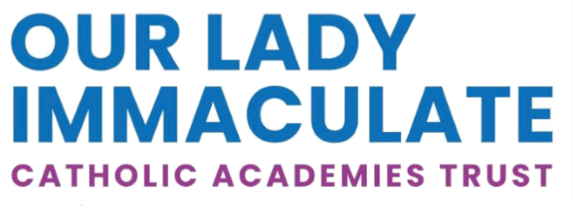
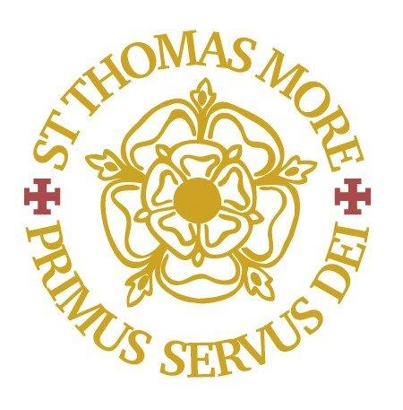lLogo

St Thomas More Catholic Secondary School
Full time SENDCo
MPS-UPS3 (Commensurate with experience)
Plus SENDCo allowance
For Easter 2026 start
Permanent position
The Directors of this successful Catholic Secondary School wish to appoint an enthusiastic, highly motivated and forward thinking SENDCo to inspire and lead our students. In return, we can offer a supportive and caring work environment.
The core purpose of the SENDCo is to take responsibility for the day-to-day provision made by the school for pupils with SEND and to provide professional guidance in the area of SEND in order to secure high quality teaching and the effective use of resources to bring about improved standards of achievement for all pupils. The SENDCo’s fundamental task is to support the Head Teacher in ensuring that all staff recognise the importance of planning their lessons in ways that will encourage the participation and learning of all pupils.
Closing date: 16th January 2026 at 12.00 noon
Interview date: Week commencing 19th January 2026
Suitable candidates may be interviewed before the closing date and the school reserves the right to withdraw the position if an early appointment is made. Applicants are therefore encouraged to apply early.
St Thomas More is committed to safeguarding and promoting the welfare of children and young people and expects all employees and volunteers to share this commitment. The suitability of all prospective employees or volunteers will be assessed during the recruitment and selection process in line with this commitment. Successful applicants will be required to undertake an enhanced DBS check.
Our Lady Immaculate Catholic Academies Trust is a large Catholic Multi Academy Trust situated in the northern half of the Catholic Diocese of Northampton formed by the merger of three former Catholic Trusts in February 2020. The Trust currently leads and manages ten Catholic primary schools located across the geographical area of Northamptonshire and Bedfordshire and, two Catholic secondary schools – St Thomas More in Bedford and Thomas Becket in Northampton.

