Ridgefield Primary School

Brave Explorers
Great Thinkers

Headteacher Recruitment Pack 2026
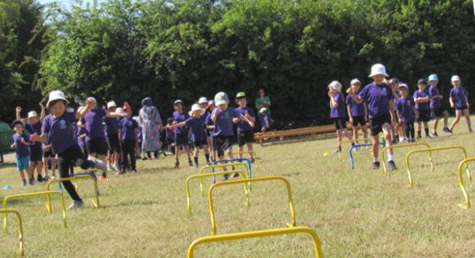

Sports Day 2025
a whole school activity with 4 houses, air, earth, fire and water
competing against one another

Ridgefield Primary School, Radegund Road, Cambridge, CB1 3RJ www.ridgefieldprimary.org Telephone 01223 712418


Contents
Letter from Governors 3
Our School 4
Our Ethos 4
Our Children and The Community 4
School Structure 5
The Ridgefield Team 5
Our Recent Achievements 6
Our Location 6
School Performance 7
Challenges and Opportunities 7
Summary 7
What makes Ridgefield great! By our pupils …. 8
Safeguarding 9
Equal Opportunities 9
The Selection Process 9
Key Dates 10
Headteacher Job Description & Person Specification 10
Job Description 10
Person Specification 12

Letter from Governors
Thank you for your interest in the Headteacher position at Ridgefield Primary School and Nursery. We are a vibrant, inclusive, and nurturing school community committed to ensuring every child feels valued and inspired to achieve their full potential.
Located on the eastern side of the historic university city of Cambridge, Ridgefield enjoys proximity to cultural and educational institutions. Our pupils benefit from regular visits to local museums and colleges.
We serve a diverse cohort of approximately 230 pupils, and we are proud of our strong relationships with families and the wider community. We celebrate the richness that different backgrounds, identities, and perspectives bring to our school community. We actively promote a culture where everyone feels respected, valued, and able to thrive.
Our recent Ofsted inspection in April 2023 rated us ‘Good’, with praise for our caring ethos, dedicated staff, and commitment to continuous improvement.
We are seeking a visionary and compassionate leader who will build on our successes and lead the school into its next exciting chapter. We welcome applications from experienced Headteachers as well as ambitious senior leaders seeking their first Headship. The successful candidate will be passionate about inclusive education, skilled in fostering a positive school culture, and committed to raising standards through collaboration and innovation.
This is a unique opportunity to make a lasting impact on the lives of children and families in our community. You will be supported by a dedicated team of staff, a proactive governing body and an engaged parent community, who support the school through volunteering and the Friends of Ridgefield group.
Our application pack provides further details about the role, our school, and our community. It offers insight into the vibrant character and ethos that make Ridgefield a special place to learn, teach, and grow.
We warmly welcome visits to the school, as we believe seeing Ridgefield in action is the best way to understand what makes it special. To arrange a visit on the dates listed in the key dates section, please contact Bruce Napier, Vice Chair of Governors on B.Napier@ridgefield.cambs.sch.uk.
Applications close on 16 March 2026, and interviews will be held on 26 March 2026.
Full details of the application process and person specification can be found in the accompanying recruitment pack.
If you are an inspiring leader ready to shape the future of Ridgefield Primary School, we would be delighted to hear from you.
Warm regards,
Rachael Conchie
on behalf of all school governors

Our School

Our Ethos
Brave Explorers and Great Thinkers, is more than a strap line, it underpins our approach to all aspects of school life.
We want everyone at the school to be Brave about Exploring their world of opportunity, this applies to pupils, staff and parents. We expect that we demand the best for ourselves and for those connected with the school.
Great Thinkers is about challenging ourselves to be our very best, be open minded to new ideas and concepts and to be resilient when facing challenges and fresh obstacles.
Through our values our intent is that every child should feel a sense of belonging. Our interactions are led through promoting kindness and respect for ourselves, each other and our environment. We also recognise the importance of diversity. These values create a supportive atmosphere where every child can thrive, grow, and develop the skills they need to succeed both in school and in life.

Our Children and The Community
Most of our children come from a catchment area with a radius of 400m from the school, thus putting the school as a key central point of the community. Since opening in 2002, it has forged its own ethos, identity and reputation. Coupled with a single form entry of 30 pupils, we are routinely oversubscribed with a substantial waiting list.
The school is located in one of the older Cambridge suburbs but reflects the modern and diverse nature of Cambridge, being a modern and international city.
This is reflected by 20.1% of pupils being eligible for Free School Meals and that 53.6% of the children, have English as an Additional Language (EAL)L. The composition and the dynamic nature of the local community are continually changing; with many of the children coming from professional families.
Our nursery offers 30-hours funded childcare which is very popular. It also provides an opportunity for children progressing to Reception begin developing an understanding of the high aspirations that we hold for everyone associated with the school.
We provide wrap-around care through our Breakfast Club and after-school provision the latter provided through a wide variety of clubs. Our main after school provider is “Cambridge Kids Club” an independent company that also operates during school holidays.
We offer a range of after-school activities including Latin, STEM club, French, and various sports activities including football, rugby, cross country, swimming and a fun run!
Our children learn through experience, performing Shakespeare at The Junction, singing with the English Touring Opera, exploring the Globe Theatre and Tate Modern, or investigating science at Addenbrooke’s. Every trip, visitor, and creative project contributes to the sense that learning here is an adventure.
Most of our pupils progress to local secondary schools and we maintain strong community connections with Coleridge Community College (part of United Learning MAT) which is located alongside Ridgefield. We have a good working relationship with the Coleridge team, giving us access to their sports fields and astro turf areas.
The Friends of Ridgefield (PTFA) supports the school through major fund-raising efforts and by organising several events a year. Our open approach to community engagement, which is reflected in the wide range of activities we host, including the annual international evening, seasonal discos and school fêtes. The PTFA also leads more practical engagements, such as second-hand Ridgefield school uniform sales.
In addition, we benefit from ongoing, enthusiastic support from parents in various ways, including many who visit the school to discuss careers in Science, Technology, Engineering or Maths during STEM week.
We have four schoolhouses; air, earth, fire and water and all children belong to one of these houses sharing in a whole school sports day and point achievements throughout the year. This gives children a wider sense of belonging outside of their year group. All new joiners in Reception are paired with a buddy from year 5 or 6 to further cement that sense of belonging, support settling in for our new joiners and provide a sense of responsibility to our older pupils.
We have a school council where children from years 1-6 are elected to represent the student voice and are elected by their peer group. We also have a team of Junior Travel Ambassadors from years 5 and 6 whose aims are promoting road safety, raising awareness, making sure students and parents are safe whilst travelling to and from school and teaching the green cross code.

School Structure
The school is a Member of the City of Cambridge Education Trust. The land and building are owned by the Trust, but with the funding and controlling framework being led by Cambridgeshire County Council

The Ridgefield Team
The Governing Body has a broad range of experience encompassing; former Headteachers, school advisors, parents and members of the community.
The Leadership Structure. This appointment of a new Headteacher offers the school an opportunity to further develop its leadership structure in support of future plans and ambitions. This may include the opportunity to make new senior appointments. The Governors are committed to working with the new Headteacher.
The Teaching Staff have a great range of skills and interests. They are a highly effective team of 9 members with a great range of skills and interests. Some classes are covered by teaching partnerships and have benefitted from a culture of continuing professional development. All are very ambitious for their pupils. Many also harbour ambitions for their own development and are keen to lead on various curriculum developments within the school.
The Teaching Assistants provide support to every year group. They are very experienced and skilful practitioners and work very closely with the class teachers to deliver high levels of support and bespoke interventions.
The wider team. The school has worked hard to develop a range a contacts and relationships embracing The University of Cambridge, Anglia Ruskin University and Cambridge Regional College. We have a great team of volunteers who help with a variety of activities including reading.

Our Recent Achievements
The school’s success has been built upon working together with the community, volunteers and outside organisations.
To give you a flavour of our approach, below are just some of our highlights over the last 12 months:
- Achieved Arts Mark Gold, recognising our outstanding commitment to high-quality arts education and creative opportunities for all students.
- Year 5 students performed Macbeth at The Junction as part of the School Shakespeare Festival, showcasing their drama skills and confidence in a professional performance setting.
- Hosted a vibrant Summer Music Festival featuring performances from students and alumni
- Enhanced Key Stage 2 physical education by partnering with local secondary school teachers, providing Year 5 and 6 students with specialist coaching and a broader range of sporting experiences.
- Delivered an inspiring STEM Week, engaging parents with careers in science, technology, engineering, and maths to lead lectures on diverse topics including AI in healthcare, cellular biology using transparent fish, linguistics, and neuroscience, enriching students’ real-world understanding and curiosity.
- Upgraded IT resources with 30 new laptops, enhancing students’ access to technology.

Our Location
Ridgefield School is located just off the Cambridge ring road, with excellent access to the A14 and the A11. Cambridge Railway station is a few minutes’ walk away.
As a city, Cambridge offers a great range of free museums that the school regularly visits, including the Zoology Museum and the Scott Polar Institute. Trips play an important part in the development of our pupils and the school community. Recent trips have included trips to Shepreth Wildlife Park, as well as seasonal visits to the local church, Cambridge Mosque and the pantomime at Cambridge Arts Theatre.
Not only can the pupils take full advantage of Cambridges physical attractions, but as a school we are also bring the diverse offerings the city has to offer directly to the pupils. This ensures as many students as possible get involved.

School Performance
This table shows the percentage of Year 6 children achieving the expected level in comparison to Cambridgeshire and National figures

 | Ridgefield | Cambs | National
Reading | 77% | 74% | 75.0%
Writing | 81% | 65% | 72%
Mathematics  R+W+M | 84%  77% | 72%  56% | 74%  62%

Challenges and Opportunities
Our School Improvement Plan has identified the following key areas for focus;
- Assessment is used effectively to identify when pupils are ready for more challenging
knowledge
- To improve the quality of pupils’ writing
- Guided reading builds on pupils’ phonic foundations and ensures measurable
progress in fluency, comprehension
- To ensure stability and continued progression during a time of leadership and staffing
change

Summary
Ridgefield is an integral part of the local community; it has an experienced and highly motivated team, it offers a fantastic opportunity for the right candidate to build on the strengths and foundations we have achieved so far, to share our vision and lead our school to even better things!

What makes Ridgefield great! By our pupils ….



Reception
- We are kind.
- I like playing with my friends.
- I enjoy listening to stories.

Year 3
- Everyone is kind and the achievement assemblies are great.
- Learning and making friends,
- The writing! You learn to write stories inspired by authors. You also learn about things from long ago.

Year 1
- School trips!
- We have lots of equipment to help us learn.
- Lunchtimes are fun

Year 2
- There's loads of wildlife around our school and you get to have fun in your learning.
- Assemblies, playtime, homework... everything.
- I love reading and listening to stories

Year 5
- You learn a lot whilst having fun.
- Everyone is really kind. It is a really peaceful place to learn

Year 4
- We get to learn lots of new things - things we've never thought of before.
- All the lessons!
- Everyone is kind and uses their manners

Year 6
The community and how the adults help us learn.
Everyone is kind to each other and supportive of what we want to do.
You can play with your friends at playtime.

Our Headteacher Wish List, by Ridgefield pupils ….
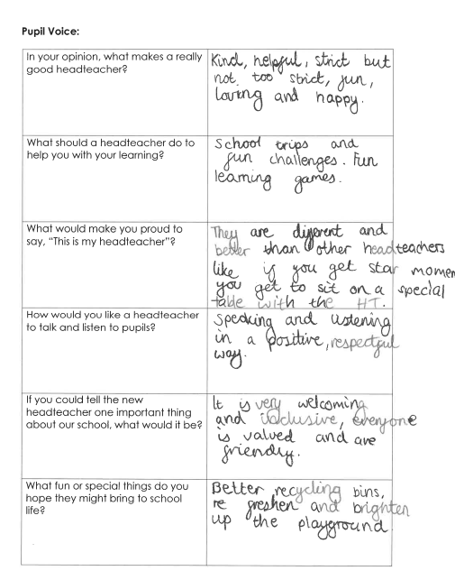
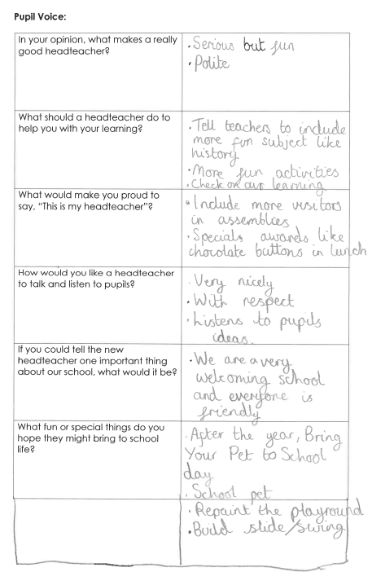

Safeguarding
Ridgefield Primary School is committed to safeguarding and promoting the welfare of all children and expects every member of staff, governor, volunteer and visitor to share this commitment. Our recruitment and selection procedures are designed to identify, deter and prevent unsuitable individuals from working with children, ensuring the highest standards of safety and care across our school community.
All appointments are subject to robust pre-employment checks, including verification of identity, qualifications, right to work in the UK, satisfactory references and an enhanced Disclosure and Barring Service (DBS) check with barred-list clearance where applicable.
It is a criminal offence for anyone who is barred from engaging in regulated activity with children to apply for, or undertake, such work. Some posts may not be exempt from the provisions of the Rehabilitation of Offenders Act 1974, as certain spent convictions and cautions are considered ‘protected’ and not subject to disclosure. Applicants are therefore required to provide upfront and accurate disclosure of all unspent convictions, cautions, reprimands or warnings that are not filtered under DBS guidance.
Failure to declare relevant information may result in the withdrawal of a job offer or, if discovered after appointment, could lead to dismissal and possible referral to the relevant authorities.

Equal Opportunities
Ridgefield promotes equality of opportunity and will deal with unlawful discrimination robustly. Job applicants and existing employees are prohibited from unlawful discrimination on the grounds of gender, age, disability, marital status, pregnancy, religion and belief, race, nationality and sexual orientation

The Selection Process
We are recruiting a Headteacher for Ridgefield Primary school who will ideally take up appointment in September 2026. This is a full-time position. A copy of the school recruitment and retention policy is available on request.
The starting salary will be Group 2 with a range of L8 to L21 (£61,534-£83,860), salary will depend on experience.
The Governing Body is committed to the continued professional development of all staff and will seek to support the successful applicant in their new role.
Visits to the school are warmly welcomed. To arrange a visit or if you have any other questions about the school, please contact, the Chair of Governors via email: chair@ridgefield.cambs.sch.uk

Key Dates
- Visits to the school can be scheduled by contacting B.Napier@ridgefield.cambs.sch.uk to confirm a suitable time to visit.
- Closing date for applications 16 March 2026
- Shortlisting of applicants to take place on 19 March 2026
- Interviews to take place on the 26 March 2026
Please apply via MyNewTerm and the recruitment process with be managed in partnerships with Cambridge County Council’s School Governance Team.

Headteacher Job Description & Person Specification

Job Description
As Headteacher, you will be accountable for the education of current and future generations of children at Ridgefield Primary School. You will need to love learning yourself, and work with staff and governors to shape the teaching and learning within the school. You will need a strong set of personal values, enabling you to serve as lead professional and role model and you will need a clear vision for education, so that you can inspire pupils, staff and the wider school community. In order to fulfil these expectations, you will:
Maintain and enhance our school’s ethos and values by:
- Working in partnership with the governing body to continue to provide a shared vision firmly rooted in our educational values and high-performance ethos
- Communicating the school’s vision confidently and compellingly to all members of our school community and to prospective parents
- Demonstrating our vision and values (Brave Explorers, Great Thinkers) in your daily practice
- Playing an active role in all aspects of school life.
Develop and embed professional dialogue and development by:
- Routinely assessing the impact of whole school practice through systematic monitoring, evaluation and review
- Creating an ethos in which staff are inspired, motivated and supported to enhance their own practice, skills and subject knowledge
- Actively embracing opportunities for your own professional growth and development.
Establish high expectations and secure accountability by:
- Providing a safe, calm and well-ordered environment in which pupils can thrive and develop a love of learning
- Setting high expectations for all pupils, recognising differences and respecting cultural diversity
- Instilling a strong sense of accountability on the basis of which staff routinely evaluate the impact of their work on outcomes for pupils

- Securing the core features of highly effective classroom practice as standard across the school
- Implementing curriculum design which leads to enrichment opportunities that promote the development of the whole child.
Manage the organisation by:
- Ensuring that the school’s systems, organisation and processes are well considered, efficient, fit for purpose and value for money
- Establishing fair, transparent and rigorous systems and measures for managing the performance of all staff, addressing any under-performance, supporting staff to improve, and valuing excellent practice
- Appropriately distributing leadership amongst staff, ensuring that roles and responsibilities are well understood and effectively carried out
- Actively supporting the governing body to understand its role and deliver its functions effectively
- Working with governors to ensure that strategic financial planning leads to fair and transparent deployment of budgets and resources
- Ensuring compliance with statutory regulations and requirements.
Work with and for our community by:
- Demonstrating optimism and nurturing positive relationships with pupils, staff, parents, governors and members of the local community
- Looking for opportunities to work collaboratively with other schools and organisations.
Notes
- This job description is based on Headteacher Standards: https:/www.gov.uk/government/publications/national-standards-of-excellence-for-headteachers
- This job description will be reviewed on an annual basis. In addition, it may be amended at any time after consultation with the posy holder.

Person Specification
 | Essential characteristics | Desirable  characteristics | Identified by:
Qualifications | - QTS  - Degree  - National Professional Qualification for Headship (NPQH) or willingness to work towards this, or equivalent qualification  - Experience of being a designated safeguarding lead  - Evidence of continuing Professional  development |  | - Certification  - Application
Leadership | - Ability to encourage, motivate and nurture others working collaboratively in a collegiate style  - Ability to confidently articulate a clear sense of direction for the school  Demonstrate the courage to hold others to account and the skills to deliver challenging feedback  - Ability to model excellence in behaviour and relationships, even under pressure  - Ability to manage complaints, conflicts and divisions calmly, sensitively and constructively to achieve resolution  - Demonstrate a creative approach to driving innovations at the same time as embedding good practice  - Track record of developing others through delegation and supporting in appropriate measures | - Knowledge and experience of working in partnership with governors.  - Track record of inspiring loyalty in colleagues  - Evidence of leading Continuing Professional Development for others.  - Working in a range of school settings, e.g. Multicultural settings with high levels of EAL; deprived communities  - Experience of working collaboratively with another school/schools to secure improvement. | - Application  - Interview  - References

Experience | - Significant successful experience as a senior leader within a school  - Provide excellent teaching across the primary phase  - Work closely with staff and governors to develop a school’s ethos, values and objectives.  - Development of effective curriculum initiatives.  - Leadership of monitoring and assessment.  - Effective financial planning and budgeting within a school. | - Evidence of leading Continuing Professional Development for others.  - Working in a range of school settings, e.g. Multicultural settings with high levels of EAL; deprived communities  - Experience of working collaboratively with other school/schools to secure improvement. | - Application  - References
Knowledge and skills | The ability to analyse and interpret data accurately and critically in order to raise standards.  - The skills to communicate effectively, confidently and fluently in person, on paper and electronically.  - Ability to engage with parents/carers to support their child’s learning.  - Knowledge of all primary key stages, including EYFS.  - Thorough understanding of effective safeguarding practices.  - Demonstrate knowledge and understanding of different approaches to the curriculum and a commitment to building memorable learning experiences  - Ability to build outstanding relationships with children and adults whilst maintaining a focus on school improvement | Ability to promote the activities and ethos of the school through various media, and to “sell” the school to prospective parents.  - Ability to innovate around SEND. | - Assessment at interview
Personal | - Ability to manage time and prioritise effectively.  - Relish challenge and tackle aspirational goals with bold enthusiasm and resilience  - Ability to “bounce back” and remain optimistic in the face of adversity.  - Ability to build outstanding relationships with children and adults whilst maintaining a focus on school improvement  - Proven ability to manage situations with a calm and consistent approach  - Proven capacity to find creative solutions, take the initiative and think laterally |  | - Application  - Interview  - References
Development | Accurate self-awareness of strengths and areas for growth, with a clear commitment to self-improvement.  - Value and learn from constructive feedback |  | - Interview  - References
Values | - Creative commitment to guiding the ethos and vision of the school in the future  - Ambition for all our learners and all our community to reach their full potential.  Compassion for and an understanding of diversity and its impact on school life. |  | - Interview

