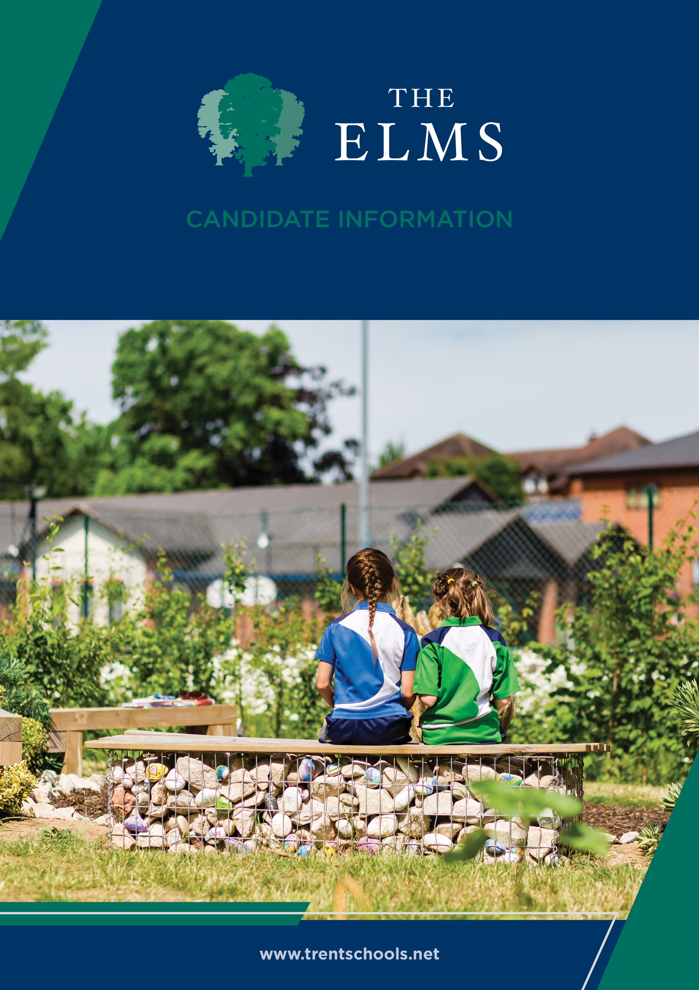


Welcome
The Elms is an independent co-educational school for children aged from 6 weeks to 11 years old. Located in Long Eaton, Nottinghamshire, The Elms is part of Trent College, and enjoys a beautiful, shared 45-acre campus with state-of-the-art facilities, including modern classrooms and sports facilities, as well as dedicated Nursery and Pre-School buildings, and wonderful outdoor learning facilities.
The Elms journey begins in the Nursery, which was recently rated ‘Outstanding’ in all areas. Here learning through play and exploration builds confidence and curiosity about the world around them.
As children progress through the school, the focus on exceptional pastoral care and inspirational teaching, along with a vast array of enrichment opportunities, ensure that our children leave us with the independence and resilience to embark successfully upon their senior school education.
Rated ‘Excellent’ across the whole school by the Independent Schools Inspectorate in 2021, we have highly qualified and experienced teaching staff who are committed to providing an excellent standard of education. We also have a large population of support staff, ensuring that our friendly school and beautiful campus operate to the very highest standards and our pupils are happy and flourish.
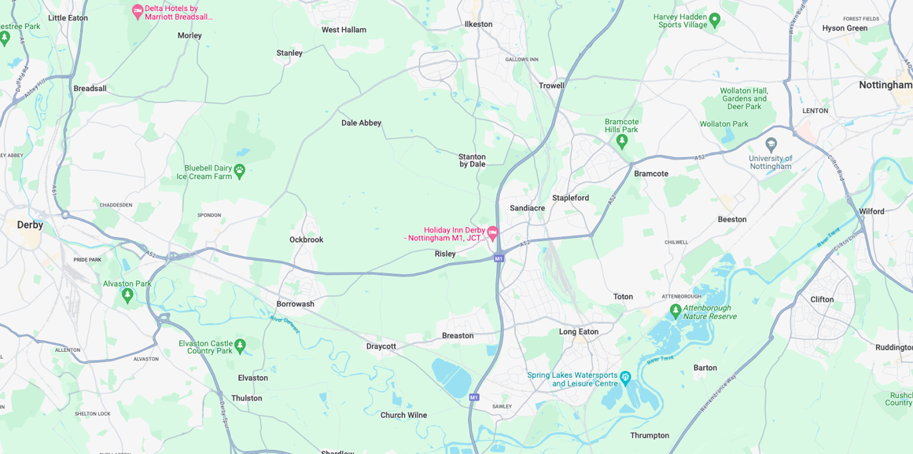


Our Location
Trent College and The Elms are conveniently situated on the border of Nottinghamshire and Derbyshire.
Ideally located at the heart of the UK’s motorway system, we are only 2 miles from junction 25 of the M1, which provides easy access to the M42 and A1.
Reaching Trent College by rail couldn’t be easier. Long Eaton boasts its own train station, located 1.5 miles from the schools. Rail routes through Long Eaton run along the Midlands Main
Line route, with direct routes to London, Loughborough, Leicester, Birmingham, Nottingham, Derby, Chesterfield and Sheffield.

Our Local Community
Working in partnership and serving the community are natural and very important values at Trent College and The Elms. We work with many local schools in Long Eaton and the wider Erewash borough to increase opportunities and aspirations, and to share the school’s excellent grounds, facilities and specialist staff.



Maternity Cover

Assistant Head – EYFS and Key Stage 1

Job Description
Maternity Cover - Assistant Head (EYFS & Key Stage 1)

Purpose of the Role
The Assistant Head (EYFS & Key Stage 1) will provide strategic and operational leadership across the Early Years Foundation Stage and Key Stage 1. The postholder will play a key role in maintaining high standards of teaching, learning, assessment, pastoral care and pupil wellbeing, while supporting the school's vision, values and objectives.
The role combines leadership responsibilities with a substantial teaching commitment and requires a collaborative and forward-thinking individual who can inspire staff, pupils and families to achieve excellence.

Key Responsibilities

Leadership and Management
- Support the Head in the day-to-day leadership and management of the school.
- Lead and promote high standards of teaching, learning and pupil achievement across EYFS and Key Stage 1.


- Contribute to the development, implementation and evaluation of school improvement priorities.
- Actively contribute as a member of the senior leadership team.
- Support the monitoring and evaluation of educational provision, identifying areas for development and implementing appropriate actions.

Teaching and Learning
- Deliver high-quality classroom teaching, maintaining a teaching commitment of approximately 50%.
- Promote innovative and effective teaching practices that enhance pupil engagement and progress.
- Support curriculum development to ensure a broad, balanced and enriching educational experience.
- Monitor pupil attainment and progress, ensuring appropriate interventions and support are in place.

Staff Development
- Provide guidance, coaching and support to teachers and support staff.
- Foster a culture of professional development, collaboration and continuous improvement.
- Support performance management processes and contribute to staff development initiatives.

Pupil Welfare and Pastoral Care
- Promote a positive, inclusive and nurturing environment where pupils feel safe, valued and supported.
- Uphold the highest standards of safeguarding and child protection.
- Support pupil wellbeing, behaviour and personal development across the school.

Communication and Partnerships
- Develop positive relationships with parents, pupils and the wider school community.
- Work collaboratively with colleagues to ensure effective communication and consistency of approach.
- Represent the school professionally at meetings, events and activities as required.

General
- Undertake any other duties reasonably required by the Head that are consistent with the nature and level of the post.
- Support and promote the ethos, values and reputation of the school at all times



Qualifications
Essential
- Qualified Teacher Status (QTS).
- Degree or equivalent qualification.

Experience
Essential
- Successful teaching experience in EYFS and/or Key Stage 1.
- Experience of leading staff, a curriculum area, or school improvement initiatives.
- Experience of monitoring and improving pupil outcomes.
Desirable
- Previous middle or senior leadership experience.

Knowledge and Skills
Essential
- Strong understanding of EYFS and Key Stage 1 provision.
- Excellent communication and interpersonal skills.
- Ability to lead, motivate and develop others.
- Sound knowledge of safeguarding and pupil welfare.

Personal Attributes
Essential
- Inspiring and approachable leader.
- Commitment to high standards and pupil achievement.
- Collaborative and positive approach.
- Strong organisational skills and ability to manage competing priorities.
- Commitment to the ethos and values of the school.

Person Specification



Benefits
- Staff can enjoy complimentary lunches in the Obolensky Dining Hall during term time. Free car parking is available on site and staff have access to a cycle to work scheme.
- Staff are able to make free use of the school gym and leisure facilities at designated times.
- A defined contribution pension scheme is available to join, provided by AVIVA, with a generous employer contribution. Members also benefit from death in service and income protection.
- Enhanced sick pay and maternity pay is available to staff.
- Staff are entitled to a fee remission for children attending the school, in line with our policy.
- We provide a range of benefits to support staff, including counselling, an employee assistance programme and 24/7 online GP consultations.

Terms and Conditions
- Full-time, term-time only maternity cover position for up to one year.



Making an Application
Candidates who wish to apply for this post should apply via our website.
If you have any questions about the role please email recruitment@trentcollege.net or telephone 0115 949 4949 (during term time).
The closing date for applications is included in the advert.
Interviews are scheduled to take place on the week commencing 2 November 2026
We reserve the right to close this advertisement early if we receive a volume of strong and suitable applications.

The school is committed to safeguarding and promoting the welfare of children and young people and expects all staff and volunteers to share this commitment.
Applicants will be required to undergo child protection screening appropriate to the post, including checks with past employers and the Disclosure and Barring Service (DBS). The school may carry out online searches on shortlisted applicants and all applicants will be required to provide details of their online profile, including social media account names/handles, as part of their application
The post is exempt from the Rehabilitation of Offenders Act 1974. The school is therefore permitted to ask job applicants to declare all convictions and cautions on a self-declaration form in advance of attending an interview (including those which are "spent" unless they are "protected" under the DBS filtering rules) in order to assess their suitability to work with children.



