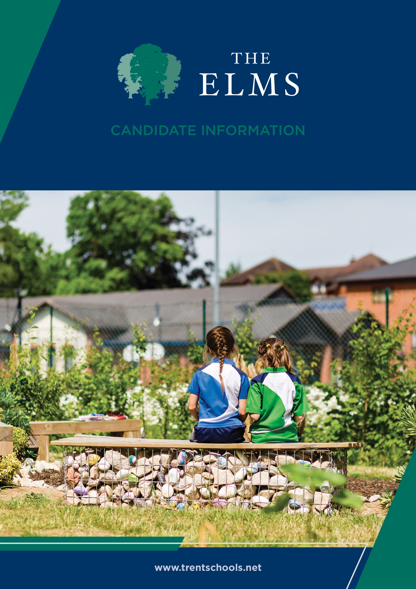


Welcome
The Elms is an independent co-educational school for children aged from 6 weeks to 11 years old. Located in Long Eaton, Nottinghamshire, The Elms is part of Trent College, and enjoys a beautiful, shared 45-acre campus with state-of-the-art facilities, including modern classrooms and sports facilities, as well as dedicated Nursery and Pre-School buildings, and wonderful outdoor learning facilities.
The Elms journey begins in the Nursery, which was recently rated ‘Outstanding’ in all areas. Here learning through play and exploration builds confidence and curiosity about the world around them.
As children progress through the school, the focus on exceptional pastoral care and inspirational teaching, along with a vast array of enrichment opportunities, ensure that our children leave us with the independence and resilience to embark successfully upon their senior school education.
We have highly qualified and experienced teaching staff who are committed to providing an excellent standard of education. We also have a large population of support staff, ensuring that our friendly school and beautiful campus operate to the very highest standards and our pupils are happy and flourish.
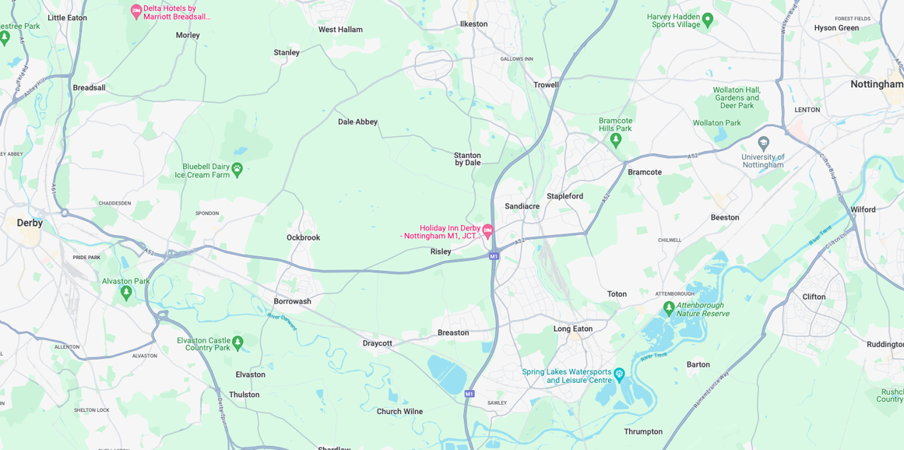


Our Location
Trent College and The Elms are conveniently situated on the border of Nottinghamshire and Derbyshire.
Ideally located at the heart of the UK’s motorway system, we are only 2 miles from junction 25 of the M1, which provides easy access to the M42 and A1.
Reaching Trent College by rail couldn’t be easier. Long Eaton boasts its own train station, located 1.5 miles from the schools. Rail routes through Long Eaton run along the Midlands Main
Line route, with direct routes to London, Loughborough, Leicester, Birmingham, Nottingham, Derby, Chesterfield and Sheffield.

Our Local Community
Working in partnership and serving the community are natural and very important values at Trent College and The Elms. We work with many local schools in Long Eaton and the wider Erewash borough to increase opportunities and aspirations, and to share the school’s excellent grounds, facilities and specialist staff.



Director of Music – The Elms

At The Elms, music lies at the heart of school life. It is a powerful force that brings our community together, nurtures confidence, and allows every child to discover their voice. From the earliest experiences in our Nursery to the assured performances of our oldest pupils, music is woven through daily life - shaping not only skills, but character, creativity and joy.

We are seeking an exceptional and inspiring Director of Music to lead this vibrant area of the school. This is a rare opportunity to build upon a strong and established musical culture, and to shape a vision that will continue to enrich the lives of our pupils for years to come.

The successful candidate will be both an outstanding practitioner and a creative leader - someone who understands that the true power of music lies not simply in technical excellence, but in the experiences, confidence and sense of belonging it creates. You will foster a genuine love of music in every child, whether they are taking their first tentative steps in rhythm and melody, or performing with confidence on stage.

Music at The Elms is inclusive, ambitious and celebratory. Pupils are given opportunities to perform, collaborate and grow, whether through choirs, ensembles, productions or individual instrumental learning. As Director of Music, you will lead and develop this rich programme, creating memorable performances and ensuring that every child feels able to participate and succeed.

You will also oversee a thriving instrumental provision, working closely with a dedicated team of visiting music teachers, and ensuring that pupils have access to high-quality tuition and meaningful progression. Through careful leadership and organisation, you will enable music to flourish both within the curriculum and beyond it, contributing fully to the broader life of the school.

Working collaboratively with colleagues, parents and the wider community, you will champion music as a central part of a holistic education. The role offers the opportunity to develop strong partnerships, including with the wider Trent College music department, and to ensure that The Elms continues to offer a rich and connected musical journey for its pupils.

While the role includes a teaching commitment, it also requires strategic leadership. You will set a clear direction for music within the school, ensuring high standards of teaching and learning, supporting colleagues, and contributing to the wider development of the school. You will bring both creativity and organisation, balancing the joy of music-making with the effective management of programmes, people and resources.

We are looking for someone with a strong musical background and experience of teaching across the primary or preparatory age range. You will combine expertise with warmth, enthusiasm and a genuine commitment to the development of young people. Most importantly, you will share our belief that music should be accessible, inspiring and central to every child’s experience at school.

The Elms is part of Trent College, located on a beautiful 45-acre campus on the Nottinghamshire and Derbyshire border. The school is known for its outstanding pastoral care, strong sense of community and commitment to providing a rich and varied educational experience. In 2025, the school’s co-curricular provision was also noted as a significant strength in its latest ISI inspection report.

We offer a supportive and collaborative working environment, alongside a competitive salary and a range of benefits, including use of excellent facilities, professional development opportunities and a strong culture of staff wellbeing.

The successful candidate will take up the post in September 2026.

We warmly welcome visits from prospective applicants, and encourage those who share our passion for music and education to apply.

Closing date for applications: 18 May 2026 at 9:00am
Interviews: 21 May 2026

The Elms and Trent College are committed to safeguarding and promoting the welfare of children and young people. All staff are expected to share this commitment.



Benefits
- Staff can enjoy complimentary lunches in the Obolensky Dining Hall during term time. Free car parking is available on site and staff have access to a cycle to work scheme.
- Staff are able to make free use of the school gym and leisure facilities at designated times.
- A flexible retirement plan run by TPT Solutions (formerly The Pensions Trust), including Death in Service benefit.
- Enhanced sick pay and maternity pay is available to staff.
- Staff are entitled to a fee remission for children attending the school, In line with our policy.
- We provide a range of benefits to support staff, including counselling, an employee assistance programme and 24/7 online GP consultations.

Terms and Conditions
- Permanent, Full Time.


Making an Application
Candidates who wish to apply for this post should complete the online application process.
If you have any questions about the role, please email recruitment@trentcollege.net or telephone 0115 949 4949 (during term time).
The closing date for applications is 18 May 2026 at 9:00am

Interviews are scheduled to take place on 21 May 2026
We reserve the right to close this advertisement early if we receive a volume of strong and suitable applications.

The school is committed to safeguarding and promoting the welfare of children and young people and expects all staff and volunteers to share this commitment.
Applicants will be required to undergo child protection screening appropriate to the post, including checks with past employers and the Disclosure and Barring Service (DBS). The school may carry out online searches on shortlisted applicants and all applicants will be required to provide details of their online profile, including social media account names/handles, as part of their application
The post is exempt from the Rehabilitation of Offenders Act 1974. The school is therefore permitted to ask job applicants to declare all convictions and cautions on a self-declaration form in advance of attending an interview (including those which are "spent" unless they are "protected" under the DBS filtering rules) in order to assess their suitability to work with children.



