

Headteacher Recruitment Pack
April 2026


CLOSING DATE: 15th May 2026
INTERVIEWS: Week of 1st June
Letter from the Chair of Governors
Dear Applicant,
Thank you for your interest in applying for the position of Head Teacher at Milton Road Primary School. This is a full-time role starting in January 2027. The salary range is L18 - L24.
Milton Road is a two form entry primary school located close to the centre of the beautiful university city of Cambridge. We are a diverse and inclusive school with a vibrant and engaged school community.
We were Ofsted inspected in September, 2025 and rated ‘Good’ on Quality of Education and ‘Outstanding’ on all other areas. We are looking for an ambitious, passionate Head Teacher to lead the school in the next step of its development and shape our response to the changing education landscape.
Our student body is courteous, articulate and engaged by their learning which is centred around our unique, local and experience rich “Cambridge connected curriculum”. We also offer a wide-range of extra-curricular activities for students as we seek to ensure they are happy and healthy today, fulfilled in the future and able to make their world an even better place.
We are delighted to be supported by a multi-cultural engaged parent body, including an excellent PTA. Our teaching body is strong and united in delivering a comprehensive curriculum for our pupils.
The school buildings are around twenty years old, with the classrooms progressing from Early Years to Year 6 round a central courtyard. The buildings are in generally good repair, although in some areas are starting to show their age and addressing these issues is a focus for the governing body.
The school grounds include a large playing field and playgrounds for Early Years, Key Stage 1 and Key Stage 2. We also have a special Forest School area, with pupils enjoying weekly Forest School lessons every other half-term throughout their years at MRPS.
The governing body is committed to teacher well-being, including a dedicated wellbeing link governor. We commit to supporting our new Head Teacher in ensuring their work/life balance and ensuring they receive a proper induction and support as they take up the role.
We would be delighted to host you for an informal visit to the school either before or after your application is received.
Yours faithfully,

Richard Wielechowski
Chair of Governors (Chair@miltonroad.cambs.sch.uk)
An introduction to Milton Road Primary School
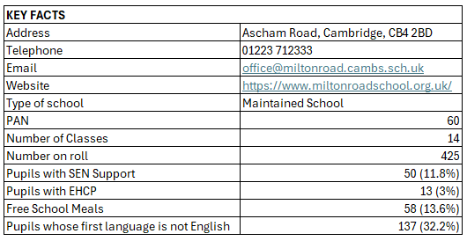
Milton Road Primary School is a two-form entry primary school located to the north of the centre of the beautiful university city of Cambridge. We are a local authority-maintained school.
Our school moved to its current location in 2006. The spacious site sits at the end of a residential street and benefits from separate playgrounds for each of Early Years, Key Stage 1 and Key Stage 2. There is a large playing field adjoining the Key Stage 2 playground as well as a wooded Forest School area. Each of the classrooms benefits from a seating “pod” outside, with children engaging with outdoor learning opportunities when the weather permits.
We have strong links with other primary schools within our cluster area. We are a partner school with the highly regarded Chesterton Community College secondary school.
Safeguarding and welfare are extremely important and pupils are taught the virtues of kindness, respect, and recognising the needs of others via our “no outsiders” programme. We foster open and honest communication with parents and carers and actively seek to engage with all members of the school community in a positive and supportive manner.

Our Aims and Vision
“We want our children to be happy and healthy today, fulfilled in the future and able to make their world an even better place.”
Our core school values are Courage, Responsibility, Excellence and Wisdom and these align with our holistic curriculum design set around the four points of the compass. "We are crew not passengers" captures a central element of the school’s ethos. Milton Road's on-going success is a team effort and we all work hard to ensure that the children have a positive learning experience every day. Find out more about our values and ethos in our video.
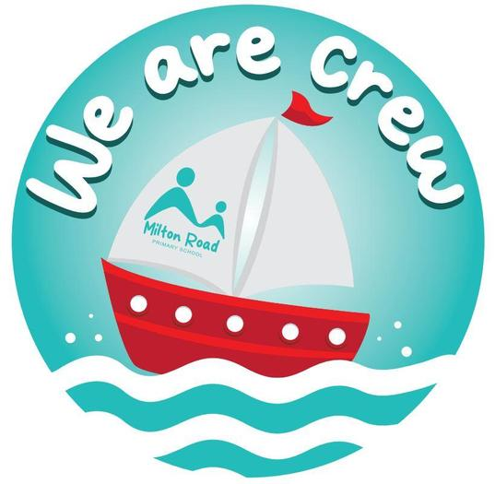
Our curriculum is designed around a compass to signify that we offer a holistic whole education; one which develops the whole child: the personal, social, academic and moral.
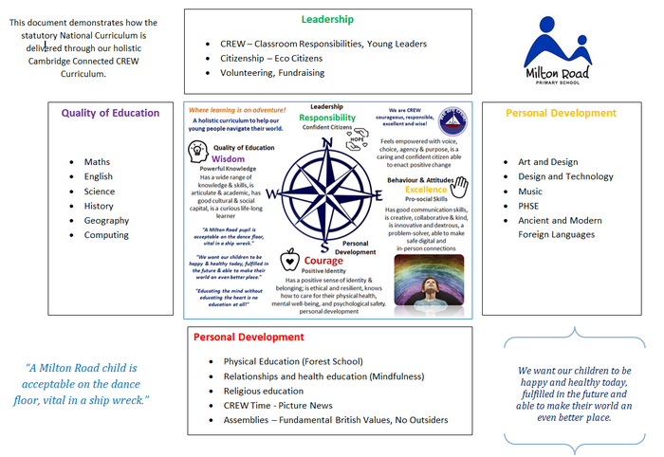
School Priorities
Our current school improvement plan focuses on the below areas:
Priority 1: Close Achievement Gaps for Disadvantaged Pupils and Pupils with SEND
Priority 2: Ensure Curriculum Quality and Consistency Across All Subjects
Priority 3: Achieve Excellence in Early Reading, Phonics, and Transcription Skills
Priority 4: Improve Mathematical Fluency and Multiplication Tables Check (MTC) Outcomes
Priority 5: Significantly Improve Attendance and Reduce Persistent Absence
We expect the new Head Teacher to evolve and develop their own priorities over time with the support of the governing body. The governing body is particularly interested in the potential impacts of AI and new technologies on education and will be interested in how applicants expect the use of these tools to impact education over the medium-term.

The Governing Body of Milton Road Primary School
There are fifteen governors made up of representatives from the parents, staff, the local authority, and the community, including the headteacher. Our governors have diverse backgrounds and skills and work closely with the headteacher to set the strategic direction of the school. Governors are committed to high standards of governance and both challenge and support the headteacher, as appropriate. The Chair meets regularly one on one with the headteacher to discuss issues as they arise. Governors also regularly visit the school, including meetings with their link subject champions amongst the staff.

Wraparound Care
We have both before and after school clubs provided by Premier Education. The Breakfast Club opens for an hour from 7:45am until the start of the school day and the after-school club runs from 3:20pm to 6:00pm during term time. Holiday clubs run from 8am until 6pm on most professional days and part of the school holidays.

Parent-Teacher Association
We have an excellent PTA, who support and enrich the school. They organise the whole school events, such as World Book Day and Halloween discos, Summer Fair and Winter Market and Parent Music nights. They have also developed relationships with local businesses to support fundraising for the school. Funds raised from the PTA have helped re-develop the pond area in Forest school, built extra outdoor classroom seating and currently re-developing the Early Years playground.
Job Description for the Head Teacher
Salary: L18-L24.
Type of role: Permanent, Full-time
Start date: 01 January 2027
Hours: Under the School Teachers’ Pay and Conditions Document, a full-time
teacher must be available to work for 195 days a year, made up of:
• 190 days of teaching and other duties
• Five days on other duties (which typically involve training and development).
However, the Headteacher will work additional hours within reason as needed to fulfil
the responsibilities of the role.
Reporting to: Board of Governors

Main Purpose
The headteacher will:
- Establish and sustain the school’s vision, ethos and strategic direction together with the governing board and through consultation with the school community.
- Establish and oversee systems, processes and policies so the school can operate effectively.
- Identify problems and barriers to school effectiveness, and develop strategies for school improvement that are realistic, timely and suited to the school’s context.
- Make sure these school improvement strategies are effectively implemented.
- Monitor progress towards achieving the school’s aims and objectives.
- Allocate financial resources appropriately, efficiently and effectively.
- To take responsibility for Health & Safety throughout the school.
- Delegate professional duties to the Deputy Headteacher in the event of absence.
Qualities
The headteacher will:
- Uphold public trust in school leadership and maintain high standards of ethics, behaviour and professional conduct
- Build positive and respectful relationships across the school community
- Serve in the best interests of the school’s pupils

Duties and Responsibilities
School Culture and Behaviour
The headteacher will:
- Create a culture where pupils experience a positive and enriching school life
- Uphold ambitious educational standards in order to prepare pupils from all backgrounds for their next phase of education and life
- Ensure a culture of staff professionalism
- Encourage high standards of behaviour from pupils, built on rules and routines that are understood by staff and pupils, and clearly demonstrated by all adults in school
- Use consistent and fair approaches to managing behaviour, in line with the school’s behaviour policy
Teaching, curriculum and assessment
The headteacher will:
- Establish and sustain high-quality teaching across all subjects and phases, based on evidence
- Ensure teaching is underpinned by subject expertise and thought leadership on the changing educational landscape
- Effectively use formative assessment to inform strategy and decisions
- Ensure the teaching of a broad, structured and coherent curriculum
- Establish curriculum leadership, including subject leaders with relevant expertise and access to professional networks and communities
- Use valid, reliable and proportionate approaches to assessing pupils’ knowledge and understanding of the curriculum
- Ensure the use of evidence-informed approaches to reading so that all pupils are taught to read
Additional and special educational needs (SEN) and disabilities
The headteacher will:
- Promote a culture and practices that enables all pupils to access the curriculum
- Have ambitious expectations for all pupils with SEN and disabilities
- Make sure the school works effectively with parents, carers and professionals to identify additional needs and provide support and adaptation where appropriate
- Make sure the school fulfils statutory duties regarding the SEND Code of Practice.
Managing the school
The headteacher will:
- Ensure staff and pupils’ safety and welfare through effective approaches to safeguarding, as part of a duty of care
- Lead staff well with due attention to workload and wellbeing
- Ensure rigorous approaches to identifying, managing and mitigating risk
Professional development
The headteacher will:
- Ensure staff have access to appropriate, high standard professional development opportunities
- Keep up to date with developments in education
- Ensure training and continuing professional development is effectively planned, delivered and evaluated
- Make sure professional development opportunities draw on experts both within, and beyond the school
- Seek training and continuing professional development to meet the needs of all staff members
Governance, accountability and working in partnership
The headteacher will:
- Understand and welcome the role of effective governance, including accepting responsibility
- Ensure that staff understand their professional responsibilities and are held to account
- Ensure the school effectively and efficiently operates within the required regulatory frameworks and meets all statutory duties
- Work successfully with other schools and organizations
- Maintain working relationships with fellow professionals and colleagues to improve educational outcomes for all pupils

Other areas of responsibility
- To contribute to the positive team atmosphere and public image of the school.
- To act professionally and with integrity at all times.
- To assist with the general care and welfare of all pupils striving to maintain a happy safe environment at all times
- To adhere to and maintain school routines and codes of conduct, including confidentiality
- To maintain personal and professional development to meet the changing demands of the job, participating in appropriate training activities
- To undertake other such duties and training as may be reasonably required and which are consistent with the general level of responsibility of this job
Notes:
This job description may be amended at any time in consultation with the postholder.

Headteacher Person Specification
Qualifications, Training, and Experience | Essential | Desirable
Qualified teacher status | X
National Professional Qualification for Headship (NPQH) or equivalent |  | X
Effective senior management experience, e.g. as head, acting head, or deputy head | X
Experience of leading and managing a team in an educational environment | X
Thorough knowledge and understanding of the primary curriculum  and recent developments | X
Evidence of recent in-service training | X
Experience of working constructively with governors | X
Evidence of at least good classroom practice | X
Experience of being Designated Safeguarding Lead |  | X
Competences
A proven ability to motivate, lead and interact with staff, pupils  and parents/carers | X
Able to inspire outstanding levels of teaching standards | X
Able to put in place strategies to support both SEN and higher  achieving children | X
Ability to plan strategically and prioritise effectively | X
Able to use appropriate leadership styles in different situations | X
Able to demonstrate high level organisational skills | X
Substantial experience of curriculum innovation and development  that has resulted in raised standards | X
The ability to analyse and present data and information coherently | X
Excellent oral and written skills | X
The ability to deploy staff and resources economically, efficiently  and effectively | X
A creative and innovative mindset, willing to take risks and try new  approaches to solving difficult problems |  | X
A record of involvement in school extracurricular activities,  educational visits, etc. |  | X
Experience of financial management at a whole school level |  | X
Work-related personal requirements
Personal impact and presence | X
Self-confidence and emotional resilience | X
Adaptability to changing circumstances and new ideas | X
Good interpersonal skills, including the ability to deal sensitively  with people, work collaboratively with others, and resolve conflict | X
An ability to work under pressure and meet deadlines | X
The ability to grasp and communicate a complex vision in simple  and easily understood terms to a variety of audiences | X
Commitment to safeguarding and promoting the welfare of  children | X
A strong sense of accountability for fulfilling the requirements of  this post on an ongoing basis | X

Applications
All applications should be made via the listing on MyNewTerm.
In the application form and personal statement, you should demonstrate how you meet the requirements set out in the Person Specification. Please include specific examples which support your application.
Applications must be received no later than midday on 15th May 2026. Applications received after this date and time will not be considered.

Shortlisting
Applicants will be advised whether they have been shortlisted by 20th May 2026.

Interviews
The selection process will consist of a range of panel discussions, tasks and presentations. Shortlisted candidates will receive further details to support preparation. The provisional date for the interview process is the week of 1st June 2026. This will be confirmed after shortlisting.

References
We require two satisfactory references before a job offer is confirmed; one of which must be your line manager / Headteacher / Chair of Governors in your present or most recent employment. Please remember to check that your referees are available to provide a reference, as failure to do this could cause a delay in confirming your appointment.

Notification of outcome
The successful candidate will be notified of the outcome as soon as possible following the interview process. Please ensure you have given day and evening telephone numbers on which you can be reached.

Taking up post
The successful candidate will take up post on 01 January 2027, however a comprehensive handover will be offered. Should you require any additional information, please contact Richard Wielechowski, Chair of Governors, Chair@miltonroad.cambs.sch.uk.

All staff are required to undertake employment checks which include:
• References (for all staff and volunteers)
• Right to work in the UK (ID check)
• Qualification checks
• Barred List check
• DBS check (for all staff and volunteers)
• Childcare Disqualification check (primary only)
• Online Search checks
• Health checks

Safeguarding Statement
Milton Road Primary School is committed to safeguarding children and promoting the welfare of children and young people and expects all staff and volunteers to share this commitment. We will ensure that all our recruitment and selection practices reflect this commitment.
All successful candidates will be subject to an enhanced Disclosure & Barring check along with other relevant employment checks. Disclosure of any criminal convictions and an enhanced DBS check will be required for this post. It is an offence to apply for the role if you are barred from engaging in regulated activity relevant to children. The post may not be exempt from the Rehabilitation of Offenders Act 1974 as certain spent convictions and cautions are ‘protected’ and are not subject to disclosure. It is important that an applicant provides the school with upfront disclosure of all unspent convictions, cautions, reprimands or warnings.
A failure to declare the above (that are not subject to the Disclosure and Barring Service filtering) may disqualify an applicant for appointment and may result in summary dismissal if the discrepancy subsequently comes to light.

