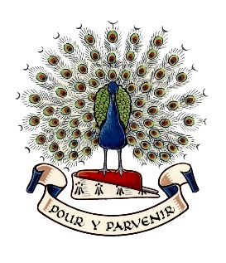
Lady Manners School

The English and Media Faculty

The English and Media Faculty
The English and Media Faculty consists of specialist teachers who work collaboratively and enthusiastically to support learners of all abilities. Students at Lady Manners School enjoy their English lessons and are highly motivated to succeed. Ofsted recently noted how "the school's values of 'aspire, include and thrive' help pupils to understand what is expected of them. They meet these expectations, and most make excellent progress through the curriculum" (March 2025).

Subjects taught:

- English Language (all key stages)
- English Literature (all key stages)
- Film Studies (Key Stage 4)
- Media Studies (Key Stage 5)

Leadership and Staffing
The Senior Assistant Headteacher, with responsibility for teaching and learning across the school, is the Faculty SLT link and provides excellent support to all team members. Leadership of the Faculty is coordinated by the Director of Learning who also has a whole-school role, currently for developing oracy across the curriculum. There are three Curriculum Leaders within the faculty who specialise in English Language, English Literature, and Media and Film.

There are currently twelve members of staff who work within the Faculty. All are experienced and highly successful subject specialists. Teachers in the Faculty have additional responsibilities in several areas including teacher training and ICT. There is also an intervention mentor, who works primarily with SEND and disadvantaged students.

The Curriculum
Our curriculum is dynamic and forward-thinking so that we can consider how skills are spiralled across the key stages and knowledge interleaved within schemes of work.

In Key Stage 3, all students have three lessons a week in Year 7 and 8, and four lessons a week in Year 9. Students are taught in mixed ability groups. The Faculty is heavily involved in promoting reading and we work closely with colleagues across the school to inspire and encourage 'reading for pleasure'. We have library lessons once a fortnight in KS3 and weaker readers are provided with interventions to close gaps and make progress in line with their peers.

At Key Stage 4, all students have four lessons each week and study AQA English Language and English Literature for GCSE. During the last two years, we have developed as a Faculty by offering Film Studies as a GCSE option.

At Key Stage 5, the Faculty currently offers A levels in English Language, English Literature and Media Studies. All three courses recruit well, and each class is taught by two teachers who share five lessons.

Achievement
The Faculty is committed to improving outcomes for students. Our GCSE results in English Language and English Literature are strong with positive Progress 8 figures and continue to improve due to robust planning, teaching and assessment.

We are proud of the consistently excellent results students achieve at A level English Literature, where ALPs grades are normally 2 or 3. English Language and Media Studies are popular A level subjects, and we are particularly proud of the results achieved by some of the students who have a less academic profile on entry to our Sixth Form.

Facilities
Classrooms are equipped with visualisers and touch-screen interactive LCD screens. Learning is further supported by a wide range of resources available in our library and through our extensive computer network.

March 2026

