St Andrew’s School

“Encouraging every student through learning, creativity and adventure to become a kind, respectful and independent young adult prepared for the future.”

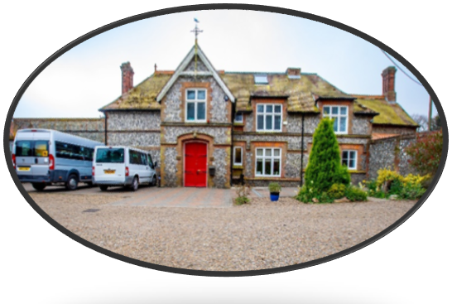
“Pupils blossom here. This is because leaders have created an orderly and peaceful school environment and staff use patience and expertise to notice and respond to pupils’ emerging needs.” Ofsted 2026

Our School…
St Andrew’s School is a successful and thriving independent special school in beautiful North Norfolk. Currently there are 48 students on roll but in September we will be supporting 60 students and therefore we are currently recruiting additional staff for September. We support students aged 6-16 who have an Education and Health Care Plan (EHCP) and a diagnosis of Autism.
At St Andrew’s School we aim to deliver a highly personalised, inclusive curriculum that balances academic learning with social communication, independence and wellbeing. The focus is on enabling our students to access education meaningfully, develop essential life skills and prepare for adulthood.
In accordance with Quaker principles, all members of our school community are valued as equals for the important contribution they make to the school and wider community.
We are committed to providing our students and staff with a wide experience of opportunities linked to their own interests, so they are prepared for life beyond St Andrew’s. We want our students to leave being the best they can be and ready for further education and adulthood and our staff to be prepared for the next stage in their career journey.

What can we offer…
- Friendly students who look forward to coming to school.
- Excellent continued professional development opportunities for all staff.
- A friendly and caring team of staff, leaders and trustees.
- The opportunity to make a difference and have a lasting impact on the lives of students.
- Access to free wellbeing support, including GP support 24 hours a day.
- A beautiful North Norfolk setting to work in.

