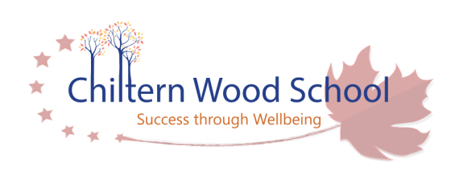

Parent Ambassador
Term time + INSET days (39 weeks per year)
Hours: 12 hours per week
Actual pay £6,878 – 7,443 per annum

Chiltern Wood School is an expanding Special School currently supporting over 200 students ranging from ages 3 to 19 years with a wide range of complex needs. The school is located over three sites in Cressex, Downley and Studley Green.
We pride ourselves on building positive relationships with our pupils, their families and supporting professionals to enable communication, physical, social and emotional development for each individual.
We have an exciting opportunity for the role of Parent Ambassador at Chiltern Wood School.
Do you love building strong relationships, connecting families to helpful services, and bringing a community together?
Join our school as a part-time Parent Ambassador and make a real difference for local parents, carers and SEN children.
Why this role matters:
You’ll be the friendly, trusted link between families, the school and local support services helping parents access resources, strengthening home-school relationships, and creating warm, welcoming opportunities for families to connect.
You’ll be knowledgeable about the facilities and resources available for families in need especially for those with special educational needs
What you’ll do:
- Work directly with families in the community, at school and—when appropriate—in homes to strengthen relationships between parents/carers, children and the school.
- Establish positive, confidential relationships with families and act as a regular, reliable point of contact.
- Proactively signpost families to appropriate community and external services and encourage access to SEN resources.
- Create, advertise and coordinate an annual calendar of family-focused events: coffee mornings, workshops, information sessions and social events with partner agencies.
- Coordinate and lead weekly Parent Volunteers: plan activities, supervise volunteers and maintain accurate records.
- To keep up to date with SEN resources, charities and support available for our families
- Provide clear information and signposting to parents at the start of each day.
Who we’re looking for:
- Confident, resourceful and discreet — able to handle sensitive information with high confidentiality.
- Excellent communicator with strong interpersonal skills and the ability to build trust quickly.
- Organised and proactive: able to plan events, manage volunteers and keep accurate records.
- Experienced working with parents, carers or community services (school or community setting preferred).
- Experience and knowledge of SEN and what might be available to families in need.
- Comfortable liaising with partner organisations and external agencies.
12 hours per week; flexible scheduling to suit school activities and community needs.
Based at the school with community/ home visits as required.
Join us and become the heart of our family support network — helping parents thrive, children succeed, and our school community grow.
Further detail can be found within the Job Description.
Visit to school are keenly encouraged and all applications to be made via My New Term
Chiltern Wood School is committed to safeguarding and promoting the welfare of children. All appointments are made subject to a satisfactory, Enhanced DBS, qualifications and reference checks.
We do reserve the right to close this advertisement early if we receive a high volume of suitable applications
Closing Date: 20th April 2026
Interviews: 27th April 2026

Chiltern Wood School is committed to safeguarding and promoting the welfare of its pupils and expects all staff and volunteers to share this commitment. The successful candidate will be subject full vetting checks, including a disclosure of criminal records at an enhanced level.
Closing date:
Interviews:
For full details and application form please visit www.chilternwood.bucks.sch.uk
Visit to school are keenly encouraged; requests and Applications via Non-teaching Application form to: office@chilternwood.bucks.sch.uk

.

