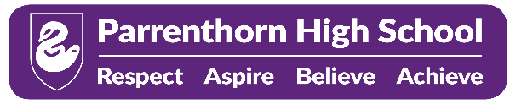

Post: Teacher of Physical Education (GIRLS’ PE)/ COVER SUPERVISOR

Responsible to: Head of PE

Key Responsibilities:

- Plan, prepare and deliver high-quality Girls’ PE lessons in line with the curriculum.
- Assess, monitor and support student progress to ensure positive outcomes.
- Create a safe, inclusive and positive learning environment for all students.
- Deliver pre-prepared cover lessons across the secondary curriculum when required.
- Manage classroom behaviour effectively and uphold school expectations and policies.
- Build positive and professional relationships with students, staff, parents and the wider school community.
- Contribute to the wider life of the school, including participation in extracurricular sports clubs, fixtures and enrichment activities.
- Work collaboratively as part of a supportive team and contribute positively to departmental and whole-school initiatives.
- Promote student wellbeing, safeguarding and personal development at all times.

The Ideal Candidate Will Have
- A passion for Physical Education and supporting young people to succeed.
- Experience of planning and delivering engaging lessons.
- Strong classroom and behaviour management skills.
- Excellent communication and interpersonal skills.
- The ability to adapt confidently when delivering cover lessons across different subjects.
- A flexible, proactive and team-oriented approach.
- A commitment to extracurricular involvement and wider school life.
- High expectations of themselves and their students.

Progress:
- Use appropriate quality assurance strategies and effective self-reflection to continuously improve teaching practice whilst ensuring effective implementation of Parrenthorn High School policies.
- Ensure student data is accurate and up to date and used proactively to develop individual targets which enable students to monitor their own progress.

- Monitor and measure progress and achievement at all levels across the school to contribute to timely and accurate tracking data.

- Set high expectations and targets for students to drive up achievement.

- Contribute to curriculum/pastoral development.

Personal Responsibilities:
- Supporting the Head of Department in embedding Parrenthorn High School’s ethos and policies.

- Be prepared to take on specific responsibilities within the department such as resource development and schemes of learning.

- Accountable for delivering and promoting high levels of achievement.

- Acting as a positive behaviour role model.

- Being proactive in forging links with parents, community figures and external organisations to ensure the diversity of the local area and outside world is reflected in pupils’ experience in school.

- Promoting a shared commitment to the safeguarding of children at all times.

- Carry out responsibilities under professional standards as laid down in the staff code of conduct.

- Take part in the school’s Performance Management system and ensure effective Continuous Professional Development (CPD)

