

ROLE PROFILE

*Red Kite Learning Trust is committed to supporting work–life balance and recognise the benefits of flexible working. We welcome requests for flexible working arrangements as part of the recruitment process. While flexibility may be possible for many roles, each request will be considered on an individual basis.
Job Title: | Childcare Assistant | School: | Meadowfield Primary School
Salary Grade: | Band A3 SCP 3-4 | Working Hours: | 35 hours  Shift pattern 8am – 3.30pm  10.00am- 5.30pm
Contract Type: | Part time, Permanent  Term Time only + 2 Training days | Location: | Leeds
Responsible to: Headteacher
Role summary: To support the provision of a stimulating and effective Early Years Foundation Stage curriculum which will enhance children’s emotional, social, physical, and intellectual development. To provide high quality childcare and education that meets the professional inspection standards. To assist the Nursery Officer and Managers in the day-to-day efficient running of the Early Education setting as directed.
Special conditions of service:
No smoking policy, including e-cigarettes/vaping.
Role specific responsibilities:
- To provide high quality care and education for all children
- To demonstrate a positive attitude and always provide a welcoming environment
- Establish rapport and respectful, trusting relationships with children, young people and those caring for them
- Communicate effectively and establish constructive relationships with all staff, children, parents, families, carers, external agencies and other professionals
- To establish the Key persons role, to make assessments and keep records of your key children’s development and learning journals, and future developments of all key children, to share with parents, carers and other key adults in the child’s life at regular intervals
- To ensure good standards of safety, hygiene and cleanliness are maintained at all times
- To be aware of and support differences and ensure all children have equal access to opportunities to learn and develop
- Engage in good team working with all Early Education and wider school community
- To support the team to provide a broad and balanced Early Years Foundation Stage curriculum that will meet the requirements of relevant national and local standards
- To promote the inclusion and acceptance of all children within the nursery environment, assisting in the implementation of appropriate behaviour management strategies
- Report any concerns about child welfare to the appropriate member of staff in a confidential manner
- To maintain confidentiality
- To take responsibility for a group of children during any building evacuation
- To actively promote an inclusive environment
- To read, understand and adhere to all policies and procedures relevant to your role as deemed appropriate. Record accidents as per the Early Education procedures
- To develop your role within the team, contributing actively to team meetings and planning sessions.
- To be aware of the high profile of the setting and to uphold its standards at all times, both within work hours and outside
All colleagues, regardless of career stage, will make a positive contribution to the wider life and community of our school, for example through sport, music, hobbies etc.
RK People responsibilities:
- Contribute to the overall aims and values of our Trust, appreciate and support the roles of other members of the wider team and attend and participate in relevant meetings as required
- Comply with all Trust policies and procedures including child protection, health, safety, welfare, security, confidentiality and data protection etc., reporting any concerns to the appropriate person
- Contribute to ensuring safeguarding procedures are in place and used effectively at all times.
The role holder must demonstrate a flexible approach to the delivery of the role. Consequently, the role holder may be required to perform work not specifically identified in the role profile but which is in line with the general scope, grade and responsibilities of the role.
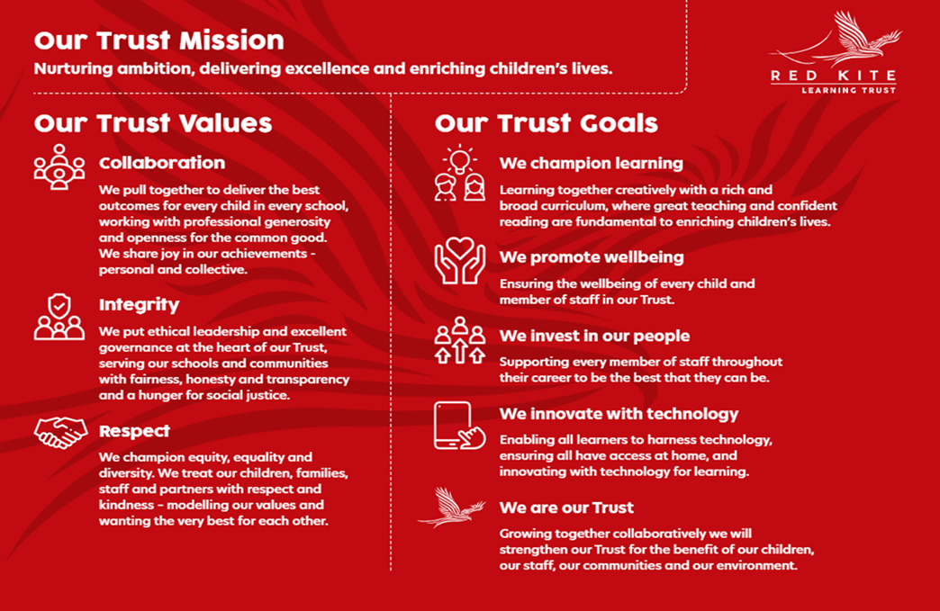
PEOPLE PROFILE
Aptitudes and Characteristics |  |  | Essential | Desirable
Ability to relate well and form effective and appropriate working relationships and boundaries with young people |  |  | *
A commitment to our mission and values demonstrated by current practice |  |  | *
Ability to adopt confidentiality, discretion and judgement, communicating effectively with staff, students and parents |  |  | *
An understanding of the strategies that can be used to reduce the barriers to learning |  |  | *
Willingness to undertake training |  |  | *
Understanding of individual children and young peoples’ needs |  |  | *
Have an enthusiasm for and an active interest in children’s play |  |  | *
Ability to work flexibly and collaboratively as part of a team as well as on own |  |  | *
Qualifications, Knowledge and Experience |  |  | Essential | Desirable
GCSE English and Maths grade A - C |  |  | *
Level 2 Childcare Qualification |  |  | *
Paediatric First Aid certificate |  |  |  | *
Experience of delivering evidenced based interventions and accelerated learning |  |  | *
Experience working with children/young people in a work/voluntary setting |  |  | *
Experience in safeguarding children |  |  | *
Competent in using IT systems |  |  | *
Knowledge of a range of factors which create stress for children and families |  |  | *
Knowledge of the SEN code of practice and the Early support Programme |  |  | *
Good knowledge of a child’s development and learning processes, understanding that all children have differing needs and knowledge of how to apply inclusive practice |  |  | *
Safeguarding and Promoting the Welfare of Pupils |  |  | Essential | Desirable
An appropriate motivation to work with children and young people |  |  | *
Ability to maintain appropriate relationships and personal boundaries with children and young people |  |  | *
Emotional resilience in working with challenging behaviours and appropriate attitudes to the use of authority and maintaining discipline |  |  | *

