


JOB PROFILE
Job Title: | Site Supervisor | School/Department: | Temple Learning Academy
Salary Grade: | Band S01  FTE £34,434– £36,363 per annum | Working Hours: | Full time, 37 hours per week
Contract Type: | Permanent, All year | Location: | Leeds
Responsible to: Site Manager
Role summary:
To supervise and work as part of our committed site team. You will be required to be flexible and have the ability to multitask to meet the demands of the team. Under the instruction/guidance of appropriate senior staff provide maintenance and security services on school sites and premises. Flexibility to cover for staff absence or altered hours for school events or lettings is required.
Red Kite Learning Trust is committed to safeguarding and promoting the welfare of students and expects all colleagues and volunteers to share this commitment.
Special conditions of service:
No smoking policy, including e-cigarettes.
Occasional requirement to work outside of school hours and off school premises.
Role specific responsibilities:

Security:
- Lock/unlock school buildings and areas.
- Undertake regular security checks and identify security risks.
- Monitor fire safety equipment and carry out fire drills.
- Operate and respond to alarm systems where appropriate, outside of any specialist monitoring brief.
- Monitor CCTV or surveillance equipment where appropriate.
- Liaise with police, security and surveillance contractors.
- Undertake lettings and carry out associated clerical tasks.
- Provide emergency access to the school site.
Maintenance:
- Undertake appropriate repairs e.g. redecorating and fixing.
- Undertake minor/simple repairs e.g. minor plumbing, changing light bulbs unblocking drains.
- To organise and carry out various maintenance duties to ensure that the general upkeep and maintenance of the premises is satisfactory, as per specific schedule for your school.
- To organise and carry out minor decoration programme as agreed with the Site Manager.
- To organise and carry out minor improvement work e.g. erecting shelves, notice boards, bookshelves etc. as agreed with the Site Manager.
- To be responsible for the operation of a preventative planned maintenance programme and for routine inspections of the buildings, fixtures, fittings, furniture, premises and grounds to assess for minor work or repairs required to be carried out to maintain safe and satisfactory conditions.
- Operation and maintenance of heating plant and lighting systems.
- To oversee and monitor the electrical testing of portable electrical appliances and to maintain the appropriate records.
- Undertake regular site inspections and identify and record repair and maintenance requirements.
- Identify defects and record repair and maintenance requirements
- Collect and assemble waste for removal.
- Undertake emergency and specialist cleaning tasks.
- Undertake cleaning duties such as graffiti removal, litter-picking.
- Provide emergency access to the school site.
- Coordinate deliveries to the school site.
- Monitor performance of contracts and record performance against specified standards
- Liaise with contractors and undertake client role in connection with premises-related contracts
- Co-ordinate work of Recreation Assistant staff (where applicable).
- Ensure that satisfactory levels of caretaking, cleanliness and hygiene are achieved and maintained through the whole of the premises.
- Ensure that pathways and all other external hard surface areas are kept clean, free of litter and weeds and that they are gritted or salted when required during wintry conditions.
- Maintain hydrotherapy pool and other specialist sports equipment after specialist training.
Resources:
- To advise the Site Manager on matters relating to energy control and conservation.
- Deputise for the Site Manager in their absence, acting as the lead site representative on days when the Site Manager is not on site. This includes taking responsibility for the safe and effective day-to-day operation of the school premises, delegating tasks to the site team, prioritising maintenance and compliance activities, responding to operational issues, and making appropriate decisions to ensure the continued safe running of the school.
- To assist in safety audits of the premises and contribute to relevant risk assessment activity.
- Work alongside the Site Manager to ensure all statutory compliance checks, inspections and records are completed, maintained and accurately documented, ensuring the school remains compliant with all relevant health, safety and premises requirements.
- Promote and ensure the health and safety of students, staff and visitors (in an accordance with appropriate health and safety legislation) at all times.
Supervision and organisation:
- Demonstrate and assist in the safe and effective use of equipment/materials.
- The banking of cash on behalf of the school, such duties to include the transportation of cash from the school to the banking agent and vice versa, the deposit of cash and when requested by the Site Manager the withdrawal of cash (where required).
- Provide advice and guidance as required.
- Portering duties e.g. delivering mail, moving furniture and equipment.
- Assisting in management, administration and operation of lettings system
- Direct/supervise cleaning and/or site staff and ensure cleaning is in accordance with specification (as required).
- Where appropriate to organise and administer the use and maintenance of all school vehicles and to carry out driving duties when required by the Site Manager.
- Liaise with line manager and attend meetings as required.
Responsibilities:
- Comply with health and safety policies and procedures at all times.
- Promote and ensure the health and safety of students (staff and visitors) at all times.
- Be aware of and comply with policies and procedures relating to child protection, health, safety and security and confidentiality, reporting all concerns to an appropriate person.
- Contribute to the overall ethos/work/aims of the school.
- Appreciate and support the role of other professionals.
- Attend and participate in relevant meetings as required.
- Participate in training and other learning activities and performance development as required.
- Ensure health and safety policies and procedures are complied with at all times.
- Treat all users of the school with courtesy and consideration.
- Present a positive personal image, contributing to a welcoming school environment which supports equal opportunities.
- To be trained and qualified to drive the school minibus (if applicable).

RK People responsibilities:
- Contribute to the overall aims and values of our Trust, appreciate and support the roles of other members of the wider team and attend and participate in relevant meetings as required
- Comply with all Trust policies and procedures including child protection, health, safety, welfare, security, confidentiality and data protection, reporting any concerns to the appropriate person
- Contribute to ensuring safeguarding procedures are in place and used effectively at all times

The role holder must demonstrate a flexible approach to the delivery of the role. Consequently, the role holder may be required to perform work not specifically identified in the job profile but which is in line with the general scope, grade and responsibilities of the role.
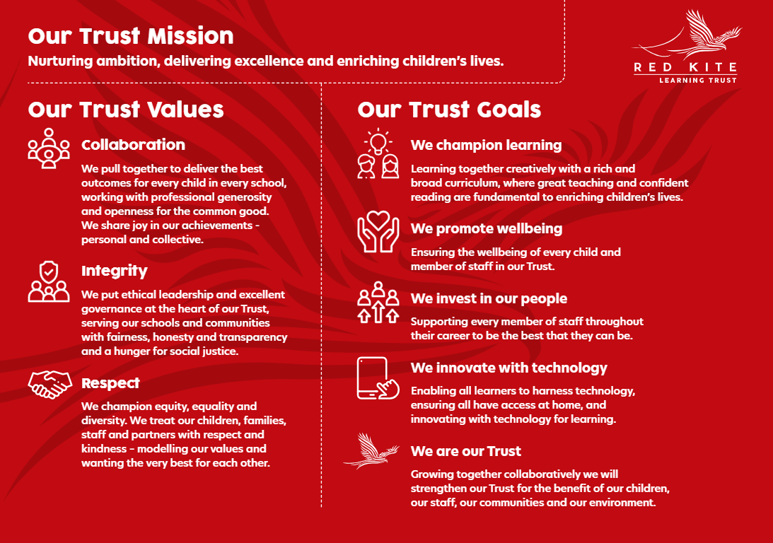
PEOPLE PROFILE
Aptitudes and Characteristics |  |  | Essential | Desirable
Ability to work flexibly and collaboratively as part of a team as well as on own |  |  | *
Ability to communicate and influence effectively with colleagues at all levels |  |  | *
Ability to deal with day-to-day issues and work on own initiative |  |  | *
Ability to move heavy furniture |  |  | *
Possess good DIY skills |  |  | *
Ability to present a positive personal image, contributing to a welcoming school environment which supports equal opportunities for all |  |  | *
Ability to work under pressure and meet deadlines |  |  | *
Qualifications, Knowledge and Experience |  |  | Essential | Desirable
Caretaking/site-keeping experience in a school or similar environment |  |  | *
Experience of working as part of a team |  |  | *
Awareness and understanding of basic safety and security measures |  |  | *
Working knowledge of relevant polices/codes of practice/legislation |  |  | *
Awareness of health and hygiene procedures |  |  |  | *
Knowledge of moving and handling procedures |  |  |  | *
Knowledge of COSHH regulations |  |  | *
Full driving licence required |  |  |  | *
Safeguarding and Promoting the Welfare of Students |  |  | Essential | Desirable
An appropriate motivation to work with children and young people |  |  | *
Ability to maintain appropriate relationships and personal boundaries with children and young people |  |  | *
Emotional resilience in working with challenging behaviours and appropriate attitudes to the use of authority and maintaining discipline |  |  | *

