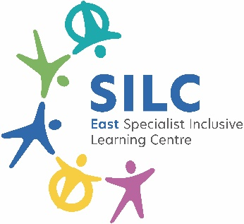 | External Job Advertisement  East SILC  Hollin Hill Drive,  Leeds,  LS8 2PW  Tel: 0113 2930236  www.eastsilc.org
Post: | Teaching Assistants – Level 1 – Part time
Salary Details: | B1 FTE £25,185 (£14,832.00 - Actual salary- 26 hours)
Hours: | 26 hrs Fte Monday- Friday (part time pro rata) - Term time only
The East Specialist Inclusive Learning Centre (SILC) is a 2-19 generic special school with 470 learners on roll. All our learners have special learning needs and some have physical/ medical difficulties. The East SILC is a complex organisation which operates on a variety of sites to provide a range of outreach services across the city, including partnerships with primary and secondary providers, the city-wide Physical Difficulties and Medical Service including a moving and handling service, as well as the Medical Needs Teaching Service for Leeds.
Do you want to join a team making a difference to learner’s lives?
An exciting opportunity has arisen to join our expanding school community.

We have a vacancy for a Level 1 teaching assistant for 26 hours per week over 5 days at the East SILC, based at John Jamieson. The majority of our learners have learning difficulties, and some have physical difficulties.

We require a skilled, enthusiastic person who is willing to learn, support teaching and learning and address the personal needs of our learners. You will need to be flexible and adaptable, a good communicator, cheerful, calm and be able to work as part of our team.
The permanent posts are subject to a 6 month probationary period, to start as soon as possible.

The East SILC has a progressive staffing structure in place for teaching assistants which is supported by Continual Professional Development. A thorough induction process is in place.

To apply please visit eastsilc.org/News/Vacancies.
Closing date for applications: |  | Monday 16th March 2026
Interviews to take place: |  | W/C 23rd March 2026
The East SILC is committed to safeguarding and promoting the welfare of children and young people and expects all staff and volunteers to share this commitment. Appointments are made subject to a satisfactory enhanced Disclosure and Barring Service check (DBS formally CRB) and medical clearance from Leeds City Council’s Occupational Health Service.
All shortlisted candidates must complete a self-disclosure form before interview.
It is illegal to apply if you are on the Children’s Barred List.
The East SILC promotes diversity and wants a workforce which reflects the population of Leeds.

