



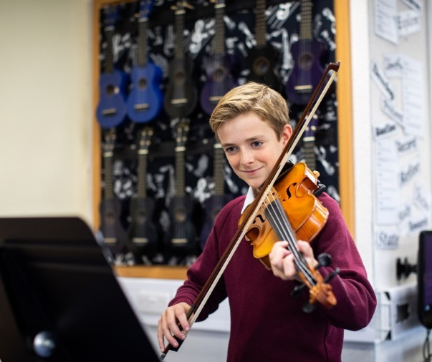
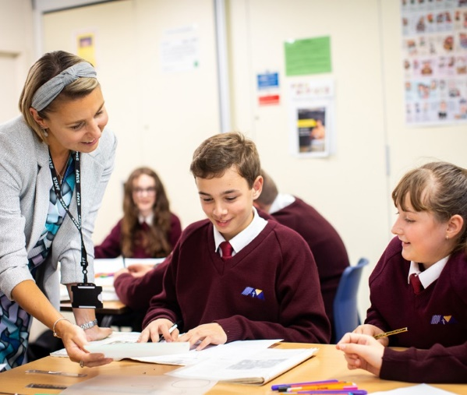
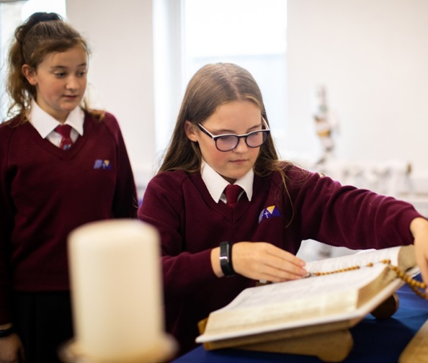
Design & Technology Technician

Start Date: February 2026

Line-manager: Head of Technology


Welcome
The St Thomas More Mission:

We the St Thomas More family, ‘aspire not to have more but be more’.

We aspire not to have the world but be more for the world.

#BeMore
am delighted to welcome you to St Thomas More Catholic Voluntary Academy.
I

We think that STM is a special place where every child is seen as an individual, and where nurturing the gifts and talents of our children is central to our mission. Our motto of ‘aspire not to have more but to be more’ summarises our ambition for our young people to #BeMore.

We achieve this by offering the highest quality of education possible, which includes a broad range of experiences aimed at developing the whole child and enabling all to grow in their faith in a safe and happy environment.

Our academic achievements and the standards of our pastoral care are excellent. We are very proud of the academic progress our students make and we are also very proud of the personal growth that they achieve during their time at St Thomas More.


If you choose to join the St Thomas More family, you will be joining a school which strives for excellence through our strong Catholic faith, our commitment to high standards of achievement, our high expectations of behaviour and respect for all, and a belief in developing a love of learning and healthy living.

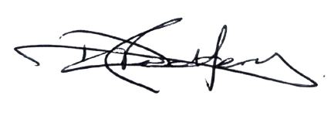

Mr D Redfern Headteacher

About this post

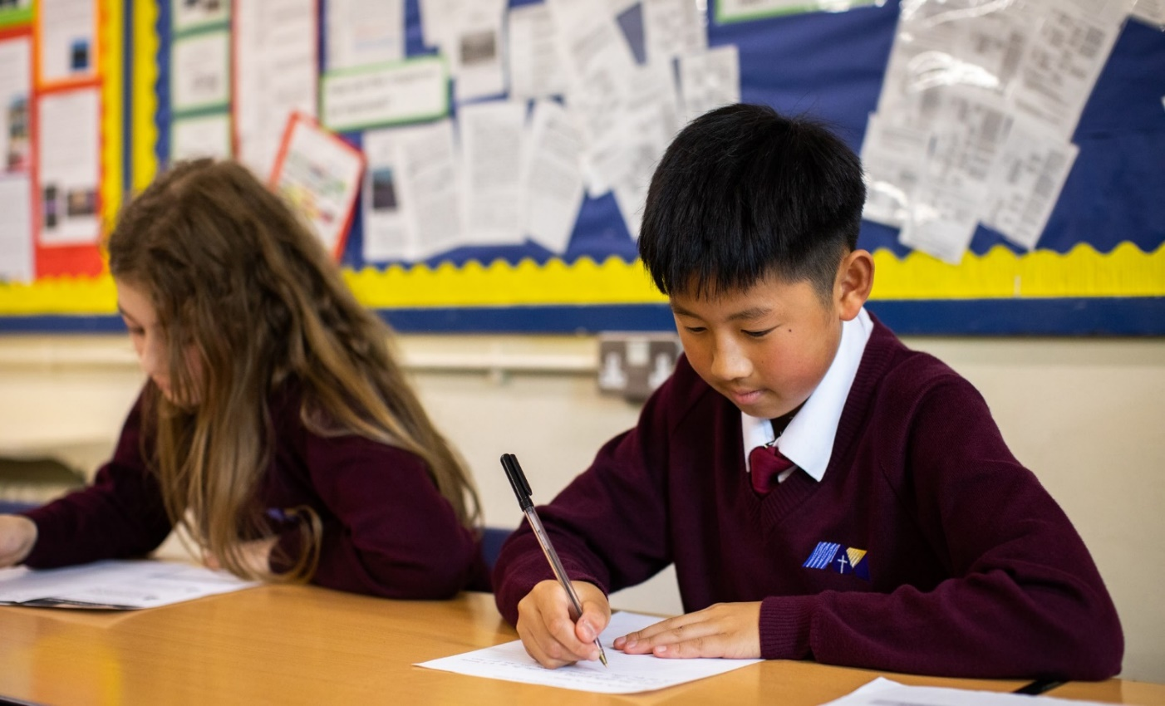
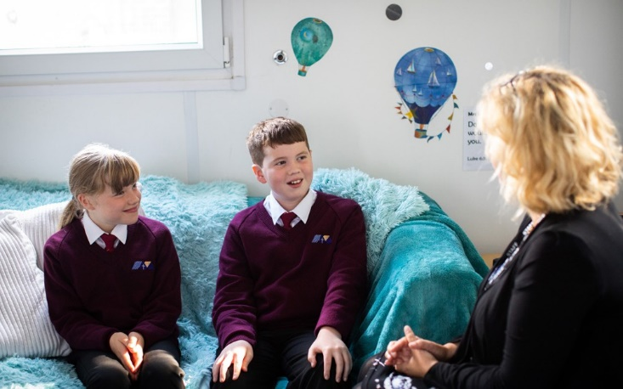

The Role

The Post
The successful candidate will provide support for our Technology Department, ensuring that the needs of all students are met and promoting amongst the pupils a keen desire to learn Design & Technology with an interest in CAD/CAM.

We are looking for a keen and enthusiastic technician to help support the Technology Department at St Thomas More Catholic Voluntary Academy. This is an exciting opportunity to join #TEAMSTM as we continue our journey.

#BeMore

‘Aspire not to have more but to be more’
Saint Oscar Romero

St Ralph Sherwin Catholic Multi-Academy Trust
Job Description
St Thomas More Catholic Voluntary Academy is committed to creating a diverse workforce. We’ll consider all qualified applicants for employment without regard to sex, race, religion, belief, sexual orientation, gender reassignment, pregnancy, maternity, age, disability, marriage or civil partnership.
Reporting to: Head of Technology, SLT, Headteacher.
Grade/Salary: Band 2, SCP 3-5 £24,796.00 - £25,583.00 Annually (FTE)
Contract Type: Permanent
Hours: 15 hours per week
Location: St Thomas More Catholic Voluntary Academy

Person Specification

 | Essential Criteria | Desirable Criteria
Education &  Qualifications | - Be educated to at least A Level in DT (desirable) or have equivalent industrial or school experience
Competence Summary (knowledge, abilities, skills, experience) | - It would be desirable to have knowledge of Engineering/CAD/ CAM  - Ability to communicate clearly - clear spoken English.  - Ability to relate well to children and adults.  - Ability to work constructively as a team, understanding school roles and responsibilities and the post holder’s position within these.  - Ability to identify own training and development needs and cooperate with means to address these.  - To be responsible for promoting and safeguarding the welfare of children and young people within the school.
Work related personal requirements | • Have the capacity to work collaboratively as part of a team  • Enjoy working in a challenging but highly rewarding environment  • Demonstrate practical knowledge and problem-solving skills  • Good housekeeping  • Strong interpersonal, written and oral communication skills  • A good attendance record.  • Evidence of stamina required to cope with the demands of the post.  • Willingness to support Catholic life and ethos in the Trust and its academies  • Attention to detail and can-do approach
Other requirements | - Ability to form and maintain appropriate relationships with colleagues, students and parents  - Ability to work both autonomously and as a member of a team  - Empathetic and approachable manner  - Highly motivated and pro-active  - Flexible  - Sense of humour | - Willingness to contribute to the wider life of the school

Job Description

- Provide timely and effective preparation of materials for lessons (from Key Stage 3
- Key Stage 4), through regular liaison with teaching staff
- To clear and tidy workplaces and preparation areas after lessons and at the end of the day
- Checking and compiling stock lists for apparatus and resources
- Assist students with practical work as directed.
- Carry out regular safety checks on equipment and classrooms as appropriate
- To ensure the maintenance of a healthy and safe working environment through:
  - actively contributing to the assessment, monitoring and review of both health & safety procedures and information resources
  - keeping up to date with current procedures and practices through continuing professional Development
  - the provision of technical advice and support on health & safety issues to teaching and trainee technical staff
  - the safe treatment and disposal of used materials including hazardous substances and responding to actual or potential hazards

- Be able to use wood/metal equipment and arrange necessary servicing. (3D printer and laser cutter etc)
- Place orders and work to budget
- Maintain health and safety standards
- Be aware of lesson rotations, rotas and projects taught
- Completing risk assessments
- Photography of practical work
- Making lesson resources
- Reprographics as needed
- Small group work
- Any other relevant tasks as directed by the Head of Department

Any other duties which may arise during the course of work and as authorised by the Headteacher or membership of the Senior Leadership Team. Such duties will be commensurate with the general level of this post and will be subject to the skills and abilities of the post holder.

Any other duties which may arise during the course of work and are authorised by the Headteacher or member of the Senior Leadership Team. Such duties will be commensurate with the general level of this post and will be subject to the skills and abilities of the post holder.

Headteacher/line manager’s signature: _______________________________________
Date: _______________________________________

Postholder’s signature: _______________________________________
Date: _______________________________________

‘Aspire not to have more but to be more’
Saint Oscar Romero

St Thomas More Catholic Voluntary Academy, Palace Fields,

Buxton, Derbyshire,

SK17 6AF


enquiries@stm.srscmat.co.uk
01298 23167 scan the QR code to visit our website

