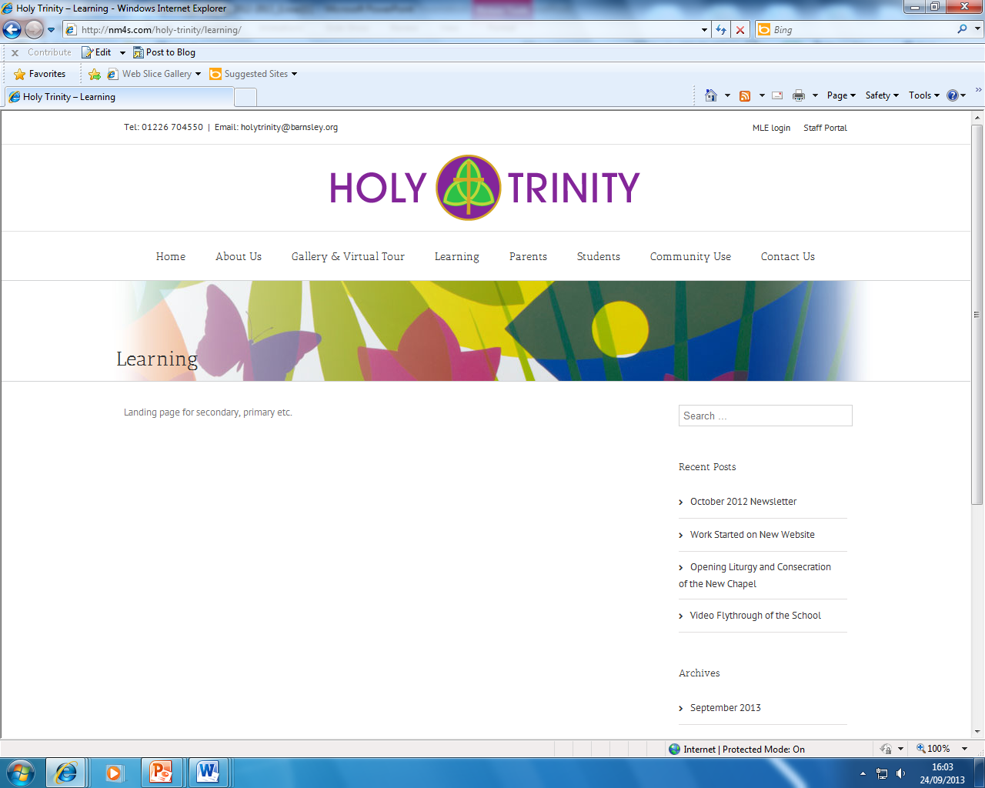

PERSON SPECIFICATION
POST TITLE: Teaching Assistant for the Primary Phase

ATTRIBUTES |  | ESSENTIAL | DESIRABLE | HOW IDENTIFIED
RELEVANT EXPERIENCE | Experience of working with children |  |  | A/R
RELEVANT EXPERIENCE | Experience of working with children of the relevant age (Early Years / Primary / Secondary) |  |  | A/R
RELEVANT EXPERIENCE | Experience of working in a school environment |  |  | A/R
RELEVANT EXPERIENCE | Experience of working with children with Special Educational Needs and Disabilities |  |  | A/R
RELEVANT EXPERIENCE | Experience of administering first aid |  |  | A/R
EDUCATION AND TRAINING | Level 2 qualifications in English and Maths |  |  | A
EDUCATION AND TRAINING | Level 2 Certificate in Supporting Teaching and Learning in Schools |  |  | A
EDUCATION AND TRAINING | Appropriate first aid training |  |  | A
EDUCATION AND TRAINING | Paediatric first aid training |  |  | A
GENERAL AND SPECIAL KNOWLEDGE | Effective use of ICT to support learning and administration |  |  | A/I/R
GENERAL AND SPECIAL KNOWLEDGE | Excellent literacy and numeracy skills |  |  | A/I/R
GENERAL AND SPECIAL KNOWLEDGE | Excellent oral and written communication skills |  |  | A/I/R
GENERAL AND SPECIAL KNOWLEDGE | General understanding of the curriculum relevant to the post; specifically foundation stage curriculum / national curriculum / KS4 Curriculum |  |  | A/I/R
SKILLS AND ATTRIBUTES | Basic understanding of child development and learning  Sensitivity and understanding, to help build relationships and meet needs |  |  | A/I/R
SKILLS AND ATTRIBUTES | Knowledge of how to help adapt and deliver support to meet individual needs |  |  | A/I/R
SKILLS AND ATTRIBUTES | Understanding of roles and responsibilities within the classroom and whole school context |  |  | A/I
SKILLS AND ATTRIBUTES | Good organisational skills |  |  | A/I/R
SKILLS AND ATTRIBUTES | Ability to remain calm in stressful situations |  |  | A/R
SKILLS AND ATTRIBUTES | Ability to maintain confidentiality |  |  | A/R
SKILLS AND ATTRIBUTES | Ability to build effective working relationships with relate well to children and adults |  |  | A/I/R
SKILLS AND ATTRIBUTES | Ability to work constructively as part of a team |  |  | A/I/R
SKILLS AND ATTRIBUTES | Ability to self-evaluate learning needs and actively seek learning opportunities |  |  | A/I/R
ADDITIONAL FACTORS | Commitment to work in line with the school ethos and mission |  |  | A/I
ADDITIONAL FACTORS | Willingness to work flexibly in accordance with policies and procedures, to meet the needs of the school |  |  | A/I/R
ADDITIONAL FACTORS | Willingness to undertake training and continuous professional development in connection with the post |  |  | A/I/R
ADDITIONAL FACTORS | Compliance with policies relating to Health and Safety, Equality and Diversity and data protection |  |  | A/I/R
ADDITIONAL FACTORS | Satisfactory enhanced DBS disclosure to work in an environment dealing with young people |  |  | A/I/R
ADDITIONAL FACTORS | Ability to form and maintain appropriate relationships and personal boundaries with children and young people |  |  | A/I/R
ADDITIONAL FACTORS | A commitment to safeguarding and promoting welfare for all |  |  | A/I/R

A: Application, I: Interview, R: Reference

