


Teacher – Kirton Tribe Coritani Academy
Candidate
Information Pack
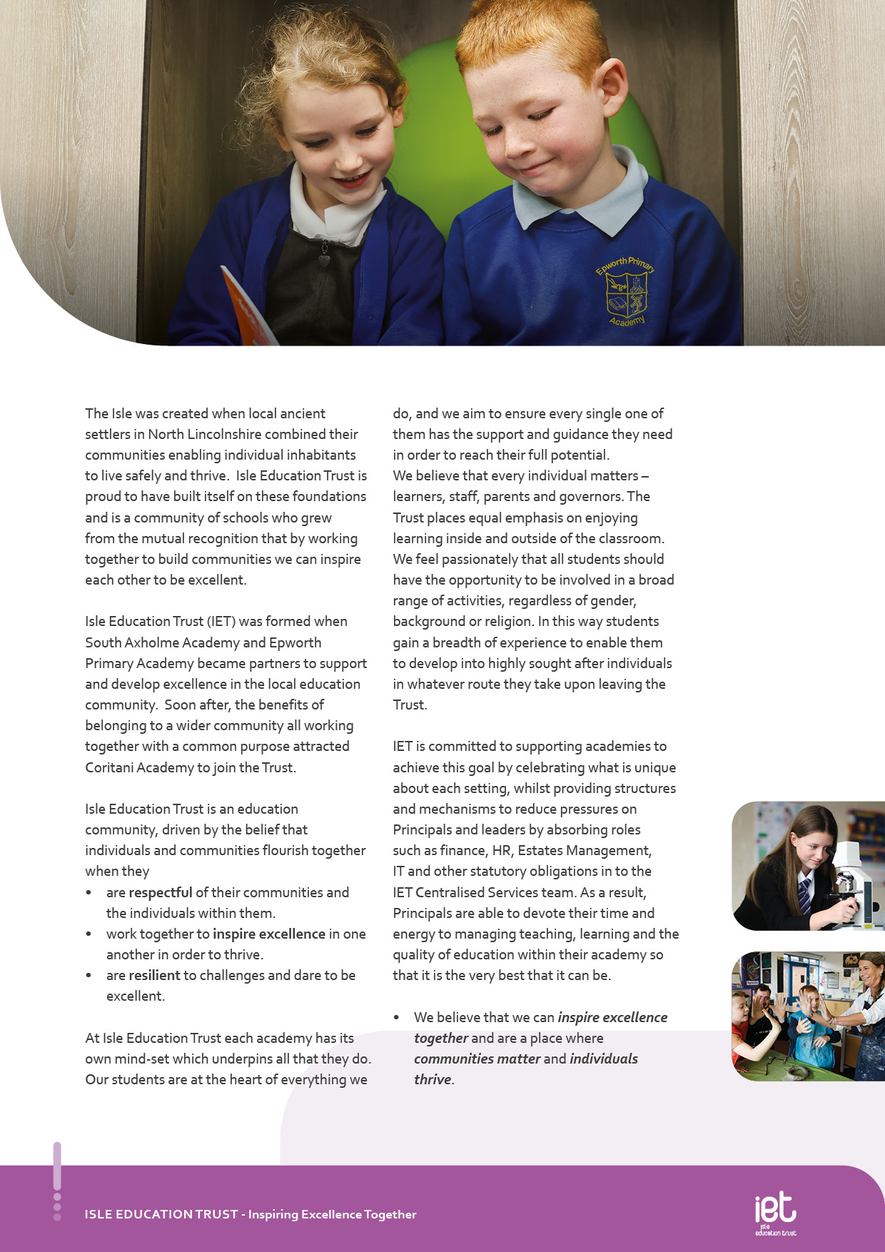
About IET

Dear Prospective Colleague,

Thank you for your interest in joining Isle Education Trust. Whether you are at the start of your teaching journey or bringing a wealth of experience, I’m delighted that you’re considering becoming part of our community.

At Isle Education Trust, our vision is simple yet powerful: Inspiring Excellence Together. We believe in creating environments where individuals thrive and communities flourish. Across our 6 academies - South Axholme Academy, Coritani Academy, Epworth Primary Academy, Alkborough Primary Academy, Kirton Lindsey Primary academy and Burton upon Stather Primary Academy—we are united by a shared commitment to high standards, inclusive practice, and a deep sense of belonging.

Our values are not just words on a page—they shape how we work, how we support one another, and how we grow. We ask every member of our team to:

Be respectful – acting with honesty, consistency, and care.
Be resilient – embracing challenges and daring to be excellent.
Be inspirational – leading by example and lifting others through our actions.

We know that great teachers change lives. That’s why we invest in your development, champion your wellbeing, and celebrate your successes. Whether it’s through high-quality CPD, collaborative networks across the Trust, or leadership pathways, we are committed to helping you thrive professionally and personally.

Our academies are vibrant, welcoming places to work—where innovation is encouraged, support is ever-present, and every voice matters. If you share our belief in the power of education to transform lives, I warmly invite you to explore the opportunities within our Trust.

We look forward to the possibility of welcoming you to our team.

Warm regards,



Sarah Sprack
CEO, Isle Education Trust

Welcome from the CEO

Welcome from the Executive Principal Academy
Do you want to work at a school that really makes a difference to children’s lives? To be part of a school with very small class sizes, where trust and human relationships are central to all that we do? To belong to a community where the curriculum is built for each individual child and children are made to feel safe and valued? To be challenged and feel a sense of fulfilment every day? To inspire a small group of learners and to be inspired?

If this sounds like the place for you then come and join us at Coritani Academy.

We are a small academy offering academic qualifications to learners who need a school community with a more individual approach to learning than you would traditionally find in a mainstream school. We deliver relationship-based education, a learning experience for students that is truly unique and tailored to the needs of the individual child. Our staff are open and caring and have a passion and desire to ensure that students achieve excellent outcomes at the end of their time with us.

The Academy offers a safe and welcoming environment for children from Year 3 to Year 13.
Low admission numbers mean that we can offer one to one and small group learning that is truly matched to individual need. Class sizes at the Academy are a maximum of 8 children.
Our belief is that students will thrive when they feel safe and supported within their surroundings and once we have this right the best start in life we can give them is a good set of academic results.

Our Academy boasts results well above the national averages for similar alternative Academies and in some cases for mainstream schools. We have an excellent track record of re-engaging students in education and ensuring they achieve excellent results that allow them to move on to their next steps in life.

Our learners are proud of their academy, and those who have left to go on to successful placements at college, school sixth forms or back in to mainstream school continue to visit and contact the academy into their adult lives.

Thank you for taking the time to put together your application we hope to see you as part of the team soon. Until then we would encourage you to view our website or come in and visit the Academy in person to find out more.
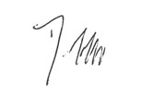
Dave Flowitt
Executive Principal


Ethos and Values
Our Academy works with local schools and local authorities to ensure that learners who need an individual approach to learning have a quality educational alternative. We believe that every young person should have the opportunity to succeed by being motivated and inspired.
Our aim is to inspire learners with quality education and support through the development of the Coritani Mindset, to meet their personalised learning need, make them safe and ensure that they are ready to develop into respectful members of their communities.

Objectives of the Academy
To provide support to students to help them re-engage and be ready for education
To provide a safe and inspiring environment in which students can develop into respectful adults
To ensure all our students have access to the same opportunities as students in mainstream schools through an inspiring, broad and balanced curriculum

Coritani Mindset
Inspire Excellence, Safe, Respectful, Ready
At Coritani Academy everyone works collectively using the Coritani Mindset, a set of values that we have all agreed together to help us to be successful in our lives. Coritani Mindset Inspires Excellence and encourages students to be safe, respectful, ready in all that they do.

The School Day
The school opens for staff at 8:25am with a staff briefing each day at 8:30am. Learners arrive between 8:45am and 9:15am. And have a 30-minute lunch break. The day school ends at 2:30pm. Staff complete joint PPA and training from 2:30pm until 3:30pm each day. In addition, staff meet formally once a week and are involved in a full programme of CPD.
Staff are given generous PPA time within the Academy day and most complete planning and marking within these working hours.

Staff involvement
The small school structure of the Academy is such that every member of staff and often learners are invited to participate in policy-making though the final decisions must rest with the Principal who is responsible to Governors for the conduct and curriculum of the Academy. Nevertheless, consultation is real and decisions are arrived at by discussion and an exchange of opinions. Such a consultative decision-making process can only work effectively if all staff accept the personal responsibilities this brings.

The demands on staff are considerable; in the classroom, in preparation, in marking, in attending meetings, in CPD work, in out-of-school activities and in parent-teacher contact, however, it is a rewarding job that presents staff with many opportunities which in turn brings great benefit to the Academy and to the teachers themselves as professionals.
About the Academy
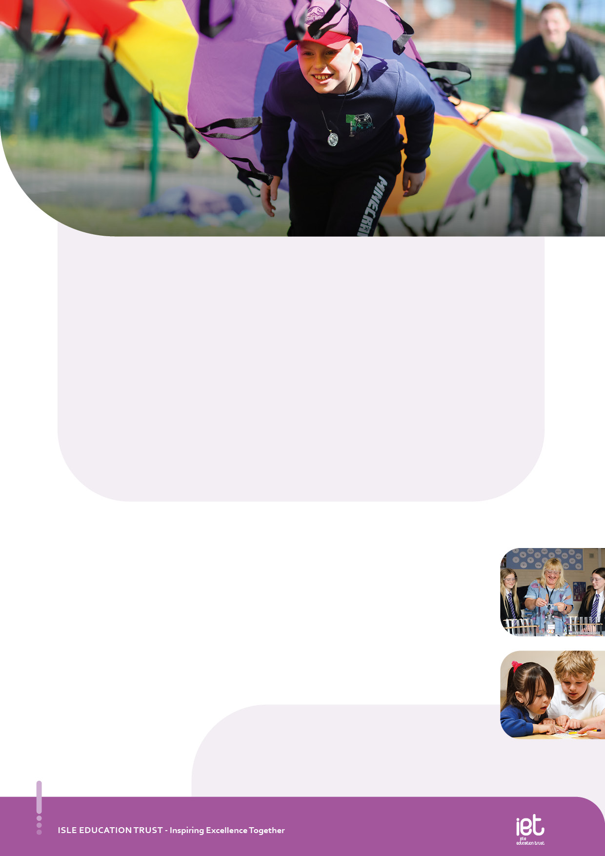
Job Purpose
Class Teacher responsible for the development of learners Academic, Social and Emotional abilities within the Academy

Job Title Teacher- Kirton Tribe

Salary | Teachers Pay Scale Depending on Experience
Job Details | Full Time Permanent
Location | Kirton Primary Academy Tribe- Coritani Academy
Required | September 2026
Application Close | 09:00 Friday 8th May
Interview Date | Thursday 14th May

Job Description

Teaching and Learning

Meet the expectations as laid out in the STPCD including:
- To develop, plan and deliver an appropriately broad, balanced, relevant and differentiated curriculum for students
- To facilitate and encourage a learning experience which provides all students with the opportunity to achieve their individual potential
- Promote students’ spiritual, moral, social and cultural development in the planning and delivery of lessons
- Make use of information concerning progress and prior attainment to set appropriate and demanding expectations for students’ learning and motivation
- Provide targeted support for students within teaching groups who have special educational needs and/or for whom English is an Additional Language
- Liaise with the SENDCo and teacher responsible for EAL as appropriate regarding students causing concern
- Use a range of appropriate strategies for teaching and classroom management that engage students and stimulate intellectual curiosity, creating a thirst for learning through the effective use of questioning, clear presentation, good use of resources and high-quality feedback
- Set high expectations for students’ behaviour, establishing and maintaining a good standard of discipline through well-focused teaching and through positive and productive relationships
- Assess how well learning objectives have been achieved and use this assessment to inform teaching
- Attend all staff meetings
- Contribute to the development of appropriate syllabuses, resources, schemes of work, approaches to assessment and feedback to students, and teaching and learning strategies.
- Undertake research and development of new initiatives in mathematics and the wider curriculum.

Assessment, Recording and Reporting

- Set, mark and monitor students’ class work and homework in accordance with the Academy and departmental marking policies
- Involve students in self-assessment within the subject
- Record and report on students’ progress as outlined in the Academy and departmental assessment policies
- Produce written reports in line with the Academy and departmental reporting policies
- Meet Academy deadlines for recording and reporting
- Attend all parents’ evenings relevant to classes which you teach or part teach
- Communicate effectively with the parents/carers of students as appropriate
- Where appropriate, to communicate and cooperate with persons or bodies outside the Academy

Key Responsibilities and Accountabilities


INTERVIEWS:
Thursday 13th June 2024
CLOSING DATE:
Tuesday 11th June 2024 at 9:00am
- Work with all students ensuring equality of opportunity for all.
- Take responsibility for Safety and Welfare of all students, raising any concerns following the Academy/Trust protocols and procedures.
- Work proactively and effectively in partnership with all stakeholders.
- Carry out a share of statutory supervisory duties.
- Treat students with dignity and build relationships rooted in mutual respect and at all times observing proper boundaries appropriate to the professional position.
- Participate in CPD relevant to the role.
- Accompany teaching staff and students on visits, trips and out of school activities as required.
- Demonstrate an understanding of and take responsibility for promoting high standards of literacy including the correct use of spoken English and numeracy.
- Participate in arrangements for examinations and assessments.
- Take an active role in promoting good behaviour in and around the Academy/Trust.
- Ensure that students adhere to the uniform code and apply sanctions when this code is breached.
- Develop an academy learner mind-set – the attitudes, skills and learning habits needed to become an inspired, confident and independent learner.
- Be a positive role model and demonstrate consistently and effectively the positive attitudes, values and behaviour which are expected of students.
- Work as a team member and identify opportunities for working with colleagues and sharing the development of effective practice with them.
- Regularly review the impact of their work and its impact on students’ progress, attainment and well-being, refining approaches where necessary and responding to advice and feedback from colleagues.
- Proactively participate with arrangements made in accordance with the Appraisal Policy.
- Have professional regard for the practice, ethos and policies of the Academy/Trust and maintain high standards in your own attendance and punctuality.
- Operate at all times within the stated policies and practices of the Academy/Trust.
- Contribute positively and effectively to the whole Academy/Trust ethos.
- Cooperate with other staff members to ensure a sharing and effective use of resources to the benefit of the Academy, individual departments and students.
- Attend and participate in appropriate calendared meetings.
- Take responsibility for own professional development and duties in relation to Academy policies and practices.
- Liaise effectively with staff, students, parents and governors.
- Ensure compliance with Health and Safety at Work Act 1974 and all other policies related to health and safety, and to ensure compliance with the Data Protection Act 1988.
- Ensure compliance with data protection laws and safeguarding procedures.
- Carry out any other duties as directed by your Line Manager as may from time to time be agreed in accordance with the nature of the job described above.

We expect all Trust staff to:

This is not an exhaustive list of tasks and job descriptions will be continually reviewed and changed according to the needs of the Trust.

Post holders will be expected to be flexible in undertaking duties and responsibilities attached to their post and may be asked to perform duties, which reasonably correspond to the general character of the post and are commensurate with its level of responsibility. This job description is provided for guidance only and does not form part of the contract of employment.

  Qualifications |  | Essential |  | Desirable
Qualified Teacher Status |  | A I
Professional development relevant to the post |  | A
Qualified to degree level or relevant qualification |  | A
Personal Qualities |  | Essential |  | Desirable
passionate about making sure the most vulnerable students succeed in life |  | A I
is positive with students and staff despite any challenges or adversity |  | A
believes all students can succeed given a safe and nurturing environment |  | A I
believes in a small school approach with the use of Empathy and Unconditional Positive Regard for all |  | I
is a champion of diversity |  | A I
wants the most vulnerable students to receive the best quality curriculum and teaching and learning |  | A I
can develop close partnerships with students and parents |  | A I
puts student voice at the heart of development |  | A
believes in Restorative Practice over sanctions |  | A
is capable of delivering differentiated learning to very small groups |  | I
is flexible in their approach to the delivery of an inspiring curriculum |  | I
experience of working in an educational setting or similar environment |  | A
good understanding of child development and learning |  | A I
a flexible and adaptable approach |  | A I
an innovator with the desire to continue to learn |  | A I
resilience and the determination to be successful within this role and ambitious for the Academy and its students |  | I
Safeguarding Students | Essential |  | Desirable
Committed to safeguarding and promoting the welfare of children and young people |  | I

Person Specification:

Equal Opportunity | Essential | Desirable
The ability to ensure that there is equality of access to educational attainment and that all aspects of equal opportunities are adhered to | I

KEY
A = assessed through the application process
I = assessed through the interview process


c
 Pension Scheme
All staff are enrolled in either the Teachers’ Pension Scheme or Local Government Pension Scheme, whichever is relevant.
 Continuous Professional Development
IET offers numerous opportunities for continued CPD for all staff including NPQs and apprenticeships

 Cycle to Work Scheme
Eligible staff may apply to purchase a new bike, e-bike or cycling accessories through this salary sacrifice scheme, making significant savings.

 Staff Wellbeing
This is a priority for the Trust. All staff have access to a free Employee Support Package, including 24/7, 365 days a year online and telephone support covering areas such as mental health, bereavement, financial advice and counselling.

 Healthcare
All staff have free access, 24/7, 365 days a year to an online doctor.

 Flu Vaccinations
All staff are able to request a free voucher for a flu vaccination in the Autumn term.

 Discounts
Through our employee benefits platform, staff can make significant savings through discounts and vouchers in a range of areas including restaurants, supermarkets, retail and holidays.

Trust Benefits:


Appointment Process
How to apply
To apply for this post, visit the IET website:

Isle Education Trust - Vacancies

Please note that the personal statement you provide as part of this process must be no longer than 1000 words.

Receipt of early applications from candidates with the appropriate experience, qualifications and personal qualities may result in an early interview being offered.

Isle Education Trust promotes equality of opportunity and welcomes applications from all sectors of society.

Isle Education Trust is committed to safeguarding and promoting the welfare of children and expects all staff and volunteers to share this commitment. All posts at Isle Education Trust are subject to an Enhanced Disclosure and Barring check.

