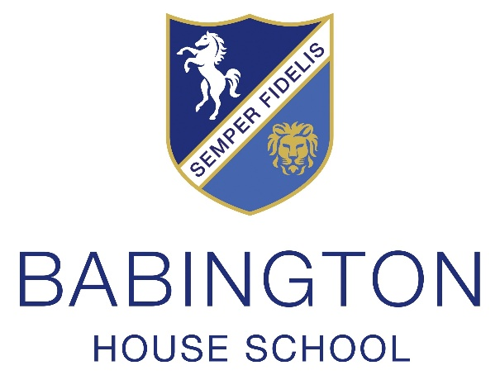
ART & DESIGN TECHNICIAN
JOB DESCRIPTION

Title: Art & Design Technician

Job Purpose:
To support the Art and Design department as directed by the Head of Art & Design.

Responsible to: Head of Art & Design

Main Duties:
- To carry out daily maintenance duties as specified by the Head of Art & Design
- To prepare and teach art lessons within the prep department under the guidance of the Head of Art & Design.
- To maintain equipment, materials, facilities and services in the Art & Design department.
- To manage the storage of materials, equipment and artwork efficiently.
- To prepare specialist materials and equipment for use in lessons.
- To assist with the documentation of pupils’ work and to distribute work back to pupils.
- To provide technical assistance to pupils during lessons and study sessions.
- To assist with reprographics and ICT administration.
- To assist with Art & Design departmental displays and the preparation, mounting and installation of artwork around the school.
  - Assist mounting and display - of GCSE Art & Design for moderation.
  - Assist with display of subject specific language to develop vocabulary.
- To provide skilled assistance to academic staff in preparation of teaching aids.
- Liaise with cleaners and maintenance staff.
- Have a technical frame of mind and the ability to resolve technical issues.
- To undertake any other reasonable duties as required.

Administration
- To assist with ordering of materials under the guidance of the Head of Art & Design.
- To check incoming deliveries, to unpack and distribute as necessary.
- To issue materials as required.
- To maintain a suppliers database.
- To review the inventories of resources Health and Safety requirements.
- To be responsible to the Head of Art & Design for health and safety matters and to carry out Risk and COSHH assessments as required by the site manager.
- Manual handling/lifting.

Qualifications and skills
- Art & Design based degree would be highly beneficial but not essential.
- Knowledge of Sewing Machine, Embellisher, 3D printer and Laser Cutter required.
- Computer skills in Word, Excel and Photoshop/Procreate/illustrator.
- To keep abreast of new techniques in identified specialist areas.
- Excellent communication skills and ability to build effective working relationships with staff and pupils.
- An appreciation of children’s specific needs and a desire to play an active role within the life of the school.
- Training on use of machinery will be provided as necessary.
- Specialist Art & Design training in newly developed areas of the curriculum.

For the avoidance of doubt, the duties and responsibilities contained within this job description may change from time to time according to the requirements of the role and it is not intended to have contractual effect.
Agreed by Headteacher 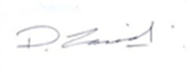
Date: 14 September 2026

Agreed by Jobholder ………………….……………
Date:

ART & DESIGN TECHNICIAN
PERSON SPECIFICATION

- Qualified to degree level
- Enthusiastic, positive and self-motivated with a desire to inspire and pass on their skills to young people.
- Organised and efficient at administrative tasks with a good range of IT skills.
- Sufficiently mature and confident to act as a role model to young people and liaise with school staff and parents as necessary.
- Prepared to familiarise themselves with school policies and formal procedures, including Health and Safety.
- Willing to be involved in the life of a busy day school
- The Art & Design Technician is expected to maintain the highest professional standards as part of the Babington community and to contribute significantly to the busy co-curricular life of the school.
- Prepared to work some evenings

