
Maths Hub Lead

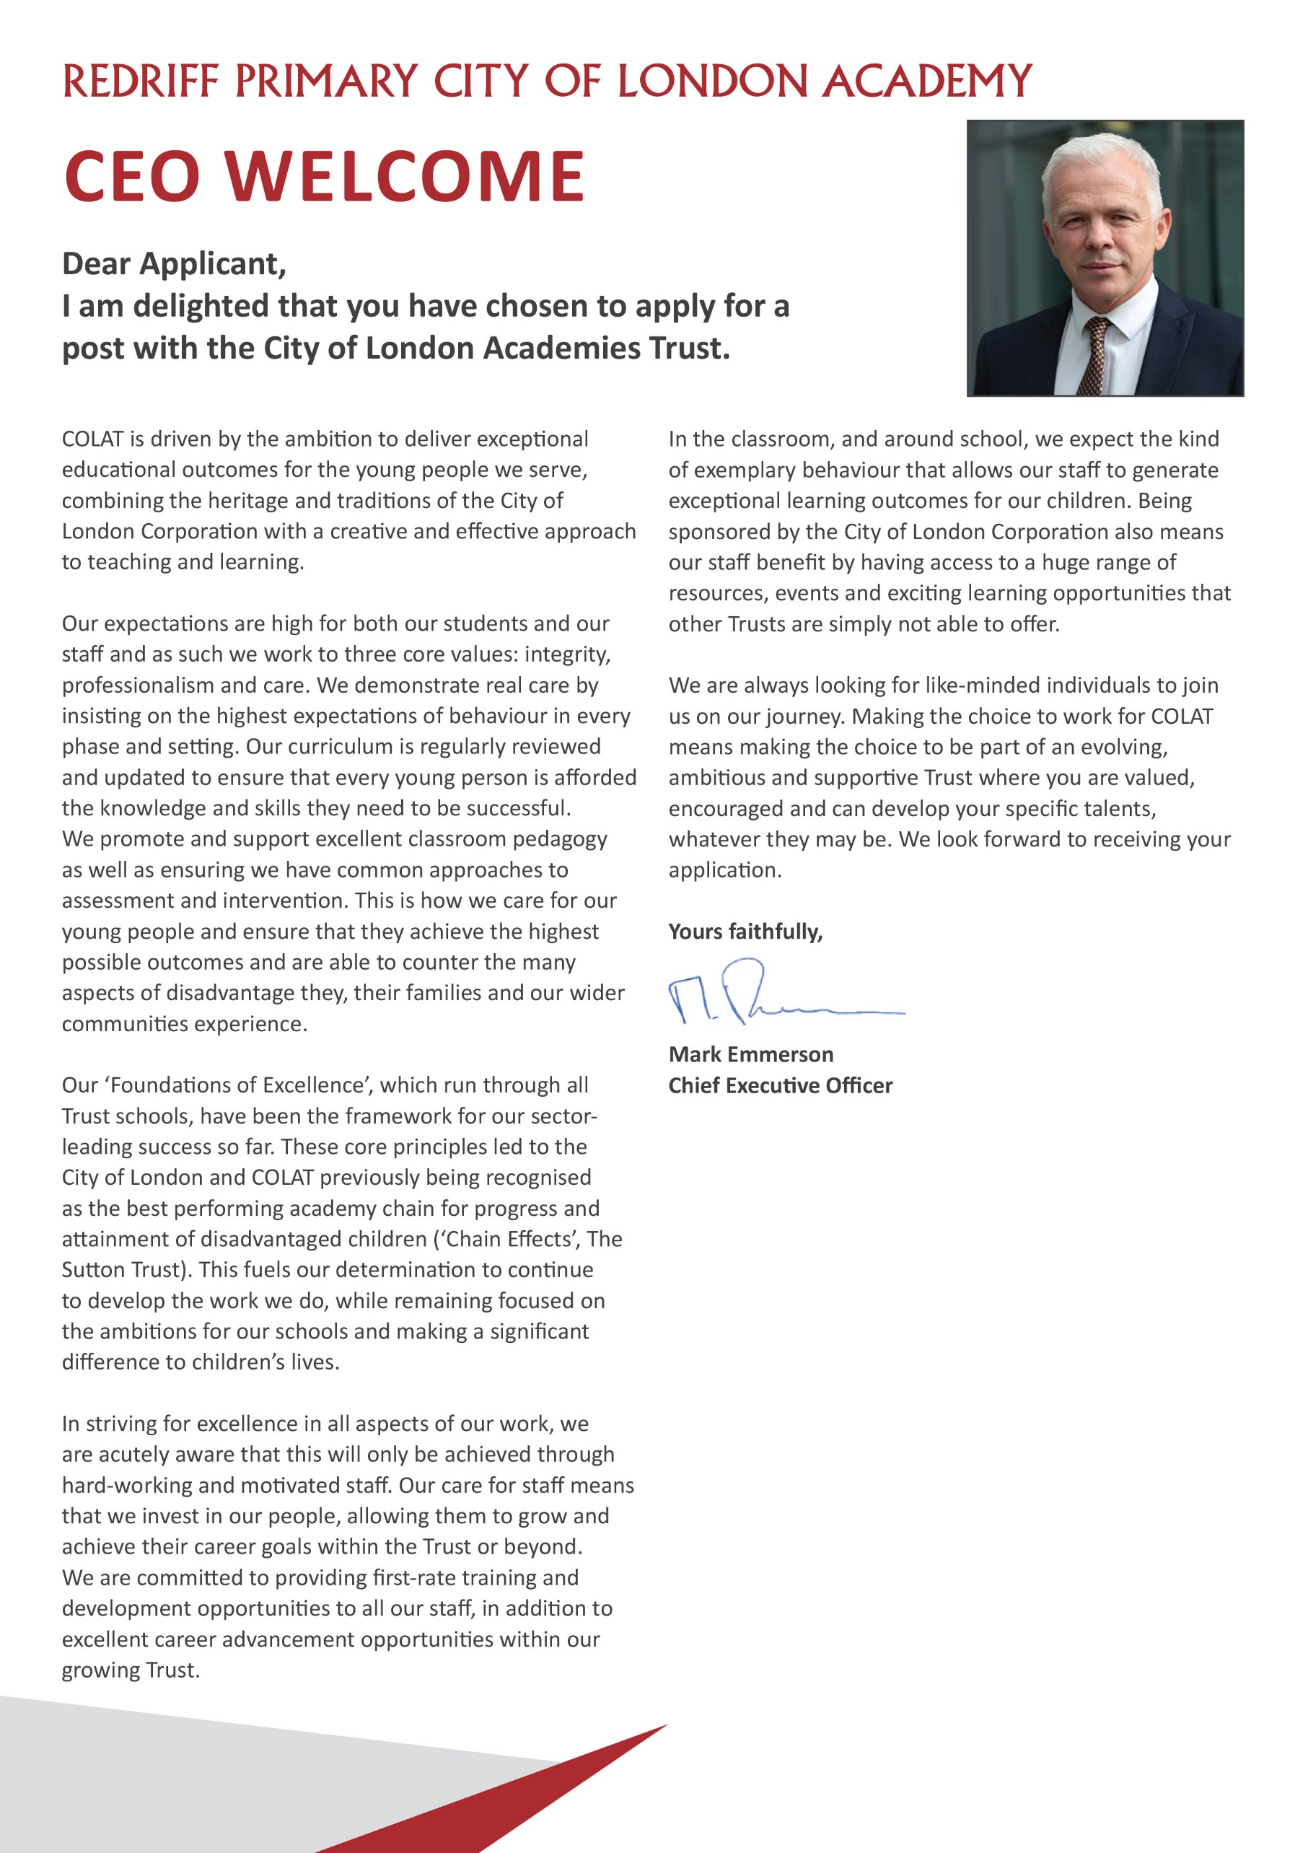

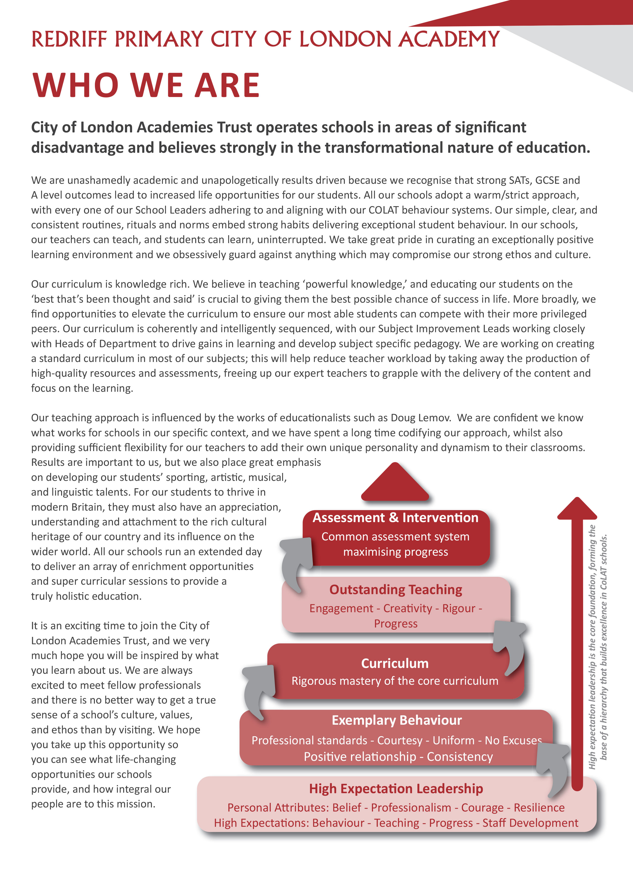

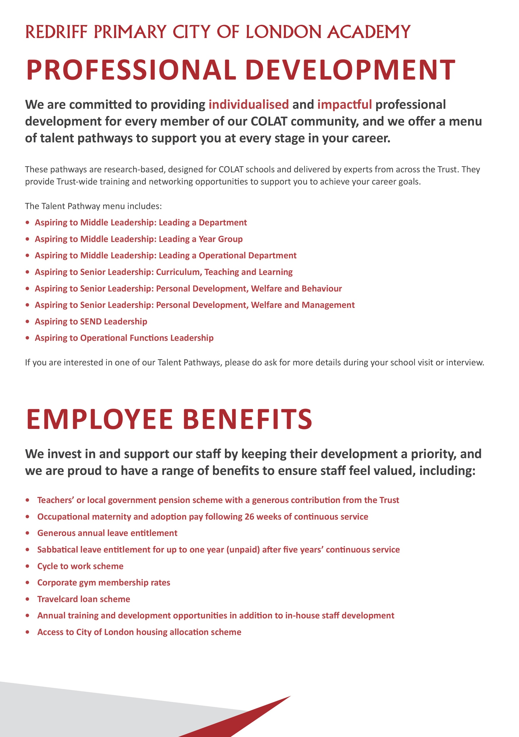
Headteachers Welcome



Maths Hub Lead - Job Description

Post: Maths Hub Lead

Accountable to: Senior Leadership Link

Salary Range: L10 – L14

Working Pattern: Full Time/Part Time (0.8 to 1.0 FTE)

Location: Redriff Primary School

Disclosure level: Enhanced DBS

Main Purpose:

The Maths Hub Lead will be expected to:

Strategically lead the London South East Plus Maths Hub from within the Lead Institution of Redriff Primary School. The Maths Hub Lead will represent the London South East Plus Maths Hub at all levels and act as a system leader across the region ensuring the Maths Hub acts as a key driver of system wide change in mathematics education across the region.

Key Accountabilities

Be accountable to Senior Leadership Link for:

Leadership and Management Team
- Establishing a shared vision for mathematics teaching and leadership within schools
- Leading Maths Hub Leadership and Management (MHLM) team and ensuring shared strategic direction and goals
- Line managing and quality assuring MHLM team
- Appointing MHLM team members with a clear focus on succession planning including for the administration function
- Reporting regularly to Senior Lead Link (SLL)
- Leading team meetings and sub-meetings.
- Identifying development needs of the MHLM team and discussing the needs of key members of the team with the SLL
- Have oversight of ongoing development of Hub Improvement Plan (HIP)

Finance and data management
- Overseeing an accurate budget for Maths Hub ensuring value for money of activities
- Quality assuring accurate data submission to NCETM

Working with NCETM and DfE
- Liaising with NCETM and working closely with the NCETM System Leadership Team
- Attending Maths Hub Lead Forums and representing the hub at national forums, workshops and other events as required
- Working as a Maths Hub Lead Link within a System Leadership Group as required
- Enabling effective collaboration between neighbouring hubs in the region
- Keeping up to date with national developments and issues

Other Responsibilities

Strategic boards and partnerships
- Maintaining a strategic view of maths teaching in the hub area
- Liaising with local stakeholders including LAs and TSHs.
- Developing and maintaining relationships with key partners including Teaching School Hubs and MATs
- Acting as a link to regional networks and system leaders (e.g., NLE, MATs, LAs)
- Attending all Strategic Board Meetings and reporting to Strategic Board as required

Local leaders of mathematics education (LLME)
- Identifying and engaging potential LLME in conjunction with the leadership team
- Appointing LLME, coordinating the hub’s LLME strategy and co-leading the LLME community
- Identifying and engaging potential intensive support partners for fulfilling Targeted Support in Mathematics work
- Work with LLME community leads to develop annual LLME development plans

Planning, monitoring and evaluation
- Planning for each annual cycle, including financial planning
- Identifying and supporting the planning of Research and Innovation Work Groups
- Ensuring production of high-quality WG/programme/community plans
- Leading on monitoring and reporting on Maths Hub progress
- Attending all Maths Hub Review Meetings (MRMs) and reporting on Maths Hub progress to NCETM
- Evaluating work and sharing impact
- Working with the Assistant Maths Hub Lead (AMHL) to quality assure work of Work Group Leads/Cohort Leads
- Updating and reviewing, together with the Senior Lead Link, the regular Grant Objective Reviews required by the NCETM/DFE

Communication, engagement, and recruitment
- Being the public face of the Maths Hub, communicating aims, vision and ambition of the Maths Hub, thus demonstrating mathematical leadership
- Encouraging Maths Hub Leadership and Management team and all LLMEs to be part of national mathematics conversations and keeping up to date with new developments
- Ensuring a consistent message with regards to teaching for mastery
- Ensure Maths Hubs offer is well understood across the region
- Overseeing recruitment to all Maths Hub activity
- Working with AMHLs in targeted recruitment activity and ensuring sustained participation
- Speaking at engagement events
- Attending various stakeholder meetings including Primary Heads, HODs, MATS etc

Safeguarding Children
COLAT is committed to safeguarding and promoting the welfare of children and young people. We expect all staff to share this commitment and to undergo appropriate checks, including enhanced DBS checks.

The above responsibilities are subject to the general duties and responsibilities contained in the Statement of Conditions of Employment. The duties of this post may vary from time to time without changing the general character of the post or level of responsibility entailed.

The person undertaking this role is expected to work within the policies, ethos and aims of the Trust and to carry out such other duties as may reasonably be assigned. The post holder will be expected to have an agreed flexible working pattern to ensure that all relevant functions are fulfilled through direct dialogue with employees, contractors and community members.

English Duty
This role is covered under part 7 of the Immigration Act 2016 and therefore the ability to speak fluent spoken English is an essential requirement for this role.

Maths Hub Lead – Person Specification

Our Values and Vision
The City of London Academies Trust, sponsored by the City of London Corporation, aims to provide high-quality education for students and pioneer educational innovation. We are driven by the ambition to provide world-class experiences and deliver exceptional educational outcomes for the young people we serve.

All City of London academies draw upon the traditions, institutions, heritage and historical successes of London to furnish each of their diverse communities with life-transforming learning experiences. In doing so, we believe that the young people we serve develop into successful, compassionate young adults, who make a positive contribution to their local, national and global communities.

Our schools are characterised by a common understanding of what makes outstanding schools, based on five key principles which are known as our 'Foundations of Excellence'​.

Our Staff
Our staff have high expectations, are consistent and driven to provide the best teaching and opportunities for our students. Teachers work in a well-disciplined environment where they are able to teach creative and engaging lessons, and all staff are given exciting opportunities to develop and learn from exceptional practitioners.

Equal Opportunities
The postholder will be expected to carry out all duties in the context of and in compliance with the COLAT Equalities policies.

 | Essential | Desirable
Qualifications
Educated to degree level or equivalent
Qualified teacher status
NCETM Mastery Specialist/PD Lead/SD Lead
Evidence of continuing professional development
Experience
Proven leadership experience
Demonstrated success in leading or significantly contributing to the development of an educational organisation
Skilled in leading and developing staff to become highly effective practitioners
Experience of leading Maths Hub work groups as a Local Leader of Education
Experience of teaching in, or leading across more than one educational phase
Extensive experience of working with children facing significant barriers to learning
Excellent organisational abilities and strong interpersonal and communication skills
Experience of working as a system leader across multiple establishments/organisations to coordinate school development
Experience of managing large budgets and making financial decisions
Teaching and Learning
Demonstrate an understanding of exceptional classroom practice
A strong understanding of the NCETM 5 Big Ideas and Teaching for Mastery
Displaying the ability to construct relevant school structures, pedagogical systems and routines in order to secure the best possible pupil outcomes in line with CoLAT expectations that challenge and inspire pupils
Vision and Strategy
Have a strong understanding of the vision of Maths and their purpose within the education system
Understand how to create a strong culture based on high aspirations and effective strategies across all aspects of the Maths Hub
Be committed to further developing a vision and strategy that encompasses improving maths education for all pupils
Have a strong commitment and vision for how we can develop an equitable education system
Leadership Attributes
Demonstrates the mindset, expertise, commitment, and proven track record required to lead a COLAT school to achieve a Progress 8 score of +1 or higher.
Deeply committed to building a strong Local Leader of Maths Education Community
Maintains a meticulous eye for detail, identifying and addressing any aspect of operations that falls short of excellence
Takes pride in implementing, refining, and perfecting systems that drive organisational excellence.
Able to develop, empower and sustain individuals and teams
Ability to delegate to others and hold them to account for outcomes without ambiguity
Leading Relationships with Stakeholders
Commitment to working with others to secure the best outcomes for children
Skilful management and understanding of how to inspire and secure strong partnerships with other organisations for the betterment of the education system
Work-Related Personal Qualities
Demonstrate personal enthusiasm and commitment to leadership aimed at making a positive difference to children and young people and raising standards
Demonstrate personal and professional integrity, including modelling values and vision
Flexible and able to manage competing deadlines, prioritising appropriately and maintaining good humour
Evidence of commitment to and understanding of collective responsibility

Maths Hub Lead

Fixed Term Contract (Full Time and Part Time Working Considered)

Redriff Primary AcademyAcademy
01 May 2026 at 09.00

Applications must be submitted via the link to My New Term portal

