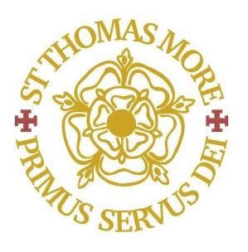


St Thomas More Catholic Secondary School
Inclusion Support Worker
Grade F Point 6 - £25,989 FTE Pro-rata
Fixed Term – 1 Year

Start ASAP
The Directors of this successful Catholic Secondary School are looking to appoint a confident and passionate Inclusion Support Worker to start as soon as possible. The successful candidate will have strong motivational, communication, administrative skills and will support students experiencing difficulties with behaviour for learning across all year groups, providing early intervention, support, and guidance to improve behaviour.

In return we can offer a supportive and caring work environment suitable for both ECTs starting out on their teaching career and experienced teachers too. We also welcome applications from teachers interested in part time working hours.

Closing date: 22nd February 2026
Interview date: Week commencing 23rd February 2026

Suitable candidates may be interviewed before the closing date and the school reserves the right to withdraw the position if an early appointment is made. Applicants are therefore encouraged to apply early.

St Thomas More is committed to safeguarding and promoting the welfare of children and young people and expects all employees and volunteers to share this commitment. The suitability of all prospective employees or volunteers will be assessed during the recruitment and selection process in line with this commitment. Successful applicants will be required to undertake an enhanced DBS check.

Our Lady Immaculate Catholic Academies Trust is a large new Catholic Multi Academy Trust situated in the northern half of the Catholic Diocese of Northampton formed by the merger of three former Catholic Trusts in February 2020. The Trust currently leads and manages ten catholic primary schools located across the geographical area of Northamptonshire and Bedfordshire and two Catholic secondary schools – Thomas Becket in Northampton and St Thomas More in Bedford.

