

JOB PROFILE
Job Title: | Apprentice Site Operative | School/Department: | Colton Primary School.
Salary Grade: | APC5 | Working Hours: | 37 hours per week  Monday - Friday
Contract Type: | Fixed Term linked to the length of the apprenticeship.  All Year Round. | Location: | Leeds
Responsible to: Business Operations Manager
Role summary: To support the safe, compliant, and efficient operation of the school site while undertaking an apprenticeship in site and facilities operations. The Apprentice Site Operative will work under the close supervision of the Site Supervisor and wider site team, learning practical caretaking, maintenance, cleaning, and health & safety skills while contributing to a safe, welcoming, and well-maintained environment for pupils, staff, and visitors.
This role is designed to support training and development, allowing the post holder to gain knowledge, skills, and experience alongside formal apprenticeship learning.
Red Kite Learning Trust is committed to safeguarding and promoting the welfare of students and expects all colleagues and volunteers to share this commitment.

Red Kite Learning Trust is committed to safeguarding and promoting the welfare of students and expects all colleagues and volunteers to share this commitment.
Special conditions of service:
No smoking policy, including e-cigarettes/vapes.
Occasional requirement to work outside of school hours and off school premises
Role specific responsibilities:

1. Caretaking / General Maintenance (Learning & Support Role)
- Assist with basic maintenance tasks (e.g. minor repairs, painting, furniture movement/replacement) under supervision and in line with agreed risk assessments.
- Support the Site Supervisor in identifying maintenance issues across the school site and reporting these appropriately.
- Take utility meter readings as directed and report unusual usage or potential issues to the Site Supervisor.
- Support daily water fountain hygiene checks and help replenish hygiene consumables (e.g. soap, toilet rolls, hand towels).
- Assist with basic grounds and site checks, including reporting any concerns relating to trees or outdoor areas to the appropriate team.
- Support the wider Trust site team with day-to-day duties, as required, to build skills and experience.
- Carry out tasks as directed within the agreed plan of work, with guidance from the Site Supervisor.
2. Site Safety

- Support the locking and unlocking of buildings and gates, under supervision, ensuring site security procedures are followed.
- Assist in ensuring safe access to buildings during adverse weather conditions, including snow clearing and gritting of essential pathways.
- Maintain awareness of pupil safety and safeguarding while undertaking duties, reporting concerns immediately to a senior member of staff.

3. Cleaning
- Clean designated areas as directed, including toilets and shared facilities, ensuring they are kept clean, safe, and hygienic.
- Assist with general cleaning tasks such as dusting, sweeping, mopping, vacuuming, and cleaning internal glass surfaces.
- Use, as appropriate, powered equipment as provided and ensure that relevant Health & Safety regulations are always adhered to.
- Use cleaning equipment and materials safely and appropriately, following training and Health & Safety guidance.
- Support deep cleaning tasks during school closure periods.
- Maintain daily water fountain hygiene under supervision.

4. Health and Safety (Supported Learning)
- Assist with regular site walk-arounds and inspections alongside the Site Supervisor.
- Learn and follow statutory guidance, school policies, and Trust procedures relating to health & safety.
- Completion of tasks assigned via the Trusts Compliance portal: Risk Manager and/or instructions from the Site Supervisor.
- Report hazards, defects, and potential risks promptly to the Site Supervisor.
- Support making areas safe (e.g. signage or barriers) under instruction.
- Attend and participate in required health & safety, safeguarding, and compliance training as part of the apprenticeship.
- Store equipment and materials safely, following COSHH guidance as trained.
- Participate in emergency and contingency planning exercises.
- Adhere to all school/estate policies (e.g., Safeguarding, Equal Opportunities, Health & Safety etc).
- Complete compliance tasks via the Trust’s Compliance portal: Risk Manager.

5. Porterage and Site Support
- Provide porterage services, receive deliveries, and transport items within the site.
- Support the preparation of rooms and halls for meetings, events, and activities, returning them to their original layout afterwards.
6. After School Lettings
- Support after-school lettings, ensuring hired areas are safe and appropriately prepared.

7. Contractors and Visitors
- Assist in supporting contractors and visitors on site by following agreed procedures and reporting to the Site Supervisor.
- Learn how contractor documentation, permits and site procedures are managed.
- Assist contractors in accessing relevant estate documentation and procedures.
8. General Duties and Development

- Log faults or issues on the Trust Helpdesk as directed and report progress to the Site Supervisor.
- Learn about efficient energy use and support good practice around the site (e.g. switching off lights and equipment when not in use).
- Take part in apprenticeship training, reviews, and assessments.
- Participate in the Trust’s appraisal and development processes.
- Carry out any other duties appropriate to the apprenticeship and grade of the role, as directed.

9. General
- Provide basic estate-related information to senior leadership team when required.
- Understand legal boundaries, ownership, and restrictions of the estate.
- Monitor energy usage via the Energy Sparks portal and promote good practices (e.g., switching off unused systems, ensuring the heating is only on when required etc).
- Participate in behavioural change programmes and training on efficient building use.
- Log faults on the Trust Helpdesk in a timely and appropriate fashion as required. Liaise with the Site Supervisor and/or Headteacher, to ensure they are up to date with any faults/concerns.
- Conduct regular premises walk-arounds and inspections, recording findings and actions.
- Participate in school Performance Management/Appraisal process and seek to develop skills further through professional development opportunities.
- Carry out any other duties commensurate with the grade of the post, as directed by the Headteacher.

RK People responsibilities:

- Contribute to the overall aims and values of our Trust, appreciate and support the roles of other members of the wider team and attend and participate in relevant meetings as required
- Comply with all Trust policies and procedures including child protection, health, safety, welfare, security, confidentiality and data protection, reporting any concerns to the appropriate person
- Contribute to ensuring safeguarding procedures are in place and used effectively at all times

The role holder must demonstrate a flexible approach to the delivery of the role. Consequently, the role holder may be required to perform work not specifically identified in the job profile, but which is in line with the general scope, grade and responsibilities of the role.

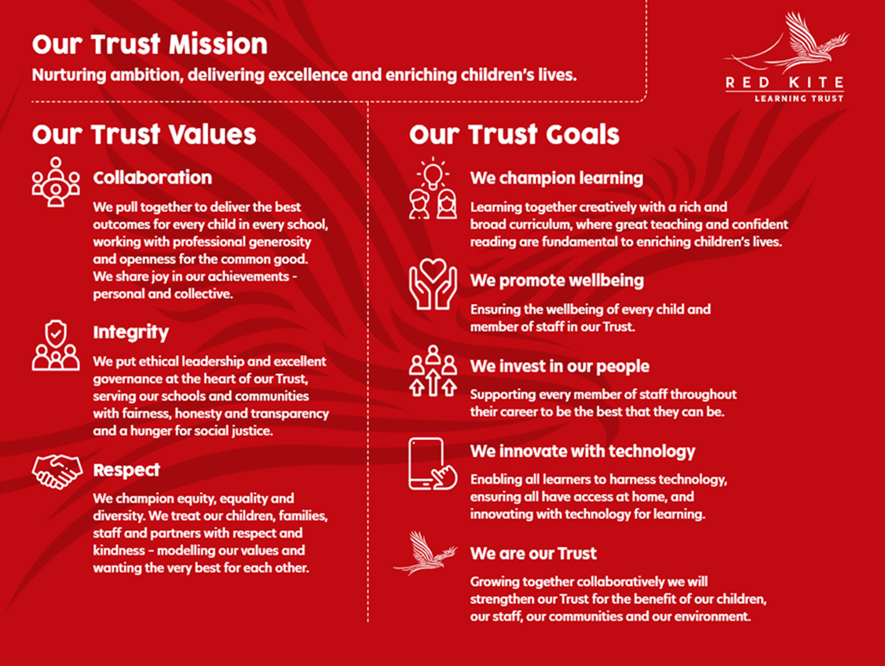

PEOPLE PROFILE
Aptitudes and Characteristics |  |  |  | Essential | Desirable
Able to communicate effectively with staff at all levels within the school and across the MAT. |  |  |  | *
Able to identify and report risks and maintenance concerns. |  |  |  | *
Able to relate positively to young people. |  |  |  | *
Able to work effectively as part of a team. |  |  |  | *
Able to take initiative and work independently. |  |  |  | *
Ability to work under pressure. |  |  |  | *
Able to work to high levels of accuracy / maintenance standards. |  |  |  | *
Able to prioritise and plan to ensure completion of tasks. |  |  |  | *
Able to take a considered and safe approach to maintenance and security. |  |  |  | *
Demonstrates a sense of pride in work, the school and wider environment. |  |  |  | *
Demonstrates a positive attitude and a solution-based focus. |  |  |  | *
Able to be discreet at all times in the disclosure of information about the school and MAT and has a clear awareness of confidentiality. |  |  |  | *
Demonstrates a full commitment to safeguarding and promoting the welfare of children and young people. |  |  |  | *
Sense of humour and optimism. |  |  |  | *
Self-motivated and hard working. |  |  |  | *
Open and honest. |  |  |  | *
Flexible and willing to comply with requests to ensure site services are delivered to an outstanding standard for all school pupils, staff, parents, and visitors. |  |  |  | *
Willingness to undertake additional training and develop personal skills. |  |  |  | *
Willingness to be flexible and work to meet the best interests of the school and MAT. |  |  |  | *
Willing to carry out any other duties commensurate with the grade of the post, as directed by the Headteacher. |  |  |  | *
Qualifications, Knowledge and Experience |  |  |  | Essential | Desirable
Level 2 Qualification and GCSE English and Maths A-C. |  |  |  | *
Prior experience in an estates or premises maintenance environment. |  |  |  |  | *
Existing knowledge/experience of a particular maintenance trade. |  |  |  |  | *
PAT testing qualification and experience or willingness to undertake training. |  |  |  |  | *
Knowledge / prior training of Health and Safety legislation. |  |  |  |  | *
Experience of supporting general trade tasks/skilled trade workers. |  |  |  |  | *
Demonstratable problem solving skills within a work environment. |  |  |  |  | *
Good numeracy and literacy skills. |  |  |  | *
Competency when using IT software and systems. |  |  |  | *
Knowledge of health & safety legislation and site security measures. |  |  |  |  | *
Driving Licence - be willing to drive and undertake tasks as required. |  |  |  |  | *
Experience in an educational setting. |  |  |  |  | *
Safeguarding and Promoting the Welfare of Students |  |  |  | Essential | Desirable
Has appropriate motivation to work with, and at times alongside, children. |  |  |  | *
Ability to maintain appropriate relationships and personal boundaries with children. |  |  |  | *
Has emotional resilience in working with challenging behaviours; and appropriate attitudes to the use of authority and maintaining discipline. |  |  |  | *

