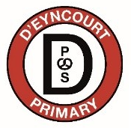
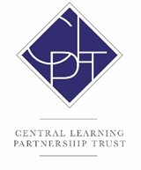
Person Specification – ASSOCIATE STAFF
Level 3 Teaching Assistant

FACTORS | ESSENTIAL | DESIRABLE
Qualifications | L3 NVQ or relevant qualification | Qualified as HLTA/ A levels / Degree level qualification/  EYFS qualification
Training | Appropriate recent professional training, Safeguarding training | Attendance on courses related to behaviour management  Paediatric 1st aid training
Experience | Successful, recent experience as a Teaching Assistant. | Successful experience of working with children in EYFS
Knowledge & Skills | Proven effective teaching assistant who:  - supports children in making good progress  - uses initiative  - ability to lead interventions under the direction of the class teacher  - an understanding of targeting and supporting children to raise standards,  - is aware of effective strategies to support behaviour management Child-centred ethos. | Knowledge and understanding of the Primary curriculum in all subjects  Excellent behaviour management
Personal Qualities | - Good communication skills  - Ability to work under the direction of the class teacher / SLT  - Well organised  - Child-centred  - Enthusiastic team approach  - Ability to relate to a wide range of people – children and adults  - Ability to set targets, meet deadlines and to work under pressure  - Ability to promote the child centred ethos within the schools. | Adaptable and versatile approach  Ability to organise others  Flexibility
Interests/ Motivation relevant to the job | Ability to contribute to extra-curricular activities Interests other than education. | Ability to support extra-curricular activities
Commitment | Should have a commitment to:  - all children at D’Eyncourt  - continuing the process of raising standards  - maintaining high expectations and helping children of all abilities to reach their full potential  - working in a multicultural Trust with a genuine commitment to equal opportunities,  - involving parents in the life of the school

