

JOB PROFILE

Red Kite Learning Trust is committed to supporting work–life balance and recognise the benefits of flexible working. We welcome requests for flexible working arrangements as part of the recruitment process. While flexibility may be possible for many roles, each request will be considered on an individual basis.
Job Title: | Higher Level Teaching Assistant (HLTA) | School/Department: | Temple Learning Academy
Salary Grade: | S01 | Working Hours: | Full time, 37 hours  Monday - Friday
Contract Type: | Permanent, Term Time Only + Training Days | Location: | Leeds
Responsible to: Headteacher
Role summary: As a HLTA - Primary, you will play a key role in ensuring pupils from Reception to Year 6 access inspiring, inclusive and enriching learning experiences, with a clear focus on delivering high‑quality PE and sport across the Primary Phase, both within and beyond the curriculum. You will complement the professional work of teachers by taking responsibility for agreed learning activities under an agreed system of supervision.
You will advance pupils’ learning across a range of classroom settings, including working with individuals, small groups and whole classes where the assigned teacher is not present. This may involve planning, preparing and delivering learning activities, as well as monitoring pupils, assessing and marking work, and recording and reporting on progress and development.
The role also includes contributing to the wider management and development of responsibilities within school, including supporting, guiding and, where appropriate, overseeing the work of other teaching assistants through the allocation and monitoring of tasks, appraisal and training. Throughout, you will contribute to a positive, inclusive and engaging learning environment that enables all pupils to thrive.
Special conditions of service:
No smoking policy, including e-cigarettes. Requirement to occasionally work outside of school hours and off school premises as required by the school.
- To work with the teacher to establish an appropriate learning environment. Support the learning process for pupils including directing other appropriate staff e.g. teaching assistants, students and volunteers who may be working in class with you.
- Within an agreed system of supervision, plan and deliver teaching activities using appropriate learning objectives.
- Covering classes from Reception to Y6, working collaboratively with an all-through PE team to provide high quality sport to the Primary Phase.
- To monitor, evaluate and adjust lessons/work plans as appropriate, according to student responses/needs.
- Provide objective accurate feedback and reports as required on student achievement, progress and other matters, ensuring the availability of appropriate evidence.
- Organise and manage appropriate learning environment and resources.
- Use ICT to advance students’ learning, use common ICT tools for own and students’ learning.
- Work with the School’s agreed behaviour policy to anticipate and manage behaviour constructively, promoting self-control and independence.
- As required assist with administrative support e.g. dealing with correspondence, compilation/analysis, reporting on attendance, making phone calls etc.
- Work with other staff in planning, evaluating and adjusting learning activities as appropriate.
- Communicate effectively and establish constructive relationships with all children, parents, families, carers, external agencies and other professionals. Understand that communication is a two-way street.
- Participate in the marking of students’ work and accurately record achievement/ progress.
- Provide advice and guidance as required and appropriate.
- Observe a child’s behaviour, understand its context and notice any unexpected changes – to ensure continued delivery of the highest quality teaching, safeguarding and welfare practices. Using observations to assist the teacher in planning teaching and learning.
- Participate in the recruitment/induction/appraisal/training/mentoring of other support staff working across the school.
- When required, with agreement from the teacher, lead the work of the team of Teaching Assistants.
- Assisting with play activities and occasional lunch time supervision.
- To be aware and comply with policies and procedures relating to child protection, health, safety and security, confidentiality, equality and data protection - reporting concerns to an appropriate or designated person.
- Providing, with appropriate guidance and supervision limits, educational, emotional and physical support to pupils.
- To encourage pupils to interact and work co-operatively with others and engage all pupils in activities.
- To establish productive working relationships with pupils, acting as a role model and setting high expectations.
- Support all children, including those with disabilities or special educational needs through the provision of care and encouragement to the pupil at all times.
- Where appropriate, to liaise sensitively and effectively with parents/carers within your role/responsibility and participate in feedback sessions/meetings with parents, where requested.
- Support school staff with the preparation of materials, resources, displays including undertaking clerical duties.
- To be aware of and support differences and ensure all pupils have equal access to opportunities to learn and develop.
- To contribute to the overall ethos/work/aims of the school, in accordance with your role and the direction of the Headteacher.
- To undertake supervision of pupils sitting internal and external examinations, as required, ensuring all examinations comply with current Exam Board Regulations.
- Participate in the schools’ performance management scheme.
- Willingness to be involved in extra-curricular activities such as making a contribution to after-school clubs or organised school events and visits.

RK People responsibilities:
- Contribute to the overall aims and values of our Trust, appreciate and support the roles of other members of the wider team and attend and participate in relevant meetings as required
- Comply with all Trust policies and procedures including child protection, health, safety, welfare, security, confidentiality and data protection, reporting any concerns to the appropriate person
- Contribute to ensuring safeguarding procedures are in place and used effectively at all times
- The role holder must demonstrate a flexible approach to the delivery of the role. Consequently, the role holder may be required to perform work not specifically identified in the job profile but which is in line with the general scope, grade and responsibilities of the role.

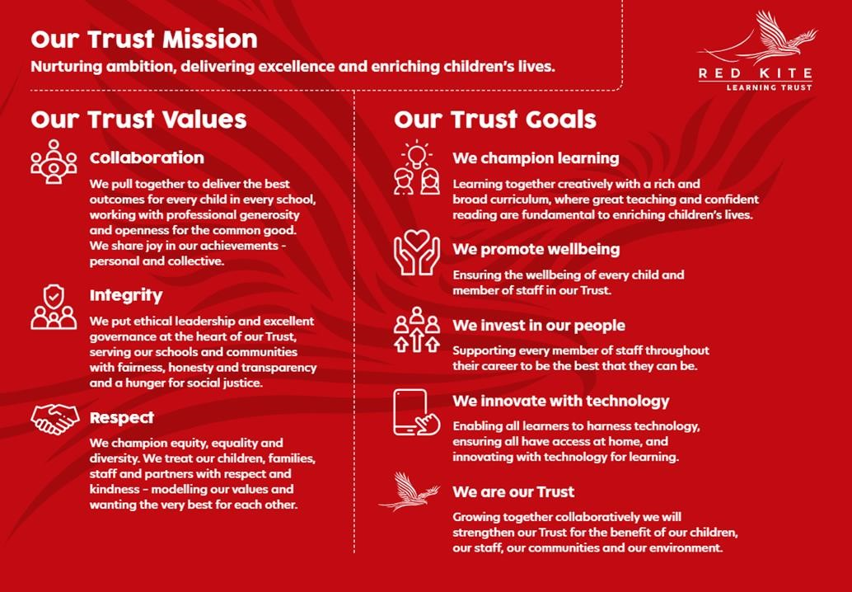
PEOPLE PROFILE
Aptitudes and Characteristics | Essential | Desirable
Ability to relate well to, and work positively and effectively with, children and young people | *
Has a passion for education and an active interest in children’s learning and play | *
Ability to challenge and motivate pupils, promote and reinforce self-esteem | *
Ability to adopt confidentiality, discretion and judgement, communicating effectively with staff, students and parents | *
Ability to manage pupil behaviour in a supportive and effective manner and understanding of individual children and young people’s needs | *
Ability to work constructively as part of a team, understanding roles and responsibilities and own position within these | *
Self-motivated and hard-working colleague with the ability to maintain effective working relationships | *
Able to communicate effectively using both written and verbal communication skills | *
Willingness to be flexible and work to meet the best interests of the school, including working across the whole primary age range | *
Interest in girls sport, dance and competitive opportunities |  | *
Ability to use creativity to problem solve | *
Committed to safeguarding and inclusion | *
Willingness to participate in training, learning activities and performance development as required | *
Qualifications, Knowledge and Experience | Essential | Desirable
HLTA Qualification (or working towards) | *
Teaching Assistant L3 Qualification | *
GCSE grade C or equivalent in English and Mathematics | *
Competent IT skills | *
Experience delivering high-quality PE and sport | *
Experience of working successfully with children and young people and with a wide range of Special Educational Needs, either in a paid or voluntary position | *
Experience / knowledge in general subject matters such as English, Maths, Art, Music, Science and Sport | *
Experience of leading whole-class sessions (required for HLTA level) and delivering evidenced based interventions and accelerated learning | *
Working knowledge of a child’s development and learning processes, understanding that all children have differing needs and knowledge of how to apply inclusive practice | *
Knowledge of behaviour management techniques & child protection / health and safety policies & legislation | *
Working knowledge of relevant policies, codes of practice, and legislation |  | *
Working knowledge of national curriculum and other relevant learning programmes/strategies | *
Understanding of SEND and strategies to support diverse learners |  | *
Understanding the importance of exercising confidentiality and judgement within this role and how it relates to a school setting | *
Current first aid qualification or willingness to undertake training | *
Safeguarding and Promoting the Welfare of Students | Essential | Desirable
An appropriate motivation to work with children and young people | *
Ability to maintain appropriate relationships and personal boundaries with children and young people | *
Emotional resilience in working with challenging behaviours and appropriate attitudes to the use of authority and maintaining discipline | *

