

JOB PROFILE
Job Title: | Student Receptionist | School/Department: |  | Harrogate Grammar School
Salary Grade: | Band 5 | Working Hours: |  | 37 hours per week
Contract Type: | Permanent/Term Time only plus training days (39 weeks per year) | Location: |  | Harrogate, North Yorkshire
Responsible to: Deputy Headteacher
Role summary:
- To support the attendance team and Year Mangers in first response to student and family need.
- To support the Year Managers in delivering First Aid to students
Red Kite Learning Trust is committed to safeguarding and promoting the welfare of students and expects all colleagues and volunteers to share this commitment.
Special conditions of service:
No smoking policy, including e-cigarettes.
Role specific responsibilities:
- Supporting with late arrivals of students and follow ups with home.
- Work with the Year and Attendance team to make some strategic ‘first day’ contact home calls when students have not arrived at school.
- Work with the Year and Safeguarding team on joint home visits.
- Supporting with students who need to re-set on arrival.
- Supporting the Behaviour Manager with locating students and supporting on-call.
- Support the Attendance team with administrative and organisational tasks.
- Deputise for Attendance Officer where required.

RK People responsibilities:
- Contribute to the overall aims and values of our Trust, appreciate and support the roles of other members of the wider team and attend and participate in relevant meetings as required
- Comply with all Trust policies and procedures including child protection, health, safety, welfare, security, confidentiality and data protection, reporting any concerns to the appropriate person
- Contribute to ensuring safeguarding procedures are in place and used effectively at all times
The role holder must demonstrate a flexible approach to the delivery of the role. Consequently, the role holder may be required to perform work not specifically identified in the job profile but which is in line with the general scope, grade and responsibilities of the role.
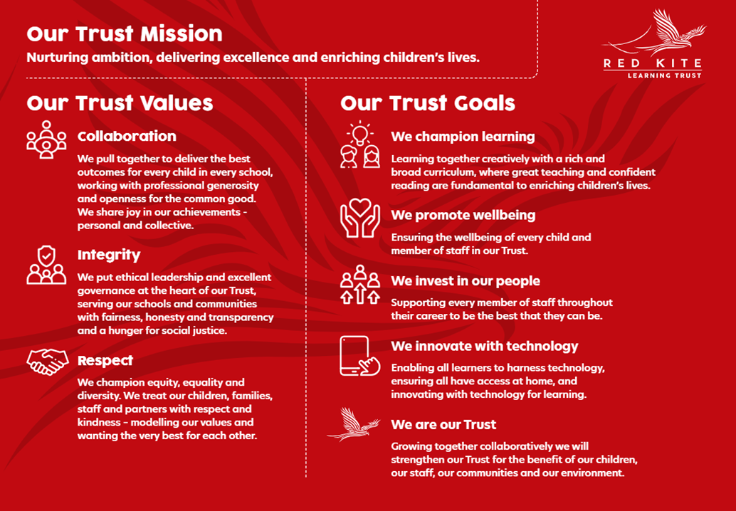
PEOPLE PROFILE
Aptitudes and Characteristics |  |  | Essential |  | Desirable
Ability to work flexibly and collaboratively as part of a team as well as independently with limited supervision |  |  | *
Ability to communicate effectively with staff, students and parents/carers |  |  | *
Ability to relate well to young people and develop positive relationships in an appropriate manner |  |  | *
Ability to command presence |  |  | *
Ability to use own initiative and be flexible and solutions-focused |  |  | *
Ability to deal with sensitive information in a confidential manner |  |  | *
Ability to practice and plan to ensure completion of tasks |  |  | *
Ability to work under pressure and meet deadlines |  |  | *
Excellent organisation and administrative skills and ability to work to high levels of accuracy |  |  | *
Ability to negotiate challenging situations |  |  | *
Hard-working, well-motivated and positive |  |  | *
Empathy towards young people facing barriers to their learning |  |  | *
Willingness to be flexible and work to meet the best interests of the school |  |  | *
Willingness to undertake further training where appropriate |  |  | *
Qualifications, Knowledge and Experience |  |  | Essential |  | Desirable
GCSE Mathematics and English or equivalent (grade C or above) |  |  | *
High level of ICT skills |  |  | *
NVQ Level 3 for Teaching Assistants or equivalent or experience |  |  |  |  | *
Counselling or coaching skills |  |  |  |  | *
Experience of working with young people in a challenging environment |  |  |  |  | *
First Aid at Work or Emergency First Aid at Work, or willingness to attend training |  |  |  |  | *
Safeguarding and Promoting the Welfare of Students |  |  | Essential |  | Desirable
An appropriate motivation to work with children and young people |  |  | *
Ability to maintain appropriate relationships and personal boundaries with children and young people |  |  | *
Emotional resilience in working with challenging behaviours and appropriate attitudes to the use of authority and maintaining discipline |  |  | *

