


Application Pack
Nursery Practitioner - Subject
Date: March 2026

The Right To Be Safe - The Right To Play - The Right To Learn




CONTENTS

Welcome 4
About Beaumont Primary Academy 5
How to Apply 6
Job Description 7
Person specification 9
Safeguarding Notice 12
Partners of the SPA Trust 14

Submit your application by 9:00am on 20th March 2026

If you have any queries regarding the application process please contact our HR on 01484 503111

Closing date for applications: 9:00am on 20th March 2026

Interviews: week commencing 23rd March 2026



Welcome

Dear Potential Colleague,

Firstly, thank you for your interest in working at Beaumont Primary Academy, a proud member of the highly regarded Trust, South Pennine Academies. If you’re impressed by our exciting work, understand our vision, and want to be part of our journey, then we are keen to hear from you.

Beaumont Primary Academy was last inspected in December 2024 when inspectors recognised the culture of very high expectation throughout the school. They reported that staff felt very well supported by leaders and were in no doubt that only the best practice was good enough. We continue to build on developing a staff workforce, with low staff turnover, who are very well supported and enjoy working here at Beaumont.

Our motivation is to ensure our children feel valued, challenged and are well taught every day- many of our children face significant challenge and vulnerability and we take our responsibility seriously to support the academic, social and emotional development of every pupil. Positive relationships are at the core of what we do each and every day and these are underpinned by our core values of rights; the right to be safe, the right to learn and the right to play. Our core rights are lived every day across the academy.

If this is a position that appeals to you, and you have the passion to make a positive impact on the life chance of our students, then we would very much like to hear from you.

If you wish to discuss any of the opportunities we have on offer, please contact us at office.beaumont.spacademies.org or call 01484 503111. We also invite you to visit our website www.beaumontprimary.org.uk and our social media pages to learn more about Beaumont Primary and the Trust.

Yours sincerely,

Anita Mather
Principal

About Beaumont Primary Academy

OUR VISION AND VALUES

Our vision is to ensure every child receives the best possible opportunity to access education from their own starting point and that we then provide the highest quality academic and social skills opportunities in order to accelerate progress and prepare pupils ready for leaving us to go to
Year 7.

Our core values of rights underpin everything we do as and academy, and we passionately believe that as educators, we have the power and responsibility to inspire our students to be the best they can be and enabling them to pursue their dreams and become the leaders of tomorrow.



Why join us
- Be part of a passionate committed team who know that every day they make a difference; together we have created an ethos and culture which we feel very proud of
- Work with children who love learning and have well established learning behaviours
- Work for a leadership team who have integrity and genuinely care about staff well being
- Support our families who all want the best for their children
- Be the creative educator that you are and bring yourself to the classroom
- Benefit from a strong professional development offer
- Be part of a trust who believe in improving life chances through education and looking after their workforce

How to Apply

Thank you for taking time to read about the academy and Trust. If you wish to apply you should:

- Complete the application form fully, via My New Term www.mynewterm.com ensuring all details are accurate and all declarations are signed.
- Please ensure you enclose at least two professional referees with one being your current employer and any other employers in the last two years (with professional email addresses if possible).
- Do not enclose additional CVs.
- Ensure you fully complete the relevant skills and experience section of the form, addressing the key characteristics and experiences outlined in the person specification and the unique contribution that you could make to the future success of our Trust.
- Please ensure that you also include information on how you will develop the role and how your previous experience has equipped you for this.

The academy is committed to safeguarding and promoting the welfare of all students, and staff must share this commitment. Appointment is subject to a satisfactory enhanced Disclosure & Barring Service check and the Academy’s Safer Recruitment policy and procedures. Please note two references will be taken up prior to the interview process; please ensure your referees are prepared and aware of your application.

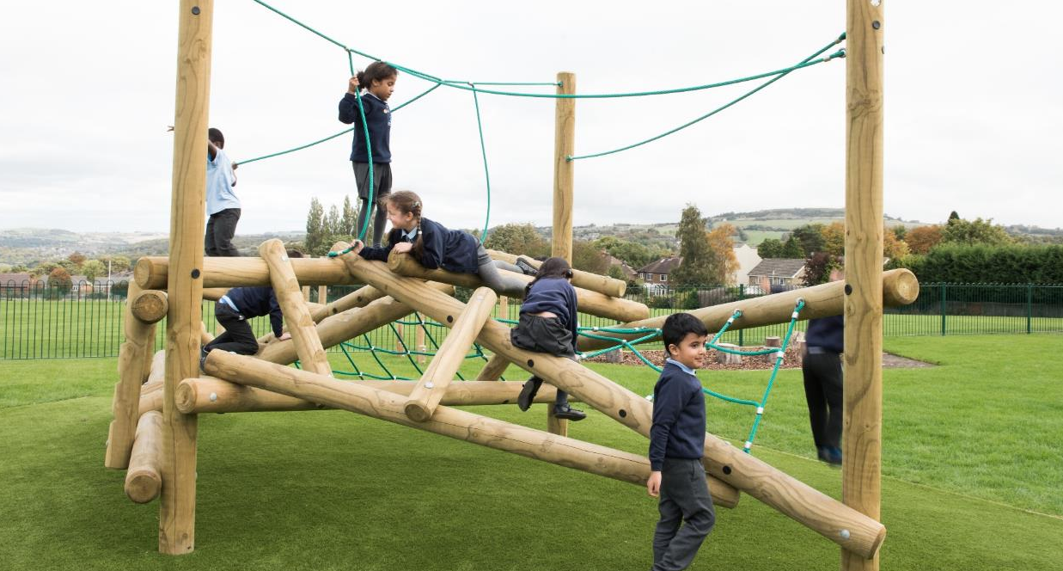

Job Description
Nursery Practitioner

Reporting to: | Assistant Principal for Early Years / Senior Nursery Practitioner
Salary: | £19,713
Hours: | 08:30am – 3:30pm, Monday to Friday
Grade/SCP: | Grade 6/SCP 7
Term: | Term Time
Location: | Beaumont Primary Academy

PURPOSE OF POST
- To provide a high standard of physical, emotional, social and intellectual care for children placed at Beaumont Primary Academy Nursery
- To give support to other personnel within the setting
- To implement the daily routine in the preschool.

KEY AREAS
- Work with children, ensuring progression and record keeping
- Teamwork
- Effective communicator, including liaising with parents/carers

Duties & Responsibilites
- Operate a programme of activities suitable to the age range of children in conjunction with other staff
- To keep a proper record of achievement file on your all children to effectively track progress
- Work with parents/carers of all children including those with additional needs ensuring full integration in the Setting; inclusive practice.
- Provide a warm, welcoming, friendly, stimulating environment.
- Support all staff and engage in a good staff team
- Liaise with and support parents/carers and other family members
- To be involved in out of working hours activities, e.g. training, monthly staff meetings,
fundraising events
- To be flexible within working practices of the Setting. Be prepared to help where
needed, including to undertake certain domestic jobs within the Setting,
e.g. preparation of snack meals, cleansing of equipment etc.
9. Work alongside the manager and staff team to ensure that the ethos behind the
preschool is fulfilled.
- Recording accidents /incidents in the accident/incident logs. Ensure the manager
has initialled the report before the parent receives it.
- Look upon the Setting as a “whole” where can your help can be most utilised, be constantly aware of the needs of children;
- Ensure child is collected by someone known to the setting and that procedures are
followed correctly
- To respect the confidentiality of information received
- To develop your role within the team especially with regard as a nursery practitioner

2. Specific Childcare Tasks
2.1 The preparation and completion of activities to suit the child's stage of
development
2.2 To ensure that mealtimes and snack times are a time of pleasant social sharing
2.3 Washing and changing children as required
2.4 To ensure the setting is of a high quality environment to meet the needs of individual children
2.5 To be aware of the high profile of the setting and to uphold its standards at all times
2.6 To actively promote and support the safeguarding of children and young people in the
workplace, ensuring policies and procedures are observed at all times.

4. Communication
4.1 Develop and maintain effective relationships with parents, colleagues, and the local
community.
4.2 Develop and maintain links with the LA advisory and support services.
4.3 Actively communicate with the local community for opportunities to extend the curriculum and enhance teaching and learning in early years.
4.4 Liaise closely with parents to help them promote their child's health, wellbeing, learning
and development.
4.5 Provide necessary information to the Assistant Principal to ensure the governing body is
able to meet its responsibilities.
4.6 Communicate any local and national changes to members of nursery staff.
4.7 Liaise with other colleagues to ensure a smooth transition for all pupils from 2 to 3 year
old provision and then to Reception.

Person specification
E = Essential
D = Desirable
A = Application Stage
I = Interview and Assessment stage
R = References

Relevant Experience
Experience of caring for, or working with children aged 0-5 in a voluntary
or paid capacity E A

An understanding of the Early Learning Goals E A

Knowledge of the National Standards for the regulation of childcare provision E A

A commitment to the provision of high quality childcare E A
A positive approach to learning and gaining new skills through teamwork
and training opportunities E A
Experience and/or strong understanding of the DDSL role / Safeguarding E A
Experience and/or strong understanding of high quality provision for SEND
and the ability to lead staff E A

Interest in the care, learning and development of young children E A,I
An understanding of the Foundation Stage curriculum E A,I

Education & Training Attainments
Minimum requirement is the completion of a recognized  Level 3 qualification eg Level 3 certificate for the Children & Young  People’s Workforce, NVQ Level 3 in Children’s Care, Learning & Development or equivalent | E |  | A
A positive approach to gaining further qualifications and a  Commitment to continuous development | E |  | A
Some understanding of the importance of Health & Safety and  Food Hygiene in the workplace | E |  | A
First Aid certificate | E |  | A
Completion of other relevant courses | E |  | A

General & Specialist Knowledge
To undertake such other duties and responsibilities of an equivalent nature, as may be determined by the postholders manager from time to time, in consultation with the postholder.
The postholders duties must at all times be carried out in compliance with the academies Equal Opportunities Policy and other policies designed to protect employees or service users from harassment.
- Take reasonable care of the health and safety of self, other persons and resources whilst at work.
- Co-operate with management of the academy as far as is necessary to enable the responsibilities placed upon the academy under the Health and Safety at Work Act to be performed, e.g. operate safe working practices.
- It is the duty of the postholder not to act in a prejudicial or discriminatory manner towards employees. The postholder should also counter such practice or behaviour by challenging or reporting it.
As part of your wider duties and responsibilities you are required to promote and actively support the academies responsibilities towards safeguarding. Safeguarding is about keeping people safe and protecting people from harm, neglect, abuse and injury. It is about creating safe places, being vigilant and doing something about any concerns you might have. It isn't just about the very old and the very young, it is about everyone who may be vulnerable. Please refer to your Employee Handbook for further information regarding Safeguarding

Skills & Abilities
Good organizational record keeping and planning skills | E |  | A
Punctuality | E |  | A
Excellent communication skills, with children, colleagues  Advisors and parents/carers | E |  | A
Patience | E |  | A
Empathy with children, colleagues and parents/carers | E |  | A,I
Reliability and trustworthiness | E |  | A,I
Must have an outgoing personality, flexible, hardworking  And passionate about children’s learning, play and development | E |  | A,I
A positive approach to inclusive practice with children and colleagues | E |  | A,I
Able to work in small teams | E |  | A,I
Flexibility – occasionally working hours may be changed  eg. parent’s evening | D |  | A,I
E = Essential
D = Desirable
A = Application Stage
I = Interview and Assessment stage
R = References

Any additional factors
- Ensure a high standard of care for pupils is consistently maintained.
- Act as a role model for members of staff and pupils.
- To be involved in out of working hours activities, e.g. training, monthly staff meetings, fundraising events
- To respect the confidentiality of information received
- Ensure child is collected by someone known to the setting and that procedures are followed correctly
- Recording accidents
- Plan and provide effective care, teaching and learning for children from 2 to 3 years, that enables them to progress and prepares them for their next stage of learning
- Seek and implement areas for school improvement and the development of staff with regards to early years.
- Evaluate the effectiveness of all provision in nursery years in close collaboration with the Assistant Principal/Senior Nursery Practitioner
- To be flexible within working practices of the Setting. Be prepared to help where needed, including to undertake certain domestic jobs within the Setting, e.g. preparation of snack meals, cleansing of equipment etc.



Safeguarding Notice

Important Safeguarding notice/ Statement of Intent

As part of your wider duties and responsibilities you are required to promote and actively support the Trusts ‘responsibilities towards safeguarding. Safeguarding is about keeping people safe and protecting people from harm, neglect, abuse and injury. It is about creating safe places, being vigilant and doing something about any concerns you might have. It isn’t just about the very old and the very young, it is about everyone who may be vulnerable

South Pennine Academies is committed to ensuring a culture of safer recruitment and as part of that implement recruitment procedures that deter, reject or identify people who might abuse children. All Academies across the Trust adopt a consistent and rigorous approach in the recruitment and selection processes, with the aim of ensuring that those recruited are suitable for such an important and responsible role. The purpose of safer recruitment is ultimately to:

- Deter: From the beginning of the recruitment process, it is important to send the right message – that the organisation has a rigorous recruitment process and does not tolerate any form of abuse. Wording in adverts and recruitment information must aim to deter potential abusers.
- Identify and Reject: It will not always be possible to deter potential abusers. Therefore, careful planning for the interview and selection stage, in terms of asking the right questions, setting appropriate tasks and obtaining the right information can assist in finding out who is suitable for the role and who is not.
- Induct: Induction is an essential part of our recruitment process, we ensure that comprehensive induction processes are in place, together with appropriate policies and procedures, raising awareness through staff training and generally developing and maintaining a safe culture within the organisation will all help to prevent abuse or identify potential abusers. Academy is committed to safeguarding and promoting the welfare of all students and staff must share this commitment. Appointment is subject to a satisfactory enhanced Disclosure & Barring service check and the Academy’s Safer Recruitment policy and procedures. Please note two references will be taken up prior to the interview process, please ensure your referees are prepared and aware of your application.

The intention of this policy is to ensure that all stages of the recruitment process contain measures to deter, identify, prevent and reject unsuitable people from gaining access to pupils within the organisation. The policy and the practical implementation of recruitment and selection processes also aim to meet all legislative requirements, any statutory or other guidance that may from time to time be issued in order to keep children safe and safer recruitment in education, as well as principles of general good practice.

As part of our shortlisting process, in accordance with KCSIE Guidance, an online search will be completed on all shortlisted candidates.



Equality
The Board of Trustees and school are committed to a policy of equality and aims to ensure that no employee, job applicant, pupil or other member of the school community is treated less favourable on grounds of sex, race, colour, ethnic or national origin, marital status, age, sexual orientation, disability or religious belief. Any behaviour, comments or attitudes that undermine or threaten an individual’s self-esteem on these grounds will not be tolerated.

We aim to provide equal access to high quality educational opportunities and to ensure that everyone feels that they are a valued member of the school community. We seek to provide a safe and happy environment where all can flourish and where cultural diversity is celebrated.

Disabled applicants
Disabled applicants are guaranteed an interview if they meet the essential requirements of the Personnel Specification. As an equal rights employer our school is committed to make any necessary reasonable adjustments to the selection process, the job role and the working environment that would enable access to employment opportunities for disabled people. Where a disabled applicant is being assessed the selection panel's decisions will be based on an assessment of that person's expected capabilities once reasonable adjustments have been made.

Privacy notice
Our school aims to ensure that all personal data collected about staff, pupils, parents, governors, visitors and other individuals is collected, stored and processed in accordance with the General Data Protection Regulation (GDPR) (EU 2016/679) and the provisions of the Data Protection Act 2018 (DPA 2018). This policy applies to all personal data, regardless of whether it is in paper or electronic format. For further information please see the full privacy policy on our school website.


Beaumont Primary Academy, Dryclough Road Campus,
Dryclough Road, Crosland Moor,
Huddersfield, HD4 5JA
Telephone: 01484 503111, Email: office@beaumont.spacademies.org
Website: www.beaumontprimary.org.uk



Partners of the SPA Trust

South Pennine Academies is a charitable multi academy trust established in 2012. We currently work with eleven primary and secondary converter and sponsored academies located in Calderdale, Kirklees and Oldham. The Trust also operates Huddersfield Horizon SCITT, rated an Outstanding ITT provider by Ofsted.

The team at South Pennine Academies are committed to delivering school improvement through the development of effective partnerships with our academies, the communities we serve and external organisations. Our academies are an integral part of their local communities. We value the diversity and distinctive opportunities that working within our local communities brings. Development of local solutions to meet local needs is a key aspect of our work.

BENEFITS OF JOINING THE TRUST:

- Professional Development - The Trust is committed to developing all staff within their roles and creating continued fantastic opportunities for further career progression.
- Pension – Every employee of South Pennine Academies has access to the Teachers’ Pension Scheme or the Local Government Pension Scheme.
- Wellbeing Benefits – Through our wellbeing provider, Smart Clinic, staff can access a number of generous wellbeing benefits including physiotherapy, 24-hour GP helpline, cancer support, stress counselling support and weight management.
- Free Will writing service – Provided via solicitors Dunham McCarthy – a free and completely confidential service for all SPA employees. The free service is provided remotely, either by telephone or video call, at a time to suit you. You will have an adviser to help you complete each step from start to finish.
- Cycle to Work Scheme – The Trust has registered to join this scheme as a provider for staff to be able to take advantage of the salary sacrifice tax-relief arrangement. For more information, eligibility criteria and details of how to apply, please contact the central HR team.
- Annual Flu Vaccinations – Annual Flu vaccinations offered to staff either by visit from nurse on site or via vouchers, accepted at various GP surgeries or pharmacies



