
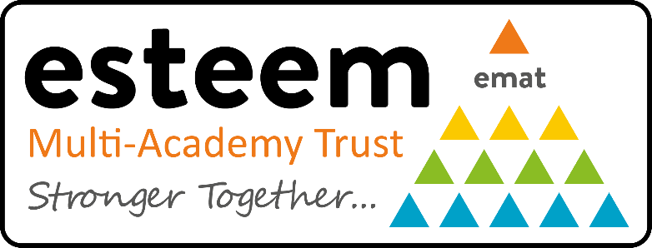

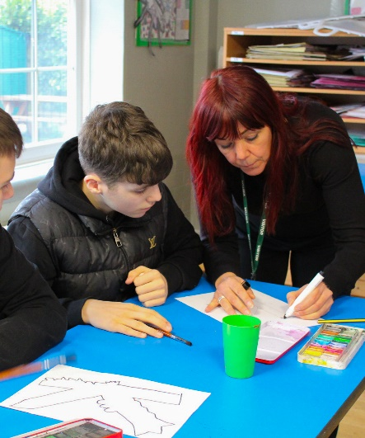
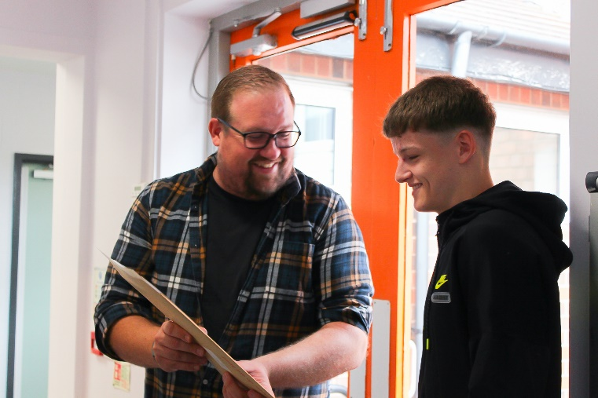





Application Support Pack
Welcome from The Headteacher

Dear Applicant,

We are an academy of 120 pupils, and we are continuing to grow. This gives the academy a close community atmosphere, where pupils feel safe and happy as they are supported and empowered to reach their full potential by a committed and dedicated staff team. We are proud of the fact that our academy is an amazing place, both to learn and to work.
Stanton Vale is an all-age academy with pupils joining from age two and potentially staying with us until they are nineteen. Pupils have a range of needs and abilities, and as such there are 5 curriculum Pathways and Avenues to meet their very individual needs.

We are a school designated to meet the needs of children with Severe Learning Difficulties (SLD). Previously, most pupils were recognised as having SLD, Profound and Multiple Learning Difficulties (PMLD) and very complex health needs.
There has been increased demand for places at the school since 2022 and many of these pupils are working at Pre-key Stage Standards and accessing the National Curriculum and we have an increasing number of pupils who are autistic. The school has responded to this demand by increasing capacity and re-designing the school curriculum and assessment systems which has had a positive impact on pupil engagement and progress.

Our staff team at Stanton Vale are resilient, dedicated and incredibly positive, celebrating every child and young person as an individual, always seeing the potential of every pupil and ensuring they reach that potential. Our staff team are aspirational and inspirational for themselves and for our pupils and their families.

We are a supportive community where everyone is valued and individuality is celebrated. Relationships between staff and pupils are extremely positive and a strength of the school. Relationships are fundamental to school life at Stanton Vale and it is through strong relationships with our pupils, their families and other agencies that we prepare our pupils for the transition into adulthood.

We have a talented staff team who have genuine ambition for the pupils they teach and for each other. Our governing body is supportive and challenging as well as being open to new ideas and fresh approaches.

Please see our website for more information about the school and how we work.
As well as making a positive contribution to the lives of our pupils, we can offer you:

- A supportive, collaborative and friendly staff environment where you will have the chance to make a real and positive impact on the lives of Stanton Vale pupils and their families.
- Professional and continuous training programmes and a supportive career progression
- Generous pension schemes (LPGS)
- A range of health and wellbeing services through Westfield Health
- Free, on-site car parking
- School social events
- A commitment to staff well-being

We welcome applications from candidates who, having read the application pack, feel they have the necessary skills, experience, and strength of character to fulfil the challenges of the role. Visits to the site are encouraged, please contact the school on0115 972 9769 to arrange this.

I wish you well in your application.

Yours faithfully,

Emma Kehoe
Headteacher
Stanton Vale School

About Stanton Vale School
Stanton Vale School is a vibrant all age special academy located in Long Eaton, working with students primarily from the south east of Derbyshire but also from Derby City, Nottinghamshire and Leicestershire. Our students’ complex needs can act as a barrier to effective learning. The academy has a strong reputation for multi-disciplinary work aimed at overcoming these challenges. We then build on this by focusing on what students can do.

Our most complex students benefit from a specialist sensory based approach and learn through an experiential curriculum. Our more able students spend time working on key skills of learning and, at an appropriate time, their curriculum may become more formal in line with their developing skills and understanding. For all our students, outcomes rooted in their Education Health Care Plan (EHCP) are the driver to their learning and individual curriculum. As with any special school, we ensure equality of opportunity for our students and work hard to provide a range of additional activities such as college visits, residential activities, community visits and enhanced provision in sports and especially the arts.

The academy also benefits from having a dedicated nurse on site as well as access to speech & language therapy, physiotherapy and occupational therapy. Strong links with parents and governors are fostered through a range of formal and informal events with the academy striving to be at the centre of its community.

The students benefit from access to a swimming pool on site as well as specialist teaching spaces such as a ‘soft mobility room’, library, adapted kitchens. Externally we have large grounds. Dedicated play spaces are complimented with an allotment, quiet area and an outdoor willow learning space. Students also spend time at The Long Eaton School as well as attending Central College as appropriate. The academy is a MOVE Centre of Excellence as the purpose of MOVE is to help children gain functional mobility.

Further information about our academy can be found on the website at:

https://www.stantonvale.co.uk/


Welcome from the Chief Executive Officer
Dear Applicant,

Thank you for your interest in joining Esteem Multi-Academy Trust.
You are considering Esteem at an important point in our journey.

Over recent years, the Trust has focused deliberately on strengthening its foundations.
- Clearer systems.
- Stronger processes.
- Greater consistency.
- A sharper strategic direction.

This work matters.
It allows our schools to focus on what matters most.
High-quality provision for children and young people with complex needs.
Support for the staff who work with them every day.

Esteem is a values-led organisation, but we are also ambitious and disciplined.
We are building a Trust that is:
- Strategically clear about what we exist to do
- Operationally strong and financially responsible
- Supportive of professional growth and collaboration
- Confident in its voice across SEND and Alternative Provision

We believe good systems should enable people, not constrain them.
We believe strong leadership is built on trust, clarity and accountability.
We believe improvement is sustained when people feel supported and challenged in equal measure.

If you join Esteem, you will be part of a Trust that is still evolving.
A Trust that reflects, learns and adapts.
A Trust that invests in its people and expects high standards in return.


We are always keen to hear from people who share our values, bring fresh thinking, and want to contribute to something purposeful and meaningful.

I wish you well in your application and thank you for taking the time to consider Esteem.

Kind Regards,

Karen Hayes
Chief Executive Officer
Esteem Multi-Academy Trust

About Esteem Multi-Academy Trust
Esteem Multi-Academy Trust was established in 2018 and now consists of fourteen academies across the East and West Midlands.
We are a specialist Trust with deep expertise in special educational needs, disabilities, and alternative provision. Many of our pupils have experienced disrupted education, disadvantage, or complex personal circumstances. We work relentlessly to ensure these young people receive the high-quality education, care, and opportunities they deserve.
Our purpose is simple: to improve life chances through strong schools, strong systems, and strong relationships.
We believe the best outcomes are achieved when high expectations sit alongside care, understanding, and inclusion. We combine ambition with realism and challenge with support.
Our vision is to be a Trust that:
- Delivers consistently strong education and personal development
- Builds confident, values-led leaders at every level
- Balances clear Trust-wide standards with local identity
- Acts as a respected voice for SEND and alternative provision
- Works in close partnership with families, communities, and local authorities
Our work is guided by five strategic aims: educational excellence and belonging; people development and wellbeing; community engagement and partnerships; operational efficiency and innovation; and sustainable growth.
Our values shape everything we do: working together, celebrating difference, being brave, and enjoying learning.
Our people are central to our success. We invest in professional development, collaboration, and leadership pathways, creating an environment where staff feel supported, trusted, and challenged to grow.
Each of our academies serves a unique community. Being part of Esteem provides stability, shared expertise, and collective strength, while preserving local character and purpose.
Through honest reflection, strong governance, and a commitment to continuous improvement, we work together to secure the best possible outcomes for every pupil.
Safeguarding and checks
Esteem Multi-Academy Trust is committed to safeguarding and promoting the welfare of all its students. We expect all staff, volunteers and agency staff to share this commitment. The successful candidate will be required to undertake a Disclosure and Barring Service (DBS) check. The possession of a criminal record will not necessarily prevent an applicant from obtaining this post, as all cases are judged individually according to the nature of the role and information provided. Esteem Multi-Academy Trust’s Safeguarding Policy applies to all adults, including volunteers and agency staff, working in or on behalf of the MAT.
Each student’s welfare is of paramount importance. We recognise that some children may be especially vulnerable to abuse e.g. those with special educational needs and disabilities, those living in adverse circumstances. We recognise that children who are abused or neglected may find it difficult to develop a sense of self-worth and to view the world positively. We recognise that some children who have experienced abuse may harm others. We will always take a considered and sensitive approach in order that we can support all students within our academies.
The MAT pays full regard to the DfE ‘Keeping Children Safe in Education
September 2025’ guidance. We ensure that all appropriate measures are applied in relation to everyone who works for the MAT who is likely to be perceived by the students as a safe and trustworthy adult including volunteers and agency staff. As part of our safer recruiting practises, we scrutinise applicants; verify their identity, academic or vocational qualifications, obtain professional and personal references, check full employment history and ensure the applicant’s health and physical capacity is suitable to undertake the role. Interviews and DBS checks are also undertaken.
This post is exempt from the Rehabilitation of Offenders Act 1974 and therefore all convictions, cautions and bind-overs, including those regarded as “spent” must be declared.If you are currently working with children, either paid or voluntary, your current employer will be asked about disciplinary offences, including those related to children or young people (whether disciplinary sanction is current or time-expired), and whether you have been the subject of any child protection allegations or concerns and, if so, the outcome of any investigation or disciplinary proceedings.If you are not currently working with children, but have done in the past, that previous employer will be asked about these issues. Where neither your current or previous employment has involved working with children or young people, your current employer will be asked about your suitability to work with children and young people, although it may be answered “not applicable”, where appropriate, if your work has not brought you in to contact with children or young people.
Application process and timeline
Applications are completed online via MyNewTerm via the Esteem MAT Website.
After the closing date, shortlisting will be conducted by a panel who will match your skills interview purely on your application form, so please ensure that you read the Job Description and Person Specification carefully before you complete your application form.
All candidates invited to the interview and assessment day must bring the following documents; original documents only, copies will not be accepted:
- Documentary evidence for your right to work in the UK
- Documentary evidence of identity which meets the DBS requirements i.e. current photocard driving licence including a photograph and/or a passport and/or a full birth certificate
- Documentary proof of current name and address i.e. utility bill, financial statement etc.
- Where appropriate, documentation evidencing a name change
- Educational or professional qualifications that are essential or necessary for relevant for the post
Further information relating to DBS check documentation requirements can be found on the Government website at https://www.gov.uk/guidance/documents-the-applicant-must-provide.
If you are not the successful candidate, all your personal information will be destroyed, in a secure way, in line with General Data Protection Regulations (GDPR May 2018) guidelines.
References will be sought for shortlisted candidates for and we may approach previous employers for information to verify experience or qualifications prior to interview. Any relevant issues arising from references will be discussed at interview.
Your completed application form and supporting letter should address and evidence the essential and desired criteria in the Person Specification.

