








The CAM Academy Trust
Maths Hub Administration & Communications Officer
Candidate information pack

WELCOME FROM
THE CHIEF EXECUTIVE

Thank you for your interest in joining The CAM Academy Trust. It’s a great time to join our team, as we enter an exciting phase of development and look to the future.

I feel highly privileged to lead our trust at this time. Our five year strategy – CAM30 – sets out our roadmap to becoming a truly exceptional family of schools.

We are a values-driven trust – our six principles underpin all that we do – and
we’re committed to excellence. As a teacher myself, and someone who has benefited hugely from an education, I absolutely believe in the transformational power of what we do in schools. This is particularly important for our most vulnerable young people, those who could become marginalised and not reach their potential due to their background or learning needs. It is up to us to make sure that doesn’t happen.

Vibrant learning communities are built when pupils of all abilities and backgrounds thrive together, and a truly excellent education enables choice and agency for all children. This is at the heart of our comprehensive principle.

We want people on our team who are excited by the prospect of having a deep and lasting impact on the lives of young people. We want people who are honest, curious, intellectually rigorous and committed to the challenges and opportunities of innovation and collaboration. We also want people who are committed to contributing to the wider education system.

As Chief Executive, I am committed to raising standards for young people, in a sustainable way through a strong MAT operating model and an insistence on excellence whilst understanding that schools need to retain their unique identity so they can be at the heart of their communities. I also know that investing in all our people is critical to success. It is our leaders, teachers and school staff that make the difference for children every day.

Join our team and we will work together to deliver ‘excellence for all’, enabling all pupils and staff to thrive and be successful. If this excites you; we want to hear from you!

Claire Heald

ABOUT US
The CAM Academy Trust was established in 2011 and currently comprises twelve primary schools and five secondary schools, four of which include sixth forms. In January 2026, ACES Academies Trust - a Huntingdon-based multi-academy trust - merged with CAM, adding five additional schools to our family.

Our primary schools are Cromwell Academy, Everton Heath Primary School (just inside Bedfordshire), Gamlingay Village Primary, Godmanchester Bridge Academy, Godmanchester Community Academy, Jeavons Wood Primary School, Offord Primary School, Hartford Infant and Pre-School, Hartford Junior School, Harston and Newton Primary School, Spaldwick Primary School and Thongsley Fields Primary and Nursery School. Bourn Primary Academy joined as the first Associate Member in 2021.

Our secondary schools are: Comberton Village College (and Sixth Form), Cambourne Village College (and Sixth Form), Hinchingbrooke School, Melbourn Village College and St Peter’s School (and Sixth Form).
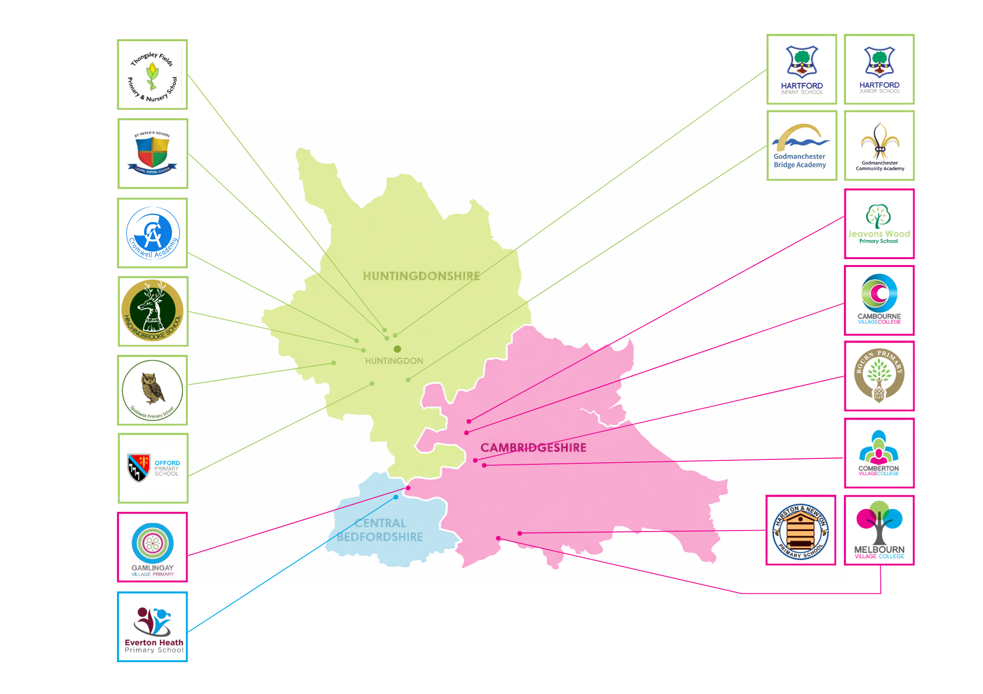


ABOUT US
Continued

Teacher training (CTSN)

The CAM Academy Trust supports the training of new teachers to become qualified members of the teaching profession. We do this through our SCITT (CTSN).

As a school-based provider of initial teacher training, CTSN SCITT is very much grounded in the life of its local schools and its tutors are experienced practising teachers drawn from, not only CAM Academy Trust schools, but also a wide network of schools across the region.

Our SCITT has a strong regional reputation.

Maths Hub

The CAM Academy Trust is proud to be the base for the Cambridge Maths Hub which is promoting excellence in maths teaching across Cambridgeshire, as well as Peterborough, West Suffolk, King’s Lynn and West Norfolk.

The Hub supports teachers to improve educational standards for students in our region from the youngest child in Early Years to Post-16.

The Cambridge Maths Hub offers free, high-quality professional development to maths teachers across the Hub area.

The Cabins

Our Cabin provisions are attached to four of our schools. The Cabins provide autistic students with an opportunity to be educated in mainstream settings.

We set high expectations for students but provide expert support from highly skilled and caring staff.

All our cabins strive to ensure that every pupil attains the highest possible academic achievement and offer high levels of pastoral support.

THE VACANCY
Salary: NJC Scale 3, points 5 to 6 (£25,583 to £25,989 per annum FTE). Actual salary £8,775.87 per annum.

Contract: Permanent, 15 hours per week - Monday to Friday – Term time plus 2 training days in September and October (38.4 weeks per year).

Start date: As soon as possible

Place of work: Cambourne Village College, Cambourne

The Cambridge Maths Hub is working to improve the quality of mathematics teaching in Cambridgeshire, West Suffolk, King’s Lynn and West Norfolk. With an excellent team of teachers, we are making a real difference to the 500+ schools across the county and beyond.

Due to rapid growth, we are now looking to appoint an Administrator & Communications Officer to work with our Project Manager to ensure the smooth and effective running of the Hub. This position is for 15 hours per week, term time only, based at Cambourne Village College. Daily hours of work will be subject to discussion at the point of interview, but the hours can be flexible.

The successful applicant will become part of an efficient administrative team that seeks to support work across the region. We are looking for a committed, flexible and reliable person with good administrative experience. Your interpersonal skills will be excellent, you must be highly organised and comfortable working at pace and meeting deadlines.

The Cambridge Maths Hub is one of a national network of 40 Maths Hubs funded by the DfE through the National Centre for the Excellence in Teaching of Mathematics.

For further details on the Maths Hub and Cambourne Village College, please visit the websites - Home | CambridgeMathsHub and Homepage - Cambourne Village College

HOW TO APPLY

To apply for this position, please submit your completed application form with supporting statement on MyNewTerm.

Your supporting statement should demonstrate how your career to date has prepared you for this post and be no longer than two sides of A4.

Applications will only be accepted from applicants completing the application form in full. Please note that we do not accept CVs.

Interviews will be offered to those applicants who best demonstrate how their skills, abilities and experience meet the person specification, taking into consideration the job description.

We reserve the right to interview and appoint within the application window. With this in mind, we encourage you to apply as soon as possible.

If you have any questions about this role, please contact Parul Burman, Maths Hub Project Manager on pburman@cambournevc.org .

Closing date: 09.00 on Thursday 20th August 2026

Thank you for your interest in The CAM Academy Trust.

JOB DESCRIPTION

Salary:
NJC Scale 3, points 5 to 6 (£25,583 to £25,989 per annum FTE). Actual salary £8,775.87 per annum.

Line of responsibility:
The administrator will be directly responsible to the Cambridge Maths Hub Project Manager

Strategic purpose:
To provide direct administrative support to the Cambridge Maths Hub team. To perform other relevant tasks as required to support the day to day running of the Maths Hub.

In addition to the responsibilities described above, to carry out any other duties of a similar nature at the reasonable request of the central education team.

The job description will be subject to regular review and any changes will be made in consultation with the post holders. The aim will always be to reach agreement on any changes, but if agreement is not possible, the trust reserves the right to make the changes following consultation.

Six core principles

At the heart of our work lie the six core principles of The Cam Academy Trust. These drive everything that we do.

 | EXCELLENCE
 | We insist on the very best. This means setting out a clear entitlement to excellence for all our young people. For us, excellence comes from the highest standards of curriculum, teaching and pupil support. We adopt a mindset that keeps us striving for better.
 | COMPREHENSIVE EDUCATION
 | We are proud to educate pupils of all abilities, backgrounds and needs. Inclusive schools are vibrant communities, that are richer for their diversity. We value fairness and social equity.
 | BROAD EDUCATION
 | Our pupil entitlement offers more than just academic success. A broad education develops confidence, creativity and character. The wider experiences and opportunities offered in our schools mean that our pupils have more choice and agency.
 | COMMUNITY
 | We prioritise our civic duty. Our schools are at the heart of their local communities. We draw on the best that our local area has to offer and work with community leaders to help our schools thrive.
 | PARTNERSHIP
 | Together we achieve more than we can alone. We deeply value the partnerships we have with our families. CAM plays an active role in our communities, our region and the wider education system. We share, and build connections to help make the system better.
 | INTERNATIONAL
 | We think beyond borders; we value diversity. We prepare pupils to thrive in a global society, promoting cultural understanding and awareness of the wider world.

The CAM Academy Trust is committed to safeguarding and promoting the welfare of children and young people and expects all staff and volunteers to share this commitment. Successful candidates will be subject to an enhanced DBS check, barred list check and a medical questionnaire
JOB DESCRIPTION continued

Key Responsibilities | - Build and maintain positive working relationships with colleagues, suppliers, contractors and external professionals  - Liaise with Work Group Leads regarding IT, printing and general administrative requests  - Prepare promotional materials, including flyers and digital content, for Maths Hub programmes  - Set up and manage Basecamp groups and attendance registers  - Maintain accurate data entry on the Maths Hub Programme Online Database (MHPOD)  - Organise hospitality, catering and room bookings for meetings, training events and conferences  - Update and manage the Microsoft Calendar with all Maths Hub events  - Act as front of house for training events and conferences, welcoming delegates and providing support  - Undertake general administrative duties, including photocopying and filing  - Update and maintain the Cambridge Maths Hub website  - Manage and update social media platforms to promote Maths Hub activity  - Prepare evaluation spreadsheets and reports based on participant feedback  - Take accurate minutes of team meetings  - Assist in organising conferences and meetings.  - Participate in the national Maths Hubs network, including webinars and online forums
Personal development | - Maintain excellent subject expertise and awareness of the latest, evidence informed practice  - Engage in regular professional learning and reading.  - Engage positively in the Trust’s arrangement for performance management and professional growth.
Safeguarding | - Adhere to Trust safeguarding policy and procedure at all times.  - Promote strong cultures of safeguarding across the Trust and schools.  - Responsible for the safeguarding of students who are under their immediate care, following relevant school policies, reporting concerns promptly (including Health and Safety).  - Safeguarding the mental health and wellbeing of students and staff
Advocacy and influence | - Be an advocate for the Trust externally and across our schools.  - Be outwards facing and see opportunities for positive influence and external partnership and networking.

The CAM Academy Trust is committed to safeguarding and promoting the welfare of all children and young people. We expect all staff to actively share this commitment. All adults working in our Trust in whatever capacity will be part of a thorough safer recruitment process. All appointments will be subject pre-employment checks including the taking of satisfactory references and enhanced criminal record clearance (via the Disclosure and Barring Service) in line with the need to create and maintain a safe culture.

PERSON SPECIFICATION

CRITERIA | ESSENTIAL | DESIRABLE
Qualifications and Experience
Good basic education to GCSE level (C and above) in English and Maths, or the equivalent | X
Experience of liaising with professional colleagues | X
Experience of working in a school or similar educational setting |  | X
First Aid qualification or willingness to undertake training |  | X
Marketing or communications experience |  | X
Experience updating databases and websites |  | X
Experience liaising with national or regional bodies such as the NCETM |  | X
Experience keeping records of engagement, attendance and impact |  | X
Knowledge and Interpersonal Skills
Proficient in Microsoft Office, including Outlook, Word and Excel | X
Strong organisational skills with the ability to plan, book and evaluate events | X
Experience organising events, including venue booking, hospitality and guest coordination | X
Ability to manage room bookings, refreshments and special requirements | X
Ability to send reminders and manage event communications | X
Experience preparing documents and materials for meetings and events | X
Ability to communicate clearly and professionally with a wide range of stakeholders, including administrative staff, teachers, headteachers and external organisations | X
Confident providing front-of-house support at events and conferences | X
Ability to promote Maths Hub activity effectively | X
Experience creating flyers and publicity materials using Canva and Publisher. | X
Strong social media knowledge and experience | X
Strong administrative skills and attention to detail | X
Ability to work collaboratively with the Maths Hub team and respond efficiently to queries | X
BENEFITS

We offer the following benefits, designed to promote your wellbeing and make your time with The CAM Academy Trust satisfying and rewarding.

Core benefits
- Paid leave – enhanced sick pay, maternity pay, and adoption leave pay (linked to service) and paid leave for unforeseen personal situations.
- Pension – a generous pension scheme.
- Death in service payment – lump sum payment and an ongoing pension for your partner & children (subject to conditions & membership of our pension scheme).

Health and wellbeing
- Employee counselling and support – free, independent 24/7 help and advice for work related issues, as well as problems affecting your home life.
- Environment – good working environment with excellent facilities.
Professional development
- Professional development – full and part-funded training courses and a wide range of learning opportunities available to all staff.
Employee discounts
- Car parking – free and on-site.
- Hot drinks – tea & coffee making facilities provided.
- Cycle-to-work scheme – save £££ on a new bike and accessories.

Work-life balance
- Flexible working – all staff can make a request to work flexibly.


The CAM Academy Trust
Head Office | Cambourne Village College
Sheepfold Lane| Cambourne | CB23 6FR
info@catrust.co.uk
www.catrust.co.uk

