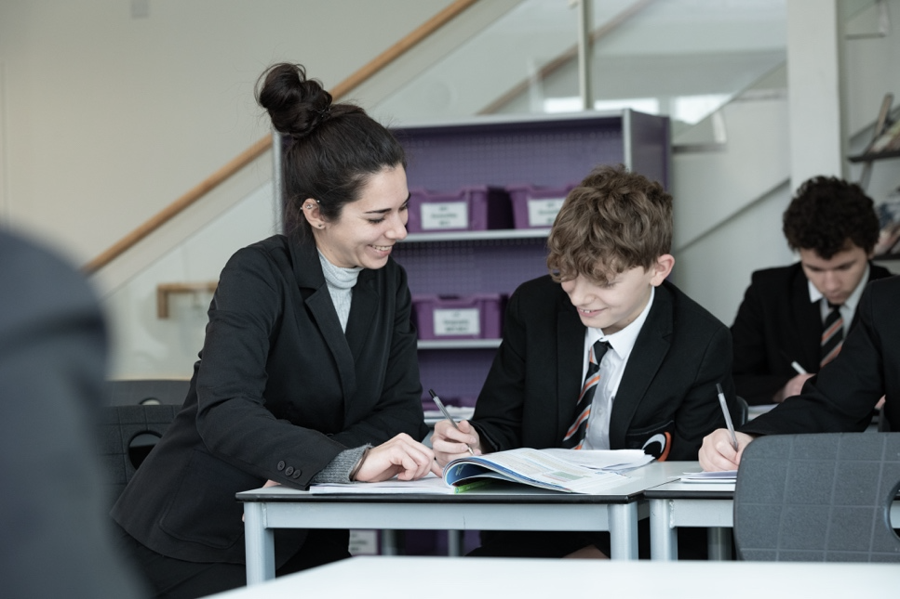
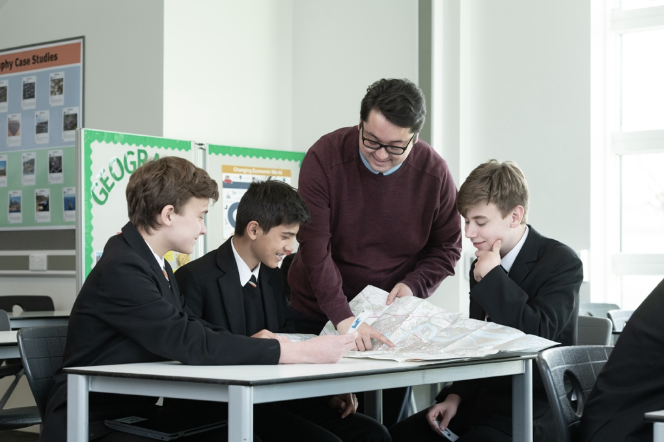



Media

At Northfleet Technology College, our Media Team nurtures creative skill an imagination through exploring concepts, techniques and processes to collaboratively and independently communicate ideas. NTC students develop independence, are persistent in their efforts and encouraged to take creative risks without fear of failure.
Our Faculty gives an exciting opportunity for staff to develop their subject knowledge and teaching pedagogy within a secure and supportive team. We want you to share with our students your skills and knowledge to create a secure and focused learning environment. At NTC, we focus on developing our learners to be independent, resourceful learners, and to develop their personal skills and attributes to be valued members of the local and wider community.
A new eSports Academy pathway at Sixth Form is being lunched from September 2025 and this is a great opportunity to become involved in developing the programme.
Media allows students to be curious about different media sectors, developing an understanding through being creative and producing their own media. They can also understand how digital products are constructed and how the representations of people are presented and interpreted by different audiences.
Media Studies covers a broad range of topics from TV and film, radio and advertising and even computer games. Media Studies gives a great opportunity to academically discover the key issues relating to the Media, as well as, discuss current trends and issues within the different sectors of the industry.
Students are taught in mixed ability groups and work is differentiated to reflect the wide range of abilities and capabilities among our students. During lessons, students will gain subject knowledge and skills by investigating and responding to an authentic, engaging, and complex question, problem, or practical challenge.
At Key Stage 4 Media Studies is taught as a BTEC and over the course of two years Students study interrelated units of work which gives a broad understanding of the Media industry. These include units such as Research and Understanding the Media Industry, Animation Planning and Techniques, Audio Production, Magazine Publishing Production, Advertising Production for Television.
We have excellent facilities and a wealth of resources that are available for use in lessons. We are a Voice 21 school and encourage debating and ‘learning outside the box’ to enable our students to follow our ethos of Curious, Creative and Caring learners.
Our staff are highly dedicated and creative group where team work is paramount to our ethos. This is an excellent opportunity for an individual, who is as passionate about Art and Media as we are, to join a supportive, friendly and committed team, dedicated to achieving the highest possible standards in both ourselves and our students.

