


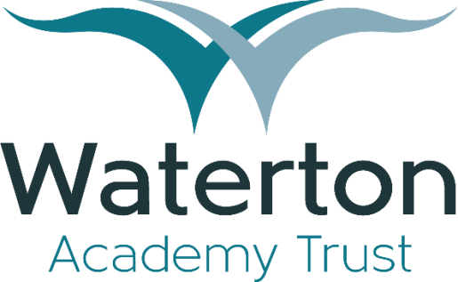

Employee Benefits Guide
Where success is a shared experience









Our Vision
At the core of our Trust is a deeply held belief in the value and potential of every child we educate and every member of our team. We understand that our success, and the success of those we serve, hinges on the well-being, satisfaction, and growth of our employees. That’s why we’ve taken great care to design an Employee Benefits Package that goes beyond the basics, aiming to support you not just in your professional life, but in your personal endeavours as well.
This booklet is your comprehensive guide to understanding the wide array of benefits you are entitled to as a valued member of our team. From health and wellness programs to retirement plans, and from flexible working arrangements to professional development opportunities, we’ve compiled everything you need to know to make the most of your time with the trust.
We encourage you to read through this booklet carefully and to reach out to our Human Resources team with any questions or for further clarification. Remember, these benefits are here for you — to support your journey with us, to help you grow, and to ensure that you feel valued and supported every step of the way.
Welcome aboard, and here’s to a rewarding experience with us!

Warm regards,

Dave Dickinson OBE Chief Executive Officer

Employee Assistance Programme

The importance of looking after our employees within Waterton cannot be overstated. We understand the pressures you face daily, and that's why as a trust we provide access to a range of support through the Schools Advisory Service (SAS) where you can access free and confidential Wellbeing Services
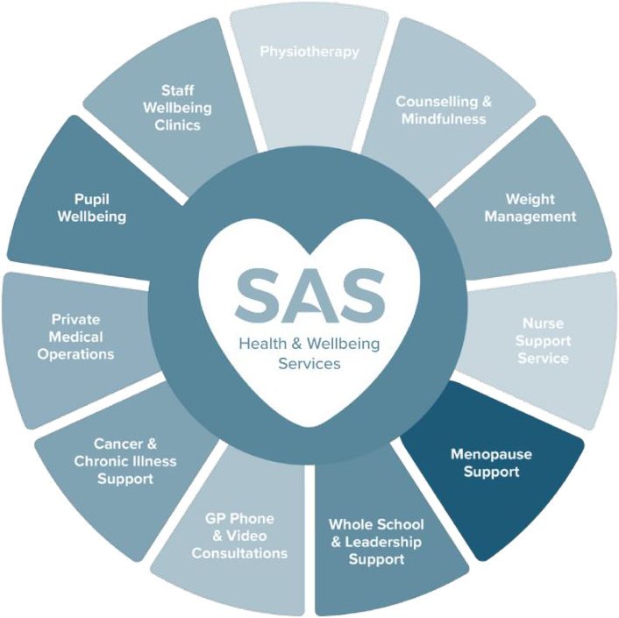
To access the services, Waterton staff can call SAS registered nursing staff on 01773 814403, email nurse@uk-sas.co.uk or download the free Wellbeing App now at schooladvice.co.uk or via the Apple & Android store. The app details services available and provides a point of contact.

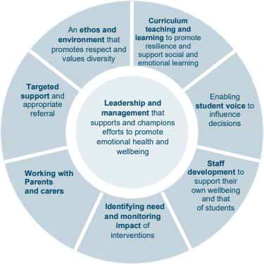
Wellbeing Charter

Recognising the critical importance of well-being in fostering a positive and productive working environment, we have taken a pioneering step by creating a Wellbeing Charter for our schools, based on the 8 principles of a whole school approach to wellbeing published by Public Health.
This charter serves as a cornerstone of our commitment to nurturing the physical, emotional, and mental health of our entire educational community. It outlines clear principles and practices aimed at promoting a healthy work-life balance and creating a supportive and
inclusive culture. Eight principles to promoting a whole school or college approach to mental health and wellbeing











Wellbeing Charter
Key aspects include:
A dedication from the Trust's leadership to champion mental health and wellbeing, including the appointment of a senior mental health lead in each school and team, and a Wellbeing Network for the trust.
An emphasis on creating respectful and diverse environments that value each individual, promoting a sense of belonging and reducing work-related stress.
Encouraging staff voice in decision-making processes to enhance a
sense of community belonging and feeling valued.
Commitment to staff wellbeing through mental health awareness training, access to a comprehensive SAS package, lifestyle health screening and counselling services
Focus on prevention, early identification, and targeted support for mental health needs, including collaboration with Mental Health Support Teams and external agencies for specialist support.




Occupational
Health Services
Recognising the importance of both physical and mental health for all our employees, we offer the opportunity for our employees to access advise and support from occupational health.
This dedicated team of health professionals are committed to providing expert advice, support, and interventions to promote a healthy, safe, and productive work environment. Whether you're looking to address specific health concerns, seeking preventative care, or require assistance navigating health-related workplace challenges, our Occupational Health Service is here to support you every step of the way.

Flexible Working
Our Trust is committed to fostering a supportive and flexible work environment that adapts to the diverse needs of our employees, enhancing our inclusive workplace culture.
This initiative allows for a variety of flexible working options, including but not limited to job sharing, part-time hours, compressed hours, hybrid working, home working and phased retirement. We encourage employees interested in flexible working to discuss this further with their line manager to ensure appropriate consideration is given to requests that align with both personal needs and service delivery requirements.
By integrating flexible working into our trust's operations, we aim not only to support our employees' well-being, but also to maintain high standards of educational excellence and operational effectiveness.

Pensions Schemes
Waterton Academy Trust are members of both the Teachers’ Pension and Local Government Pension Schemes, which ensures our staff have access to those schemes and the various benefits provided by each.


A Local Government Pension Scheme gives you:
- Secure benefits – the scheme provides you with a future income, independent of share prices and stock market fluctuations.
- At a low cost to you – with tax-efficient savings.
- And your employer pays in too – the scheme is provided by your employer who meets the balance of the cost of providing your benefits in the LGPS.
What kind of scheme is it?
The LGPS is a tax approved, defined benefit occupational pension scheme. The LGPS meets the government’s standards under the automatic enrolment provisions of the Pensions Act 2008. The amount of pension you earn in a scheme year is worked out each year and added to your pension account. The total amount of pension in your pension account is revalued at the end of each scheme year so your pension keeps up with the cost of living. The LGPS is very secure because the benefits are set out in law.

A Teachers’ Pension gives you:
- An income for your retirement, and you can even take part of your pension as a tax free lump sum when you retire.
- A great way to save for your future and also pay a little less tax every month, as you’re taxed on your salary after your pension contribution has been taken.
- Benefits that are for you and your loved ones. It doesn’t belong to your employer and it doesn’t belong to the government.
As long as you’re in eligible employment your pension stays with you, wherever you go throughout your teaching career.
The Teachers’ Pension Scheme is a Defined Benefit Scheme based on your annual pensionable earnings, re-valued each year, rather than a scheme reliant on how investments perform, so you can see what pension benefits you’ve built up and can work out how much pension you’ll receive at your chosen retirement date.

Additional Support

Cycle to Work Scheme

Our Trust Employee Benefits Package includes an innovative Cycle to Work Scheme, designed to support and encourage our team members in adopting a healthier, more sustainable mode of transportation. This program allows employees to purchase bicycles and
cycling equipment at a significantly reduced cost, facilitating an eco-friendly commute to work. By taking advantage of this scheme, employees can not only improve their physical health through regular exercise but also contribute to reducing traffic congestion and environmental pollution. This initiative is part of our commitment to promoting wellness and sustainability within our community, offering a practical solution for employees to enhance their daily commute while supporting their overall well-being.




We are excited to offer a forward-thinking Salary Sacrifice Scheme for Electric Vehicles, in partnership with Octopus Electric Vehicles. This innovative program empowers our employees to drive cleaner, more sustainable vehicles by sacrificing a portion of their pre- tax salary in exchange for a brand-new electric car. This arrangement not only provides significant savings on tax and National Insurance contributions but also supports our commitment to environmental stewardship. By participating in this scheme, employees can enjoy the benefits of driving a state-of-the-art electric vehicle at a reduced cost, contributing to a greener planet while also experiencing the latest in automotive technology and efficiency. This offering reflects our dedication to providing valuable, environmentally conscious benefits that meet the needs of our employees and our planet. Terms and conditions will apply.

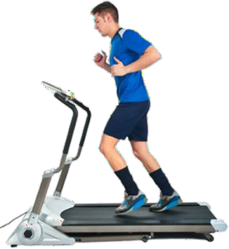
Discounted Gym Membership
In 2024-25 we are hoping to provide a discounted gym memberships in both Wakefield and Barnsley. Understanding the importance of physical fitness and its positive impact on mental health, we are actively working towards partnerships with local gyms to secure exclusive, cost-effective memberships for our team members.

