About the role:
We are looking to appoint a Cover Supervisor who is ready to play a key role in our school community. You will be instrumental in ensuring that our students continue to receive quality education and maintaining the continuity of education in the absence of their regular teachers. You will be responsible for managing the classrooms, supporting students, and uphold our school's high standards of behaviour and learning.

We are looking for someone who can:

· Supervise classes during the short-term absence of teachers
· Manage the behaviour of students to ensure a constructive learning environment
· Support students with tasks and activities set by the teacher
· Ensure the classroom is left tidy and ready for the next lesson
· Liaise with teaching staff and provide feedback on lessons covered

APPLICATION DEADLINE – Thursday 30 April 2026 at 8am

Why Blessed William Howard?

- A Christian community with a caring, secure and
disciplined environment.
- A wide range of extra-curricular activities.
- High academic standards.
- A commitment to success for all.
- Ongoing CPD for all staff.

“There is a warm atmosphere and the quality of relationships between all members of the school community are a particular strength. Pupils and staff are friendly, helpful, polite and welcoming to visitors.” Diocesan Section 48 Report

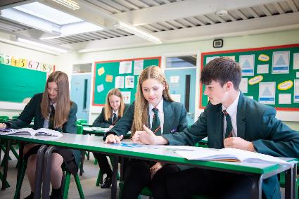
Further details and application forms can be accessed via My New Term https://mynewterm.com/ This school is committed to safeguarding and promoting the welfare of children and young people/vulnerable adults and expects all staff and volunteers to share this commitment. This position is subject to appropriate vetting procedures including a criminal record check from the Disclosure and Barring Service (formerly CRB), which will require you to disclose details of all unspent and unfiltered spent reprimands, formal warnings, cautions and convictions as part of the recruitment process.

Blessed William Howard is proud to part of the St Gabriel the Archangel Catholic MAT, A company limited by guarantee registered in England & Wales with company number 08146661. Registered Office Address: Station Road, Cheadle, Staffordshire ST10 1LH. Telephone: 01538 493777 Web: www.bwh.staffs.sch.uk
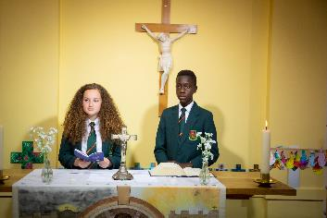
Cover Supervisor
Grade 5
Permanent full-time or part-time position
Blessed William Howard
Catholic High School, Stafford ST17 9AB
Part of the St Gabriel the Archangel Catholic
Multi – Academy Trust

Are you looking for a new opportunity in an innovative and supportive 11-18 Catholic school? Now part of the St Gabriel the Archangel Catholic Multi – Academy Trust, the largest multi-academy in the Archdiocese of Birmingham. Blessed William Howard is looking to recruit dynamic, forward-thinking and inspirational staff to join us on our journey to success. With a strong Catholic ethos that puts ‘love’ at the heart of its community, the school provides a haven where all can flourish. Situated just outside the town centre and easily accessed by train, bus or the M6, Blessed William Howard is proud of its strong community links and its beautiful grounds.

