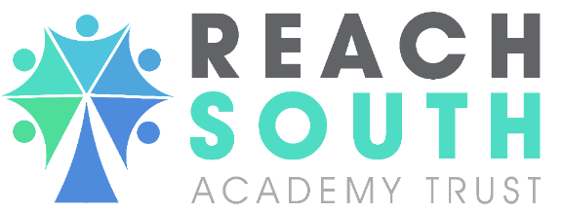

Candidate Pack
For the vacancy of
EYFS/Key Stage 1 Autism/ SEND Teacher

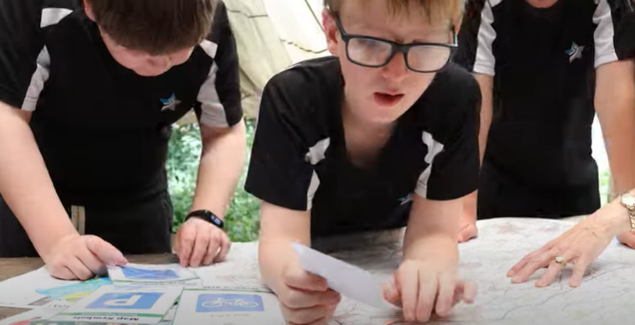


at
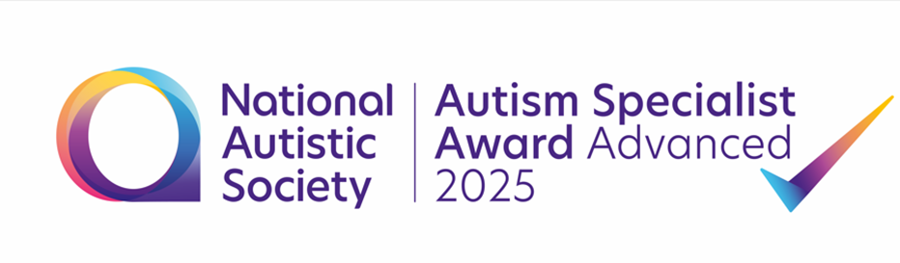


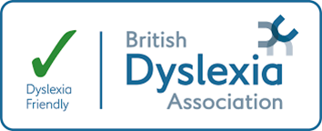

Letter from the Headteacher of The Springfields Academy:
Dear Candidate,

Thank you for taking the time to consider applying for the role of EYFS/Key Stage 1 Autism/SEND Teacher at The Springfields Academy. Being an Autism/SEND Teacher at Springfields is a privileged opportunity as it is an innovative and inspirational place where both children and staff can learn, grow, and develop.
Our talented, multi-disciplinary team work together to ensure all our pupils achieve aspirational outcomes to live a ‘safe, independent life’ beyond Springfields through support, understanding and enablement. Our educational approach is child - centred, we value each pupil’s uniqueness and view each pupil as an individual within our community. We remove barriers to learning and social interaction so that each child can achieve their potential. Our therapy first culture is integral to giving each individual the best foundation for learning and development. We are proud to have our own in-house Therapy Team and bespoke Therapy facilities allowing us to offer a range of therapeutic interventions to meet a range of needs.
Our strength is the diversity of provision we offer, ensuring pupils access the right autism and communication friendly environment to enable them to thrive. Our curriculum pathways are specifically structured and sequenced to ensure pupils have the knowledge and skills they need to know more, remember more and apply this functionally to achieve both academically and, more importantly, to enable them to lead a ‘safe, independent life’ when they leave us.
We are proud to have achieved the National Autistic Society ‘Advanced Specialist Award’ for the second time in June 2025 and be accredited as a Dyslexia Friendly School with the Dyslexia Association.
This is an exciting time to join Springfields as we have grown to provide provision for 250 + pupils. To accommodate this growth we have renovated a new classroom block, have new classrooms spaces being developed for September 2025 and have developed outdoor learning spaces to complement our already well-resourced site.

We are SEND system leaders who contribute to the wider SEND system through our successful ‘Springfields Autism Support’ outreach service supporting a number of schools and organisations within Wiltshire, surrounding areas and Reach South. We are proud to be the home of A-Fest, a festival celebrating autism which has just successfully entered its 7th year and host regular Neurodiversity networks in addition to our high-quality professional development offer.
You would be joining a friendly and child -centred team who are passionate about providing high quality SEND education for our autistic community. You would be part of a highly skilled and knowledgeable staff team who make a difference in the lives of our pupils every day. We know that if we invest in our staff they will be the best practitioners for our pupils therefore we devote significant resource into professional learning opportunities and staff wellbeing. We have recently been accredited the Creative Education ‘Staff Wellbeing Award’ demonstrating our commitment to supporting our team.
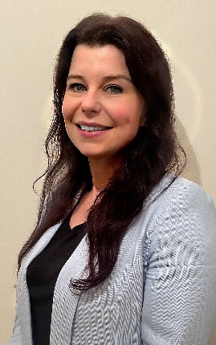
The information in this candidate pack can only give you a glimpse of what life at Springfields is like. I invite you to come and visit us and experience Springfields for yourself!



Nicola Whitcombe
Headteacher
The Springfields Academy

Who we are and what drives us

Reach South is a young and developing Trust which operates across the South West of England with the aim of delivering all through 3-19 education. We operate 21 academies in Devon, Dorset, Gloucestershire and Wiltshire. We are building this Trust on a clear set of values, behaviours and curriculum principles. At the heart of those values and principles is a belief in our young people and a determination to support them to develop the knowledge, skills and attitudes to become the successful citizens for today and all of their tomorrows.

Our core business is delivering exceptional education for children and young people with a mission to help all pupils aspire to achieve beyond the expectations that others put on them. We do this through the development of a talented and committed workforce. In order to deliver exceptional opportunities for learning, we need highly motivated staff across all parts of the organisation.

Teachers within Reach South belong to a national community of professionals, and benefit from a wide range of networks and development opportunities across the Trust. In time, our best teachers are able to work across schools, develop specialisms and step up to leadership roles within and beyond their own academy. The Trust provides a strong culture of collaboration and support, together with high expectations for staff and pupils alike.

Those we recruit are able to demonstrate that they share our values, are highly motivated to work with colleagues, within and beyond their school, to continuously develop their skills and pursue professional excellence.

Equal Opportunities and Safeguarding our Children

Reach Academy South is an equal opportunity employer. We are committed to creating an inclusive work environment for all employees and actively encourage applications from all parts of the community. We are working hard to create a dynamic and inclusive environment and it’s important to us that our people come from a variety of different backgrounds. As part of this we are committed to ensuring that there is no discrimination on the grounds of age, disability, gender reassignment, marriage/civil partnership, pregnancy, maternity, race, religion or belief, sex or sexual orientation at any stage of the recruitment process or in the terms and conditions offered to new employees or promoted employees.

We are committed to safeguarding and promoting the welfare of children and young people and expect all staff and volunteers to share this commitment. Each post is subject to an enhanced DBS check.

We’re proud of how we support our staff seeking to achieve high levels of job satisfaction for our workforce and are aware of the contribution our staff make for the children and families we deliver for and the contribution they make towards our community.


About the School:

The Springfields Academy is specialist academy for 250 + pupils aged 4-19 who have a diagnosis of autism and/or present with a speech, language and communication need. Over recent years the school has substantially grown in response to Wiltshire need and now offers high quality research based education to its population.

The Springfields Academy builds safe, independent lives through support, understanding and enablement for our autistic population. To achieve this goal, we look at the unique impact autism has on the individual child and as a result, personalise the child’s curriculum, care and therapeutic package to ensure every child achieves and experiences success and independence. This model is based on personalisation and innovation, and we pride ourselves on approach to meeting the presenting needs of all pupils.

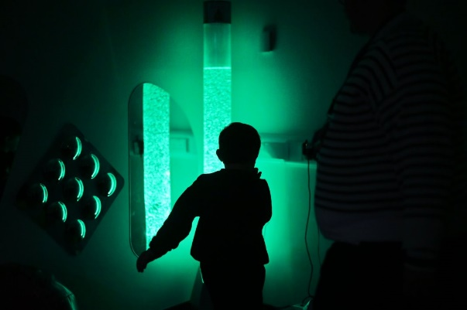
We are proud to be recognised as an Ofsted ‘Good’ school that holds the NAS Advanced Specialist Award. We have a clear strategic vision of becoming a ‘centre and system of excellence’ for autism and are two years through a four-year plan to achieve this.

What is the Springfields Therapy Offer?

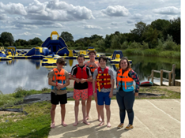
Our Therapy first culture lays the foundation lays the foundation for all our pupils to learn. Our Therapy Team implement our tiers of therapeutic support in Occupational Therapy, Speech and Language and Wellbeing. They detail our whole school and class approaches, group and individual therapy.

What is the curriculum offer?

At Springfields we have two clear curriculum pathways. When pupils join us in Reception we assess which
Curriculum pathway they will access from year 1.

• Discovery Curriculum – semi-formal Pathway. A Semi-Formal Curriculum Pathway is a sensory and developmental curriculum, aimed at learners that are in the very early stages of learning and development. Discovery learners work consistently below the National Curriculum, with aspiration to work towards end of Key Stage 1 expectations by the end of Key Stage 4.

• Explorer/Pathfinder Curriculum – following a formal curriculum pathway that makes reference to the National Curriculum. This Pathway is aimed at learners that are able to work within the levels of the national curriculum and Early Years Foundation Stage Framework. However, our curriculum is structured to bespoke curriculum journeys towards aspirational outcomes tailored for our pupils.

What Autism Enablement approaches are in place?
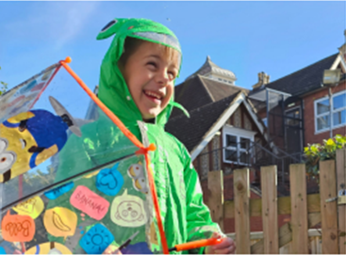
Springfields' approach to autism enablement is based on the social model of support, removing barriers to enable our learners to thrive. Pupils benefit from an autism friendly environment and sensory support strategies where the TEACCH principles are embedded throughout our environment at whole school, class and individual level (as required).

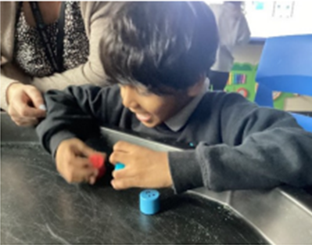
Our learning approach ensures that pupils have the opportunity to retrieve/recap information, develop key vocabulary and learn key concepts in a variety of ways using our 8 Steps to Lesson Success Model. As well as experiencing a Total Communication Environment, specific speech and language approaches are embedded into our teaching such as Attention Autism, shape coding, word aware, sensory stories, task cards and graphical organisers. In addition, our Discovery learners benefit from Intensive Interaction, Identiplay, PECs, Communication boards and aids and follow a communication curriculum.

How is Springfields structured?

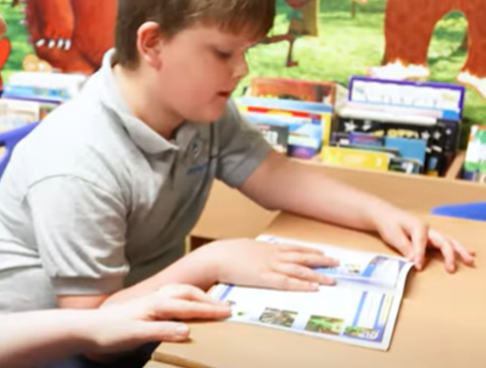
When pupils join us in Reception access a bespoke early years environment where we can gain a greater understanding of their academic and communication profile before they move onto a semi – formal or formal curriculum pathway.

Primary and Secondary pupils up to Year 8 benefit from a ‘core class’ approach with consistent staff Pupils in Year 9/10 benefit from a ‘core class’ approach, with limited transitions to their chosen Pathway. We find this approach helps pupils to have a sense of belonging and reduces transitions, which may cause anxiety. Pupils in Year 10/11 can access a subject specific class
having built up the self-reliance skills. In order to transition and
organise themselves during their Springfields journey.

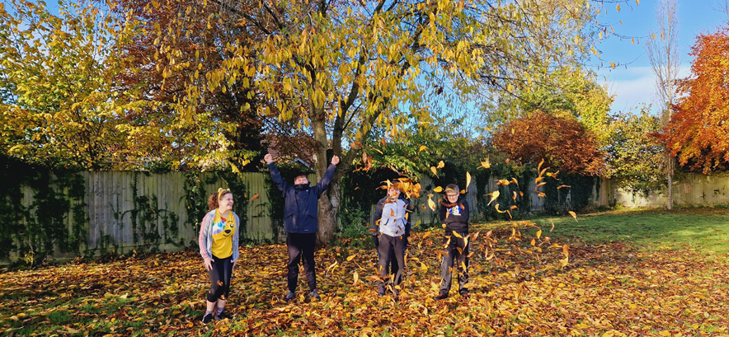

How are pupils prepared for adulthood?

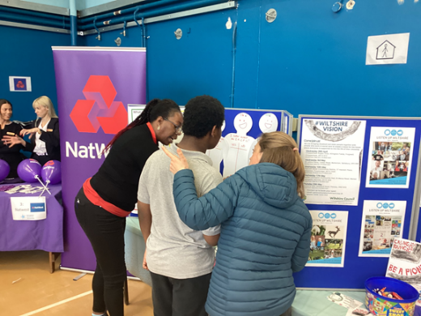
We appreciate that every child’s developmental journey to adulthood is unique. Our curriculum has a specific Personal Development focus which helps our pupils develop the knowledge and skills to inform post-school planning regards employment, independent living, community inclusion and health. The Annual Review of Education, Health and Care Plans encompasses a personal centred ‘My Life, My Way’ PATHs approach to planning provision and pupils’ next steps. All pupils access an accredited ‘Life and Living’ program personalised to their needs and we aspire that pupils achieve Duke of Edinburgh Award and qualifications in first aid, travel training and health. We are proud to host our annual Neurodiverse ‘Futures Fair’ which brings together employers, support services and further and higher education establishments to inspire our pupils at the possibilities that lie ahead post Springfields.


Come and Join us!
This is an exciting time to join Springfields! The school supports many schools and organisations across the South West of England and is positioning itself positively to support and respond to an ever changing national SEND picture.

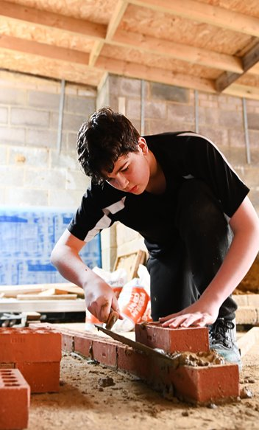

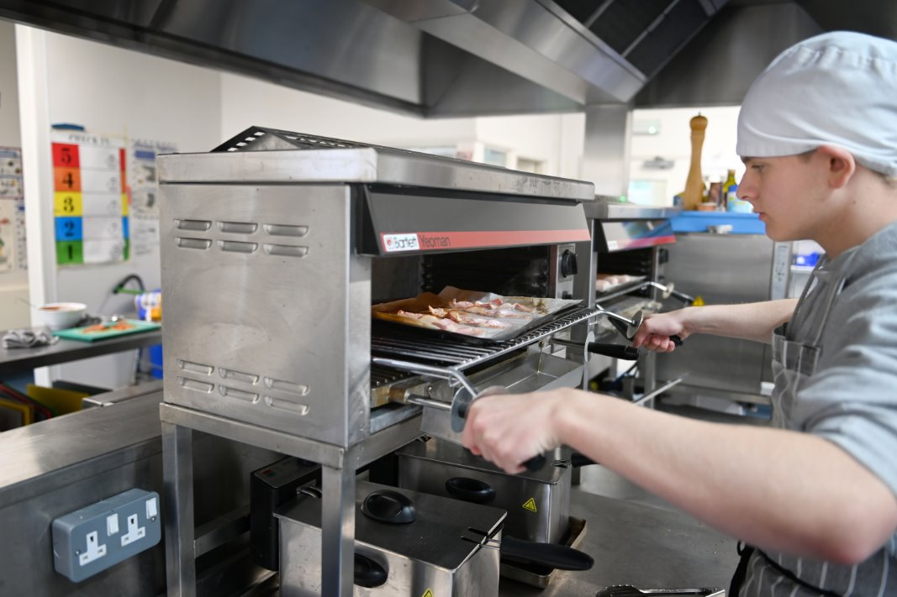

About the role:
Are you looking for a new challenge? We are looking for a passionate and inspirational Autism/SEND Teacher to join our team at The Springfields Academy.
Post: Autism / SEND Teacher
Location: Curzon Street, Calne. Wilshire, SN11 0DS
Salary Range: Main Pay Scale/ Upper Pay Scale + SEND Allowance
Contract Type: Permanent, Full Time

The Role:
The role of Autism SEND Teacher is an exciting role working with our team in Calne to support our growth in pupil numbers. The core purpose of the role is to develop and deliver a holistic academic, social communication and life skills curriculum for our pupils with autism. It is a unique opportunity for the successful candidate to join our team in creating a developmental learning experience that not only enables the pupils to thrive within our setting but maximises opportunities to develop the skills for a ‘safe, independent life’ using autism enablement structures and systems.
The role requires the successful candidate to be passionate about enabling our learners to achieve their potential and have aspiration beyond expectation for each individual. Alongside this they will have an understanding/commitment to understanding the theories of autism and how they can be applied in practice to meet individual need; in addition to creativity, flexibility, resilience and a commitment to meeting the needs of our pupils through innovative provision and pedagogy.
The Springfields Academy is a Reach South Academy for autistic young people aged 4-19, we are proud to hold the NAS Advanced specialist award and to be recognised as an Ofsted good school. We have 250+ pupils attending our provision. Our goal is to build safe independent lives for autistic young people through support, understanding and enablement.
Part of the excitement of teaching at Springfields is the broad range of individuals that you will care for. A key aspect of working at Springfields is taking the time to get to know pupils and their individual needs, and given their complexity, being able to create a safe, stimulating and supportive learning environment is crucial.
You will be joining a happy, hardworking and well-established team. You will also work in partnership with our multi-disciplinary therapy team as part of our therapy first culture.

The Person:
We are looking for someone with:
- A passion for making complex concepts accessible for the autistic learner.
- A child-centred practitioner who responds to the individual needs of each child.

- A teacher with a commitment to developing a good knowledge and understanding of autism and social communication needs and appropriate strategies to support pupils with this need. E.g. TEACCH
- A creative and flexible approach to teaching that builds success through challenge, personalisation and innovation.
- The confidence and skills to build positive relationships that help to break down barriers, build self-esteem.
- A commitment to enabling all our pupils to overcome their challenges and achieve their potential both socially and academically.
- Experience of primary, secondary, or specialist provision beneficial.

What we can offer you:
- The opportunity to make a difference to the lives of our autistic pupils.
- The chance to deliver an engaging and creative functional curriculum that builds independent life skills.
- A close-knit team of professionals who work in a supportive and inspirational environment.
- An outstanding learning community that engages pupils and develops positive attitudes to learning.
- The opportunity to be involved in wider-school life through trips, clubs, collapsed timetable days, Duke of Edinburgh etc.
- On-going, specialist professional development.
- A comprehensive CPD package with opportunities for individual development and development of knowledge linked to good autism practice
- A commitment to ‘Healthy Working Lives’ through a comprehensive trust Employee Assistance programme
- A work laptop
- Small class sizes
School Background:
The Springfields Academy is an academy based in Calne. We aspire to build safe independent lives for autistic young people through support, understanding and enablement. Additionally, we hold the National Autistic Society Advanced specialist award and are recognised as an Ofsted good school.
We are an acknowledged centre of excellence for Autism; we are highly reflective in our practices, and are continually working to improve our provision and practices. We provide a personalised curriculum journey that enables our autistic learners to develop skills in areas of need and to overcome their barriers to learning.
The drive to build ‘safe Independent lives’ shapes this curriculum and everything else that we do. The Academy has a PAN of 250.

Trust Background:
Reach South is a young and developing Trust which operates across the South West of England with the aim of delivering all through 3-19 education. We operate 17 academies in Plymouth, Bournemouth, Dorset and Wiltshire. We are building this Trust on a clear set of values, behaviours and curriculum principles. At the heart of those values and principles is a belief in our young people and a determination to support them to develop the knowledge, skills and attitudes to become the successful citizens for today and all of their tomorrows.
Our core business is delivering exceptional education for children and young people with a mission to help all pupils aspire to achieve beyond the expectations that others put on them. We do this through the development of a talented and committed workforce. In order to deliver exceptional opportunities for learning, we need highly motivated staff across all parts of the organisation.
Those we recruit are able to demonstrate that they share our values, are highly motivated to work with colleagues, within and beyond their school, to continuously develop their skills and pursue professional excellence.
Next Steps: If you have any queries about this role or would like an informal conversation, visits are warmly welcome, please get in touch by calling Marie Lopez on 01249 814125 or email at marie.lopez@springfieldsacademy.org. If you are experiencing any technical issues, please contact recruitment@reachsouth.org for support.
Visits to the school, phone calls and TEAMS meetings are welcomed.

Autism/SEND Teacher Job Description

The Springfields Academy builds safe independent lives for autistic young people through support, understanding and enablement from the ages of 4-19.

The role of our Autism/SEND teacher is critical to the Academy’s future. Teachers at Springfields require creativity, flexibility and a commitment to meeting the needs of our pupils through innovative provision and pedagogy.

PURPOSE
To consistently teach good/outstanding lessons that engage pupils, meet specificity of need and provide autism enablement so that progress is made across curriculum, as well as through therapeutic intervention.
Additionally, to:
- assess, monitor and record pupil progress;
- Build effective working relationships with support staff, other teachers, middle leaders and therapists to further the development the Quality of Education across the academy.
- to implement therapeutic or academic interventions to meet need as required

REQUIREMENTS AND RESPONSIBILITIES:
- To support the Academy ethos, playing a full part in the life of the Academy, and to be a positive role model at all times.
- To respond to SEND and autism initiatives relating to the quality of education as directed.
- To acknowledge existing networks for teaching, liaising with other staff at Springfields and when/if required staff at other Academies and schools in Wiltshire, to build outstanding provision.
- To set high standards, professionally and personally, and set a good example at all times.
- To be responsible, alongside other staff, for maintaining good order throughout the Academy.
- To follow the principles of the Springfields Way, especially in terms of communicating with pupils and thereby positively contribute to the ethos of the Academy.
- To follow policy.
- To ensure that high standards of provision are consistently maintained.
- To accurately record attendance.
- To log all aspects of behaviour/ presentation and report these as required.
- To be responsible for any specialist equipment commensurate with the specific teaching area.

- To communicate effectively with parents/ families regarding both celebration and concern.
- To carry out extra-curricular duties that are reasonable and practicable.
- To read, respond to and update, all individual risk assessments specific to the pupils directly in your care.
- To read and respond to any changes to any safeguarding policy that may be communicated to you.
- To be responsible for the general health and safety aspects of your specific working area.

LEADERSHIP
- To work with leaders to ensure that content is relevant and engaging to pupil need.
- To accord to the Academy’s assessment tracking system, carefully monitoring to ensure good/outstanding rates of pupil progress, and tackling underperformance through intervention related to pedagogy and/or content.
- To work with the Academy’s SENCO and Head of Therapy regarding vulnerable pupils’ provision and progress, initiating intervention to support progress as necessary.
- To demonstrate good practice in terms of planning (long term/medium term/short term),
- To be a pro-active member of the teaching team, participating in and guiding professional dialogue and discussion
- To be alert to the potential for any improvement, expansion and innovation within the Academy’s provision.

TEACHING TEAM RESPONSIBILITIES
- Attend Teachers’ meetings, Team meetings an focussed solution surgeries as required.
- To demonstrate effective collaboration and information sharing as a member of the Teaching Team and promote collaboration and positive relationships for learning within the Academy.
- Ensure that any decisions made at Leadership level are enacted.
- Disseminate relevant information to colleagues whenever appropriate.

AN EFFECTIVE MEMBER OF STAFF THROUGHOUT THE ACADEMY
- To contribute effectively to the development of a positive ethos in which all children have access to a broad, balanced and engaging curriculum which contributes to pupils’ academic, social communication, emotional and physical development whilst preparing pupils for the opportunities, responsibilities and experience of adult life.
- To support the building of autism provision for creativity, enquiry and problem solving in the curriculum that consistently engages our pupils.
- To respect all other staff in the Academy and acknowledge the importance of their roles to our overall effectiveness.

OTHER
- To contribute to creating a positive and inclusive learning climate where collaborative learning is encouraged.

Typical work activities
- The work of an Autism/SEND teacher is stimulating, challenging and varied and may involve:
- teaching individuals or small groups of pupils within, or outside the class;
- preparing lessons and resources with an appropriate level of challenge;
- marking and assessing work in line with the academy policy;
- developing and adapting conventional teaching methods to meet the individual needs of autistic pupils
- collaborating with other colleagues to define appropriate activities for pupils in relation to the curriculum with autism enablement strategies;
- liaising with other professionals, such as social workers, speech and language therapists, and educational psychologists;
- working closely with families;
- organising learning outside the classroom activities such as community visits, school outings or sporting events;
- updating and maintaining records of pupils' progress;
- attending and chairing statutory annual reviews or other related meetings, such as Looked After Child (LAC) reviews, regarding students with a SEND, which may involve reviewing Education, Health and Care (EHC) plans.

Person Specification. Autism/SEND Teacher
 | Essential | Desirable
Qualifications
Qualified Teacher status | x
Additional qualifications or awards e.g. Autism qualifications, OLEVI Outstanding Teacher Programme |  | X
Specialist qualifications related to SEND or autism |  | x
Knowledge and Experience
Experience of subject leadership and management |  | x
Experience of success in ensuring pupil engagement and progress | x
Experience of success for pupils in EYFS/KS1/KS2/KS3 with autism/SEND | x
Recent experience of teaching pupils with autism/SEND, within EYFS/KS1/KS2/KS3/KS4 | x
Knowledge of autism enablement strategies to promote success | x
Track record of delivering interventions that have had a positive impact on pupil progress. | x
Secure understanding of how to assess pupils against National Curriculum | x
Excellent classroom practitioner | x
Familiarity with using data to track/assess pupil progress | x
Safeguarding
Full understanding of the safeguarding requirements and how teachers promote the welfare of children | x
Eligibility to work in the UK | x
Recent safeguarding training |  | x
Personal Qualities
Ability to engage with, motivate and adapt for students who find learning a challenge | x
Ability to quickly build and sustain effective working relationships with a range of stakeholders, including parents, other teachers, inspection teams, Local authority officers, health professionals. | x
A flexible, innovative and consistently positive attitude | x
Excellent communicator, both orally and written | x
An ability to retain a sense of perspective and humour to motivate all pupils and colleagues. | x

Reach South Multi Academy Trust

Our Vision, Values and Principles of who we are

Aspiration Beyond Expectation

Reach South is a new academy trust that was set up as a sister trust to REAch2. The trust is founded on the same values and draws strength from being linked to a wider family of schools. At our core, we are a local trust serving the South West of England with the objective of operating schools that deliver exceptional learning opportunities for children and young people of all school ages.

Our central mission is for Reach South pupils to aspire to achieve beyond the expectations that others place on them.

Reach South Academy Trust exists to provide schools that serve their local community, offering parents and guardians access to the highest quality of local school for their children.

Our Core Values

- Inclusivity. Reach South is for all children. We recognise that some children will face greater barriers to their learning and development than others. This may be due to any number of challenges, including cultural, social, domestic, physical or cognitive. We are committed to helping all children, particularly the most vulnerable, to overcome these so that they can grow and thrive to be well rounded, healthy, educated citizens.

- Promoting social mobility. This is a fundamental driver for Reach South. Although we recognise that each school’s context and history informs our approach, this is never an excuse for accepting mediocrity or poor performance. An inclusive approach requires an explicit commitment to improving social mobility for all children. To do this, we insist on:
• high standards of educational achievement;
• high standards of social skills and interpersonal skills;

• high standards of communication skills;
• high standards of critical thinking, problem solving and creativity; and
• understanding of society, economy, environment and an appreciation of contribution and participation.

- Serving our local communities. Children’s education cannot be isolated from their social context and, in particular, their family and peer environment. To raise a child’s aspirations beyond their expectations, we must also raise the aspiration of their families and the wider community. Community engagement is not an additional activity that successful schools do; it is fundamental to how they work. Beyond that though, we embrace the fact that the school exists to serve its community; it belongs to the community. Each of our academies will ensure that the curriculum reflects the needs and uniqueness of its community.

- Believing in the potential of our young people. Aspiration is a precursor to self-improvement; it is not sufficient in itself but limited aspiration will limit achievement. It is our duty to believe in the potential of all of our children and to make that belief infectious. We need the community to believe in their children, and we need the children to believe in themselves. Aspiration itself becomes a driver and a motivator for educational achievement and personal success.

- Preparing tomorrow’s adults to contribute to social, economic, environmental and cultural sustainable development. We educate children to improve their own life chances and opportunities, but we also educate them as trusted members of a community and a global society. Through education, we want to contribute to securing a society capable of developing, evolving, improving and being sustainable.

Our Curriculum Principles

- High standards of educational achievement. Education is about much more than formal test and examination grades. Assessment and examination is, however, a measure of each individual’s mastery of skill, knowledge, attitudes and readiness to progress to the next stage of learning, work and life. Formal educational achievement provides young people with opportunities and choices. We have a duty to make sure that our young people are as well placed as they can be to access those opportunities and choices.

- Broad, rich and experiential curriculum. Our aim is not to provide a narrow education that simply provides examination grades. We want to equip young people to grow as healthy rounded individuals and citizens, who make a full contribution to community and society. Our curriculum is rich and experiential. It promotes autonomous and critical thinking skills, promoting creativity and entrepreneurship as well as social skills and communication skills.

- Relevant learning pathways. As our pupils move from primary to secondary school and on to further or higher education, we will ensure that they can access learning pathways that are relevant to their aspirations and developing talents. These pathways need to be relevant to both the individual and the needs of the wider community. Our secondary schools will engage closely with employers and Higher Education institutions to ensure that learning is truly relevant and best prepares young people for the world of work and social engagement.

- Research based curriculum. There is now significant international body of research evidence about what is effective in learning and how children’s brains develop. Our views about curriculum and learning will always be rooted in verifiable and independent research evidence.

- Teaching young people to be effective learners. So they can engage fully with our curriculum, we are committed to teaching our children and young people how to be active learners; and how to embrace feedback and mistakes as the springboard for further learning and development.

Our Core Behaviours

- Encouraging professional freedom. We expect our school leaders and staff to develop a curriculum that is relevant to local context and is consistent with the values, principles and behaviours of Reach South. We require consistency but not conformity. We encourage professional freedom within boundaries.

- Championing young people, not institutions. We will always champion our young people, even if this conflicts with being the champion of our institutions. For example, where the most appropriate learning pathway for a young person is found in another institution, this would mean a loss of funding to the Trust. Under all circumstances, we are absolutely clear that we will always put the interests of the young person first.

- Collaboration not competition. As a charitable education trust, we will collaborate and work with other organisations to deliver positive outcomes for children. Reach South already has very close synergies and association with REAch2 and other Academy trusts. We also seek to collaborate with other organisations, Local Authorities and Government agencies where it brings benefits to our young people.

- Integrity and Trust. We behave with the highest integrity at all levels of the organisation. These behaviours are critical to our organisational growth and sustainability.

- Developing our people. Integrity without competence would do little to build confidence in our ability to deliver what we promise. We will build and maintain a reputation for expert organisational competence through the development of skills and capacity in our people and our organisation.

