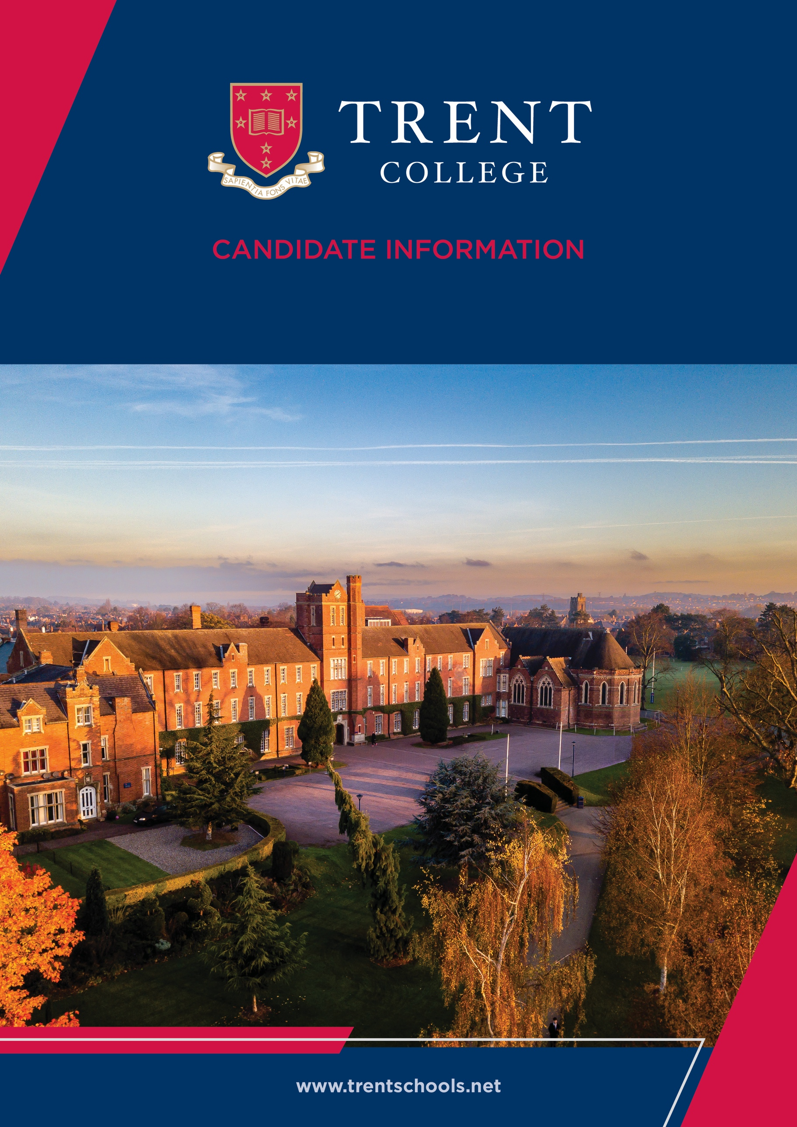


Welcome
Trent College is an independent co-educational boarding and day school, located in Long Eaton, Nottinghamshire. Founded in 1868, we have been providing a first-class education for over 150 years.
Set in a beautiful 45-acre campus we enjoy state-of-the-art facilities, including modern classrooms, sports facilities, and boarding houses. With traditional foundations and a modern outlook, Trent College is renowned for providing an excellent education for its 1,200 pupils.
The Elms is our Nursery and Junior School which provides a stimulating and nurturing environment to our youngest children, aged 6 weeks to 11 years. The two schools work closely together and share the same vision, aims and ethos. Together, we give the highest priority to the quality of our academic provision. Alongside a strong focus on sports, music, drama and a wide range of co-curricular activities to develop our pupils’ character and resilience, to prepare them for the modern world.
Rated ‘Excellent’ across the whole school by the Independent Schools Inspectorate in 2021, Trent College has a strong academic record, with a high percentage of students achieving top grades in their examinations and going on to study at some of the best universities in the UK and abroad.
We have highly qualified and experienced teaching staff who are committed to providing an excellent standard of education. We also have a large population of support staff, ensuring that our friendly school and beautiful campus operate to the very highest standards.

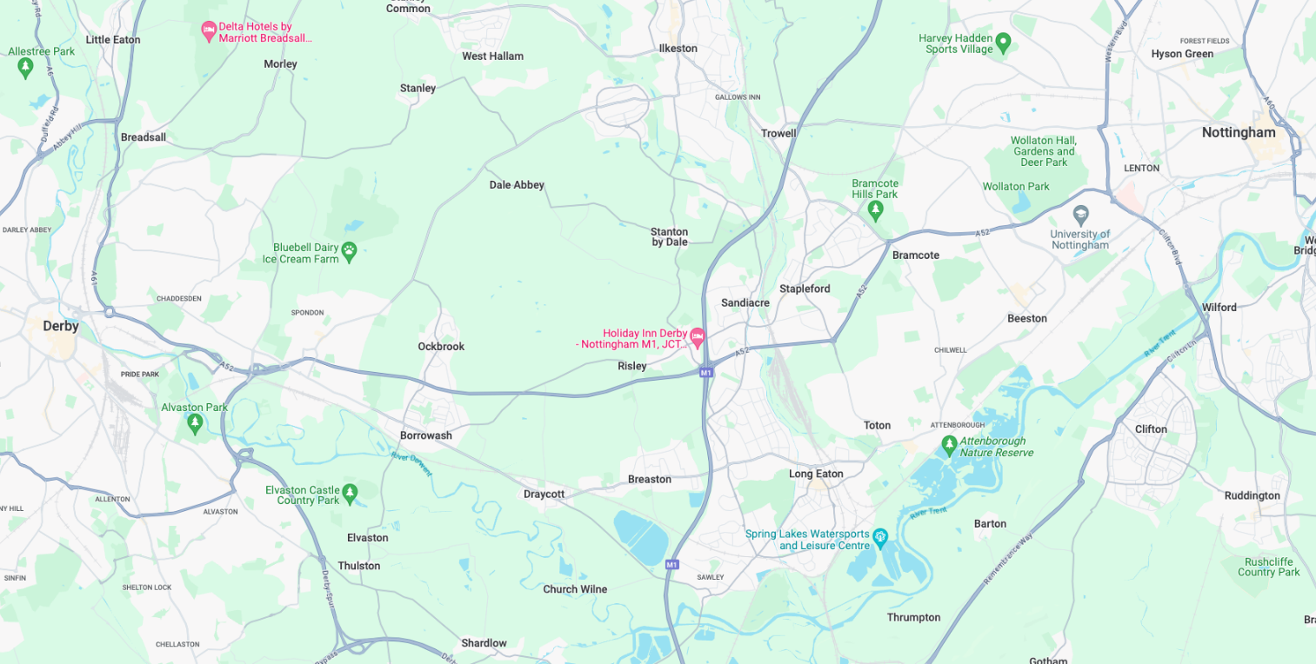
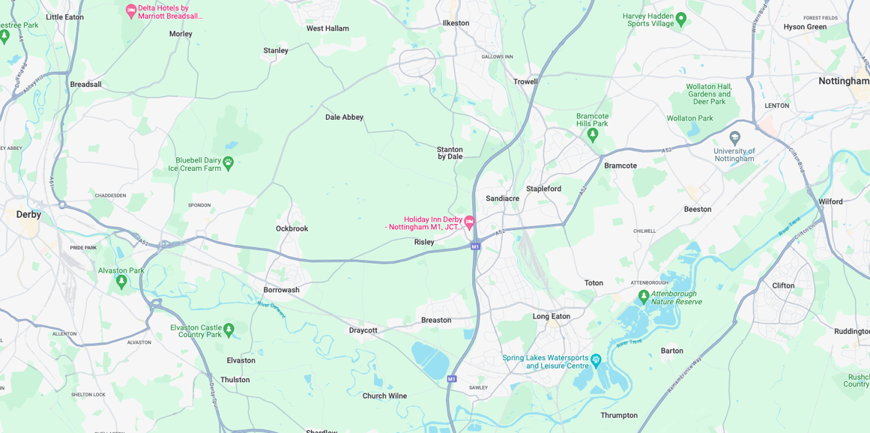


Our Location
Trent College and The Elms are conveniently situated on the border of Nottinghamshire and Derbyshire.
Ideally located at the heart of the UK’s motorway system, we are only 2 miles from junction 25 of the M1, which provides easy access to the M42 and A1.
Reaching Trent College by rail couldn’t be easier. Long Eaton boasts its own train station, located 1.5 miles from the schools. Rail routes through Long Eaton run along the Midlands Main
Line route, with direct routes to London, Loughborough, Leicester, Birmingham, Nottingham, Derby, Chesterfield and Sheffield.

Our Local Community
Working in partnership and serving the community are natural and very important values at Trent College and The Elms. We work with many local schools in Long Eaton and the wider Erewash borough to increase opportunities and aspirations, and to share the school’s excellent grounds, facilities and specialist staff.



Temporary Teacher of Technology

Job Description

The Design & Technology (D&T) department consists of three members of staff with strong Product Design backgrounds. The Head of D&T has overall responsibility for the leadership and management of the department, with responsibilities shared across the team.
The Food & Nutrition department comprises two experienced teachers who deliver engaging and effective lessons across Key Stages 3 and 4.
The department has two large classrooms equipped with computer suites, a substantial multimedia workshop and an electronics workroom, producing excellent results. In addition, there is an office space, welding and heat treatment room, and there are materials and project storerooms. The classrooms are resourced with whiteboards and projection equipment. The classrooms and offices are all linked to the school computer network. The department makes significant use of Computer Aided Design and Manufacture.
There is an outstanding Food and Nutrition suite with 12 workstations and accompanying classroom.



Teaching Responsibilities
Years 7 and 8
All pupils study both D&T and Food & Nutrition in Year 7 and 8 in small class sizes and in hour long lessons.
Years 9
Both subjects become optional in Year 9 and are very popular subjects with 3 or 4 groups most years. Pupils study in small classes and with 3-hour long lessons per fortnight.
Years 10 and 11
There are usually two sets in Year 10 and Year 11, studying GCSE D&T courses and a further two studying AQA Food & Nutrition and AQA D&T courses in May/June of Year 11. Students have five lessons per fortnight.
Sixth Form
Design & Technology is a 6th form subject. We follow the AQA Product Design specification. At present, two members of the Department teach A-Level, and students are taught for eleven hour long lessons per fortnight. The department has had a great deal of success in national competitions and students regularly gain Arkwright Scholarships and secure places at university to study design or engineering related courses.
Pastoral Care
- In addition to the academic role, every teacher is encouraged to play a full role in the life of the School outside the classroom.
- Teachers are expected to attend and support regular school events, including but not limited to assemblies, drama productions, religious services, concerts and speech days.

Additional Duties
- This is not an exhaustive job description and may be subject to change according to the needs and development of the role. It is expected that the post holder may undertake such other duties as may be reasonably be requested.
- A Trent teacher is dedicated to educating the “whole child”, in accordance with the aims of the school.
- They are aware of the individual needs of each student and strives to help each student develop his or her full potential.
- They work with students both inside and outside the classroom and are committed to active involvement in the total school curriculum.
- They co-operate with colleagues to ensure a fully integrated curriculum and regularly participates in activities directed toward their own professional development.
- A Trent College teacher is always available to students, colleagues and administration during the entire school day. In the time other than that scheduled for lunch, a teacher may be assigned activities such as supervision, tutorial, class coverage, etc. by the Head/ Deputy Head.



Person Specification

Qualifications
- Degree or equivalent qualification
- PGCE or equivalent teaching qualification
- Evidence of continued professional development

Experience & Skills
- Experience teaching Food & Nutrition at KS3 and KS4
- Ability to deliver engaging and effective lessons
- Strong classroom management skills
- Ability to contribute to a collaborative team environment

Personal Qualities
- Commitment to supporting students’ academic and personal development
- Willingness to contribute to the wider life of the school
- Flexible and adaptable approach
- Strong communication and interpersonal skills
- Commitment to ongoing professional development





Benefits
- Staff can enjoy complimentary lunches in the Obolensky Dining Hall during term time.
- Free car parking is available on site and staff have access to a cycle to work scheme.
- Staff are able to make free use of the school gym and leisure facilities at designated times.
- A defined contribution pension scheme is available to join, provided by AVIVA, with a generous employer contribution. Members also benefit from death in service and income protection.
- Enhanced sick pay and maternity pay is available to staff.
- Staff are entitled to a fee remission for children attending the school, in line with our policy.
- We provide a range of benefits to support staff, including counselling, an employee assistance programme and 24/7 online GP consultations.

Terms and Conditions
- This is a full-time position on a fixed term contract for one term (four months) commencing on the 1 September 2026.


Making an Application
Candidates who wish to apply for this post should apply via our website.
If you have any questions about the role please email recruitment@trentcollege.net or telephone 0115 949 4949 (during term time).
The closing date for applications is included in the advert.
We reserve the right to close this advertisement early if we receive a volume of strong and suitable applications.

The school is committed to safeguarding and promoting the welfare of children and young people and expects all staff and volunteers to share this commitment.
Applicants will be required to undergo child protection screening appropriate to the post, including checks with past employers and the Disclosure and Barring Service (DBS). The school may carry out online searches on shortlisted applicants, and all applicants will be required to provide details of their online profile, including social media account names/handles, as part of their application
The post is exempt from the Rehabilitation of Offenders Act 1974. The school is therefore permitted to ask job applicants to declare all convictions and cautions on a self-declaration form in advance of attending an interview (including those which are "spent" unless they are "protected" under the DBS filtering rules) in order to assess their suitability to work with children.

