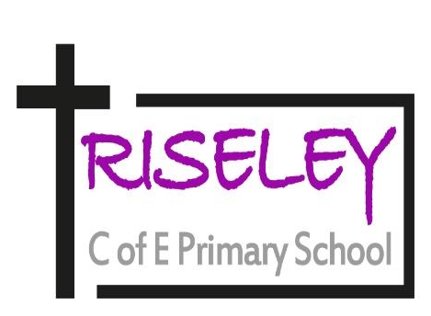
RISELEY PRIMARY SCHOOL
High Street, Riseley, Bedfordshire, MK44 1DR
Executive Headteacher: Mr Leigh Pointon
Telephone: 01234 708218
Website: www.riseleyschool.co.uk
‘Learning for life’

Job Title | EYFS Teacher
School | Riseley C of E Primary School, part of the Riseley and Wilden School Partnership
Location | Across both sites
Grade | M1-M6 (dependent on experience)

Job Purpose:

- Fulfil the professional responsibilities of a teacher, as set out in the School Teachers’ Pay and Conditions Document
- Meet the expectations set out in the Teachers’ Standards Principal

Accountabilities and Responsibilities:
- Plan and teach well-structured lessons to assigned classes, following the school’s plans, curriculum and schemes of work
- Assess, monitor, record and report on the learning needs, progress and achievements of assigned pupils, making accurate and productive use of assessment
- Adapt teaching to respond to the strengths and needs of pupils
- Set high expectations which inspire, motivate and challenge pupils
- Promote good progress and outcomes by pupils
- Demonstrate good subject and curriculum knowledge
- Participate in arrangements for preparing pupils for external tests
- Understand and support independent learning and inclusion of all pupils as required W
- hole-school organisation, strategy and development
- Contribute to the development, implementation and evaluation of the school’s policies, practices and procedures, so as to support the school’s vision and values
- Make a positive contribution to the wider life and ethos of the school
- Work with others on curriculum and pupil development to secure co-ordinated outcomes
- Provide cover, in the unforeseen circumstance that another teacher is unable to teach

Health, safety and discipline:
- Promote the safety and wellbeing of pupils
- Manage behaviour effectively to ensure a good, accessible and safe learning environment in line with school policies

Professional development:
- Take part in the school’s appraisal procedures
- Take part in further training and development in order to improve own teaching
- Take part in the appraisal and professional development of others, where appropriate

Communication:
- Communicate effectively with pupils, parents and carers
- Collaborate and work with colleagues and other relevant professionals within and beyond the school
- Develop effective professional relationships with colleagues

Personal and professional conduct:
- Uphold public trust in the profession and maintain high standards of ethics and behaviour, within and outside school
- Have proper and professional regard for the ethos, policies and practices of the school, and maintain high standards of attendance and punctuality
- Understand and act within the statutory frameworks setting out their professional duties and responsibilities

Management of staff and resources:
- Direct, supervise and collaborate with support staff assigned to them
- Deploy resources delegated to them

Safeguarding:
- Work in line with statutory safeguarding guidance (e.g. Keeping Children Safe in Education, Prevent) and our safeguarding and child protection policies
- Work with the designated safeguarding lead (DSL) to promote the best interests of pupils, including sharing concerns where necessary
- Promote the safeguarding of all pupils in the school

Please note that this is illustrative of the general nature and level of responsibility of the role. It is not a comprehensive list of all tasks that the teacher will carry out.

The post holder may be required to do other duties appropriate to the level of the role, as directed by the Executive Headteacher or line manager.

Personal specification on the next page.

Person specification
CRITERIA | QUALITIES
Qualifications and experience | • Qualified teacher status  • Degree  • Successful primary teaching experience
Skills and knowledge | • Knowledge of the National Curriculum  • Knowledge of effective teaching and learning strategies  • A good understanding of how children learn  • Ability to adapt teaching to meet pupils’ needs  • Ability to build effective working relationships with pupils  • Knowledge of guidance and requirements around safeguarding children  • Knowledge of effective behaviour management strategies  • Good ICT skills, particularly using ICT to support learning
Personal qualities | • A commitment to getting the best outcomes for all pupils and promoting the ethos and values of the school  • High expectations for children’s attainment and progress  • Ability to work under pressure and prioritise effectively  • Commitment to maintaining confidentiality at all times  • Commitment to safeguarding and equality

Notes: This job description may be amended at any time in consultation with the post holder.

