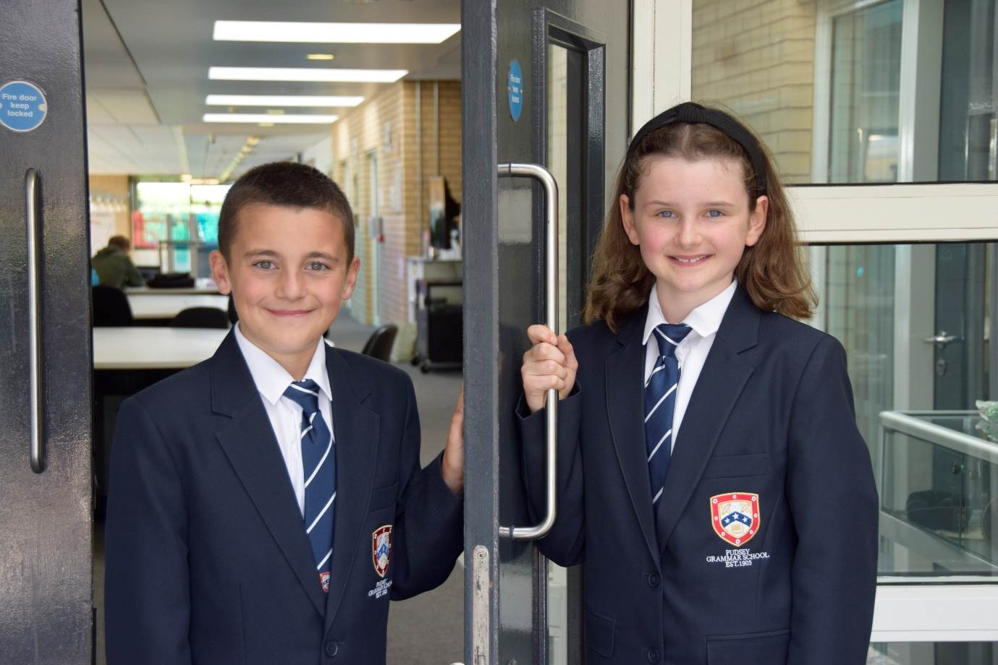

TEACHER OF
ENGLISH

APPLICATION PACK

Administrative Assistant
Temporary

B1, pt. 4-6 £25,185 - £25,989 FTE
Actual salary £22,218- £22,927

Working pattern:
37 hours per week, term time plus 10 training days.
The standard working hours are 7.30am–4.30pm, Monday to Thursday, and 7.30am–2.30pm on Fridays.
Your individual working pattern will be agreed with your line manager to ensure the operational needs of the department and the school are met.
Start Date: September 2026 or As soon as possible

Contents

- Introduction from the Headteacher
- General school details
- Information on the post
- Job description
- Person specification
- Enhanced disclosure

,

Introduction from the Headteacher

Thank you for the interest you have shown in the post of Temporary Administrative Assistant at our school. This is an excellent opportunity to join our hard working and committed Administration team.

Pudsey Grammar School is a heavily oversubscribed mixed comprehensive secondary school located in the heart of the market town of Pudsey. Situated between Leeds and Bradford the town has always valued its independence from its two larger neighbours. The school has a long and proud history stretching back to 1904. The school has 1300 students with a thriving and expanding Sixth Form of over 250 students all taught in a state of the art building. The innovative and unique style of the building creates a calm atmosphere very different to many secondary schools.

I was appointed in 2014 and since then we have received a letter from Amanda Spielman (HMCI Ofsted) which stated we ‘have transformed all aspects of the school.’ This assertion was further underlined in 2018 when the increase in our exam results resulted in the school being the most improved school in Leeds and one of the most improved in the country (we were delighted to follow these achievements up with our best ever GCSE exam results in 2019 which were above the national average). The pattern of improvement continued in 2020 with our Year 11 students achieving grades which were outstanding. The school had a highly successful Ofsted inspection in April 2019 and was judged as good in all areas including our sixth form. The school underwent an ungraded inspection in April 2024 which saw, for the first time in the school’s history, a second successive Ofsted judgement of being a good school. This is testament to the consistently high quality of education which one of the most popular schools across the city of Leeds with over 900 applications received for 215 Year 7 places for September 2024.

In 2022, the school was selected to be a national Behaviour Hub school. This was a Department for Education programme led by the Governments’ School Behaviour Advisor, Tom Bennett, which identifies schools who have ‘an exemplary behaviour culture’. We were one of only 20 secondary schools out of 4000 who have achieved this prestigious accolade, and we worked with other schools across the north of England to improve their behaviour cultures.
We have a comprehensive House system which runs across all year groups with over 30 diverse competitions across the year for students and one each half term for staff too. House assemblies take place once every three weeks lead by our four House Leaders. At the end of each academic year, the winning House is awarded our 80-year-old Victor Ludorum Cup.
We are aiming to be a centre of excellence and every indicator we have, we are on track to achieve this goal. Continuing to recruit high calibre staff is a key priority of our strategy.

The following quotes are taken from the latest Ofsted report:

- The school is welcoming and pupils respect the differences in other people.
- Safeguarding is very well led and pupils feel safe
- Pupils get on very well with each other
- Teachers have strong subject knowledge
- Pupils behave well in lessons and the vast majority focus on their work
- The school has developed an ambitious curriculum for pupils
- Staff have high expectations of all pupils. The vast majority of pupils rise to these expectations and work hard
- Pupils benefit from the curriculum and are well prepared for their next steps
- The House system plays a central role in the school and provides a sense of belonging. Pupils who earn House ties for their dedication to House competitions wear them with pride
- If bullying happens, pupils are confident that staff will deal with it quickly
The school has a long tradition in the town, being established as Pudsey Grammar School in 1905. Although the school is taught in a state of the art building, our core values of respect, resilience, integrity, compassion and ambition are highly traditional and are based on the goal of ensuring that every student reaches their true potential.

Our school is not just about the students gaining knowledge and qualifications although these are extremely important. We believe in teaching young people core values of decency, social skills and how to be a good citizen in an ever changing world. We want their character to develop and grow and for them to leave us with an inquiring and independent mind. We want our students to gain the best qualifications they are capable of whilst experiencing a range of opportunities which are second to none. As a result, the school is extremely popular with our community and is significantly over-subscribed every year.

Our Sixth Form which is rated as good by Ofsted, has grown in recent years and we now have over 250 Post-16 students studying at Pudsey Grammar. We have a strong tradition of ensuring students access the best universities including Oxford and Cambridge.

Our staff show exceptional dedication and commitment to our students. Relationships in the school are extremely strong and this underpins the ethos of the school. We pride ourselves in the care and support that we give our staff and as a result there is a real team spirit in the school where people enjoy being part of our school community. Teaching and learning is the key focus of the organisation and everything that we do is designed to ensure that the classroom experience for the students is excellent. We are currently redesigning our curriculum to ensure that the education we offer is second to none.

We offer fantastic support and professional development to staff which ensures that they are equipped with all the necessary skills to deliver excellent lessons to the students on a daily basis.

The school is a foundation Trust school and our partners include global companies such as ASDA, HSBC bank alongside leading local business and training provider, Appris. These high quality links allow our school to offer excellent careers opportunities to students across the ability range. As a result the school has 0% NEETs at Year 11.

We are currently part of The Leeds Teaching HUB which is providing outstanding opportunities and CPD for all of our staff. Subject Leaders attend their Collaborative Learning Groups, which allows them to network and share best practice. This is further disseminated through the school via regular department meetings and weekly Teaching & Learning briefings.

This clearly is an exciting time to join our school as we continue to build on our high standards and aspirations

If you have a desire to be part of one of the most exciting and rewarding schools to work in, which will also provide you with excellent development opportunities, please complete the application form. Any further details can be obtained directly from the school’s HR Team: recruitment@pudseygrammar.co.uk) or our website www.pudseygrammar.co.uk

Mark McKelvie
Headteacher
Pudsey Grammar School

Details of advert

Job Title: Administrative Assistant - Temporary
Hours and working pattern:
37 hours per week, term time plus 10 training days.
The standard working hours are 7.30am–4.30pm, Monday to Thursday, and 7.30am–2.30pm on Fridays.
To ensure appropriate office cover, the Administration Office operates throughout the school day.
Your individual working pattern will be agreed with your line manager to ensure the operational needs of the department and the school are met.
Grade: B1, point 4-6
Salary: £ 25,185 – £25,989 FTE (£22,218 - £22,927) Actual)
Start date: September 2026 or As Soon As Possible

The role involves:

To provide an efficient, professional and customer-focused administrative service to support the effective operation of the school. The post holder will undertake a wide range of administrative duties, including, providing a welcoming reception service, preparing pupil correspondence, maintaining accurate records, and supporting the day-to-day administration of the school.

Applicants will need to demonstrate:
- Excellent attention to detail, effective analytical skills and strong inter-personal and communication skills, together with the ability to work as part of a successful team.
- Appropriate qualifications and/or relevant experience in working with young people in this role.
- A commitment to:
  - Working in line with statutory safeguarding guidance (e.g. Keeping Children Safe in Education, prevent and our safeguarding and child protection policies)
  - Taking responsibility for receiving and acting upon any reported concerns and ensuring that the Child Protection Policy is implemented and promote best safeguarding practice across the school as part of the Student Support Team.
  - Promoting the safeguarding of all students in the school
Why work at Pudsey Grammar School?

- Be part of a rapidly improving school
- Work for an organisation which has staff wellbeing as its core
- Benefit from a flexible early finish to the school day on Fridays
- Embrace the opportunity to play a key part in the continuing transformation of the school
- Be part of a dynamic and enthusiastic team of staff who are ensuring our students are successful in every way
- Work alongside hub-schools in the Yorkshire and Humber region and University College London, with access to high quality Teaching and Learning training, networking events, CPD
- Belong to a supportive organisation which prides itself on high standards for staff and students
- Work in an award-winning state of art building

This school is committed to safeguarding and promoting the welfare of children and expects all staff and volunteers to share this commitment. Appointments will be subject to an enhanced DBS disclosure. If shortlisted, you will be required to disclose relevant information regarding criminal history and an on-line search will be conducted. This includes only information publicly available on-line.

We promote diversity and want a workforce that reflects the population of Leeds.

Employment is conditional on confirmation of the right to work in the UK – either as a UK or Irish citizen, under the EU Settlement scheme or having secured any other relevant work visa. If you do not have the right to work in the UK and the role does not meet eligibility for sponsorship, please consider carefully whether you meet the eligibility to apply for this position.

Application Process
Should you wish to apply for this position, please see below:
- Please be aware that we do not accept Curriculum Vitaes.
- In support of your application, you may include a cover letter. This should be in addition to the completed application form.
- Application form and full job description can be found on the school website: www.pudseygrammar.co.uk vacancies – My New Term link

Closing date for applications: Friday 14th August 2026 at 8.00am
Successful candidates will be contacted direct with details of the interview.
Interview date: Wednesday 19th August 2026

Job Description
Post Title: | Administrative Assistant
Post Purpose: | Administration
Reporting to: | PA to the Headteacher
Working time/working pattern | 37 hours per week, term time plus 10 days.  The standard working hours are 7.30am–4.30pm, Monday to Thursday, and 7.30am–2.30pm on Fridays.  Your individual working pattern will be agreed with your line manager to ensure the operational needs of the department and the school are met.  There will be a requirement to attend staff training and departmental meetings as required which may fall outside of the set hours.
Salary/Grade: | B1, point 4-6, £25,185 - £25,989FTE  £22,218 - £22,927 Actual salary
Main (Core) Duties:
Administrative Support | - Provide comprehensive administrative support to the Senior Leadership Team and wider school staff as directed by the Office Supervisor.  - Prioritise workloads effectively to meet competing deadlines.  - Maintain accurate manual and electronic filing systems and records.  - Prepare, proofread and distribute routine correspondence, including letters, emails and reports.  - Undertake reprographics duties including photocopying, scanning, laminating and document preparation.  - Manage meeting room bookings, ensuring rooms are prepared as required, and coordinate hospitality arrangements for meetings, interviews and school events.  - Collect information from a range of sources and prepare reports and documentation as required.  - Input, update and retrieve information using school management information systems and other IT applications.
Reception | - Provide a professional, friendly and efficient reception service for pupils, parents, visitors, contractors and external agencies.  - Answer telephone calls, respond to enquiries and direct calls appropriately.  - Welcome visitors, ensuring safeguarding procedures are followed, including visitor sign-in and identification checks.  - Receive, sort and distribute incoming and outgoing post and deliveries.
Relationship with Parents and the Wider community | - Develop and maintain positive relationships with pupils, parents, staff, governors, the Local Authority and external agencies.  - Respond to routine enquiries professionally, referring to more complex matters where appropriate.  - Work collaboratively with colleagues to improve administrative processes and service delivery.
Manage Own Performance and Development | - Take responsibility for own professional development.  - Share corporate responsibility to the implementation of school policies and practices.  - Participate in the school’s performance management cycle  - Provide a role model to all students through professional presentation and personal conduct.
Safeguarding | To work in line with statutory safeguarding guidance (e.g. Keeping Children Safe in Education, prevent and our safeguarding and child protection policies)  To work with the designated safeguarding lead (DSL) to promote the best interests of students, including sharing concerns where necessary.  To promote the safeguarding of all students in the school.
Physical conditions | The post is based at Pudsey Grammar School.  The school is accessible by stairs and lift and is available by disabled persons to the ground floor by a portable ramp on request.  This post is subject to an enhanced Disclose and Barring Service check.
Training | The school encourages training both “in-house” and external to meet the needs of the individual and of the Service.
Any Special Conditions of Service: No smoking policy

This job description is to assist staff joining Pudsey Grammar School to understand and appreciate the work content of their post and the role they are to play in the organisation.

Whilst every endeavour has been made to outline the main duties and responsibilities of the post, a document such as this does not permit every item to be specified in detail. This job description is not a definitive list of responsibilities but identifies the key components of the role. The post holder will, therefore, be required to undertake other reasonable duties commensurate with the purpose and salary level of this post.

Employees should not refuse to undertake work, which is not specified on this form, but they should record any additional duties they are required to perform, and these will be taken into account when the post is reviewed.
All new appointments of support staff are made subject to the satisfactory completion of a six-month probationary period.

Statement:
This school is committed to safeguarding and promoting the welfare of children and expects all staff and volunteers to share this commitment. Appointments will be subject to an enhanced DBS disclosure. If shortlisted, you will be required to disclose relevant information regarding criminal history and an on-line search will be conducted. This includes only information publicly available on-line. The employee may be subject to rechecking as required from time to time.

All appointments are subject to satisfactory references.

Pudsey Grammar School is an equal opportunities employer and requires its employees to comply with all current equality policies both in terms of equal opportunity for employment and access to the school’s services.

We promote diversity and want a workforce which reflects the population of Leeds.
Dated: July 2026

Person Specification – Administrative Assistant

Qualifications & Training, | ESS | DES
GCSE Grade 4/C or above (or equivalent) in English and Maths | X
Previous administrative experience in a busy office environment. | X
Good standard of general education | X
NVQ Level 2 or Level 3 in Business Administration (or equivalent administrative qualification). |  | X
Willingness to undertake relevant professional development and training. | X
Training in school Management Information Systems (e.g. Arbor, SIMS) |  | X
First Aid training |  | X
Knowledge
Understanding of general office and administrative procedures. | X
Knowledge of customer care principles and providing a professional reception service. | X
Understanding of confidentiality and the importance of handling sensitive information appropriately. | X
Awareness of Equality, Diversity and Inclusion principles. | X
Knowledge of school admissions processes and Local Authority admissions procedures. |  | X
Knowledge of school attendance and suspension processes. |  | X
Skills and Abilities
Excellent organisational and time management skills. | X
Excellent written and verbal communication skills. | X
Ability to prepare accurate routine correspondence and letters. | X
Strong interpersonal skills with the ability to communicate effectively with pupils, parents, staff and external agencies | X
Excellent customer service and reception skills. | X
Ability to identify opportunities to improve administrative processes. |  | X
Experience of using reprographics equipment and office technology |  | X
Ability of producing suspension letters and other pupil-related correspondence. |  | X

School Location and Travel Information

Pudsey Grammar School
Mount Pleasant Road
Pudsey
Leeds
LS28 7ND

Tel: 0113 2558277

www.pudseygrammar.co.uk
Instagram/Twitter/Facebook - @PudseyGS

