



WELCOME TO BUXTON COMMUNITY SCHOOL
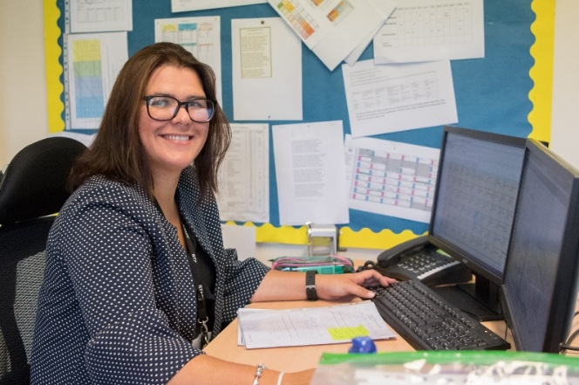
Welcome to Buxton Community School and thank you for your interest in this post. We are a successful, supportive and high achieving secondary school based in the heart of the Peak District with over 1,000 students on roll. As an 11-18 provider, we play a key part in providing the highest quality education and support for our students across a broad range of subjects at KS3, KS4 and KS5.
Our approach with the students involves acknowledging and rewarding positive behaviours and achievements whilst challenging and supporting students to be the best version of themselves. Our values, Ready, Respectful and Safe are instrumental in achieving our vision.
We have a clearly defined plan and commitment to improving learning and support for students. Our outcomes have shown significant improvement over several years as our developments to teaching and learning have taken hold.
Our principles for learning are focused on learning for the long term and developing deep understanding. We have developed a clear strategy that underpins what happens in our classrooms. Teachers who join our school will find well-resourced and planned schemes of learning. However, they are not prescriptive, we believe the professional in the classroom is the subject expert and the champion of the needs of the children in their classes. Staff wellbeing is of utmost importance to me, and we have adopted a number of approaches in order to support in this area of school life. For example, we support all our staff by providing additional non-contact time above that of most schools to allow them the chance to prepare and assess effectively.
I am keen to appoint subject specialists who are passionate and demonstrate true excitement for their subject. We want staff who are positive, energetic, enthusiastic and deeply committed to supporting our young people, and who are prepared to go that extra mile to contribute to our whole school improvement.
You will be joining the school at an exciting time as we are about to join an academy – The Embark Federation. We are excited by the opportunities that this partnership will bring in terms of developmental opportunities for both the staff and students. We want the best for our staff and young people, and we will not let it get more complicated than that.
Joining a new school will be a huge decision for you, I am sure you will have worked through our website, read our recent inspection report and looked at our data but you need to know what more there is to our school. I would be happy to talk with you as a prospective candidate before or after you apply and talk with you about our ethos and values, our priorities and answer any questions you might have. Please contact denise.lowe@buxton.derbyshire.sch.uk to arrange a call. The recruitment process will also give you every opportunity to learn more about our school.

Samantha Jones - Headteacher
The Role

Salary: Main/Upper Pay Scale
TLR: 2.2
Contract Type and Term: Full time, Permanent
Start date: September 2026
Advert closing date: Friday 15th May 9am
Interviews: Monday 18th May

Buxton Community School is seeking to appoint an outstanding and well-qualified teacher to lead our Geography Department as Head of Department.
We are looking for an outstanding candidate who will actively and positively promote Geography within the school and develop appropriate syllabuses, materials, schemes of work and homework to provide an up-to-date engaging curriculum that gives pupils the best chance of success. The role is suitable for both existing Heads of Department/Lead Teachers of Geography or for colleagues looking for their first step into leadership.
This is an excellent role for a colleague with proven classroom success as a teacher who has excellent qualifications and is enthusiastic and dynamic with a strong ambition to build on our success to date. You will be a colleague, who works collaboratively with the team, is receptive to innovative practices and is an inspirational and motivational subject leader. You will ensure the development of teaching practices of others within the department/subject area and take accountability for leading, managing and developing the curriculum and standards within the department.
We are looking for someone who understands the value of high-quality assessment and uses this to drive planning and progress. The successful candidate will be expected to draw upon the latest resources and teaching methods in delivering Geography across the ability range at all Key Stages.
We would welcome applications from any teacher who is keen to immerse themselves in a hardworking, supportive, forward-looking department. You will work closely and collaboratively with the geography team and wider humanities faculty; be receptive to innovative practices and be an inspirational and motivational practitioner.
The ideal candidate will:
· Have a tangible passion for teaching Geography and be able to share evidence of enabling students to meet and exceed expectations.
· Have experience in teaching Geography at Key Stages 3 & 4 and 5.
· Have excellent understanding of the curriculum and specifically how lesson design can help to deliver this successfully. They will have a keen interest in evidenced based research to inform their teaching.
· Be someone who understands the value of high-quality assessment and feedback to inform lesson design.
· Have strong organisational, personal time management and planning skills
· Have the knowledge and experience of / willingness to learn about effective leadership and management of people/management of change in the educational setting.
What you will get from us.
· The chance to join a forward thinking and ambitious department who are committed to providing the best education to students at BCS.
· Support regarding your own needs whether they be teaching and learning based or leadership.
· A supportive, collegiate and sociable working environment.
· Excellent opportunities for professional development.
This is a fantastic opportunity for a teacher with a proven record of achieving strong outcomes in a leadership role or to develop in a leadership role. Our priority is to appoint someone who is committed to education and being the best teacher and leader, they can be. We are looking for someone who can spark an interest in students and fully support them in achieving success in the subject.
The Department

The Geography Department is a thriving area of the school and one where students feel confident and able to succeed. It consists of 4 specialists with a wealth of experience between them. Classes are taught by extremely competent and experienced geography teachers who are driven, motivated, organised and enthused. The subject attracts large numbers at GCSE and A Level and is a popular choice amongst the students with some continuing their studies to degree level.
We follow the Edexcel specification at both A Level and GCSE where we specifically follow specification A. The specification suits the needs of our students and outcomes are consistently strong with Geography being the best performing Ebacc subject in the school. The team are committed to their own continuing professional development and keep up to date with developments not only in the subject but also related disciplines. This means that we can deliver the best, evidence informed teaching and learning for each student and in turn, unlock their true potential. Staff participate regularly in exam board training and performance evaluation with several being experienced examiners.
Currently, we run compulsory fieldwork for KS4 to the Goyt Valley and Manchester whilst at Sixth Form, students participate in a residential to North Wales to prepare for their NEA. At KS3, fieldwork is more localised to areas such as Grin Low woods, Bakewell and other surrounding locations. We are constantly looking for ways to integrate fieldwork into our schemes of work and amending and revising what we teach to students is part and parcel of what we do. Running trips further afield and offering students the chance to experience the wider world is something the department like to offer and for several years we have visited places including Iceland and New York.
We want learning in the classroom to be engaging, and evidence informed whist upholding strong academic values and behavioural standards to ensure that outcomes are strong for all. The department is very friendly and although independent, we work and socialise closely with the other members of the wider humanities team. We have a strong track record of successfully mentoring ECTs and equally, supporting colleagues who wish to move on to leadership roles of their own. If you join us, you will become part of a strong team, supported in your professional development and hopefully, feel a lot of job satisfaction in your role

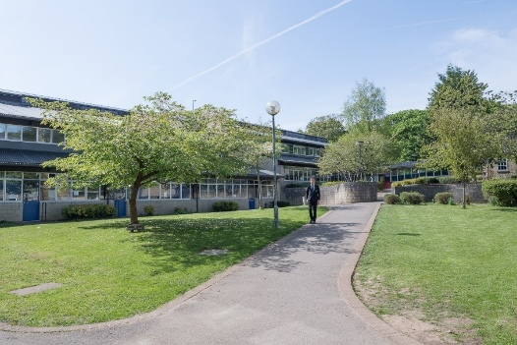

Job Description

Post Title: Head of Geography

Grade: MPS/UPR

TLR: 2.2

Responsible to: Curriculum Lead for Global Studies and SLT

Post Objectives:
The Subject Leader is responsible for the day-to-day operational leadership and management of their subject area. The role focuses on the effective implementation of the agreed curriculum, consistency and quality of teaching and learning, line management, and securing strong pupil progress and outcomes.
The Subject Leader will actively promote and model the school’s values of Ready, Respect and Safe within the department, ensuring these values underpin classroom practice, professional conduct and departmental leadership.
The post operates within the strategic direction, accountability and quality assurance framework set by the relevant Curriculum Lead.

Duties and Responsibilities:

Key Responsibilities
Operational Leadership
- Lead the day-to-day organisation and running of the department.
- Ensure consistent routines, expectations and standards across lessons within the department.
- Promote a learning environment where pupils are ready to learn, respectful in their conduct and safe in classrooms and shared spaces.
Curriculum Implementation
- Translate agreed faculty curriculum intent into detailed schemes of work, lesson sequencing and resources.
- Ensure schemes of work are followed consistently by all staff within the department.
- Review subject-level curriculum effectiveness and identify areas for refinement, feeding into faculty review processes led by the Curriculum Lead.
- Ensure curriculum delivery is inclusive and accessible to all pupils.
Teaching, Learning and Assessment
- Support colleagues to deliver consistently high-quality teaching within the department.
- Share effective practice, resources and subject expertise.
- Coordinate assessment in line with agreed faculty frameworks.
- Ensure marking and feedback expectations are applied consistently.
- Track pupil progress and implement subject-level intervention where required.
Staff Line Management and Support
- Provide day-to-day line management and professional support for staff within the department.
- Promote collaboration, shared responsibility and professional accountability.
- Model professional behaviours that reflect the school’s values of Ready, Respectful and Safe.
- Contribute evidence to appraisal and performance management processes under the direction of the Curriculum Lead.
Safeguarding
- Promote safeguarding as a core professional responsibility within the department, ensuring that pupil safety and wellbeing are consistently considered in day-to-day leadership, classroom practice and departmental decision-making.
- Act on safeguarding concerns promptly and appropriately, in line with school policy, statutory guidance and agreed reporting procedures.
- Contribute to a culture where pupils feel safe, supported and able to learn, modelling professional vigilance and high standards of care.

Professional Responsibilities
- Uphold and actively model the school’s values of Ready, Respectful and Safe in all aspects of the role.
- Promote positive behaviour, mutual respect and high expectations within the department.
- Contribute positively to the wider life and work of the school.

General
All teachers will:
- be expected to keep themselves up to date with recent education developments and to participate in Inset
- take part in break duty rotas and cover
- participate in the school QA system.

Please note that this document should be read in conjunction with the Conditions of Employment of School Teachers as outlined in the current DfE School Teacher’s Pay and Conditions Document.



Person Specification

(To be read in conjunction with the National Standards for Classroom Teachers)

Post Title: Head of Geography

Grade: MPS/UPR

 | Essential Criteria
Qualifications | QTS (when taking up post)
Qualifications | Relevant Geography Degree
 | Relevant practical experience planning, leading and delivering fieldwork
 | You are committed to teaching and learning in a comprehensive school
 | You have high expectations of all the students you work with
 | You can articulate clear educational values and apply these to your teaching
 | You understand the barriers that can affect students’ learning and show commitment to overcoming these
 | You can develop and maintain positive relationships with all students
 | You actively encourage all students to develop and maintain positive relationships with each other
 | You approach problem-solving positively and creatively
 | You are well-organised in your planning and use of classroom resources
 | You work effectively with colleagues to develop and improve learning
 | You use good communication skills (speaking, writing and listening) with the whole school community
 | You are committed to the personal development of the young people you work with
 | You constantly strive to analyse, refine and develop the learning in your classroom
 | You demonstrate high levels of commitment, enthusiasm and motivation
 | You are hard-working and dependable
 | You have an excellent record of attendance and punctuality
 | Outline of clear educational philosophy linked to post requirements
 | You have effective and positive behaviour management skills.
 | You are an effective team worker with a ‘can do’ attitude that embraces change and creativity.
 | You show clear evidence of on-going professional development.

A Great Place to Work

We care passionately about our staff, their well-being and their professional development and this is reflected in the fact that we are an enthusiastic team, committed to working collaboratively and sharing the very best practice.

We can offer:
- a strong team environment that takes staff well-being seriously
- a dedicated Senior Leadership Team who want to see their staff progress
and flourish in their career
- an active teaching and learning research and development group
- very supportive parents and a high standing in the community
close and successful working relationships with other schools within the High Peak area

Diversity & Inclusion

At Buxton Community School we hire the best, give them first-class training and if you are driven to perform, you’ll fit right in. We approach our work fearlessly, learn quickly, improve constantly, and celebrate our wins at every turn.

We are passionate about creating an inclusive workplace which promotes and values diversity in age, gender identity, race, sexual orientation, physical or mental ability and ethnicity. More importantly, creating an environment where everyone, from any background, can do their best work is the right thing to do. Everyone is welcome—as an inclusive workplace, our employees are comfortable bringing their authentic whole selves to work.

The Town of Buxton
Buxton Community School is a school truly at the heart of the town and the area is a beautiful part of the country.
At 1,030ft above sea level, Buxton is said to be the highest market town in England. Tourists have been coming to Buxton and the Peak District since the 14th Century and it’s not surprising that Buxton is today one of the most popular tourist destinations in the Peak District. Within an hour’s drive of Manchester, Sheffield, Derby and Stoke, its famous Georgian and Victorian architecture with buildings such as The Crescent, The Pavilion Gardens and The Opera House it provides an impressive backdrop to a rich and vibrant range of music, theatre and festivals.
The Buxton Festival of World Cinema takes place around March/April, with the Big Session Festival of folk music in April/May. July brings the Buxton Festival of Opera, Music and Literature, the Buxton Well-Dressing Festival, Buxton Fringe Festival and the Buxton Military Tattoo. In August the Family Festival provides fun for all the family.

The Application Process

If you are short-listed for interview, you will be contacted in advance to discuss arrangements for the interview. Unfortunately, if you have not been contacted prior to the interview day, your application has not been successful on this occasion. Buxton Community School is committed to safeguarding and the process of safer recruitment. As a result, this post is subject to an enhanced DBS check, and all shortlisted candidates will be expected to prove their identity at interview. The successful candidate will be expected to show original copies of qualifications and further proof of their identity.



