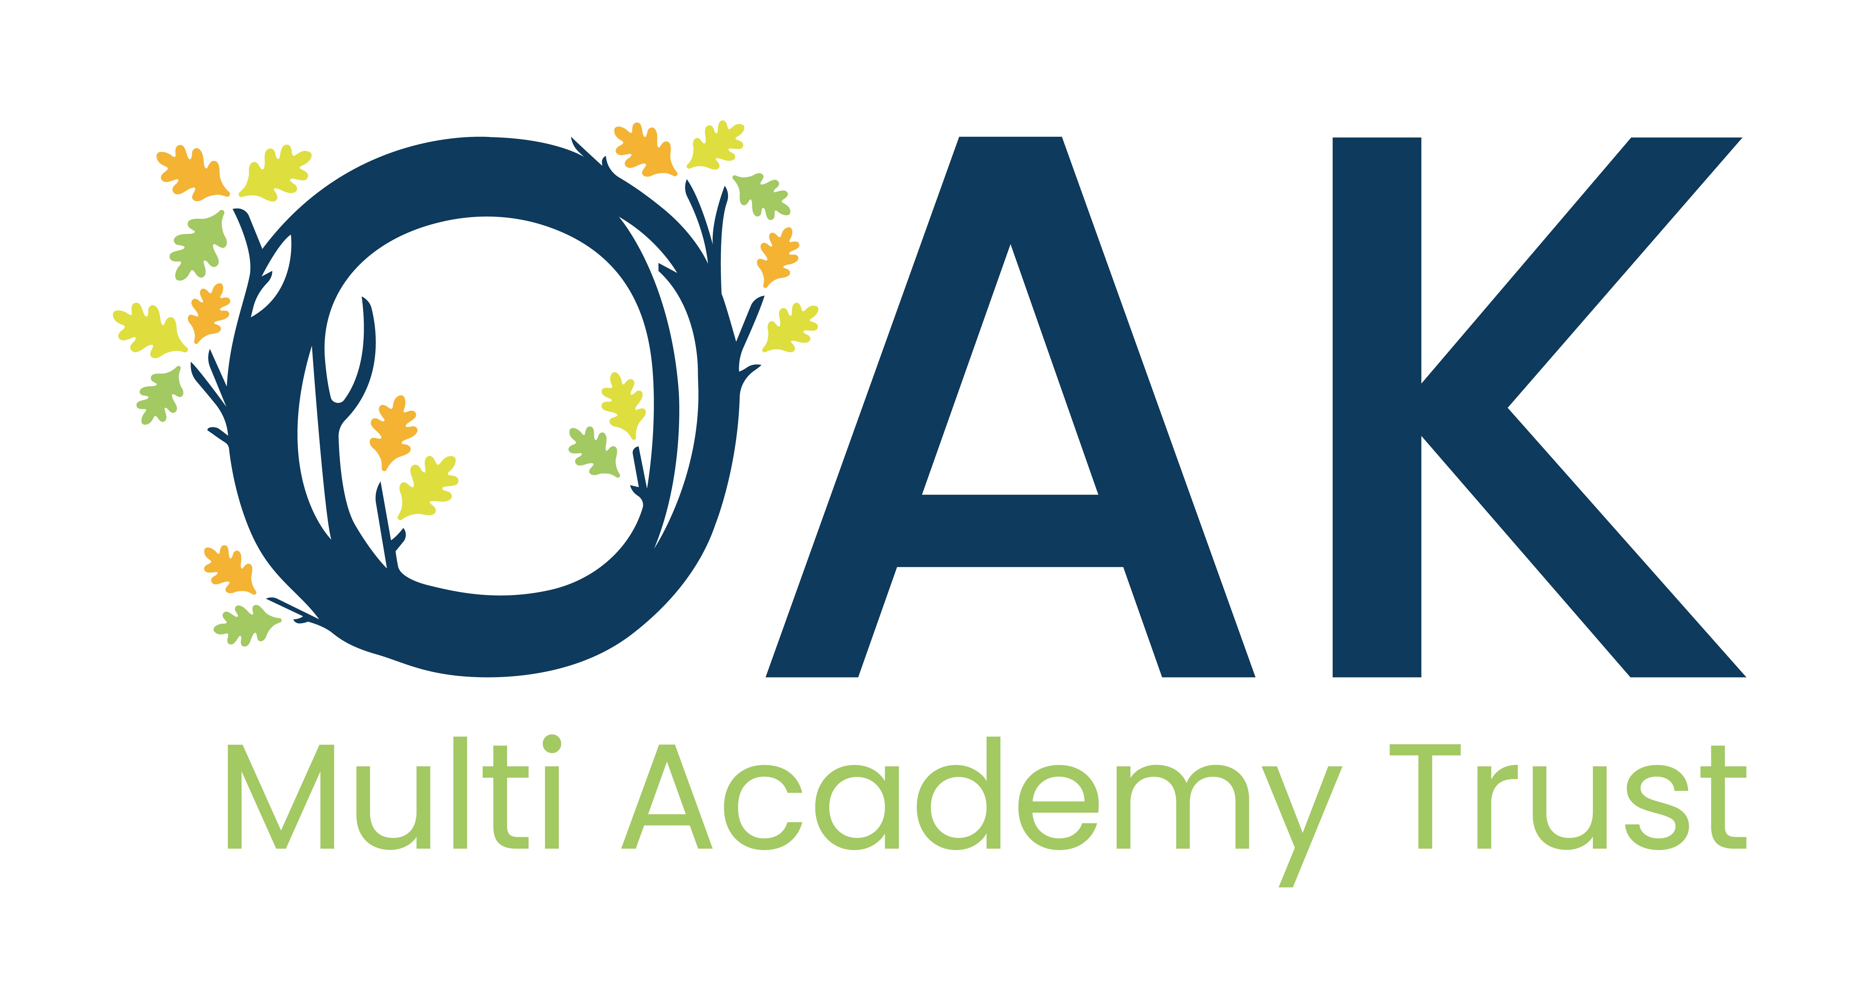
This post is eligible for a DBS check under the Rehabilitation of Offenders Act 1974 (Exceptions) Order 1975 (i.e. it involves certain activities in relation to children and/ or adults) and is defined as regulated activity under Part 1 of the Safeguarding Vulnerable Groups Act 2006.
Job Title: | Before / After School Assistant
Grade: | 3
Full time salary: | £24,796
Responsible to: | Headteacher, Before and Aftercare Leader
Responsible for:
Key Relationships/ Liaison with:
Job Purpose: | To support the Before and Aftercare Leader in the Owls Hoot provision of high quality activities for pupils before the start of or after the end of the normal school day.
Main Duties and Responsibilities
- Assist in planning programs of activities appropriate to the age and ability of the group.
- Supervise, support and assist pupils undertaking activities, ensuring that all have equal opportunity to develop their individual and team skills.
- Be aware at all times of appropriate Health and Safety procedures.
- Attend staff meetings as required.
- Assist with the organisation of equipment and accommodation.
- Quietly refer any instance of unacceptable behaviour or concerns they may have about pupils to the Before and Aftercare leader.
- Mop up spillages and accidents with the use of appropriate materials/equipment.
- Comfort and supervise pupils who are ill or have had an accident, administering to their needs, as appropriate and referring to the nominated teacher and/or First Aider ensuring that accidents are recorded appropriately.
- Be aware and apply the school’s policies and procedures.
- Being aware of confidentiality issues linked to home/pupil/teacher/school work and to keep confidences as appropriate.
- Participating in appropriate school-based meetings and training activities within contracted hours.
- Grade of the post as defined, subject to the proviso that any changes of a permanent nature shall be incorporated into the job description in specific terms, following consultation with the recognised Trade Unions.
- Participating in appropriate professional staff development training.
- To provide care and encouragement to children with disabilities or special educational needs, supporting them to participate in activities and liaising, if required, with parents / carers / other professionals as appropriate.

OPPORTUNITY, AMBITION, KNOWLEDGE
Copse Close, Oadby, Leicester, LE2 4FU
T: 0116 271 4941 E: admin@oaktrust.org W: oakacademies.org
Company No. 07695364

Before / After School Assistant
Personal Specification
 | Essential | Desirable
Qualifications | - Good numeracy and literacy skills  - IT literate | - First aid trained  - Basic Food Hygiene Certificate  - Experience of administering medication
Experience |  | - Experience of working within a school setting  - Understanding of religious and cultural diversity
Knowledge/Skills | - To be able to contribute to a stimulating and enthusiastic working environment.  - Empathy with children  - Ability to prioritise own workload and work flexibly, and at times under pressure, meeting deadlines  - Excellent organisational skills  - Ability to work collaboratively in a team  - Ability to encourage high standards of effort, care and presentation  - Able to build excellent relationships with all stakeholders
Personal Competencies and Qualities | - Enthusiastic and positive  - Ability to communicate succinctly and effectively both orally and in writing  - Friendly and approachable with a can-do attitude  - Tact, sensitivity and the ability to hand confidential material with discretion as well as the ability to remain calm and professional in all situations  - High degree of personal motivation, initiative, energy, creativity and drive  - Ability to build good relationships with parents and colleagues, including working well within a team and ability to take direction  - Punctual and flexible
Other Requirements | - Willing to receive further training  - Understanding of safeguarding issues and ability to follow all Trust procedures relating to this  - A commitment to the Trust’s aims and values  - Hold positive values and attitudes and adopt high standards of behaviour in a professional role  - Demonstrate commitment to teamwork and whole Trust improvement  - Integrity  - Self-motivated | - Able to be flexible with working hours should the need arise for extra work on an ad hoc basis

