

Candidate Information Pack
Cleaner
South Axholme Academy

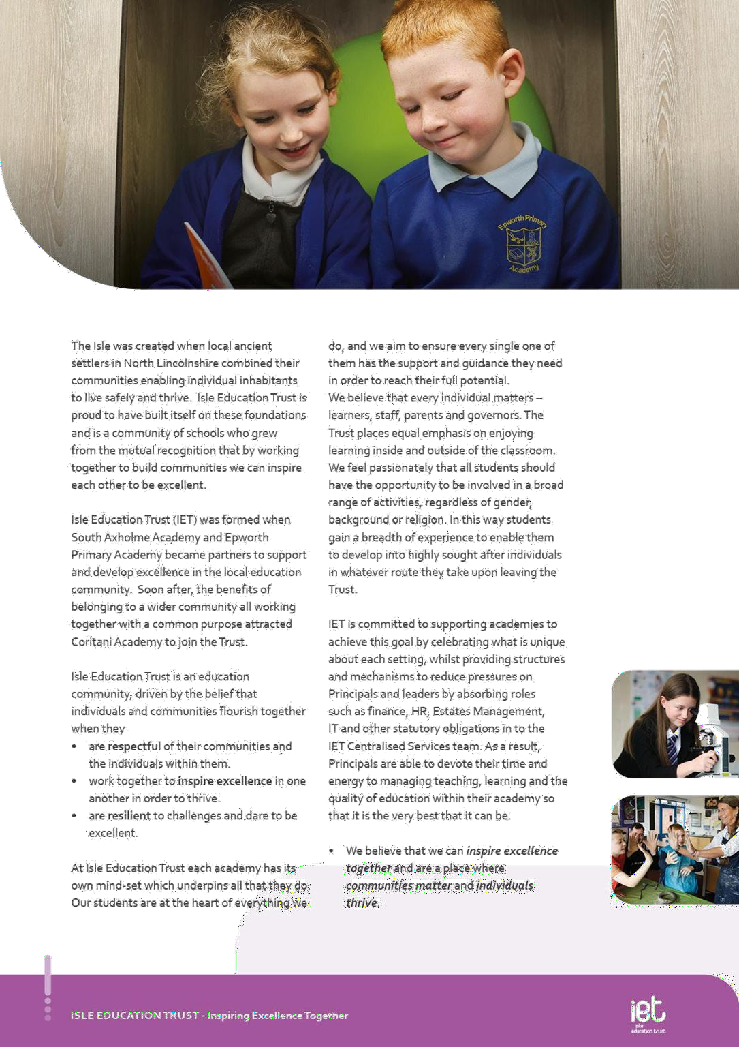

About IET



Welcome from the CEO
Dear Prospective Colleague,

Thank you for your interest in joining Isle Education Trust. I’m delighted that you're considering becoming part of our team—whether you’re looking to support students directly or contribute to the vital work that happens behind the scenes, your role matters deeply to us.

At Isle Education Trust, our vision is clear: Inspiring Excellence Together. Across our family of academies, we recognise that excellence doesn’t happen by chance—it’s built by a committed, skilled, and diverse team working together with shared purpose.

Our non-teaching colleagues are the backbone of our success. From safeguarding and administration to site management, finance, pastoral support, and everything in between, you help shape the culture and daily experience of our schools. Your expertise keeps our academies running smoothly, our environments safe and welcoming, and our pupils supported every step of the way.
We are proud to uphold values that guide our Trust:
- Respect – shown through honesty, consistency, and care.
- Resilience – demonstrated in our commitment to excellence, even in the face of challenge.
- Inspiration – sparked by individuals who lead by example and empower others to thrive.

When you join our team, you’ll find a community where your contributions are valued, your development is supported, and your wellbeing is prioritised. We offer professional learning opportunities, a culture of collaboration, and a genuine commitment to making our academies great places to work.

If you share our belief that every role within education is a chance to make a difference, I warmly invite you to explore opportunities across the Trust. We’d be thrilled to welcome you into our mission of inspiring excellence— together.

Warm regards,

Sarah Sprack
CEO, Isle Education Trust



About the Academy

South Axholme School was established in 1961. Since then, the school has been extended and is currently able to cater for approximately 930 students. In 2012 South Axholme Community School converted to South Axholme Academy. In the summer of 2013, South Axholme Academy became the lead in a small multi academy trust, Isle Education Trust. It is now an equal partner in the Trust, alongside Epworth Primary Academy and Coritani Academy.

South Axholme Academy is situated in the town of Epworth, North Lincolnshire, between Doncaster and Scunthorpe. It is an easy commute from Doncaster, Scunthorpe, Rotherham, Sheffield, Leeds and Lincoln.

The academy takes students from over 25 primary schools in North Lincolnshire, Nottinghamshire and Doncaster and has been oversubscribed for several years.

At South Axholme Academy everyone works collectively using the South Axholme Mindset, a set of values that have been agreed by all to help everyone to be successful. The South Axholme Mindset Expects Excellence and requires everyone to be ready, respectful and resilient in all that they do. At the academy, our mindset is not just words on a page, but is how we approach all that we do, how we live our lives, whatever our role.

Much of our success is derived from knowing our community – knowing our students, staff and parents. The curriculum we offer is broad and balanced, but tailored to meet the needs of all, so that we are fully inclusive. As part of this, we are currently in the process of building a nurture/study hub on the premises, with the support of North Lincolnshire Council, to work with students who would benefit from a smaller learning environment and more focused support.

The academy has a wide and varied annual calendar of events for everyone to get involved with, including a sponsored walk that the whole school completes, numerous drama and music productions, a wealth of sports teams and clubs, and a list of trips and visits too vast to list, as well as Christmas carol concerts and senior citizens parties to engage with our local communities.
South Axholme Academy is vibrant and exciting with a history of excellence in all areas, with students at the heart of everything we do.



Job Description

Job Title Cleaner

Salary FTE: £24,522
Actual £13,255.14

Job Details Monday to Friday 6am - 8am & 15:30 -17:30 (20 hours per week)

Permanent

Location South Axholme Academy

Required September 2026

Application Close 09:00 September 18th, 2026

Interview Date TBC

Job Purpose

To assist in the general cleaning of the academy, in the designated area. You will be reporting directly to the Cleaning Manager.


Key Responsibilities and Accountabilities

Job Description:
- Organise and carry out all allocated work to fulfil cleaning requirements.
- Undertake any necessary training/instruction for cleaners.
- Maintain health and safety and carry out all work in accordance with safe working practices.
- Rooms: Cleans and disinfects sinks, countertops, toilets, mirrors, floors, etc. Replenishes bathroom supplies. Polishes metalwork, such as fixtures and fittings
- Floors: Sweeps, mops, vacuums, floors using brushes, mops, vacuum cleaners and automated floor polishers. Other floor work may be required such as scrubbing, waxing and polishing floors.
- Dust: Dusts furniture, equipment, partitions, etc.
- Waste: Empties waste bins and recyclables and transport to disposal area.
- Cleans rugs, carpets, and upholstered furniture, using vacuum cleaner, washes walls and woodwork, washes windows, door panels, partitions, sills, etc.
- Litter picks, internally and externally
- Movement of equipment specific to the post
- General housekeeping of the full site including toilets and recreational areas
- Deal with and clean spillages, sickness and incidents.
- Establish good working relationships with all academy staff, students, Trust staff and visitors
- Carry out any other duties commensurate with the grade and general responsibilities of the post
- Comply with Health and Safety Regulations.

We expect all Trust staff to:


- Work with all students ensuring equality of opportunity for all.

- Take responsibility for Safety and Welfare of all students, raising any concerns following the
Academy/Trust protocols and procedures.

- Work proactively and effectively in partnership with all stakeholders.
- Carry out a share of statutory supervisory duties.

- Treat students with dignity and build relationships rooted in mutual respect and at all times observing proper boundaries appropriate to the professional position.
- Participating in CPD which is relevant to the role.

- Accompany teaching staff and students on visits, trips and out of school activities as required.

- Demonstrate an understanding of and take responsibility for promoting high standards of literacy including the correct use of spoken English and numeracy.
- Participate in arrangements for examinations and assessments.

- Take an active role in promoting good behaviour in and around the Academy/Trust.

- Ensure that students adhere to the uniform code and apply sanctions when this code is breached.

- Develop an academy learner mind-set – the attitudes, skills and learning habits needed to become an inspired, confident and independent learner.
- Be a positive role model and demonstrate consistently
and effectively the positive attitudes, values and behaviour which are expected of students.

- Work as a team member and identify opportunities for working with colleagues and sharing the development of effective practice with them.
- Regularly review the impact of their work and its impact on students’ progress, attainment and well-being, refining approaches where necessary and
responding to advice and feedback from colleagues.

- Proactively participate in arrangements made in accordance with the Appraisal Policy.

- Have professional regard for the practice, ethos and policies of the Academy/Trust and maintain high standards in your own attendance and punctuality.

- Operate at all times within the stated policies and practices of the Academy/Trust.

- Contribute positively and effectively to the whole Academy/Trust ethos.

- Cooperate with other staff members to ensure a sharing and effective use of resources to the benefit of the Academy, individual departments and students.
- Attend and participate in appropriate calendared meetings.
- Take responsibility for own professional development and duties in relation to Academy policies and practices.

  - Liaise effectively with staff, students, parents and governors.

  - Ensure compliance with Health and Safety at Work Act 1974 and all other policies related to health and safety, and to ensure compliance with the Data Protection Act 1988.
- Ensure compliance with data protection laws and safeguarding procedures.
- Carry out any other duties as directed by your Line Manager as may from time to time be agreed in accordance with the nature of the job described above.



This is not an exhaustive list of tasks and job descriptions will be continually reviewed and changed according to the needs of the Trust.

Post holders will be expected to be flexible in undertaking duties and responsibilities attached to their post and may be asked to perform duties, which reasonably correspond to the general character of the post and are commensurate with its level of responsibility. This job description is provided for guidance only and does not form part of the contract of employment.


Person Specification:

Education, Qualifications and Relevant Experience | Essential | Desirable
Ability to work both as a member of a team and on own and to
deal with any unexpected | A I
problems that may arise
Ability to work both as a member of a team and on own and to
deal with any unexpected | A I
problems that may arise
Ability to relate well to children and adults | A I
Ability to work in an organised and methodical manner | A I
Ability to complete cleaning tasks to desired standards and to | A I
work to time constraints | A I
Some knowledge of Health and Safety procedures and
precautions as they relate to the | A I
operation of cleaning equipment and the dilution of cleaning | A I
materials
Ability to read, understand, follow and respond appropriately to | A I
instructions | A I
Display a conscientious and logical approach to the variety of
tasks necessary for the smooth and efficient running of the | AI
academy
Experience | Essential | Desirable
General understanding of academy policies and procedures
relating to health and safety, behaviour, attendance, equal | A I
opportunities and child protection
Practical Skills | Essential | Desirable
Flexible approach to work as well as good organisational and | A I
communication skills | A I
Ability to demonstrate discretion, confidentiality and | A I
commitment | A I
Ability to work independently and to show initiative | A I
Ability to work under pressure, prioritise and meet deadlines | A I
Friendly, approachable and non-confrontational manner | A I
combined with the ability to be firm


Personal Qualities & Essential Attributes | Essential | Desirable
A professional approach in both manner and physical appearance | I
Ability to demonstrate discretion, confidentiality and | I
commitment | I
Enthusiasm, determination and insistence on high standards | I
Flexibility and good sense of humour | I
A proven track record of excellent attendance and punctuality | I
Ability to work with or without supervision | A I
Commitment to safeguarding and promoting the welfare of | A I
children and young people | A I
High expectations of self and others | Essential | Desirable
A flexible and adaptable approach | A I
An innovator with the desire to continue to learn | A I
Safeguarding | Essential | Desirable
Committed to safeguarding and promoting the welfare of children | I
and young people | I
Equal Opportunity | Essential | Desirable
The ability to ensure that there is equality of access to educational
attainment and that all aspects of equal opportunities are adhered | I
to

KEY
A = assessed through the application process I = assessed through the interview process


c

Trust Benefits:

Pension Scheme
All staff are enrolled in either the Teachers’ Pension Scheme or Local Government Pension Scheme, whichever is relevant.

Continuous Professional Development
IET offers numerous opportunities for continued CPD for all staff including NPQs and apprenticeships

Cycle to Work Scheme
Eligible staff may apply to purchase a new bike, e-bike or cycling accessories through this salary sacrifice scheme, making significant savings.

Staff Wellbeing
This is a priority for the Trust. All staff have access to a free Employee Support Package, including 24/7, 365 days a year online and telephone support covering areas such as mental health, bereavement, financial advice and counselling.

Healthcare
All staff have free access, 24/7, 365 days a year to an online doctor.

Flu Vaccinations
All staff are able to request a free voucher for a flu vaccination in the Autumn term.

Discounts
Through our employee benefits platform, staff can make significant savings through discounts and vouchers in a range of areas including restaurants, supermarkets, retail and holidays.



Appointment Process
How to apply
To apply for this post, visit the IET website:

Isle Education Trust - Vacancies

Please note that the personal statement you provide as part of this process must be no longer than 1000 words.

Receipt of early applications from candidates with the appropriate experience, qualifications and personal qualities may result in an early interview being offered.

Isle Education Trust promotes equality of opportunity and welcomes applications from all sectors of society.

Isle Education Trust is committed to safeguarding and promoting the welfare of children and expects all staff and volunteers to share this commitment. All posts at Isle Education Trust are subject to an Enhanced Disclosure and Barring check.

