


Candidate Information Pack

Details of the Post
Job Title: | Teacher of Computing
Start date: | September 2026
Status of post: | Permanent
Closing date for application: | 23 February 2026
Interview Date: | 27 February 2026

WELCOME – Headteacher
Dear Prospective Candidate,

Thank you for your interest in our post. I hope that after finding out more about Wood Green School, you will want to apply to be part of our dedicated staff team.

Wood Green School is an oversubscribed 11-18 comprehensive in Witney, close to the Cotswolds with excellent links to Oxford and London. We are an extremely supportive school, with staff wellbeing a priority. Our school stands out for its commitment to academic excellence and personal development. Our curriculum approach and teaching principles values subject specialism, giving strong department teams the freedom to share their love of their subject and to light fires. The extensive range of extracurricular activities encourages students to explore their wider talents and build leadership skills. Our dedicated, caring staff are passionate about nurturing each student’s academic and personal potential.

This is a very exciting time for Wood Green. We have created our Wood Green Baccalaureate, that encourages and celebrates everything that a school should develop in young people: engagement in all subjects, learning skills such as research and communication, and personal skills such as thoughtfulness for others. We believe strongly in a culture of mutual respect and strong relationships, demonstrated in our Behaviour Policy built on restorative principles and our Diversity, Equality and Inclusion Policy. Everything is underpinned by our LEARNWell values. Our strong reputation and results improving year-on-year have led to a rapid rise in student applications. This holistic approach ensures that we live out our mission to develop exceptional, well-qualified and well-rounded young people who make a positive contribution to our school, our community and the world.

I believe that investing in staff is crucial to achieving our mission. At Wood Green, we provide a comprehensive programme of staff development, sharing best practice in-school and giving staff the opportunity to work with other schools through our local and national partnerships. All teaching staff work with peer coaches in school and have opportunities for professional development through Trust Peer Reviews, Oxford University Department of Education and National Professional Qualifications.
Wood Green School is part of the Acer Multi-Academy Trust, consisting of nine schools: Wood Green School, Chalgrove Primary School, Stadhampton Primary School, Botley Primary School, Icknield Community College, Watlington Primary School, Glory Farm Primary School, Cooper School and Matthew Arnold School. All nine schools have strong track records of high performance or rapid improvement and share similar values. This partnership adds real benefit to Wood Green School, especially opportunities for staff development. The key values of the Acer Trust are Trust, Big-Heartedness and Ambition.

If this feels like a school where you can flourish, I look forward to hearing from you.

Yours sincerely

Rob Shadbolt, Headteacher

Mission, Values and Vision

Mission Statement

“Our mission is to develop exceptional, well-qualified and well-rounded young people who make a positive contribution to our school, our community and the world.”

Our Values

LEARNING EFFORT ASPIRATION RESPECT NURTURE WELLBEING
Our LEARNWell values reflect our commitment to developing the whole person and underpin everything we do:
- Learning – Wood Green students show curiosity, are creative thinkers, communicate powerfully, respond well to feedback, and find ways to learn that work for them
- Effort – Wood Green students are proud to try hard and to be successful, are not scared to fail, work well with others and by themselves
- Aspiration – Wood Green students achieve highly, believe they can improve, and leave prepared for their next exciting adventure​
- Respect - Wood Green students respect all others, take responsibility for their own actions, develop good relationships with all students and staff, and take care of their environment​
- Nurture - Wood Green students are kind to others and contribute to their community
- Wellbeing - Wood Green students manage themselves well emotionally, and know how to keep themselves healthy and safe

Department Information
Computing is an area we are keen to develop further over the next few years as we have a lot of motivated and able students who are keen to study the subject at GCSE and A level. The department is currently overseen by our very experienced Head of Mathematics, who leads the whole school digital strategy, and ensures standards remain high in KS3 lessons and that the current curriculum is well delivered. We are open to different models of staffing to secure the best candidate and to sustain and grow Computing. If you already have teaching experience and wish to play a lead role in developing Computing, we would be keen to recruit a Head of Computing with a TLR, who will play a full role in our Head of Department group and be managed by one of our experienced senior leaders, who will help you to grow as a Head of Department. It may however be that continuing to work under the leadership of the whole school digital strategy lead and use the support of large and experienced Mathematics department would best suit the successful applicant. Either way, the successful candidate will be able to help shape the future direction of the curriculum and will receive the support to grow their career and have their subject specialism valued.
Ethos
The Department is committed to developing resilient learners who are confident programmers and secure in their technical knowledge. We encourage teamwork in the form of project-based assessments and provide feedback in order to develop and improve student’s self-confidence and skills. We directly challenge students to examine their own work, learn from their mistakes and understand that these are all steps necessary in the pursuit of success.
The department works with high expectations to develop the confidence and individuality of students and enable them to develop their personal skills in a happy, supportive and motivated environment.
It is the Department's aim that every student is prepared for the digital world and is able to manage technology as expected by the world of work when they leave the school.
Curriculum
The Curriculum taught is varied and is based on a combination of skill-based learning, repetition, and Computer Science theory. It focuses on aspects of programming skills, Microsoft Office skills and uses the Software development Life Cycle for its project settings. Students are encouraged to explore beyond what is taught and to be aware of technological changes in today’s world. Programming is taught using Scratch, Python and the control system software, Flowol. In addition, Microsoft Office skills are taught with the emphasis of coursework delivery in all subjects. The Department offers Computer Science at GCSE and A Level (from September 2023). We encourage leadership skills in Computing and our older students often help out in programming lessons at KS3.
Key Stage 3
At Key Stage 3 all students in years 7 and 8 are taught in mixed ability groups which follow the National Program of Study for Computing.
BBC Micro bits are utilised as part of the curriculum to expand the students’ experience in programming. Students are also taught in depth the principles of cybersecurity with an emphasis of their own e-Safety.
In Year 8 students are introduced to more programming skills using the Python programming language. The emphasis in Year 8 is on the software development life cycle where students employ the techniques actively in their project-based topics and the documentation that they produce in the course of their projects
Throughout the year all students are encouraged to use Office products in their documentation and project with a view to improve their office software skills in preparation for their KS4 subjects and also for the world of work. Office products covered are spreadsheets, word processing and presentations and the use of emails and other related products.
Key Stage 4
At Key Stage 4 students are offered GCSE Computer Science (Edexcel, 8525). The course compromises of a study of fundamentals of algorithms, programming basics and techniques, data representation, computer systems and networks, cyber security, relational databases and SQL and impacts of digital technology.
Key Stage 5
At Key Stage 5 students are offered A Level Computer Science (AQA). The course develops students’ study of Computer Science through some similar topics at GCSE but also problem solving and theory of computation, hardware and software, computer organisation and architecture.

Job Description

Job Title | Teacher of Computing
Job Description | This job description forms part of the contract of employment of the successful applicant. The appointment is subject to the conditions of employment of Teachers contained in the School Teachers’ Pay and Conditions document and other current educational and employment legislation.
Review Date of Job Description | September 2025
Establishment | Wood Green School, Woodstock Road, Witney, OX28 1DX
Responsible to: | Head of Department
Responsible for: | Teaching and supporting all designated classes
Purpose of Post | - To implement and deliver an appropriately broad, balanced, relevant and differentiated curriculum for students and to support a designated curriculum area as appropriate  - To monitor and support the overall progress and development of students as a Teacher/Form Tutor  - To facilitate and encourage a learning experience which provides students with the opportunity to achieve their individual potential.  - To contribute to raising standards of student attainment  - To share and support the school’s responsibility to provide and monitor opportunities for personal and academic growth
Teaching | - To undertake a designated programme of teaching across all key stages  - Teach consistently high-quality lessons  - Plan and deliver schemes of work and lessons that meet the requirements of the KS3, 4 and 5 curricula  - Be a role model for students, inspiring them to be actively interested in the subject  - To maintain appropriate records and to provide relevant accurate and up-to-date information for MIS systems  - To complete the relevant documentation to assist in the tracking of students  - Set expectations for staff and students in relation to standards of achievement and the quality of learning & teaching  - Prioritise and manage time effectively, ensuring continued professional development in line with the role  - To follow the school policies and procedures  - To ensure the effective/efficient deployment of classroom support  - To maintain discipline in accordance with the school procedures, and to encourage good practice with regard to punctuality, behaviour, standards of work and homework  - Promote aspects of Personal Development related to subject  - Updating professional knowledge and expertise as appropriate to keep up to date with developments in teaching practice and methodology, in general, and in the curriculum area of the subject  - Promote subject learning through out of hour’s activities  - Ensuring a high-quality learning environment throughout the subject area.
Assessment, Feedback and Tracking | - To lead, monitor and evaluate the assessment and feedback to students in line with whole school and department policy  - To follow department monitoring and tracking systems relating to students’ attainment, progress and achievement  - Mark, grade and give written/verbal and diagnostic feedback as required  - Undertake assessment of students as requested by external examination bodies, curriculum areas and school procedures  - Assess, record and report on the attendance, progress, development and attainment of students and to keep such records as are required  - Complete the relevant documentation to assist in the tracking of students  - To follow department policy regarding department tracking of student progress and use information to inform learning and teaching  - Follow setting and co-ordinating assessment arrangements in the subject at all Key Stages, and in all areas as required by school policies, including standardising those assessments.
Staff Development | - To continue personal development in the relevant areas including subject knowledge and teaching methods  - To engage actively in the Performance Management process  - Participate in whole school CPD programmes  - To take part in the staff development programme by participating in arrangements for further training and professional development.
Student Support and Progress | - To be a Form Tutor to an assigned group of students  - To promote the general progress and well-being of individual students and the Tutor Group as a whole  - To liaise with the relevant pastoral leaders to ensure the progress of students  - To register students, accompany them to assemblies, encourage their full attendance at all lessons and their participation in other aspects of school life  - To evaluate and monitor the progress of students and keep up-to-date student records as may be required  - To lead the Wood Green Baccalaureate within the tutor group  - To contribute to the preparation of Action Plans and other reports as required  - To alert the appropriate staff to problems experienced by students  - To communicate as appropriate, with the parents of students and with persons or bodies outside the school concerned with the welfare of individual students, after consultation with the appropriate staff.  - To contribute to PSHE and citizenship and enterprise according to school policy  - To apply the Behaviour for Learning policy so that effective learning can take place  - Meet with students over whom there are concerns and contact home where necessary in conjunction with student support team and department heads.
Safeguarding | Be keenly aware of the responsibility for safeguarding children and to help in the application of the Safeguarding and Safe Practices policy within the school.  Comply with the school’s Safeguarding Policy in order to ensure the welfare of children and young persons.

Person Specification

criteria |  | qualities
Qualifications  and training | - Qualified teacher status  - Successful teaching experience  - Evidence of professional development relevant to this role
Skills and knowledge | - Good classroom practice, constantly showing a positive and resilient approach to students and staff  - Excellent communication and organisational skills  - Knowledge of effective teaching and learning strategies  - A good understanding of how children learn  - Ability to adapt teaching to meet students’ needs  - Ability to build effective working relationships with students  - Knowledge of guidance and requirements around safeguarding children  - Knowledge of effective behaviour management strategies  - Effective communication and interpersonal skills  - Ability to build effective working relationships with staff and other stakeholders
Personal qualities | - High expectations for all students and belief in bringing out the best in all  - Commitment to upholding and promoting the ethos and values of the school  - Commitment to always act with integrity, honesty, loyalty and fairness to safeguard the assets, financial integrity and reputation of the school  - Ability to work under pressure and prioritise effectively  - Commitment to maintaining confidentiality at all times  - Commitment to equality

We are not looking for the impossible! If you think that you have at least some of these attributes, we would very much like to hear from you.
Appointment will be subject to enhanced DBS check, qualifications and experience checks and satisfactory references.


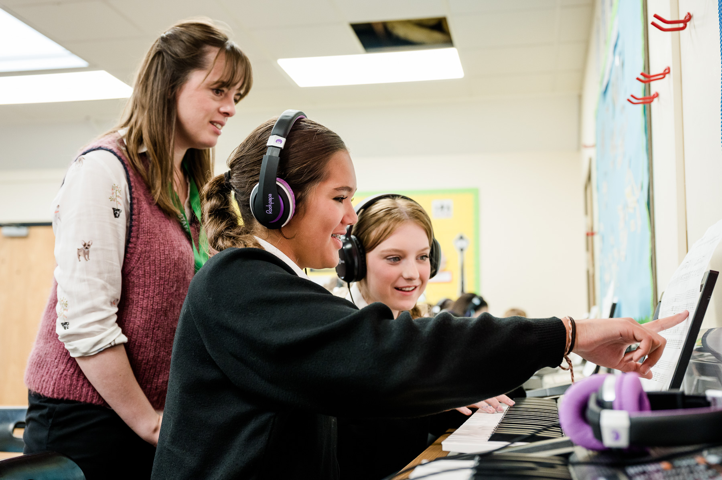

Wood Green School
Woodstock Road
Witney
OX28 1DX

01993 702355
hrwest@acertrust.org.uk
www.wgswitney.org.uk

