
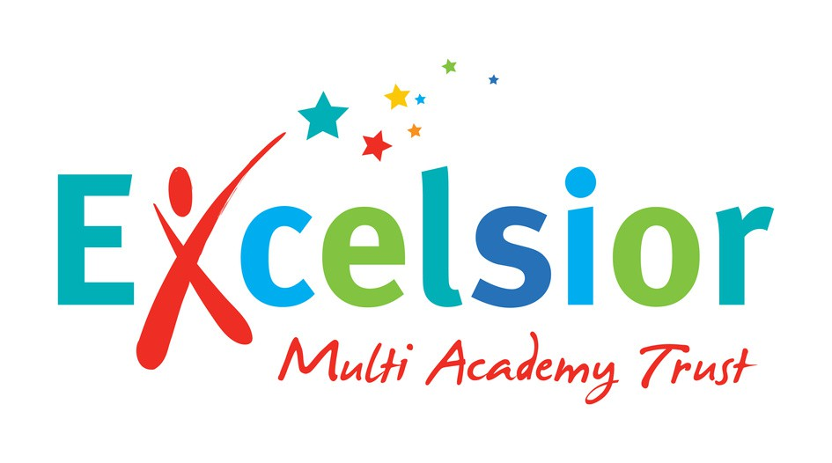



Fantastic Opportunity!
Mini Bus Driver
Excelsior Multi Academy Trust
Location: Green Meadow Primary School in the First Instance
www.greenmeadow.excelsiormat.org
www.excelsiormat.org
www.excelsiormat.org

Contract: Zero Hour/Casual Contract
Pay scale: Grade 2 Scale Point 3 - £25,614 per annum/£13.45 per hour
Term Time Only
Closing date: 18th September 2026
Interview Date: 1st October 2026

Green Meadow Primary School is proud to be part of the Excelsior Multi-Academy Trust.
With their support we continue to improve and provide our children with the best education possible as well as helping to nurture and develop their personal and social skills. Our values of succeeding together, engaging in learning, ensuring equality for all, and aspiring from the start, shape all we do across Excelsior Trust and our schools. Our ‘No Outsiders’ approach to equality ensures everyone is welcome in all our schools.

Above all, we understand that our schools are communities; and that we all benefit from creating a working environment in which staff feel happy, valued and gain satisfaction from their work. We are driven by our core values of:

OUR VALUES
Succeeding together Alone you are good, together we are amazing.

Aspiring from the start Where ambition begins on day one.

OUR VISION
Our schools to be outstanding beacons of equality, where pupils succeed in a safe, innovative, and vibrant learning community.

OUR VALUES
Ensuring equality for all Equality, first, foremost, forever.

Engaging learning
Unlocking minds every day.

Excelsior Multi Academy Trust presently comprises of Colmers Farm Primary School, Green Meadow Primary School, Heath Mount Primary School, Highters Heath Community School, Parkfield Community School, The Meadows Primary School, Thorns Primary School, and Turves Green Primary School.

Excelsior’s main aims are to:

- Provide outstanding education through our values of equality, aspiration, and innovation.
- Develop outstanding leadership and well trained and motivated and happy staff, who will improve our pupils’ outcomes in an exciting learning environment.
- Deliver a broad, balanced, and innovative curriculum of opportunity.
- Provide opportunities for pupils to develop resilience, compassion, and respect for all.
- Provide our communities with excellent schools.

Core purpose of the role

We are seeking a reliable and committed Minibus Driver to join our team, supporting Green Meadow School initially. There may also be opportunities to support other schools across the Trust on an ad hoc basis, with appropriate notice given in advance of any additional requirements.

- To provide flexible, on-demand transport cover to support Green Meadow Primary School’s curriculum enrichment and logistical needs.
- To provide safe, reliable, and efficient transport for primary school pupils.
- To operate the school minibus for educational day trips, swimming lessons, and inter-site sporting events, strictly adhering to safeguarding guidelines, transport legislation, and road safety regulations.
- To hold a full, clean UK Driving License with D1 entitlement (or equivalent older category).
- To hold a MIDAS (Minibus Driver Awareness Scheme) certificate.

What can we offer you:
An outstanding, innovative, and ambitious executive leadership team who, through their passion and drive to improve outcomes for children, support and motivate each other to achieve great things! In return for your commitment to our Trust, we can offer:

Sector competitive pay.
Excellent CPD opportunities.
A fantastic supportive working environment.
The opportunity to make a significant difference in the lives of children across Birmingham. Access to our mental health and wellbeing platform, ExcelWell.
The opportunity to develop into a highly effective leader. 24/7 advice and helpline.
Flexible working arrangements.

Recruiting and Onboarding:
If you would like an informal chat, or further information about the role, please contact hr@excelsiormat.org or contact Green Meadow Primary School directly 0121 475 4505.

How to apply:
Please visit our website to download the Job Description & Person Specification and complete the online application and monitoring forms. If you have any queries, please email: HR@excelsiormat.org. Please do not send in CVs, the application form covers the information required and is designed to ensure fairness during interview shortlisting. Receipt of two references are required as part of the interview shortlisting process. Your application may be rejected if adequate references have not been provided.

The Trust is committed to safeguarding and promoting the welfare of children and young people and expects all employees and volunteers to share this commitment.

