BIOLOGY TECHNICIAN
PART TIME HOURS/TERM TIME ONLY (March 2026 START)

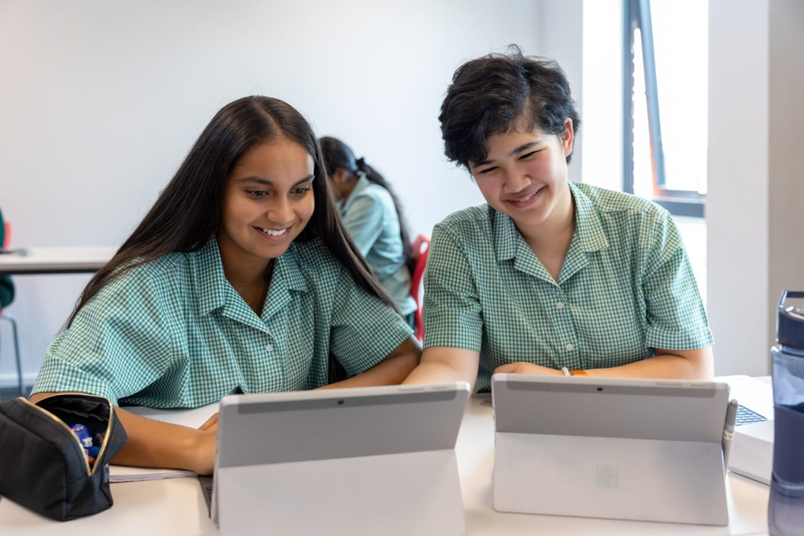
Thank you for showing an interest in this post. We hope that the following information about St Helen’s School, the job description and person specification will help you to decide that this is an application which you wish to pursue.

WELCOME TO ST HELEN’S

St Helen’s is a large, thriving all-through school and many of the girls who leave us at the end of Year 13 have been with us since Nursery or Reception. We are ambitious for every single girl: that she achieves her potential; that she leaves us to embark upon an exciting and fulfilling future, able to deal with whatever life throws at her with resilience and courage; that she possesses inner confidence, strong personal integrity, and a sense of fun; that she is ready to go out into the world and make a difference.

St Helen’s has a long tradition of academic excellence which encourages girls to pursue intellectual curiosity beyond the curriculum. We are proud of our 2025 results where 87% of A Level students obtained A*/A and 81% of GCSE grades were awarded at grades 9-7. Sixth Formers go on to established, high-ranking universities including Oxford and Cambridge, with more than a third studying STEM subjects. However, we give our girls much more than just academic success; our Co-Curricular programme is rich and varied, and our pastoral care ensures that every girl is known, valued, and cared for.

Within easy reach of central London, our school is set in 21 acres of grounds and, just as we are proud of our students’ academic achievements and their personal development, we are also proud of our facilities and buildings. We have invested significantly in developing our facilities over the last ten years and have plans to do more.

St Helen’s has a warm and lively atmosphere that makes it a rewarding and exciting place to work. Our staff and our pupils look out for each other and encourage each other to be the best possible version of themselves. As such, you will play a vital role in supporting the school in the next stage of its journey. We look forward to receiving your application.

Bridget Ward
Head
THE SCHOOL

St Helen’s is an academically selective independent girls’ day school of more than 1100 students aged 3-18, set in beautiful green space in Northwood, Middlesex.

It draws pupils from a wide area of north-west London, Buckinghamshire, and Hertfordshire with easy access by Underground from central London.
We want our students to be brave and true, ever intellectually curious. They will believe they can do anything. They will want to explore how they can best interact with the world around them and make a difference for the better in their own way. They will be ready for whatever the future brings.

Our aims are:
- To provide each and every girl with the opportunity and means to achieve academic excellence.
- To provide our students with the personal skills, emotional resilience, and the confidence to achieve their full potential through a varied, rich and challenging Co-Curricular programme.
- To know, value and respect all girls as individuals so as to best support them on their journey through the school.
- To ensure that the girls are ready to play a full and active part in their communities and in an interconnected digital world.

Our students achieve high academic standards, and we encourage them to develop lifelong skills in a diverse range of areas, both within and outside the curriculum, and to pursue their individual ambitions. The school is proud of its tradition of providing a balanced and forward-looking education through which its pupils can become confident independent learners and leaders in their fields, their professions, and their communities. Attention to the individual child is at the heart of everything we do and shapes the pastoral care, teaching and learning and the co- curricular opportunities on offer at St Helen’s.

THE DEPARTMENT

The Science Faculty in Senior School is led by the Head of Science & Physics,

supported by separate Heads of Biology and Chemistry. GCSE and A Level

Science results in recent years have been outstanding and pupil take-up of all

three Sciences at A Level is excellent. A significant number of pupils go onto

study science-related degrees, including Engineering, Medicine, Veterinary

Medicine, Natural Sciences and Engineering.

Science teaching takes place in the STEM building, which comprises the original

science block (comprising ten laboratories on two floors, ample preparation

rooms, storage facilities and offices) and a new STEM extension

accommodating Maths classrooms, Design & Technology workshops, and a

Physics project laboratory. All Departments are well-resourced with class sets of

apparatus to carry out a wide range of Biology, Chemistry and Physics

experiments and investigations. All laboratories and study areas are networked to the school system. The Science Faculty is at the forefront of the school’s use of technology to enhance learning, and pupils have access to resources and

assignments on MS Teams, OneNote, CENTURY and more. The faculty is well resourced and supported by well-qualified, experienced laboratory technicians.

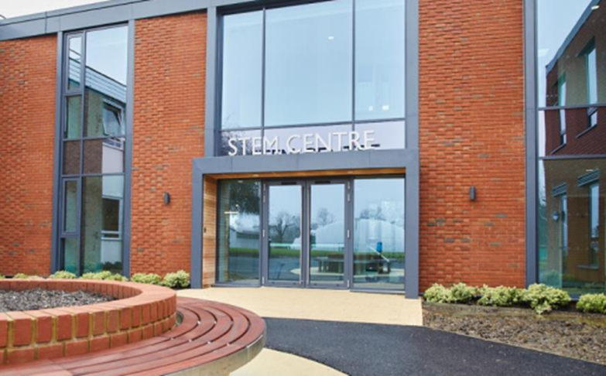

THE POST
St Helen’s is looking to appoint a Part Time Biology Technician to start in March 2026. Hours are 25 per week minimum, however there may be the possibility of additional hours, depending on the candidate. Whilst we need applicants to work a full day on a Friday, there is some flexibility as to which days of the week the remaining hours will be worked. This can be discussed further at interview.

The role is term time only plus INSET days.

Salary: Actual £22,115.18 (FTE £41,856.75))

The role will report to: Head of Biology

MAIN RESPONSIBILITIES
General:
- To maintain the teaching areas, stockroom, and preparation areas to ensure a clean, safe and orderly environment.
- To prepare equipment, materials and any necessary chemical solutions for lessons, demonstrations, displays, exhibitions, clubs, and practical examinations.
- To assist academic staff and pupils with practical work and Co-Curricular activities, such as Science clubs and Outreach events.
- To clear away equipment, materials, and chemical solutions at the end of lessons.
- To clean glassware and other equipment.
- To ensure the maintenance of adequate stock levels by keeping stock records, recommending stock needed and preparing draft requisitions for signature.
- To ensure that the gas and electricity in the laboratories are turned on at the beginning of the day and off at the end of the day.
- To maintain an awareness of curriculum changes.
- Working with other technicians to ensure the school’s smooth running of the Science Department.
- Assisting teachers during lessons as required.

Team Skills:
- To have a flexible approach to rosters, by agreement with the Head of Science, for issues such as the timing of lunch breaks and covering for absent colleagues.
- To have a flexible approach to working across the Science disciplines when needed, by agreement with the Head of Science.
- To attend meetings

Safety:
- To keep up to date with safety legislation, liaise with the Science teachers regarding safety matters and advise them of any potential problems with materials or equipment.
- To periodically test and repair equipment used in the Department to ensure that it is in good working order, and when necessary, liaise with external contractors regarding the repair of equipment, by agreement with the Head of Science.
- To ensure the safe disposal of chemical waste.
- To ensure that any appropriate chemicals are stored correctly and safely.
- To alert the Head of Science to any issues of safety within the Science Department.
- Assist with the preparation of risk assessments as required.
- First Aid provision.

Additional duties:
- To assist academic staff in duplicating and photocopying.
- To maintain Departmental records using a computer for record keeping (using Excel) and word processing (using Word) where appropriate.
- To perform any additional duties as may reasonably be assigned to the Technician from time to time by the Head of Science.

THE PERSON
It is essential for the successful candidate to have the following qualifications,
experience, and personal attributes:

- A science degree or qualification by experience of over 5 years in a similar or related field
- Experience of working with, and an ability to commit to supporting, KS3-5 microbiology lessons. Training is available for candidates who feel they would benefit from a refresher course.
- Experience in handling hazardous chemicals.
- A love of learning and a commitment to further professional development
- Be able to work well with others.
- Demonstrable passion for the subject

It is desirable for the successful candidate to have the following qualifications,
experience, and personal attributes:

- Evidence of further professional development
- Knowledge and experience of how technology can be used to support learning.

BENEFITS
- Competitive Pensions Scheme
- Competitive pay structure with opportunities for progression up the scale
- 50% fee remission for staff children subject to spaces and entry examinations (pro rata for part time staff)
- A strong culture of professional development
- Access to the School’s swimming pool and fitness suite
- High Street Discounts
- Electrical Vehicle Charge Scheme
- Subsidised Staff Coach Travel
- Cycle to work scheme.
- Free lunch and refreshments
- Free on-site parking and excellent public transport links
- Employment Assistance Programme
- Generous occupational sick pay
- A beautiful working environment – the school is set in a conservation site in excess of 21 acres.

APPLICATION PROCESS
Closing date: 9am Monday 16th February 2026

Please apply as soon as possible as shortlisting/interviews will progress up until the closing date. Should a suitable candidate be appointed, we reserve the right to close the advert early.

Due to the high volume of applicants, we receive, if you do not hear from us within 4 weeks of the closing date, please assume we will not be progressing your application further on this occasion.

THE SELECTION PROCESS
Shortlisted candidates will be invited to the school where they will be interviewed
by the Head of Science, be observed supporting a lesson, have a tour of the
school and meet other members of the Biology Department and wider
Faculty.

St Helen’s school is committed to safeguarding and promoting the welfare of children and young people, as detailed in Part 3 (Safer Recruitment) of the KCSIE 2025 guidance document. Applicants will be asked for proof of right to work in the UK and undergo child protection screening, including checks with past employers and the disclosure and barring service.
If you have any queries about this position, please contact the school at recruitment@sthelens.london
