


JOB PROFILE
Job Title: | Teacher of Religion, Ethics & Philosophy (REP) | School/Department: |  | Rossett School
Salary Grade: | M1 to UPS3 | Working Hours: |  | Full time
Contract Type: | Maternity Cover to commence September 2026 | Location: |  | Harrogate, North Yorkshire
Responsible to: Headteacher/Senior Leadership Team
Role summary:
We are looking to appoint a talented, imaginative and enthusiastic teacher to contribute to the development of teaching and learning of REP and key stages 3, 4 and 5. The successful candidate will have the ability to excite and inspire young people and have a passion for REP. This is an excellent opportunity to join a thriving department.

Red Kite Learning Trust is committed to safeguarding and promoting the welfare of students and expects all colleagues and volunteers to share this commitment.
Special conditions of service:
No smoking policy, including e-cigarettes.
Role specific responsibilities:
- To enhance students learning and experience by providing high quality teaching and learning to allow them the opportunity to achieve their individual potential.
- To implement and deliver an appropriately broad, balanced, relevant and differentiated curriculum for students and to support a designated curriculum area as appropriate.
- To monitor and support the overall progress and development of students as a Teacher/Form Tutor
- To contribute to raising standards of student attainment.
- To inspire in students a love for learning by acting as a role model and showing enthusiasm for the subject.
- To use positive management of behaviour in an environment of mutual respect which allows students to feel safe and secure and promotes their self-esteem.
- To meet (or exceed) the Professional Teachers’ Standards at a level consistent with what should reasonably be expected of a teacher in the relevant role and at the relevant stage of their career.
- To share and support the school’s responsibility to provide and monitor opportunities for personal and academic growth.

RK People responsibilities:
- Contribute to the overall aims and values of our Trust, appreciate and support the roles of other members of the wider team and attend and participate in relevant meetings as required
- Comply with all Trust policies and procedures including child protection, health, safety, welfare, security, confidentiality and data protection, reporting any concerns to the appropriate person
- Contribute to ensuring safeguarding procedures are in place and used effectively at all times
The role holder must demonstrate a flexible approach to the delivery of the role. Consequently, the role holder may be required to perform work not specifically identified in the job profile but which is in line with the general scope, grade and responsibilities of the role.
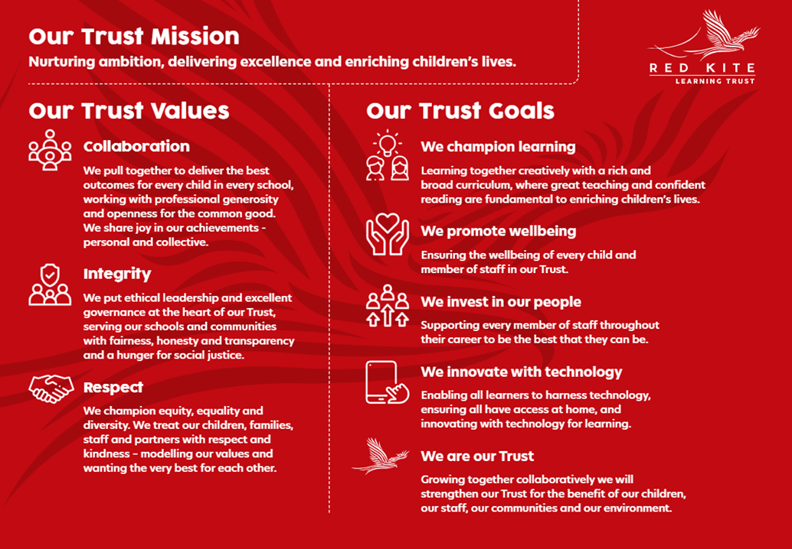
PEOPLE PROFILE
Aptitudes and Characteristics |  |  | Essential |  | Desirable
Skilled classroom practitioner |  |  | *
Highly effective communication skills |  |  | *
Ability to form good working relation ships |  |  | *
Ability to work within and contribute to an effective team |  |  | *
Capacity to evaluate and improve |  |  | *
Ability to work flexibly and collaboratively as part of a team as well as on own |  |  | *
A clear educational vision and sense of direction |  |  | *
Good organisational skills and high levels of self-motivation |  |  | *
Energy, self-confidence and ability to ‘give more’ when the occasion demands it |  |  | *
Competent in ICT including knowledge and application of Management Information Systems |  |  | *
Willingness to continue and improve on professional development |  |  | *
Ability to work under pressure and to meet deadlines |  |  | *
Record of good attendance and punctuality |  |  | *
Qualifications, Knowledge and Experience |  |  | Essential |  | Desirable
Degree level qualification |  |  | *
Ability to teach REP at Key Stage 4 + 5 |  |  | *
PGCE or relevant qualification/QTS |  |  | *
Other subject expertise |  |  |  |  | *
Experience of delivering evidenced based interventions and accelerated learning |  |  | *
Up to date knowledge of curriculum related issues 11-19 |  |  | *
Safeguarding and Promoting the Welfare of Students |  |  | Essential |  | Desirable
An appropriate motivation to work with children and young people |  |  | *
Ability to maintain appropriate relationships and personal boundaries with children and young people |  |  | *
Emotional resilience in working with challenging behaviours and appropriate attitudes to the use of authority and maintaining discipline |  |  | *

