
Woods Avenue, Hatfield, Hertfordshire, AL10 8NN
Telephone: 01707 276 504

Woods Avenue, Hatfield, Hertfordshire, AL10 8NN
Telephone: 01707 276 504

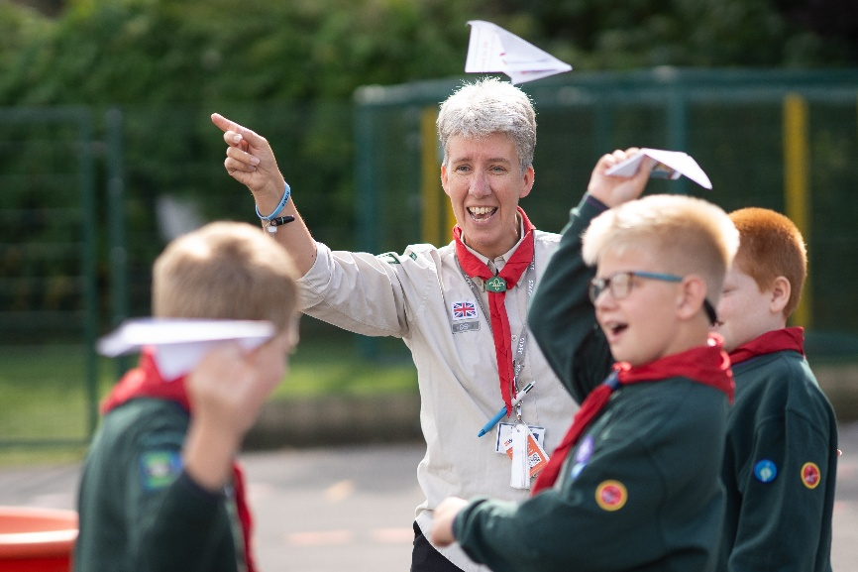
Southfield School
Candidate Information Pack
Forest School Leader

Introduction
Are you passionate about outdoor learning and inspiring children to grow in confidence,
resilience and wellbeing?
We are seeking an enthusiastic and dedicated Forest School Leader to establish, develop
and lead an exciting new Forest School provision at Southfield School.
This is a fantastic opportunity for someone who loves working outdoors in all weathers and
believes in the power of nature-based learning to support children’s emotional, social and
developmental needs.

Contract Type
This is a permanent role, working term time only.

Start Date
We are looking to appoint as soon as possible.

Please note: If we receive a high volume of applications, we may close this advert early. Southfield School reserves the right to interview and appoint candidates on receipt of applications before the closing date. We encourage you to submit your application as soon as possible.

Salary
£25,989 - £32,061 FTE (Grade 3 - 6)

About the School
Southfield is a primary school for over 100 pupils with Learning Difficulties, which include, Autism, Speech Language and Communication Needs, Global Developmental Delay, and other conditions.

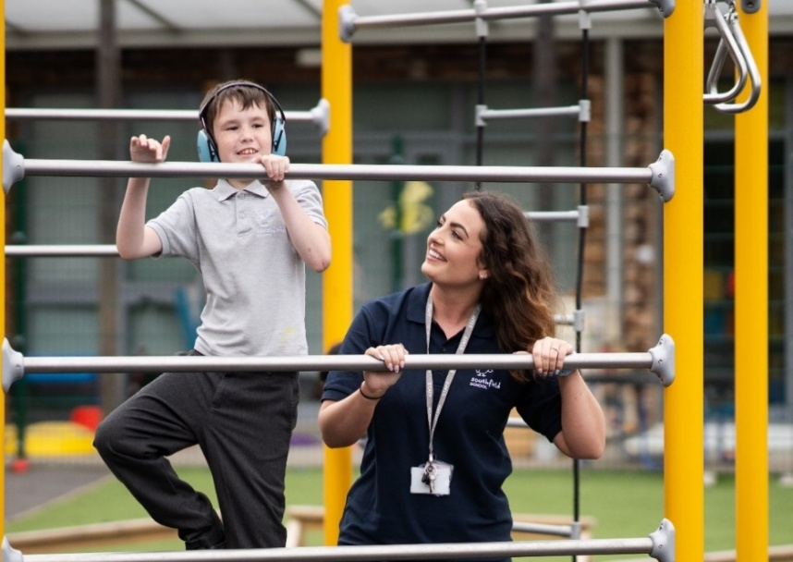
Admissions are via the Local Authority, and the present criteria is that children are accessing learning approximately 50% below their chronological age. We follow the EYFS and Key Stage 1 National Curriculum and adapt these to meet the individual interests and needs of our pupils. We do this through a 3 Phase curriculum that is presently being developed. Priority is given to communication, self-regulation, independence and functional Literacy and Maths. We use a wide range of approaches and strategies to support learning, including multi-sensory communication, social stories, TEACCH and Hertfordshire Steps. We also work with a range of professionals, from advisers in the Local Authority to Therapists and social care colleagues. Access to sporting and creative arts organisations, provide a range of enhanced learning opportunities, both in school and the local area.

Southfield is going through a period of rapid and exciting change, that you could be part of. It is a journey of challenge, in the pursuit of excellence, but one that provides huge rewards both personally, in your professional development and when you see the difference you make to the lives of our young people and their families.

About the Role
Purpose of role:
To plan, develop and establish our new Forest School
To plan and lead sessions that incorporate a wide range of activities such as outdoor cookery, environmental stewardship, woodworking and shelter building alongside other creative activities.
To promote and develop children’s confidence, wellbeing, resilience and social skills

Working Conditions
- Outdoor work in all weather conditions.
- Physical activity, including setting up equipment, walking on uneven ground, or lifting.
- Possible after school club opportunities

Key Responsibilities
Planning and Delivery
- Design and deliver Forest School programmes in line with Forest School ethos and principles.
- Adapt activities to suit pupils’ developmental, sensory, emotional, and physical needs.
- Incorporate cross-curricular links (e.g., literacy, numeracy, science, wellbeing).
- Create inclusive, child-centred sessions that promote curiosity and independence.

Supporting Pupil Development
- Build trusting relationships with pupils.
- Foster emotional wellbeing, resilience, and positive behaviour through outdoor experiences.
- Encourage teamwork, communication, problem-solving, and environmental awareness.
- Monitor and assess pupils’ engagement and development during sessions.

Health, Safety, and Safeguarding
- Conduct and record risk assessments for all activities and outdoor areas.
- Ensure safe use of tools, fire, and natural resources following Forest School best practices.
- Maintain equipment, storage, and site cleanliness.
- Follow the school’s safeguarding, behaviour, and health & safety policies.
- To participate in training and other learning as required.

Professional Collaboration
- Work closely with class teachers, TAs, SENDCo, and therapists to support specific pupils.
- Communicate regularly with staff and parents about pupil progress and wellbeing.
- Lead or support staff CPD on outdoor learning, when required.

Administration and Evaluation
- Develop curriculum planning, evaluations, and assessment records.
- Contribute to the school’s additional curriculum planning or development documents.
- Assist in reporting for school development plans, inspections (e.g. Ofsted), or funding bodies.

Person Specification:
- Qualifications: Forest School Level 3 qualification e.g. through the Forest School Association (or willing to complete). Desirable: Other outdoor experiences and/or qualifications (e.g. Bushcraft)
- Hold a current Paediatric / 16 hour outdoor first aid certificate and food hygiene certification
- Experience of working with groups of children at different stages of development and with SEN. Desirable: Experience of working in a primary school. Ability to engage constructively with and relate to a wide range of children, children with SEN and families/carers
- Recent and significant experience in leading and planning Forest School/outdoor education sessions with children of a range of ages
- A love of working outdoors regardless of the weather, whilst ensuring the safety of the children when working in wet and muddy conditions / uneven surfaces, or in hot and sunny conditions.

Knowledge, Skills and Understanding
- Knowledge and practical understanding of child development.
- Commitment to equal opportunities for all learners.
- An understanding of health and safety requirements and welfare issues of working with young children.
- A good general knowledge of wildlife, flora and fauna and conservation issues.
- Understanding of the Forest School Ethos and be able to apply this throughout all working practice, both with children and staff.
- Able to work independently and to manage own time efficiently.
- Good organisational skills
- Excellent communication skills, within a wide age range including staff at all levels.
- Computer literate for report writing and recording.
- Full working knowledge of current statutory and regulatory guidelines related to outdoor learning and education.
- Understanding of Child Protection & Safeguarding

Personal Qualities
- Enjoy working with primary aged children from a range of backgrounds and SEN needs and commitment to supporting their physical, social and emotional development through forest school activities
- Commitment to continued professional and personal development.
- Professional credibility & commitment to equal opportunities and valuing diversity
- Demonstrate a commitment to supervision and reflective practice.
- Fully adhere to all safeguarding policies and especially in support of vulnerable pupils

Personal Characteristics
- Warm and caring personality, friendly and approachable.
- Flexibility and adaptability:
- Being able to adjust plans and activities in response to the needs of the children and the environmental conditions.
- An ability to innovate and devise imaginative ways to deliver forest school experiences.
- Passion for outdoor learning
- An enthusiasm for inspiring children to learn and grow in an outdoor environment.
- Ready to learn from and rise to challenges – keen for all children and staff members to thrive. Creative, practical thinker who works well as part of a team.
- Punctual and organised

A word from our Headteacher

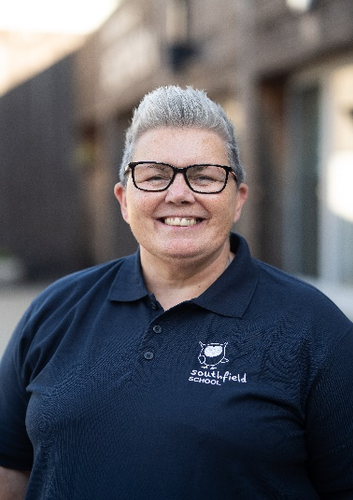
Are you bored with life? Looking for a new challenge? Have a desire to work in an environment where you can make a ‘real’ difference to the lives of young people? If so, Southfield School is the right environment for you.
We are a family with over 100 pupils. No two students are alike, and no two members of staff are alike. Our pupils all have challenging ASD and associated conditions.
Our school vision is to support all children, so they thrive during their time at Southfield School and are prepared socially, emotionally, and academically for their next steps in education. Collaboration with parents and carers and the entire multi-disciplinary team who support our students is vital and key to our success.
Everyone plays a part in the future of our students with staff skills being used in order that we have a huge range of skill set and expertise. Everyone makes a difference to the lives of our students and families.
We are looking for like-minded, resilient staff who are passionate and who can work in a team.
If you have yet to find what it is that you were meant to do with your life – Southfield School may be what you have been searching for.

Come and join us and make a difference to the lives of children every day.

Angela O’Rourke
Headteacher

Our Vision and Values

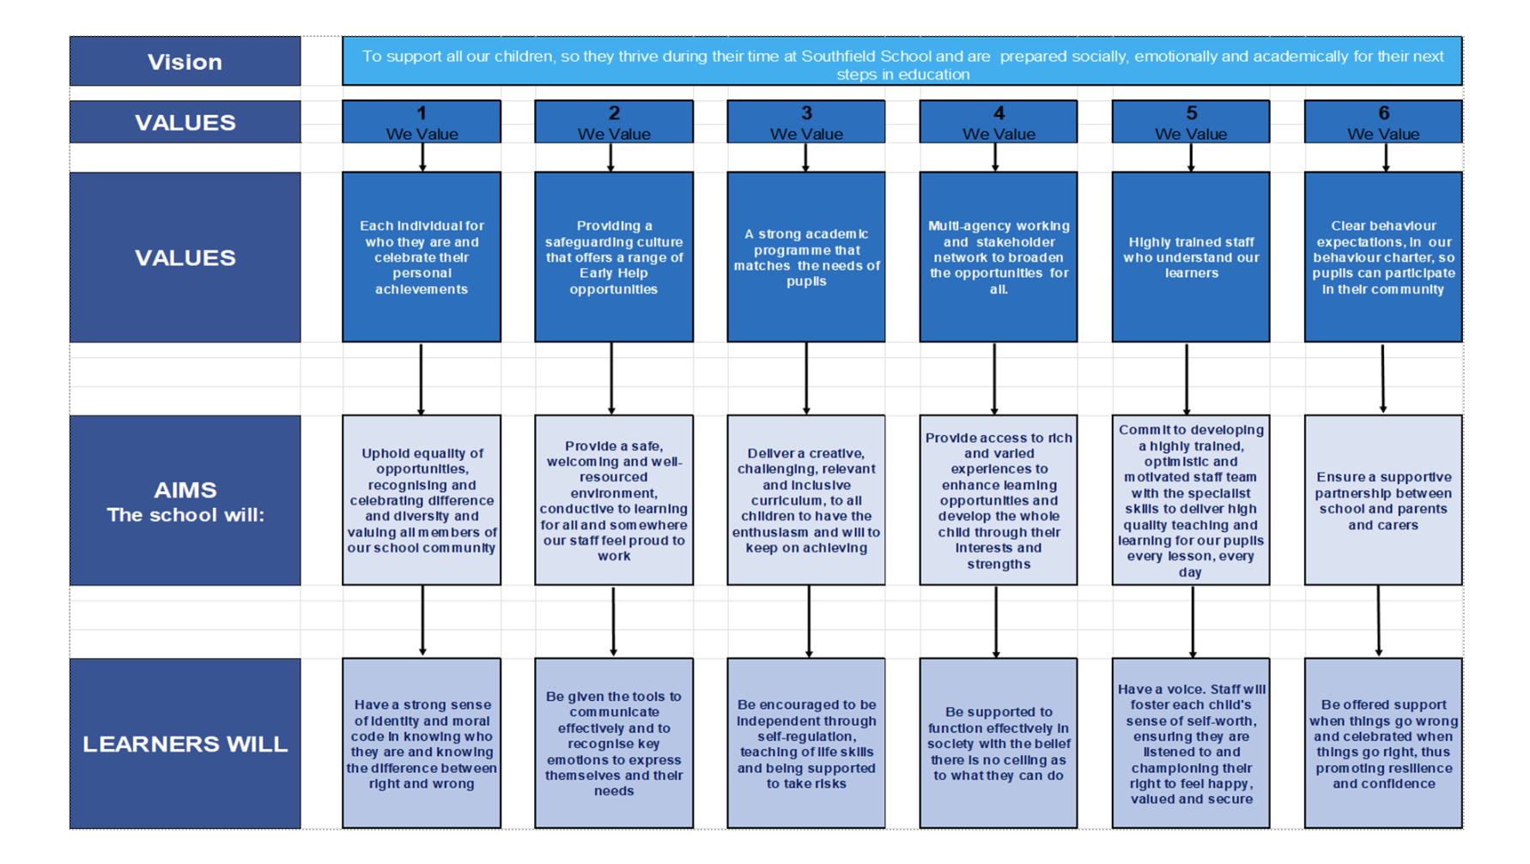
A Bright Future for ALL
Post Application Information
Equal Opportunities Monitoring Form
At Southfield School, we want our workforce to reflect the diversity of the community we
serve. It is our policy to ensure that job applicants and employees are treated justly, and are
recruited, selected, trained, and promoted on the basis of the job requirements, skills and
abilities. We will ensure that people are not disadvantaged by conditions or requirements, which cannot be shown to be justified as being necessary for the effective performance of
the job. You are under no obligation to complete this form, however if you do you are agreeing, under the Data Protection Act 2018 that Southfield School may hold and use personal information about you for monitoring purposes.

Safeguarding
Southfield School has a responsibility for and is committed to safeguarding and promoting
the welfare of children, young people, and vulnerable adults to ensure that they are
protected from harm. All conditional offers of employment are subject to the following pre-employment clearances:

Satisfactory Medical Clearance
All successful candidates complete a medical questionnaire and may be required to pass a
medical examination by the Southfield School.

Satisfactory References
It is the school’s practice to take up 2 references from your last two job references. Referees must not be a member of your family, or spouse/partner and the reference must be provided on letter headed paper or come from a work email address. If you are a recent school or further education leaver, one of your references must be from your school or college. Occasionally more than two references may be required, if this is the case, we will inform you before we contact former employers.
In line with our safer recruitment policy, we will take up references ahead of interview. Once we have received your references, we will call your referees to verify that the reference
is from them as part of the keeping children safe in education requirement. No employment
will be offered until 2 satisfactory references are received.

Rehabilitation of Offenders Act 1974
The Rehabilitation of Offenders Act 1974 makes it unlawful for prospective employers to
consider offences in relation to which the person concerned is deemed to be rehabilitated. This means that after a certain period (dependent on the seriousness of the offence
and length and severity of the punishment), the person concerned is to be assessed as if the conviction has been ‘spent’ (i.e. treated as if it had never occurred). Rehabilitation periods vary according to the type and length of conviction originally incurred. All posts within the school are covered by the Rehabilitation of Offenders Act (Exemptions)
Order 1975 and DBS clearance is required and therefore detail must be given about all
convictions, whether spent or not.

Disclosure and Barring Service (DBS) (Previously CRB) Clearance
As all posts require a DBS check, the successful candidate will be required to complete the
appropriate DBS documentation. The successful candidate will be unable to take up the
appointment until the clearance is received from the DBS. The timescale for these checks is
outside the Southfield School’s control.

Prohibition from Teaching
All teaching appointments are subject to a check with the Department for Education to
ensure that you are not subject to a prohibition order or an interim prohibition order.

Evidence of Qualifications
We will need evidence of the qualifications (original certificates) you specify in your
application form. Originals must be brought to the interview for candidates who have been
short-listed. Copies will not be accepted.

Eligibility to work in the UK
To comply with the Asylum and Immigration Act 1996 (As AMENDED) (Immigration, Asylum
and Nationality Act 2006), all employers in the United Kingdom are required to make basic
documentation checks on every person they intend to employ. We ask all short-listed applicants to provide proof that they can be legally employed. We must see satisfactory proof in the form of original documentation before we can confirm any
offer of employment. If we do not see satisfactory proof, an offer of employment can be
withdrawn.
The complete list of documents that may be accepted as proof of your identity, along with
information on the number and types required can be found below. There are three routes as outlined, however where possible, we encourage short listed applicants to produce
documents which adhere to Route 1 of the ID Checking process to avoid delays in the ID
checking process.

