

JOB DESCRIPTION
Teaching Assistant (Level 3 - Rotational)

PLACE OF WORK: Alderman Cogan’s Church of England Primary Academy |  |  |  | GRADE: NJC Scale 8-12
REPORTS TO: Head Teacher, Phase Lead or other Senior Leader within School

1. |  | MAIN PURPOSE OF JOB  - To work as part of the classroom team with a set of core duties supplemented by rotational tasks which can be adapted to meet the current and future needs of the school and its children.  - To work with teaching staff in the school as part of the classroom team, undertaking core learning, care, safeguarding and support activities which optimise opportunities for all children to learn in a safe and healthy environment.  - To focus on the areas of need within the school around Classroom Support, SEN, Safeguarding & Wellbeing, or Early Years as detailed below.
 |  | 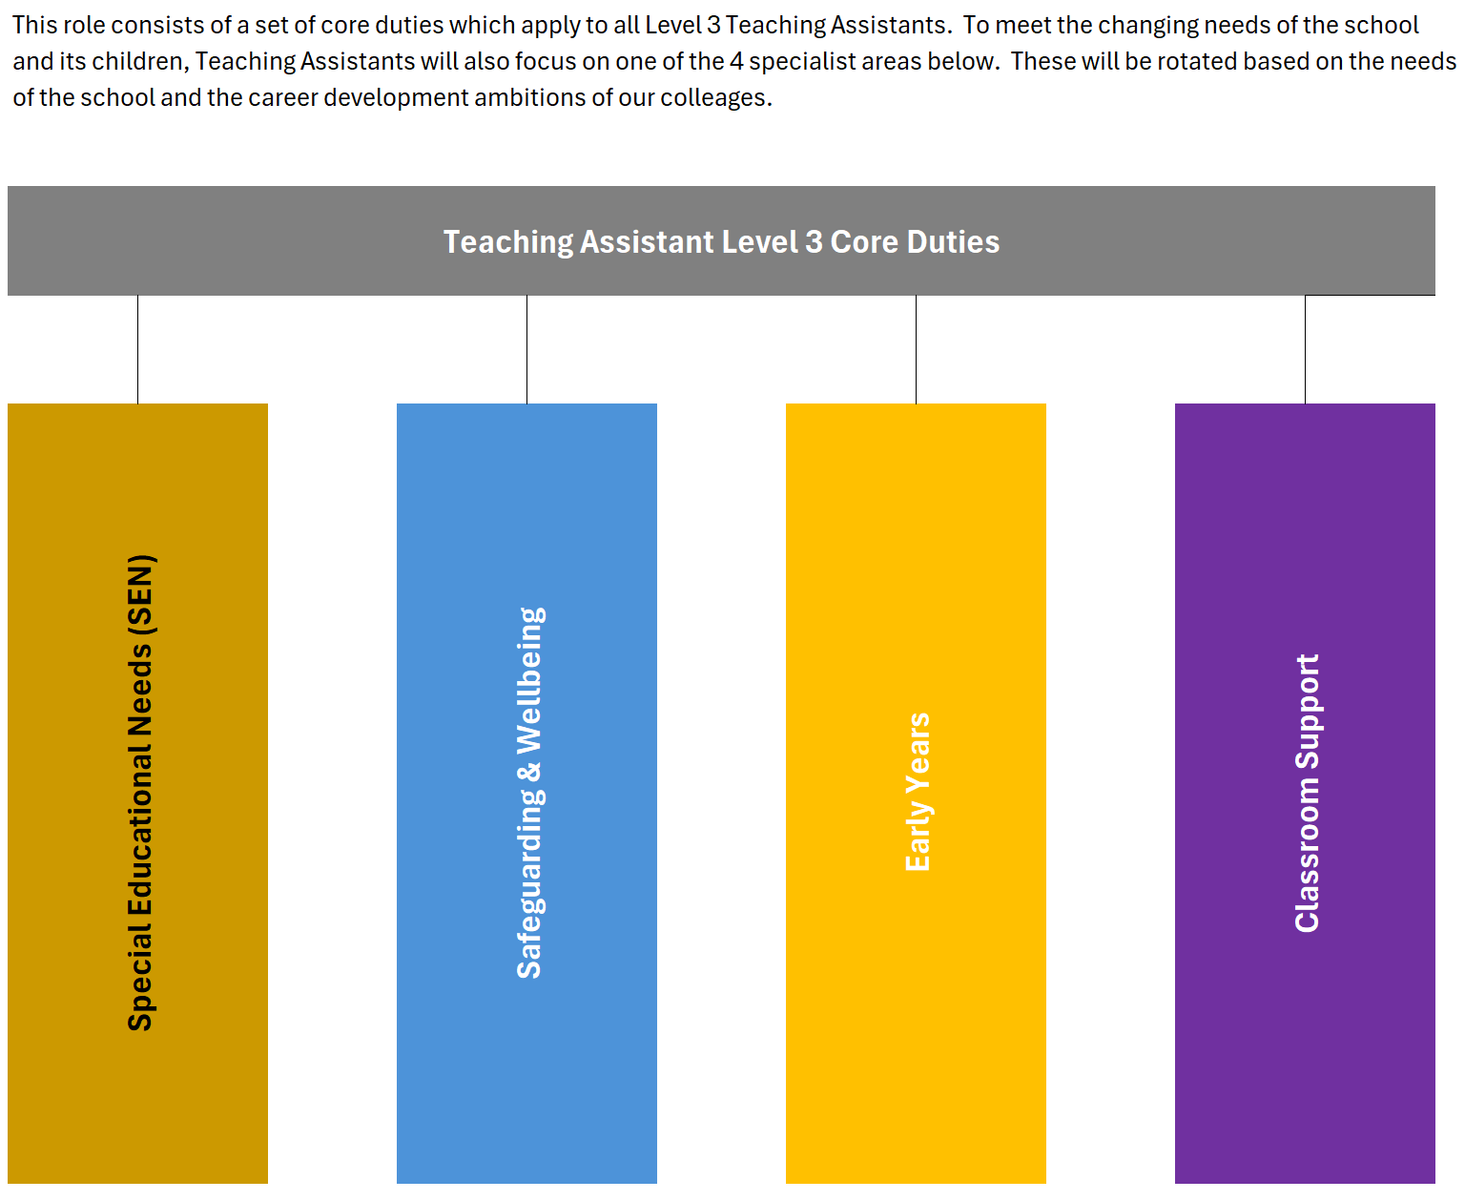
2. |  | The following key tasks will apply to all Teaching Assistant Level 3 roles.
The following key tasks will apply to all Teaching Assistant Level 3 roles. |  |  | Works under the guidance of the class teacher, SENCO or a member of the school leadership team within an agreed system of supervision. Works with individual pupils, small groups and, where appropriate and exceptionally the whole class, under the guidance of the teacher, to implement and deliver activities and interventions.
 |  |  | Uses own initiative to deliver and implement learning activities by applying specific skills, knowledge and experience with and of pupils, under the guidance of the teacher.
 |  |  | Plans and prepares own work in accordance with the teacher/ SENCO’s instructions. May be required to adapt work/activities as directed by the teacher.
 |  |  | Contributes to the planning cycle under the guidance of the teacher. Prepares and differentiates work defined within the planning cycle, under the guidance of the teacher. Monitor & provide feedback around progress & attainment.
 |  |  | Works with other adults involved in the education process under the guidance of the teacher and by application of specialist skills and knowledge. Enhance learning through speech & language development delivering interventions for identified children.
 |  |  | Attends and contributes to meetings with other staff, external professionals and parents regarding pupils under the guidance of the teacher. Support the teacher to strengthen community partnerships & links with external agencies.
 |  |  | Support colleagues across the school staff as directed by the teacher, SENCO or Leadership Team by applying any specific skills, experience and knowledge in relation to pupils and the curriculum, including routine administrative and clerical tasks.
 |  |  | Accompanies other staff on school visits and in other activities outside of the classroom and has responsibility for specific pupils or small groups as directed by the teacher.
 |  |  | Follows all school and Trust policies and procedures, in particular related to health and safety, child protection, behaviour management, inclusion, equalities Policy and Data Protection Policy.
 |  |  | Participate as required in the school’s staff development reviews and supervision systems and take part in appropriate training and development activities.
 |  |  | Support the class teacher in the delivery of school phonics (SSP SOW) including interventions which ensure learners keep up and are able to read and write at age related expectations.
 |  |  | Contributes to the overall ethos, work and aims of the School.
 |  |  | Have a flexible and proactive approach to ensure the needs of the children within the school are being met with the support of the team.
 |  |  | Undertake relevant training and be prepared to attend some training courses out of contracted hours which would be recompensed.
 |  |  | Any other duties commensurate to the level of the post.
The above will be supplemented with rotational tasks based on either SEN, SGW or Classroom Support to define the duties for the academic year. These may change in subsequent years.
Special Educational Needs (SEN) |  |  | Respond to the emotional and mental health needs of children, making adjustments as required to enable them to access learning & development opportunities in the classroom
 |  |  | Provide specialist, in-class support to individual pupils or small groups as directed by the SENCO, with a primary focus on closing the attainment and progress gap for students with specific learning needs
 |  |  | Plan, deliver, and evaluate bespoke learning activities and interventions to help pupils access the curriculum and achieve their Individual Education Plan (IEP) or Education, Health and Care Plan (EHCP) targets.
 |  |  | Support children with complex needs so that they (and others in class) optimise the learning & development opportunities of a main-stream setting by de-escalating situations and promoting a calm and effective learning environment.
 |  |  | Ensure that SEND needs are captured and considered as part of the pupil voice and in consultations involving children with alternative or additional needs.
 |  |  | Support children with English as an Additional Language to ensure that their needs are met in order to optimise their experience in the classroom setting
Safeguarding & Wellbeing |  |  | Under the direction of the DSL, support children where there is a safeguarding concern or wellbeing need, delivering required support and intervention.
 |  |  | Promote the safeguarding and wellbeing of children within the classroom setting on an individual and collective level, supporting the classroom team to deliver a safe and healthy learning environment.
 |  |  | Link with multi-agency support by providing information for early referrals and ongoing case management as support for the DSL
 |  |  | Support the DSL with the requirements for children's emotional and social needs as a result of child protection planning meetings
 |  |  | Work with school leadership to provide intervention and support for children whose barrier to education is a lack of school attendance by devising and delivering attendance improvement plans. Carry out pavement visits alongside a member of SLT.
 |  |  | Maintain and update records and administrative processes associated with pupil wellbeing and safeguarding
 |  |  | Develop and devise behaviour support plans working alongside children and staff as a mentor and positive advocate to promote positive behaviours for learning.
Early Years |  |  | Support early years development in speech and language to enable children to ensure readiness for Reception year.
 |  |  | Access tools and interventions to support early years development, building a foundation for future learning.
 |  |  | Ensure timely and accurate preparation and use of provision, equipment, resources and materials as required by the class teacher to ensure early years learning is stimulating, well organised and accessible.
 |  |  | Observe and support children as the make progress through the EYFS 7 areas of learning, using: observing, discussion, wonder, play, questioning & challenge.
 |  |  | Support the development of strong partnerships with parents-as-partners as well as developing links with community and children’s services
Classroom Support Role |  |  | Assists the teacher in the preparation of the classroom and resources for planned work to take place. This may involve adapting work and activities as directed by the teacher.
Assist with record keeping on pupil progress as directed by the teacher.
.
 |  |  | Contributes to the assessment and monitoring of pupil progress through planned pupil observation, marking, recording and feedback procedures.
 |  |  | Contributes to the school improvement plan by taking responsibility for specific areas of work that are appropriate to the individual’s skills, knowledge and experience as identified by the School leadership team.
 |  |  | May be given specific areas of responsibility within the school that are appropriate to specific skills, knowledge and experience, for example, in maintaining curriculum resources in a given subject area, preparing displays, etc.
3. |  | SUPERVISION / MANAGEMENT OF PEOPLE  This role does not require the supervision of staff.
4. |  | MAIN CONTACTS & RELATIONSHIPS  - Internal: School staff, particularly in the relevant Key Stage/ Phase  - External: Provides information about pupils’ progress to parents and external stakeholders at informal and sometimes more formal meetings.

PERSON SPECIFICATION
Teaching Assistant (Level 3 – Rotational)

5. | KNOWLEDGE AND QUALIFICATIONS  Essential, i.e. the postholder must have:  - Minimum level 2 literacy and numeracy qualification  - Competent user of IT  - Good knowledge of normal child development and children’s personal development needs  - Knowledge of strategies which promote good behaviour and discipline, including those relevant to special educational needs  - Full working knowledge of school policies relating to health and safety, behaviour, attendance, equal opportunities, child protection.  - Working knowledge and experience of implementing national curriculum and other learning programmes/strategies.  - Understanding of statutory frameworks relating to teaching  - Full Teaching Assistant Level 3 qualification, or a commitment to undertaking  this training within the first year of appointment.  Desirable, i.e. the postholder would ideally have:  - Specific knowledge relating to the learning and development of special educational needs children  - Specific knowledge relating to the learning and development of Early Years children  - Knowledge and experience of safeguarding and child wellbeing
6. | EXPERIENCE  Essential, i.e. the postholder must have:  - Significant experience working with children in a supportive capacity  - Significant experience working with children with challenges in accessing the curriculum  - Experience of adjusting planned activities to enable a pupil to access the curriculum fully and make progress, and discuss these with the class teacher  - Experience of modifying or developing resources to support teaching  - Experience of using ICT to support learning  - Experience of working with children in the relevant Phase/ Key Stage  - Experience of working effectively as part of a team.  Desirable, i.e. the postholder would ideally have:  - Experience of working in one or more of the rotational areas contained within this job description.
7. | SKILLS AND PERSONAL QUALITIES  Essential, i.e. the postholder must have:  - Excellent verbal communication skills for communicating with pupils, teachers and others in the school, plus parents and relevant others  - Strong time management and organisational skills  - Ability to work on own initiative  - Ability to participate fully in planned physical interventions, in pupil personal care routines and in moving and handling pupils with physical disabilities safely, using appropriate mechanical and other lifting devices, following recognised procedures.  - Resilience in the face of challenging pupil behaviour  - Able to take appropriate action to meet pupils’ needs as they arise to avoid undue physical or mental stress.  - Able to contribute to the planning and review of the differentiated curriculum and individual education plans/individual behaviour plans.  - Able to participate in the design of classroom and school displays  - Good team player with adaptability to meet the changing demands of a rotational role.  - Willing to continue own professional development  - Constantly improve own practice/knowledge through self-evaluation and learning from others  OR  - a willingness to undertake training where needed to meet the requirements of the relevant area of this rotational role.

