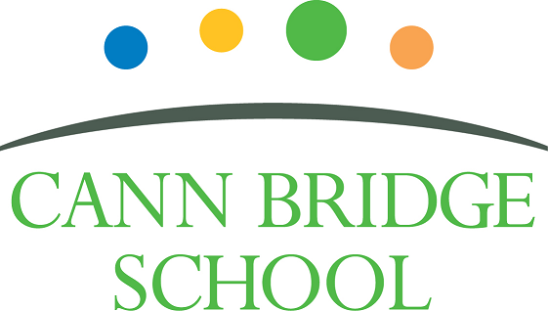

Senior Teaching Assistant (Grade D/E)
Candidate Information Pack

March 2026

Welcome from the Headteacher

Dear Prospective Candidate,

Thank you for your interest in joining our dedicated and compassionate team at Cann Bridge School. As Headteacher, I am delighted to introduce you to our school and the exciting opportunities that await you here.

Cann Bridge School, located in Estover, Plymouth, is a local authority-maintained special school serving children and young people aged 3 to 19 from Plymouth, Devon, and Cornwall. With a capacity of 108 pupils, we are a consistently oversubscribed school.

Our school is uniquely designed to meet the needs of pupils with complex cognition and learning needs. All of our learners have an Education, Health and Care Plan (EHCP) identifying either a Severe Learning Difficulty (SLD) or Profound and Multiple Learning Difficulty (PMLD). Many also experience additional specific learning challenges such as Down’s Syndrome, Autism Spectrum Condition, speech and language difficulties, physical disabilities, or complex medical conditions.

To learn more about life at Cann Bridge School and our latest updates, please visit:
- Website: www.cannbridgeschool.co.uk
- Facebook: www.facebook.com/cannbridgeschool
- School Newsletters www.cannbridgeschool.co.uk/families/newsletters-forms

At Cann Bridge School, we are committed to creating a nurturing and inclusive environment where every learner is supported to thrive. We are relentlessly learner-focused, and our mission is to provide high-quality, individualised education tailored to each child’s needs. Our dedicated staff create a calm and purposeful environment, delivering personalised learning through our Pathways to Independence Curriculum and Long-Term Rolling Programme, supported further by our EYFS and 14–19 Curriculum Policies (available on our website).

With a proud history spanning over 60 years, formerly as Downham School, Cann Bridge moved to its current purpose-built site in 2012. We are co-located with Tor Bridge High, Tor Bridge Primary, and Plym Bridge Nursery. Since then, we’ve expanded further with the opening of our Post-16 provision, Post Bridge College (2016), extensive remodelling (2022), and two new modular classrooms (2024). Our excellent facilities include sensory rooms, an immersive suite, library, warm water pool, science garden, soft play area, and Forest School. These continue to be developed with support from fundraising and our active PTFA, Friends of Cann Bridge.

We are also on an exciting improvement journey, guided by our School Development Plan and recent Ofsted Report – both available on our website. These highlight our ongoing commitment to progress, innovation, and excellence. We place strong emphasis on professional development, ensuring all staff have access to high-quality training and the latest approaches in special education.

The role of Senior Teaching Assistant (Grade D/E) at Cann Bridge School is both demanding and deeply rewarding. As a Senior Teaching Assistant, you will play a pivotal role in our classrooms – leading, mentoring, and inspiring your colleagues while supporting pupils’ educational, emotional, and social development. Working in close partnership with the Class Teacher, you will help shape learning experiences that celebrate strengths, nurture independence, and prepare our learners for the future. You will also lead small group work, deliver interventions, support positive behaviour strategies, and take on responsibility during teacher PPA or leadership time.

We are looking for experienced and passionate Teaching Assistants who are ready to take the next step in their careers or who are seeking a meaningful change in setting. This is a unique opportunity to join a supportive and forward-thinking school, where your leadership, compassion, and commitment will make a lasting impact. If you are resilient, proactive, and ready to make a difference every single day – we would love to hear from you.

If you are ready to take on this rewarding challenge and contribute to our vibrant school community, we warmly encourage you to apply. We also welcome and encourage prospective applicants to visit the school prior to applying – please contact us to arrange a tour.

Thank you once again for your interest in the role of Senior Teaching Assistant at Cann Bridge School. We look forward to receiving your application.

Warm regards,

Shane Baker
Headteacher

Our Vision & Values

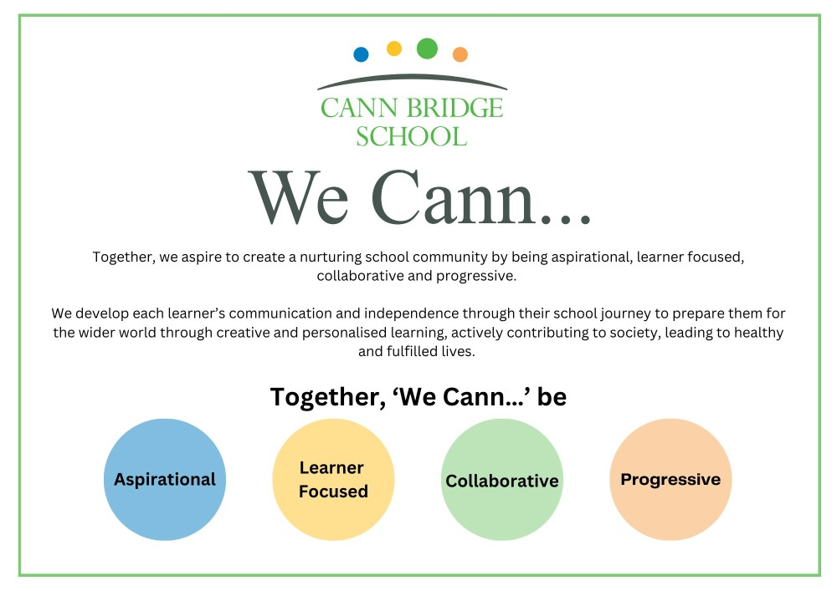

The Role

The role of Senior Teaching Assistant (Grade D/E) at Cann Bridge School is a classroom-based position supporting pupils aged 4–18 with complex and severe learning difficulties. Working in close partnership with the Class Teacher, you will play a key role in delivering high-quality, personalised education and care. You will lead and mentor a team of Teaching Assistants, support pupils’ learning through small-group and whole-class activities, and take responsibility for the class during teacher PPA, leadership time, or Early Career Teacher (ECT) release. Central to this role is modelling outstanding practice, fostering a calm, inclusive learning environment, and meeting the social, emotional, and physical needs of every learner through a trauma-informed, Total Communication approach.

As a Senior Teaching Assistant, you will act as the Class Teacher’s key support, bringing initiative, creativity, and compassion to the classroom. You will apply positive behaviour strategies, adapt learning to meet individual needs, and contribute to the smooth daily operation of the class. The role includes 1 hour and 15 minutes non-class-based time each day, providing you with the capacity to reflect, plan, and lead effectively. This is an excellent opportunity for experienced and ambitious Teaching Assistants who are emotionally intelligent and ready to take the next step in their careers within a highly supportive and purpose-driven special school setting.

All staff appointed to the Senior Teaching Assistant role will have a minimum of half a day 2.5-hours delivery and 1-hour planning, preparation and assessment time at Grade E (3.5 hours), to cover teacher PPA. Depending on school needs and through mutual agreement, the successful candidate may also have the opportunity to step up further at Grade E to provide cover for teacher leadership time, ECT release, or other planned absences. These arrangements will be reviewed and confirmed on an annual basis.

Employee Benefits

At Cann Bridge School, we cultivate an environment where both learners and staff can thrive. Our learners benefit from a well-structured curriculum, a supportive staff team, and a purposeful learning environment, all designed to help them grow into confident, well-rounded, and independent young adults. This success is made possible by our talented and dedicated team, who work together to ensure that every child has the opportunity to succeed both academically and personally.

When you join Cann Bridge School, you’ll become part of a committed team that values your professional growth.

We offer:
- Bespoke Continuing Professional Development (CPD) tailored to your individual needs and career goals
- Specialist weekly and ongoing training and development to keep you at the forefront of best practices
- Clear Career Progression pathways, providing opportunities for long-term career growth
- Access to the Local Government Pension Scheme or Teacher Pension Scheme for future financial security
- An excellent Employee Assistance Programme, offering physiotherapy, counselling, wellbeing services, and private healthcare options (where applicable) through Education Mutual
- Staff Discounts on a wide range of products and services through the Blue Card and professional student discount scheme
- A comprehensive Staff Health & Wellbeing Offer
- Excellent internal and external communications to keep everyone informed about what is happening
- DSE Eyecare Scheme for those based 80% at a screen
- The opportunity to work with incredible children, young people, and a dedicated staff team

Guidance for Applicants

If, after reading the background information, you feel this is the right opportunity for you, please follow the guidance below to support your application:
- Read the instructions on the application form carefully before completing it.
- Review both the Job Description and Person Specification thoroughly. If you do not meet the essential criteria outlined in the Person Specification, it is unlikely that you will be shortlisted.
- Use the Person Specification as a checklist to structure your supporting statement. We recommend addressing each point in order, providing clear evidence of your knowledge, skills, and experience. Wherever possible, include relevant examples from your professional and personal life.
- If you choose to handwrite your application, please ensure it is legible.
- You may use additional sheets if needed—just make sure they are clearly labelled and attached to your application form.
- Please note: providing false or misleading information at any stage of the recruitment process may result in disqualification or, if appointed, dismissal without notice.
- If you are shortlisted for interview, you will be asked to bring relevant documentation with you. Full details will be provided in your interview invitation letter.
- We warmly welcome visits to the school. Seeing our setting in action can help you decide whether Cann Bridge School is the right fit for you.

All applicants must complete the appropriate Cann Bridge School Application Form (either for Teachers or Support Staff). We do not accept CVs or letters of application. Using a standard application form ensures a fair and consistent process for all candidates.

Please ensure all relevant sections of the application form are completed in full and provide as much detail as possible, as this will be used to determine whether you are shortlisted for interview.

Check the application deadline carefully. Late applications cannot be considered, and it is your responsibility to ensure your submission reaches us on time.

The 'Fluency Duty’ applies to this post, and therefore the successful candidate would have the ability to fulfil all spoken aspects of the role with confidence and fluency in English.
We look forward to receiving your application.

Short Privacy Notice For Job Applicants

This notice explains what personal data we will hold about you, how we collect it, and how we will use and may share information about you during the application process. We are required to notify you of this information, under data protection legislation.

Please ensure that you read this notice as well as our privacy notice which can be found at www.cannbridgeschool.co.uk/about-us/gdpr which detail how we use your information.

Why Do We Collect This Information?
Once you have submitted an application form, the School use this information in order to take a decision on recruitment and to take steps to enter into a contract.

What Information Do We Collect?
We collect the following information from the application form in order to take a decision as to recruitment:
- References
- Qualifications and education history
- Employment records, including work history, job titles, training records, professional memberships, details of gaps in employment
- Supporting statement aligned to job description and specification
- Right to work and immigration status

Other personal data is captured and recorded as per the Privacy Notice.

How we may share the information
We may also need to share some of the above categories of personal information with other parties, such as HR consultants and professional advisers. Usually, information will be anonymised but this may not always be possible. The recipient of the information will be bound by confidentiality obligations. We may also be required to share some personal information as required to comply with the law.

How long we keep your information
We keep the personal information that we obtain about you during the recruitment process for no longer than is necessary for the purposes for which it is processed. How long we keep your information will depend on whether your application is successful and you become employed by us, the nature of the information concerned and the purposes for which it is processed. Full details on how long we keep personal data for is set out in our data retention policy.

We look forward to receiving your application.

Recruitment Timeline
- Opportunities to visit Cann Bridge School: Please contact the school to arrange your visit 01752 207909 or HR@cannbridge.co.uk
- Application closing date: Monday 30th March 2026
- Candidate shortlisting: Tuesday 31st March 2026
- Interviews: Wednesday 1st April 2026



Job Description: Senior Teaching Assistant (Grade D/E)

Cann Bridge School is committed to creating a diverse workforce. We’ll consider all qualified applicants for employment without regard to sex, race, religion, belief, sexual orientation, gender reassignment, pregnancy, maternity, age, disability, marriage, or civil partnership.

Job details
Position: Senior Teaching Assistant
Location: Cann Bridge School, Estover, Plymouth
Salary: Grade D/E (31.5 hours Grade D and 3.5 hours Grade E) 35 hours
Contract type: Full-time
Reporting to: Class Teacher or Senior Leader
Responsible for: N/A
Start Date: April 2026

This is a split job role encompassing a Lead Teaching Assistant (Grade D) and Higher-Level Teaching Assistant (Grade E). This role is known as a Senior Teaching Assistant.

Teaching Assistant (Grade D)

Main purpose
To work under the instruction/guidance of teaching/senior staff to undertake work/care/support programmes to enable access to learning for pupils and to assist the teacher in the management of pupils and the classroom. Work may be carried out in the classroom or outside the main teaching area, teaching assistants may work in class group/small group/1:1 situations.

Duties and responsibilities

Support for Pupils
- Supervise and provide particular support for pupils, including those with special needs, ensuring their safety and access to learning activities.
- Assist with the development and implementation of Individual Education/Behaviour Plans and Personal Care programmes i.e. personal care and medical needs.
- Establish constructive relationships with pupils and interact with them according to individual needs.
- Promote the inclusion and acceptance of all pupils.
- Encourage pupils to interact with others and engage in activities led by the teacher.
- Set challenging and demanding expectations and promote self-esteem and independence.
- Provide feedback to pupils in relation to progress and achievement under guidance of the teacher.

Support for the Teacher
- Create and maintain a purposeful, orderly and supportive environment, in accordance with lesson plans and assist with the display of pupil’s work.
- Use strategies, in liaison with the teacher, to support pupils to achieve learning goals.
- Assist with the planning of learning activities.
- Monitor pupils responses to learning activities and accurately record achievement/progress as directed.
- Provide detailed and regular feedback to teachers on pupils achievement, progress, problems etc.
- Promote good pupil behaviour, dealing promptly with conflict and incidents in line with established policy and encourage pupils to take responsibility for their own behaviour.
- Establish constructive relationships with parents/carers.
- Administer routine tests and invigilate exams and undertake routine marking of pupils’ work.
- Provide clerical/admin support e.g. photocopying, typing, filing, money, administer coursework etc.

Support for the Curriculum
- Undertake structured and agreed learning activities/teaching programmes, adjusting activities according to pupil responses.
- Undertake programmes linked to local and national learning strategies e.g. literacy, numeracy, KS3, early years recording achievement and progress and feeding back to the teacher.
- Support the use of ICT in learning activities and develop pupils’ competence and independence in its use.
- Prepare, maintain and use equipment/resources required to meet the lesson plans/relevant learning activity and assist pupils in their use.

Support for the School
- Be aware of and comply with policies and procedures relating to child protection, health, safety and security, confidentiality and data protection, reporting all concerns to an appropriate person.
- Be aware of and support difference and ensure all pupils have equal access to opportunities to learn and develop.
- Contribute to the overall ethos/work/aims of the school.
- Appreciate and support the role of other professionals.
- Attend and participate in relevant meetings as required.
- Participate in training and other learning activities and performance development as required.
- Assist with the supervision of pupils out of lesson times, including before and after school and at lunchtime.
- Accompany teaching staff and pupils on visits, trips and out of school activities as required and take responsibility for a group under the supervision of the teacher.

Higher Level Teaching Assistant (Grade E)

Main Purpose
- To complement the work of the teacher, substantially contributing to a range of teaching and learning activities and to work collaboratively with colleagues as part of a professional team.
- To plan, assess and deliver learning activities to individuals and groups or whole classes.
- To monitor and assess pupils and record and report on pupils’ achievements and development under an agreed system of supervision.
- Any other specific duties commensurate with the role – to cover PPA time in the class group to which you are allocated and to lead the class on the first day of any teacher absence
- To support all pupils in their learning and development treating them with respect and consideration
- To consistently promote positive values, attitudes and behaviour
- To have high expectations of all pupils’ achievement and a commitment to raising educational standards
- To encourage the social and emotional development of pupils
- To encourage pupils to participate in all aspects of school life
- To implement agreed work programmes with individuals or groups in or out of the classroom.
- To help pupils to become more independent
- To promote the inclusion and acceptance of all pupils
- Attend planning & preparation meetings as required (these may take place out of school hours)

Duties and responsibilities

Planning & Expectations
Working within school policies and procedures to:
- Prepare classroom as directed for lessons and clear afterwards
- Assist in the display of pupils work
- Promote equality of opportunity for all pupils
- Contribute to effective planning and preparation of lessons
- Contribute to the planning of opportunities for pupils to learn which may include out of school contexts in accordance with school policies and procedures
- Work with the teacher to plan the role of the Teaching Assistant in lessons including how feedback will be provided to pupils and colleagues on pupils learning and behaviour
- Contribute effectively to the selection and preparation of teaching resources that meet the diversity of pupils’ needs and interests
- Provide constructive feedback to the pupil and teacher (both written and verbal)

Monitoring & Assessment
- Support teachers in evaluating pupils’ progress through a range of assessment activities (including accurately marking of work in line with the school’s policy), taking this information into account when planning future lessons
- Monitor pupils’ responses to learning tasks, participation and progress, providing constructive feedback to pupils, supporting them as they learn, and modifying teaching strategies accordingly. Provide constructive feedback to the teacher (both written and verbal)
- Contribute to maintaining and analysing records of pupils’ progress

Teaching and Learning Activities
- Use clearly structured teaching and learning activities that interest and motivate pupils and advance their learning
- Communicate effectively and sensitively with pupils to support their learning
- Promote and support the inclusion of all pupils in the learning activities in which they are involved
- Use behaviour management strategies in line with the school’s policy and procedures which contribute to a purposeful learning environment
- Advance pupils’ learning in a range of classroom settings, including working with individuals, small groups and whole classes under the supervision and direction of the teacher. The teacher may not always be present in the classroom but the Higher-Level Teaching Assistant will work within the framework established by the class teacher (the role of the HLTA is not interchangeable with the Teacher)
- Guide the work of other adults supporting teaching and learning in the classroom.
- Recognise and respond effectively to equal opportunities issues as they arise, including challenging stereotyped views and by challenging bullying and harassment, following relevant policies and procedures.
- Organise and manage safely the learning activities, the teaching space and resources for which they have responsibility
- To help raise standards of achievement for all pupils

Professional Values & Practice
- Have high expectations of all pupils and promote and reinforce pupils’ self esteem
- Respect pupils’ social, cultural, linguistic, religious and ethnic backgrounds
- Be committed to raising the educational achievement of pupils
- Build and maintain successful relationships with pupils, treating them consistently, with respect and consideration and to be concerned for their development as learners
- Demonstrate and promote the same positive values, attitudes and behaviour that are expected from pupils
- Work collaboratively with colleagues to meet the needs of all pupils (inc SEN pupils)
- Carry out all aspects of the role effectively and to seek help and advice when necessary
- Liaise sensitively and effectively with parents, carers, and outside agencies (e.g. school psychology service) recognising their roles in pupil’s learning
- Continually seek to improve own practice, including through observation, examination and discussion with colleagues and to seek advice or guidance as necessary

General
- Maintain a safe environment for pupils, staff and visitors to the school
- Meet with parents (e.g. at open evenings) as necessary
- Supervise pupils off site on school trips and other external visits
- Within appropriate sessions to be responsible for the supervision of other Teaching Assistants and other adults supporting teaching and learning in the classroom
- Provide welfare support for pupils

Additional Duties
Any other duties which reasonably fall within the purpose of the post, and which may be allocated by the Head Teacher or Teacher. This may include:
- Handle small amounts of money where appropriate
- Record keeping and filing
- Producing classroom displays
- Placing classroom orders as appropriate
- Supporting students on work experience placements within appropriate sessions
- Responding to IT malfunctions by carrying out basic checks and where necessary requesting appropriate technical assistance
- Contribute to the organisation of pupil records
- Any other duties that are commensurate with the responsibilities of the role.

Please note that this is illustrative of the general nature and level of responsibility of the role. It is not a comprehensive list of all tasks that the Senior Teaching Assistant will carry out. The postholder may be required to do other duties appropriate to the level of the role, as directed by the headteacher or line manager.

Person Specification: Senior Teaching Assistant (Grade D/E)

Criteria | Qualities  Essential | Qualities  Desirable | Method of Assessment
Qualifications and training | - Minimum of Level 3 qualification in Supporting Teaching & Learning or equivalent  - Level 2 qualification in English and Mathematics (equivalent to GCSE Grade A–C / Grade 9–4* or Functional Skills Level 2)  - Evidence of recent CPD relevant to SEND and classroom support  - Willingness to undertake First Aid training | - HLTA status or working towards a relevant Level 4 qualification  - Training in specialist areas such as Makaton, PECS, sensory integration, SoSAFE! or CPI  - Current First Aid qualification | Application form
Experience | - Has demonstrable and relevant experience within a school-based setting  - Experience supporting children or young people with SEND, including autism and complex learning needs  - Experience leading groups or mentoring other support staff  - Experience supporting lesson delivery in group and whole-class settings  - Experience supporting pupils using positive behaviour and trauma-informed strategies  - Experience adapting learning to meet a range of pupil needs  - Experience implementing individual behaviour plans or sensory regulation programmes | - Experience working in a special school or specialist provision  - Experience supervising or managing classroom teams  - Experience planning and delivering learning independently  - Familiarity with alternative communication approaches (e.g. AAC)  - Experience leading classes or covering PPA  - Experience supporting off-site activities or residentials  - Experience of support, teaching, and assessing learners using the Engagement Model | Application form  Interview process
Skills & Knowledge | - Understanding of how to support adaptive and inclusive learning  - Able to monitor progress and provide feedback to learners and staff  - Confident in using ICT to support learning  - Strong interpersonal, organisational and communication skills  - Able to organise resources and manage classroom activities  - Experience in supporting or conducting assessments and maintaining records  - Knowledge and understanding of safeguarding procedures  - Demonstrate an ability to develop lessons/activities with clear intents, resources, teaching strategies within the context of the early years’ curriculum or national curriculum  - Ability to motivate and encourage pupils | - Knowledge of the SEND Code of Practice and EHCP processes  - Experience with assistive technology and learning software  - Skilled at liaising with parents/carers and external professionals  - Experience coordinating displays, timetables or activity plans  - Skilled in de-escalation and restorative approaches | Application form  Interview process
Personal qualities | - Commitment to inclusive education and the rights of children with SEND  - Calm, empathetic, reflective and resilient under pressure  - Proactive team player, works collaboratively and professionally, respects confidentiality  - Confident working independently and taking responsibility by using own initiative  - Willing to support across a range of ages, needs and environments  - High standards of personal conduct, punctuality, and reliability  - Positive role model across the wider school community  - Willing to attend evening meetings as required | - Passion for special education and a long-term commitment to the sector  - Committed to continuous professional development and reflective practice | Application form  Interview process

This job description may be amended at any time in consultation with the postholder.

Last review date: May 2025

Line manager’s signature: _______________________________________
Date: _______________________________________

Postholder’s signature: _______________________________________
Date: _______________________________________

