

JOB PROFILE

Red Kite Learning Trust is committed to supporting work–life balance and recognise the benefits of flexible working. We welcome requests for flexible working arrangements as part of the recruitment process. While flexibility may be possible for many roles, each request will be considered on an individual basis.
Job Title: | Barrier Assistant | School/Department: | Oatlands Community Junior School
Salary Grade: | RLW  £24,310/per annum (FTE)  £4,560/per annum (Actual) | Working Hours: | 8 hours 20 minutes per week  Mon-Fri  8.20am-9.05am and 2.50pm-3.50pm
Contract Type: | Fixed term until 31 July 2026 | Location: | Harrogate
Responsible to: Headteacher
Role summary: Responsible for setting out, managing and removing road barriers before and after school as part of the School Street Scheme, contributing to the safety and wellbeing of our students and wider school community. Required to work outdoors.

Red Kite Learning Trust is committed to safeguarding and promoting the welfare of students and expects all colleagues and volunteers to share this commitment. All applicants will be required to complete a DBS check prior to appointment.
Special conditions of service:
No smoking policy, including e-cigarettes. Requirement to occasionally work outside of school hours and off school premises as required by the school.
Role specific responsibilities:
- To collect and set up the barrier at the entrance of Beechwood Grove in preparation for morning school drop-off, and to remove and store the barrier at the end of drop-off (barrier in place from 8:30am–9:00am).
- To contribute to the safety of our children and wider school community during times when barrier is in place.
- To manage the barrier by allowing access for authorised vehicles during designated times, ensuring it is moved appropriately to let them in or out.
- You will be required to carry and communicate via the internal radio system to maintain contact with the school.
- To collect and set up the barrier at the entrance of Beechwood Grove in preparation for afternoon school pick-up, and to remove and store the barrier at the end of pick-up (barrier in place from 3:00pm–3:45pm).
- To follow all school policies and training including Safeguarding, Health & Safety and manual handling.
RK People responsibilities:
- Contribute to the overall aims and values of our Trust, appreciate ad support the roles of other members of the wider team and attend and participate in relevant meetings as required..
- Comply with all Trust policies and procedures including child protection, health, safety, welfare, security, confidentiality and data protection, reporting any concerns to the appropriate person
- Contribute to ensuring safeguarding procedures are in place and used effectively at all times.
The role holder must demonstrate a flexible approach to the delivery of the role. Consequently, the role holder may be required to perform work not specifically identified in the job profile, but which is in line with the general scope, grade and responsibilities of the role.
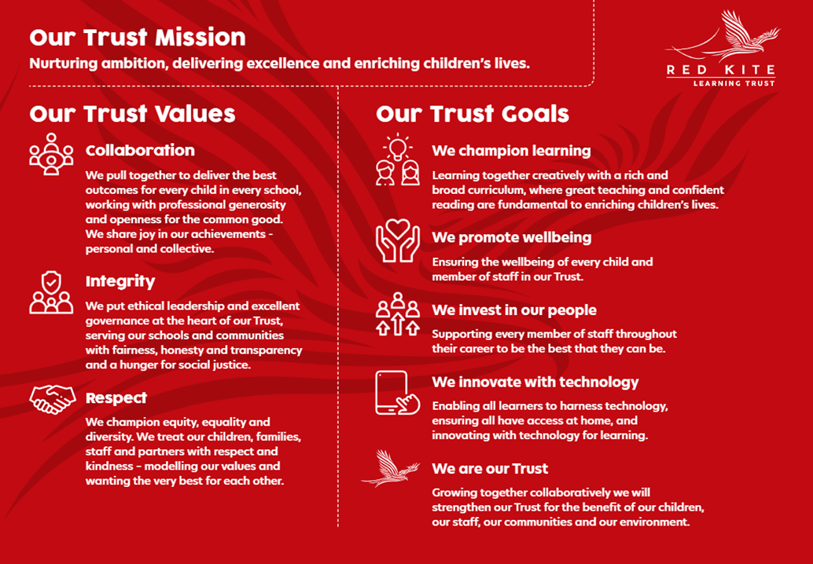
PEOPLE PROFILE
Aptitudes and Characteristics |  |  |  | Essential | Desirable
Ability to relate well to, and work positively and effectively with, children and young people |  |  |  | *
Willingness to be flexible and work to meet the best interests of the school |  |  |  | *
Self-motivated and hard-working |  |  |  | *
Willingness to follow school policies and participate in training including Safeguarding, Health & Safety and Manual Handling |  |  |  | *
Ability to lift heavy barrier including transporting to its location |  |  |  | *
Qualifications, Knowledge and Experience |  |  |  | Essential | Desirable
Good standard of education |  |  |  | *
Excellent communication skills |  |  |  | *
Knowledge of moving and handling procedures |  |  |  |  | *
Safeguarding and Promoting the Welfare of Students |  |  |  | Essential | Desirable
An appropriate motivation to work with children and young people |  |  |  | *
Ability to maintain appropriate relationships and personal boundaries with children and young people |  |  |  | *
Emotional resilience in working with challenging behaviours and appropriate attitudes to the use of authority and maintaining discipline |  |  |  | *

