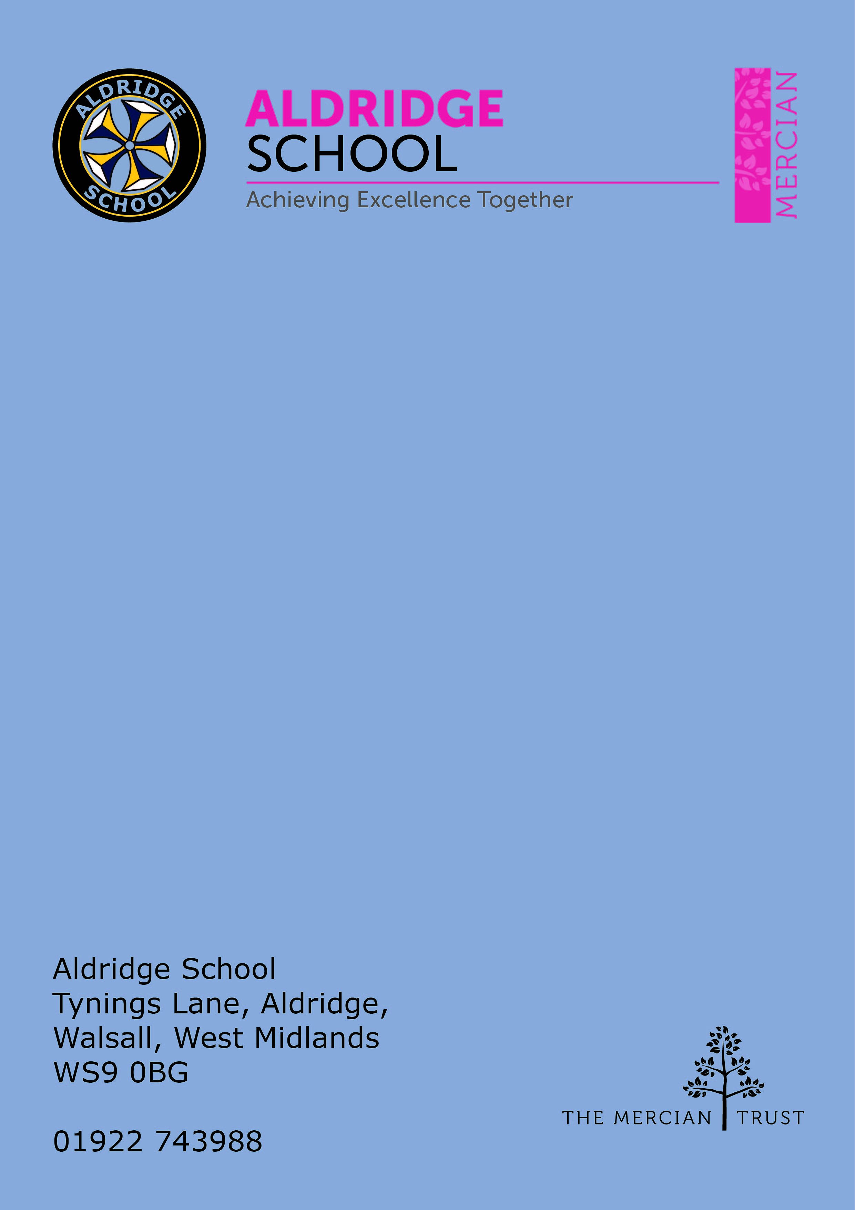

Application Pack

Administration Assistant


About Aldridge School – a Founder Academy of the Mercian Trust

About The Mercian Trust

Person Specification
How to Apply

Job Description

About Aldridge School

Thank you for taking the time to find out more about Aldridge School. This pack is intended to give you information about this role and our school's broader vision and ethos. Further background information is available in our Prospectus and Sixth Form Prospectus on our website.

We are a comprehensive school of over 1600 students situated near the centre of Aldridge village. We believe that it is our responsibility to work to meet the needs of every individual student, challenging them to achieve their best, supporting them to become responsible young adults and preparing them for their next steps into the world of work or further education.

Aldridge School is a good school (Ofsted 2022). It is a school which is proud of its traditions and successes which have been achieved through hard work and high expectations.

Aldridge School has a dedicated, talented and conscientious team of staff who work together to provide a high standard of teaching, excellent pastoral care and professional support services. Our broad curriculum is designed to meet national expectations, be relevant and interesting, support our students in achieving the best possible standards in external examinations and to equip them with the skills they need to be successful in adult life.

At Aldridge School we have a popular and thriving Sixth Form. We are very proud of our students' success with over 80% securing places at some of the top Universities and on Higher Apprenticeships last year. We offer a very broad range of both academic and vocational courses at level 3, ensuring that Aldridge School Sixth Form is an option for a wide range of students.

We also enjoy strong links with surrounding primary schools, working with students in Years 5 and 6 including work in Science, Maths, English, Performing Arts and Enterprise. We are proud of our community and we work hard to promote this pride in all our partnerships, so that we can make sure that future students from these schools enjoy an easy, enjoyable transition to Aldridge School.

Students at Aldridge School are friendly, polite and respectful. Strong relationships between staff and students contribute significantly to ensuring that students are happy and feel safe.

If you would like to find out more, please contact us to arrange a visit to see our school at work. We look forward to meeting you.


The Mercian Trust

Aldridge School is an academy in The Mercian Trust.

The Mercian Trust brings twelve very different and individual schools together as a single Multi-Academy Trust or MAT.

The twelve schools are unique in their identity and united by their ambition to offer the best possible future for their students.

The twelve schools are:
- Aldridge School
- Queen Mary's Grammar School
- Queen Mary's High School
- Shire Oak Academy
- The Ladder School
- Walsall Studio School
- Q3 Academy Great Barr
- Q3 Academy Langley
- Q3 Academy Tipton
- New Leaf
- Rushall Primary School
- Oakwood School

Each School has its own distinct ethos and approach, but we have this over-arching aim in common: we prepare all our students to enjoy life to the full by inspiring them to:

- Realise their potential as learners
- Thrive in the world of work
- Make a positive contribution to the local, national and international community

The Mercian Trust respects the autonomy of its member schools but, through collaboration, fosters strengths that are greater than the sum of its parts. Working together as a Multi Academy Trust provides a framework for sharing expertise and enthusiasm, resources and ideas.


Job Description & Person Specification

Post: Administration Assistant
Responsible to: Data Manager
Salary: Grade 4 Point 6 – 11 (pro-rata)
Term time including 5 Training days +1week

Administration
- Support the Assistant Headteacher in charge of Primary Liaison/Year 6 transition by providing an efficient administrative service for the Year 6 transition process, e.g. liaising with primary schools to request student files, corresponding with the Local Authority and parents to ensure data held is accurate and kept up-to-date, requesting and inputting student data into the School’s Information Management System, liaising with Year Offices to ensure students’ medical needs are documented and shared with staff, arranging parent meetings.
- Ensure that data held on students is kept up to date on the School’s Information Management System.
- Generate and distribute annual data collection sheets to parents.
- Support the Data Manager with the production of KS3 mid-term reports and progress checks.
- Provide general administrative, clerical, and practical support as required e.g., word processing documents, mail merging labels, designing booklets/event materials producing staff briefing notes.
- Support with digital resources and the school’s digital transformation
- Supporting with safeguarding filters
- Covering Reception where required
- To support the administration of careers events for each year group.
- Support with the organisation of school immunisations and liaising with Vaccination UK.
- Setting up parents evening appointments.
- Arranging annual school photographs for the whole school.
- Support the creation and issuing of staff door access cards for new starters, including taking photographs, in line with agreed procedures and under the direction of the Facilities Manager.
- First aid trained.
- Monitoring and ordering of stationery supplies.
- Any other ad-hoc requests from SLT including providing admin support in Year Offices.

Standards and quality assurance
- Support the aims and ethos of the school
- Set a good example in terms of dress, punctuality and attendance
- Attend team and staff meetings
- Undertake professional duties that may be reasonably assigned by the Headteacher
- Be proactive in matters relating to health and safety
- Be committed to safeguarding and promoting the welfare of children and young people



Job Requirements

Qualifications and Training | - GCSE English and Maths at Grade C or above, or equivalent (essential)
Experience | - Previous experience of working within an education setting in a similar role (essential)  - IT experience (essential)  - Previous experience of record keeping (desirable)
Knowledge and Understanding | - Excellent working knowledge of Microsoft Office – Excel, Word and PowerPoint (essential)  - Experience of using a Schools Information Management System (BromCom) or similar (desirable)
Skills and abilities | All skills and abilities below are an essential part of the role:  - The ability to work independently and show initiative  - The ability to prioritise and adopt a flexible approach to changing demands and deadlines  - A creative and highly organised approach to tasks  - Be able to work as part of a team  - The ability to communicate effectively with a range of people in a range of forums, face to face, over the phone and in writing  - Maintain confidentiality  - The ability to work well under pressure  - Demonstrate a willingness to undertake appropriate training and development

The duties and responsibilities in this job description are not exhaustive. The post-holder may be required to undertake other duties from time to time within the general scope of the post. Any such duties should not substantially change the general character of the post. Duties and responsibilities outside of the general scope of this grade of post will be with the consent of the post-holder.



How to Apply

Salary
Grade 4 (point 6 – 11) pro-rata

Hours per week
37hrs per week
39 Weeks per year including 5 training days +1week

Closing Date

Start Date
As soon as possible

Visits to School
For further information, please contact the school either by email info@ald.merciantrust.org.uk or by telephoning on 01922 743988 ex 2224

Applying
Apply via My New Term
