

Appointment Information Pack

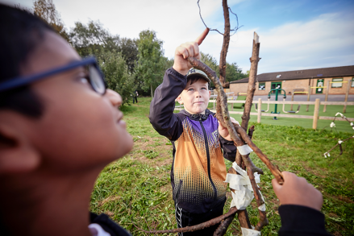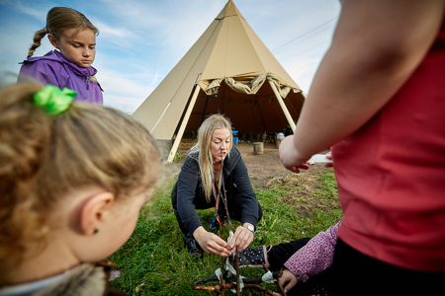
Job Description

Academy/School | Rudheath Primary Academy and Nursery
Job Family | Mid Day Assistant
Job Title | Mid Day Assistant
Grade | FT Grade 2 – SCP 2-4
Accountable to | Headteacher/Principal
Line manager | Miss P Thomas

Purpose of the role
To care for the children during the lunch time break including; effective supervision of children and supporting their learning through play by preparing, providing and overseeing suitable activities in an appropriate environment.
Main Duties
Provide support during play periods
- To ensure the supervision, security, welfare and appropriate conduct of children during the mid-day break, enforcing the expected standard of school discipline and having regard to School/Trust policies and procedures and any special or educational needs.
- To supervise and support children at play ensuring their safety and access to learning.
- To encourage children to interact with others and engage in play activities.
- To encourage children to act independently and develop independence, as appropriate.
- To establish good relationships with children, acting as a role model and being aware of and responding appropriately to individual needs
- To organise games/activities for groups of children, skipping, ball games etc during indoor and outdoor play.
- To encourage children to learn new games and participate in them
- To support the teacher in managing children’s behaviour, reporting difficulties as appropriate.
- To implement the school’s behaviour policy in a fair and consistent manner.
- To attend to minor First Aid needs of children in accordance with school policy including completion of relevant paperwork and seeking assistance for any serious accidents.
- To liaise closely with colleagues on the welfare and discipline of pupils as required.

The play environment
- To prepare play equipment ready for the correct times
- To encourage children to use equipment with respect and to return equipment
- To ensure that the Health and safety of children is observed at all times
- To be aware of potential risks
- To ensure children are appropriately dressed for the weather conditions
- During indoor play times ensure that activities are appropriate for the space being used.
- To maintain a purposeful, orderly and supportive learning environment for all children.

The dining room /eating areas
- To supervise children in the dining area, including the hygiene of children in the dining area. This will include hand washing, encouraging children to eat the food, use cutlery correctly and insisting on and modelling good table manners
- To be aware of children on special diets and to support these children with eating the correct food which meets their needs
- To be aware of potential risks and take action to remove them and/or report as necessary
- To supervise the clearing of tables, cleaning of spillages and stacking/scraping of plates and cutlery

Fulfill wider professional responsibilities
- Make a positive contribution to the wider life and ethos of the School and the Trust.
- Develop effective professional relationships with governors, colleagues, families knowing how and when to draw on advice and specialist support.
- To be willing and able to be part of a team of first aiders/fire wardens as may be required.
- Communicate effectively with pupils, school staff and visitors.
- To participate in training and other learning activities and performance development as required.
- To be aware of and comply with policies and procedures relating to child protection, health, safety and security, confidentiality and data protection, reporting all concerns to an appropriate person.
Personal and professional conduct
All Focus Trust staff are expected to demonstrate consistently high standards of personal and professional conduct. The following statements define the behaviour and attitudes which set the required standard for conduct throughout a career with the Trust.

All Staff must uphold public trust in the profession and maintain high standards of ethics and behaviour, within and outside the School, by:
- treating governors, pupils, staff, parents and visitors with dignity, building relationships rooted in mutual respect, and at all times observing proper boundaries appropriate to an adult working in an School environment;
- having regard for the need to safeguard pupils’ well-being, in accordance with statutory provisions;
- showing tolerance of and respect for the rights of others;
- not undermining fundamental British values, including democracy, the rule of law, individual liberty and mutual respect, and tolerance of those with different faiths and beliefs; and
- ensuring that personal beliefs are not expressed in ways which exploit pupils’ vulnerability or might lead them to break the law.

All staff working in the Focus-Trust must have proper and professional regard for the ethos, policies and practices of the School and the Trust, and maintain high standards in their own attendance and punctuality.

All staff must have an understanding of, and always act within, the statutory frameworks which set out their professional duties and responsibilities; and within the policies, handbooks and guidelines of the School and of the Focus-Trust.

General
The post holder will:
- Be expected to actively support the work and ethos of the Focus-Trust.
- Be expected to undertake such additional duties as may reasonably be requested by the Principal/Headteacher or their representative.
- Respect confidentiality of staff, pupils, families and visitors and not breach this trust. Any breaches of confidentiality must be reported to the Principal/Headteacher immediately.
- Participate in arrangements for appraisal and in the identification of areas in which s/he would benefit from training and undergo such training.
- Comply with and support all policies related to equal opportunities, child protection and safeguarding of children and colleagues.

This job description is neither exhaustive nor exclusive, and it may, after consultation with the post holder be subject to modification and amendment in accordance with Trust’s procedures.

Midday Assistant
Person specification

Key:
App – Application Form
Ref – Reference
SP – Selection process. This could include a range of exercises, including an interview.
Knowledge, Experience and Skills

 |  | Essential/  Desirable | How identified
Experience
Experience of working in a school environment |  | D
Experience of using computer packages for recording and reporting appropriate information |  | D | App/SP
Experience of team working to work effectively with others and meet deadlines and goals |  | E | App/SP
Experience in using and maintaining accurate and quality electronic and paper based systems |  | D | App/SP
Experience of working with or caring for children of primary age |  | E | App/SP
Skills and abilities
Ability to listen and communicate effectively with colleagues and children. Being always polite and courteous. |  | E | App/SP
Ability to relate well to children and adults |  | E | App/SP
Ability to work constructively and effectively as part of a team |  | E | App/SP
Initiative to respond and make minor decisions as may be required |  | E | App/SP
Basic Literacy and numeracy skills |  | E | App/SP
Ability to organise activities and play games with children |  | E | App/SP
Knowledge
Basic knowledge of polices/codes of practice/legislation relevant to the protection of children |  | D | App/SP
Child protection
Understands why safeguarding is important when working with children. |  | E | App/SP
Ability to deal with sensitive issues in a supportive and effective manner |  | E | App/SP
Qualifications and training
Willingness to gain a basic first aid certificate and any other training which is relevant to the role (as maybe required) |  | E | App
Personal qualities and attributes
Moral purpose (Equality, children and adults treated with respect) | E |  | SP/Ref
Child centered | E |  | SP/Ref
Integrity – to be a role model and have a positive influence | E |  | SP/Ref
Self-motivated | E |  | SP/Ref
Enjoys challenge | E |  | SP/Ref
Enthusiastic and optimistic | E |  | SP/Ref
Self-awareness, knowledge of strengths and limitations | E |  | SP/Ref
Ability to remain calm and focused in a busy and demanding environment | E |  | SP/Ref
Reliable – good attendance | E |  | SP/Ref
Caring disposition | E |  | SP/Ref

About our Academy

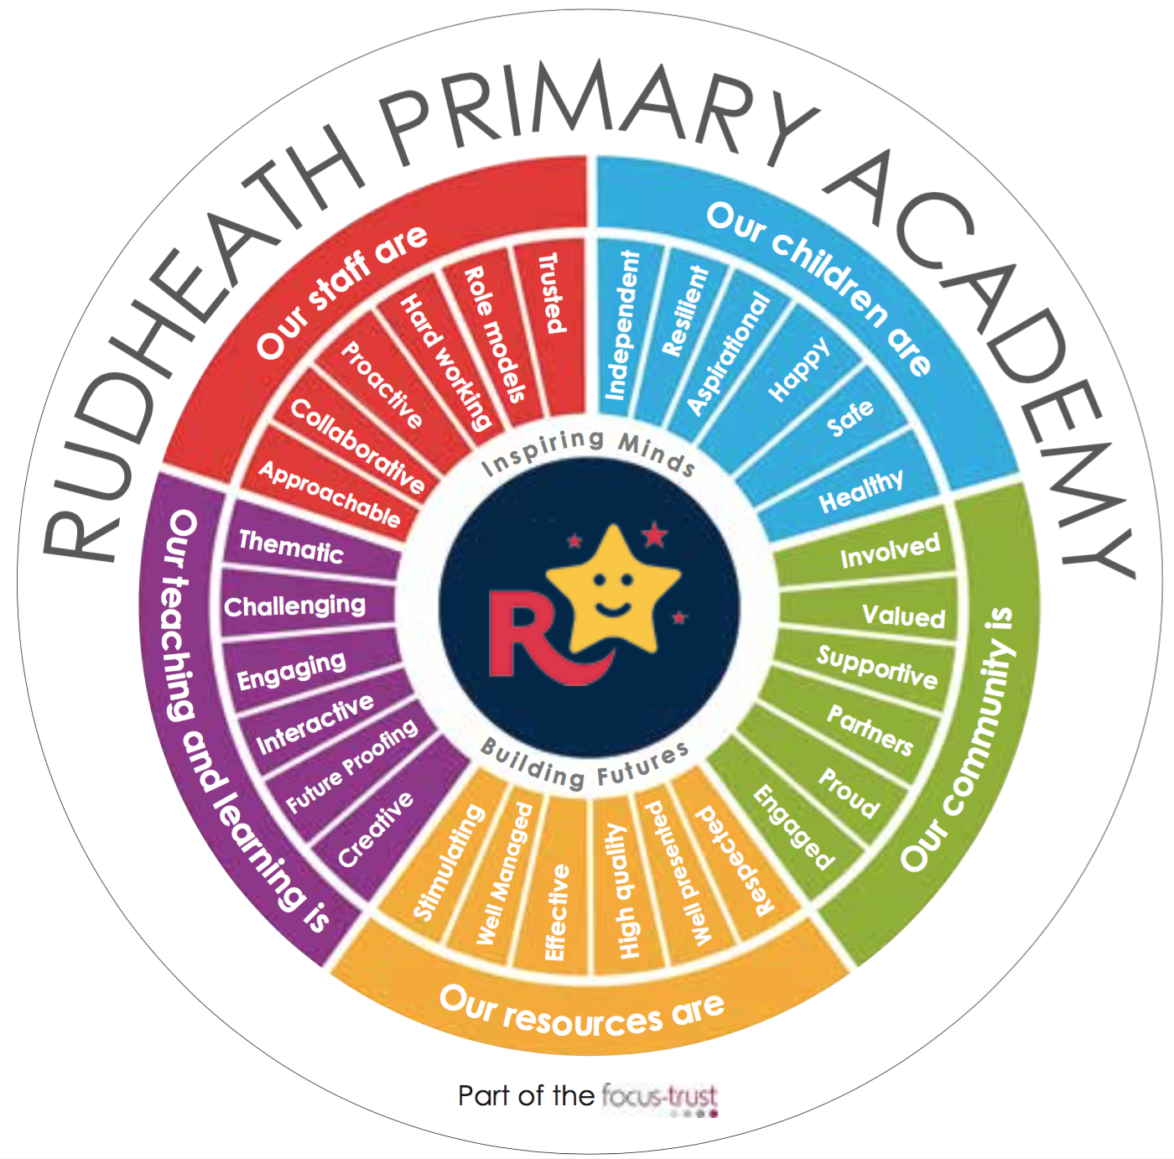

Our pupils
We currently have 369 children on roll, who are taught in 15 classes (3xEYFS, 4xKS1 and 8xKS2).

Our staff
Principal
2 x Deputy Principals
1 x Assistant Principal
16 x Teachers FTE
7 x Teaching assistants (In-class support)
5 x SEN Teaching Assistants
1 x Business Manager
3 x Admin Assistants
1 x Site maintenance Officer
7 x Mid-day assistants
1 x Head of Kitchen
4 x Catering Assistants
3 x Cleaners

Our geographical area

Rudheath is a semi-rural area on the edge of the town of Northwich

Our curriculum
Basic skills form the core on which our curriculum is built. We use a framework of ‘non-negotiables’ to ensure that the fundamental academic skills of English, Maths and Computing are delivered for a significant impact on children’s learning and progress. Alongside these academic demands we are developing our curriculum for all children to learn how to learn through promoting thinking and collaborative skills. Thematic Learning Challenges are used as hooks, to engage children’s interest.
Our extra-curricular activities; Over the year we offer a range of extra-curricular activities including; Sports Multi-skills, Drama, Dance, Computing and Textiles.

Academy Quick Facts
Type of school | Primary and Nursery
Age range | 3-11 years
Location/LA | Cheshire West and Chester
Number of children | 369
Number of teaching staff | 16
Number of educational support staff | 12
% FSM | 24%
% SEN | 15%
% EAL | 6%

Background to the Trust
Focus-Trust was incorporated in May 2012 as a primary trust. The Trust has links with the sponsor, Focus Education, but is an entirely separate legal entity. As with all academy trusts, the Trust is a company limited by guarantee and an exempt charity. The Trust’s offices are situated in a newly converted historic mill conversion in Chadderton, Oldham with excellent motorway networks to access our schools.

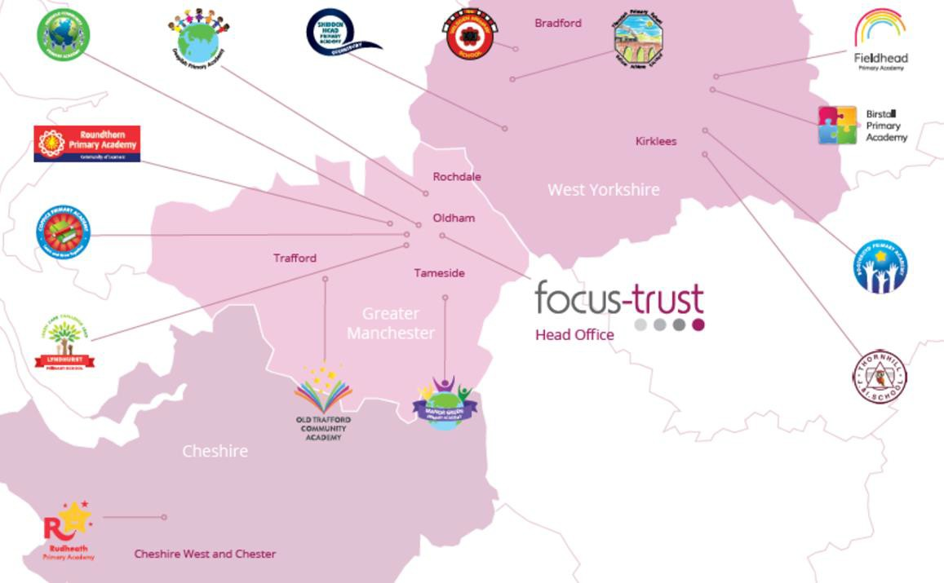
The defining feature of Focus-Trust is that it is a specialist primary phase trust. This means that the work of the Trust is driven by the distinctive needs of primary schools. Whilst the Trust has robust systems for accountability, each school has their own distinctive identity, ethos and culture, and this is a commitment to every school when they convert and join the Trust.
Focus-Trust currently has a small centrally employed team. The members of the team are highly skilled and committed to the vision, culture and values of the Trust.
All the schools within the Trust are willing partners who have actively chosen to join Focus-Trust and there is a very high degree of consensus, cooperation and commitment from within the group.
The Trust has robust policies and systems in place to govern and guide its work. These have been gradually implemented as the Trust has grown. The Trust has well-established productive relationships with trade unions and meets half termly with a group of national trade union representatives to discuss policy development. This has enabled us to introduce and change a range of policies in a streamlined and cooperative way.

Our Vision
‘Great schools at the heart of our communities’ - with our Community Champions and colleagues, we strive to ensure we are being civic leaders making a difference in the local and national communities and the community is supporting us.

Focus-Trust Mission
‘Learning together, making the difference’

Collective Efficacy
We have a well-developed and securely embedded culture of Collective Efficacy. By this we mean we have, ‘A shared commitment to work together on the things that matter to improve outcomes for all.’

The Focus-Trust Values
Professional honesty is at the heart of everything we do. The Trust knows the schools well because of the strong working partnership between academy leaders and the Trust Central Team. It is only by being honest and transparent with a balance of credible challenge and effective support, that we can move forward and get the best for all children and staff. Our work is underpinned by our values:

Care for children, adults and the learning environment
Dare to do things differently and have a go
Be fair, honest and inclusive – demonstrating integrity
Share concerns, expertise and best practice for the benefit of all learners
Our Moral Purpose

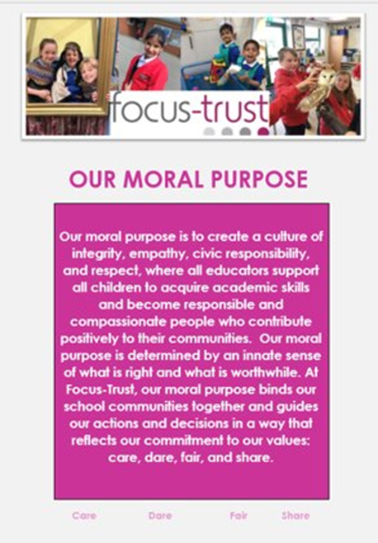

Our People Strategy

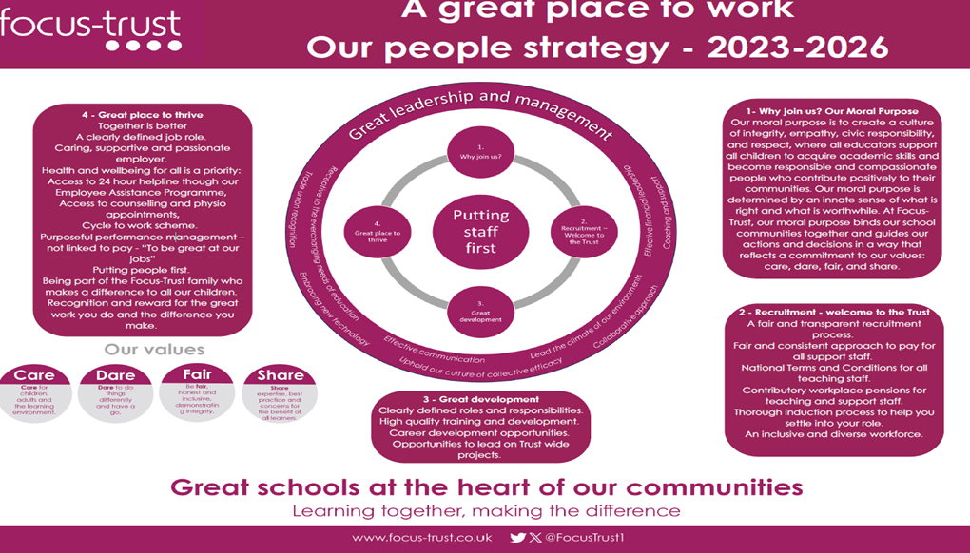
What you might want to know about Focus Trust

Pensions
Focus-Trust contributes to Teachers’ Pensions and Local Government pensions in the same way and with the same level of contribution as local authorities.
Employer Relations
Focus-Trust has a Trade Union agreement which recognises the teacher and support staff unions. This is further supported by an ongoing and productive relationship with key trade union officials.
Equality of opportunity
Focus-Trust is an equal opportunity employer, dedicated to a policy of non-discrimination in employment on any basis including age, gender, race, colour, nationality, ethnic origin, disability, gender, religion, age, marital status, sexual orientation and/or medical condition.
Safeguarding
Focus-Trust is committed to safeguarding and promoting the welfare of all children and young people. There is an explicit expectation that all employees share this commitment and adhere to all safeguarding policies and procedures. Applicants should be aware that the recruitment process will include an assessment of your suitability to work with children.

Dress code
We expect all staff to dress professionally and appropriately for the roles undertaken. We pride ourselves on the high standards of dress of both our pupils and staff; these standards are led by our staff who we expect to set an example.
Policies
Focus-Trust and the schools have a range of policies and handbooks that help to make clear our expectations and ways of working. These are always shared openly with staff and are accessible to everyone. There are several policies that prospective employees should be aware of when making an application. These can be found on the Trust website www.focus-trust.co.uk and school websites. All members of staff will be asked to sign a declaration as part of the induction process to acknowledge that they have read and understand the Code of Conduct and some of the key policies, e.g. Safeguarding and Child Protection, Health and Safety, Acceptable use of IT.
Right to work in the UK
Under the Asylum and Immigration Act 1996, it is a criminal offence to employ anyone who is not entitled to live or work in the United Kingdom. Applicants can expect us to ask for proof of this at interview stage, where you will be asked to provide some original documentation to confirm that you are eligible to work within the UK. Photographic proof of identity will also be required.
Validation of qualifications and identity
All shortlisted candidates will be asked to bring original certificates or relevant qualifications and identity documents to interview. These will be photocopied and kept on file and, if appropriate, may be confirmed as genuine with the relevant awarding bodies. The copies of the successful candidate will be retained on their personnel file. The copies of unsuccessful candidates will be treated as confidential waste and disposed of appropriately.
References and Social Media Checks
If you are shortlisted, we will take up references before the interview date. One of your referees must be your current or most recent employer. Two satisfactory references must be received before we can confirm any offer of an appointment. The information we request will relate to salary, length of service, skills and abilities, suitability for the job, disciplinary record and suitability to work with children. Copies of references or open references will not be accepted. On receipt of references, your referees may be contacted to verify any discrepancies, anomalies or relevant issues as part of the recruitment verification process.

In line with our safer recruitment policy, social media checks will be undertaken if you are shortlisted. This social media check is designed to complement the range of standard recruitment checks and allows us to identify a candidate’s online presence which potentially could damage the organisation’s reputation.

Knowledge and skills profile
This is an important part of your application and is your opportunity to explain how you meet the person specification for the post. You should demonstrate your skills, knowledge and experience and give short examples. Describe how you match the requirement of the job; include experience gained from previous jobs, community or voluntary work. Ensure that the information you give is well organised, relevant and brief. You may find it helpful to use sub-headings in order to keep your statement well focused. If you do not submit this profile, you will not be considered for short listing.
Disability
To comply with the Equality Act 2010, we are legally required to consider making reasonable adjustments to ensure that disabled people are not disadvantaged in the recruitment and selection process. We are therefore committed to meeting, wherever possible, any needs you specify on the application form. Please contact Natalie Harris if you need to discuss this in any detail. We will consider any reasonable adjustment under the terms of the Act to enable an applicant with a disability (as defined under the Act) to meet the requirements of the post.
Disclosure of a criminal record
Employment in this role is subject to an enhanced check with the Disclosure and Barring Service (DBS). Checks will also be made against the lists showing people barred from working with children. All checks must be satisfactory before any offer of employment can be confirmed and before commencement of work can take place.

Thank you for taking the time to read this information pack. We wish you every success in any application you may make.

