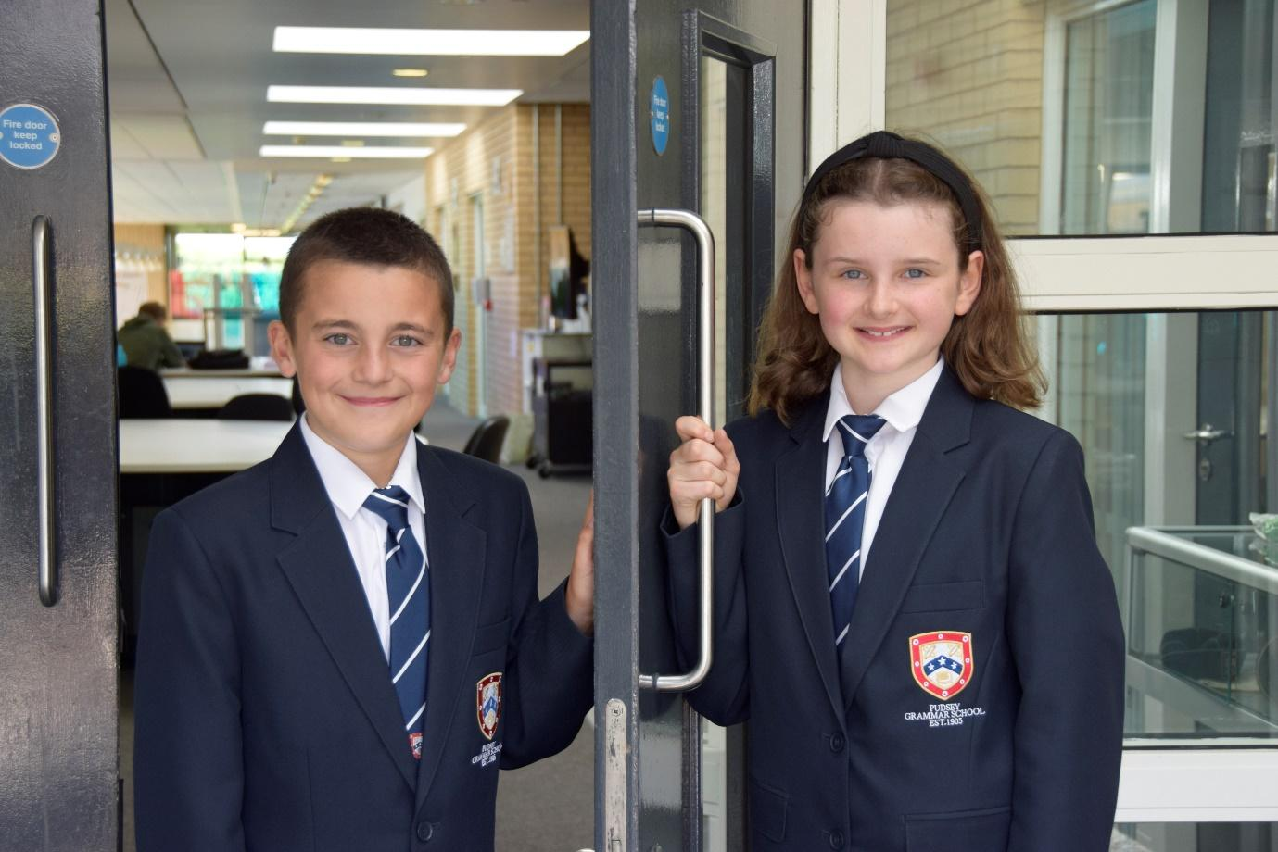

TEACHER OF
ENGLISH

APPLICATION PACK

Data Lead - Permanent

P01, (27-30) £38,220 - £40,777 FTE
Actual Salary
£33,866 - £36,132
37 hpw, term time only plus 10 days

Working pattern:
8.00am – 4.15pm Monday to Thursday
8.00 – 2.30pm Fridays

Start: As soon as possible

From September 2022

Contents
Introduction from the Headteacher
General school details
Information on the post
Job description
Person specification
Enhanced disclosure

Introduction from the Headteacher

Thank you for the interest you have shown in the post of Permanent – Data Lead. This is an excellent opportunity to join our hard working and committed Data and Exams Support Team.

Pudsey Grammar School is a heavily oversubscribed mixed comprehensive secondary school located in the heart of the market town of Pudsey. Situated between Leeds and Bradford, the town has always valued its independence from its two larger neighbours. The school has a long and proud history stretching back to 1905. The school has 1400 students with a thriving and expanding Sixth Form of over 250 students, all taught in a state-of-the-art building. The innovative and unique style of the building creates a calm atmosphere very different to many secondary schools.

I was appointed in 2014 and since then we have received a letter from Amanda Spielman (HMCI Ofsted) which stated we ‘have transformed all aspects of the school.’ This assertion was further underlined in 2018 when the increase in our exam results resulted in the school being the most improved school in Leeds and one of the most improved in the country (we were delighted to follow these achievements up with our best ever GCSE exam results in 2019 which were above the national average). The pattern of improvement continued in 2020 with our Year 11 students achieving grades which were outstanding. The school had a highly successful Ofsted inspection in April 2019 and was judged as good in all areas, including our Sixth Form. The school underwent an ungraded inspection in April 2024 which saw, for the first time in the school’s history, a second successive Ofsted judgement of being a good school. This is testament to the consistently high quality of education which the school provides for all of our students and is one of the reasons why we remain one of the most popular schools across the city of Leeds with over 900 applications received for 215 Year 7 places for September 2024.

In 2022 the school was selected to be a national Behaviour Hub school. This was a Department for Education programme led by the Governments’ School Behaviour Advisor Tom Bennett which identifies school who have ‘an exemplary behaviour culture’. We were one of only 20 secondary schools out of 4000 who have achieved this prestigious accolade, and we worked with other schools across the north of England to improve their behaviour cultures.

We have a comprehensive House system which runs across all year groups with over 30 diverse competitions across the year for students and one each half term for staff too. House assemblies take place once every three weeks lead by our four House Leaders. At the end of each academic year, the winning House is awarded our 80-year-old Victor Ludorum Cup

We are aiming to be a Centre of Excellence, and every indicator shows that we will achieve this goal. Continuing to recruit high calibre staff is a key priority of our strategy.

The following quotes are taken from the latest Ofsted report:

- The school is welcoming, and pupils respect the differences in other people.
- Safeguarding is very well led, and pupils feel safe
- Pupils get on very well with each other
- Teachers have strong subject knowledge
- Pupils behave well in lessons and the vast majority focus on their work
- The school has developed an ambitious curriculum for pupils
- Staff have high expectations of all pupils. The vast majority of pupils rise to these expectations and work hard
- Pupils benefit from the curriculum and are well prepared for their next steps
- The House system plays a central role in the school and provides a sense of belonging. Pupils who earn House ties for their dedication to House competitions wear them with pride
- If bullying happens, pupils are confident that staff will deal with it quick

The school has a long tradition in the town, being established as Pudsey Grammar School in 1905. Although the school is taught in a state-of-the-art building, our core values of respect, resilience, integrity, compassion and ambition are highly traditional and are based on the goal of ensuring that every student reaches their true potential.

Our school is not just about the student’s gaining knowledge and qualifications, although these are extremely important. We believe in teaching young people core values of decency, social skills and how to be a good citizen in an ever-changing world. We want their character to develop and grow, and for them to leave us with an inquiring and independent mind. We want our students to gain the best qualifications they are capable of whilst experiencing a range of opportunities which are second to none. As a result, the school is extremely popular with our community and is significantly over-subscribed every year.

Our Sixth Form, which is rated as good by Ofsted, has grown rapidly in recent years following significant investment and we now have over 250 post-16 students studying at Pudsey Grammar. We have a strong tradition of ensuring students access the best universities, including Oxford and Cambridge.

Our staff show exceptional dedication and commitment to our students. Relationships in the school are extremely strong and this underpins the ethos of the school. We pride ourselves in the care and support that we give our staff and, as a result, there is a real team spirit in the school where people enjoy being part of our school community. Teaching and learning is the key focus of the organisation and everything that we do is designed to ensure that the classroom experience for
the students are excellent. We are currently redesigning our curriculum to ensure that the education we offer is second to none.

We offer fantastic support and professional development to staff, which ensures that they are equipped with all the necessary skills to deliver excellent lessons to the students on a daily basis.

The school is a Foundation Trust school, and our partners include global companies such as M&S; HSBC bank, alongside leading local business and training provider, Appris. These high-quality links allow our school to offer excellent careers opportunities to students across the ability range. As a result, the school has 0% NEETs at Year 11.

We are currently part of The Leeds Teaching HUB, which is providing outstanding opportunities and CPD for all of our staff. Subject Leaders attend their Collaborative Learning Groups, which allows them to network and share best practice. This is further disseminated through the school via regular Department meetings and weekly Teaching & Learning briefings.

This clearly is an exciting time to join our school.

If you have a desire to be part of one of the most exciting and rewarding schools to work in, which will also provide you with excellent development opportunities, please complete the application form. Any further details can be obtained directly from the school's HR Team: recruitment@pudseygrammar.co.uk) or our website www.pudseygrammar.co.uk

Mark McKelvie
Headteacher
Pudsey Grammar School

Pudsey Grammar School
Pudsey Grammar School is a thriving secondary school and sixth form educating students aged 11-18. Established in 1905, our school boasts a long and proud history combined with a modern, state-of-the-art building designed to inspire learning and achievement. We are heavily oversubscribed with 1,350 students in the main school and 250 in the sixth form.
Rated Good by Ofsted in 2024, we were proudly selected as a National Behaviour Hub School in 2022. As part of the Leeds Teaching Hubs, we offer outstanding opportunities for continuing professional development (CPD), enabling our staff to grow and thrive in their careers. At Pudsey Grammar, we are committed to fostering a supportive and dynamic environment where both students and staff succeed.
Job Title: Data Lead - Permanent
Hours and working pattern: 37 hpw, plus 10 training days 8.00am-4.15pm Monday to Thursday and 8.00am to 2.30pm Fridays)
Grade: P01, point 27 - 30
Salary: £38,220 - £40,777 FTE (£33,866 - £36,132 Actual)
Start date: ASAP

We are seeking to appoint a highly skilled Data Lead to join our team on a permanent basis, supporting the school during a period of change in how data is managed and delivered.
The school is currently trialing an outsourced data model, working with an external provider to deliver core technical data processing and statutory submissions. This role has been created to ensure the school retains strong in-house ownership, coordination and quality assurance of data during this period and to help shape the future approach.
The Role
The Data Lead will be the school’s single in-school point of accountability for data, acting as the key liaison between the school and the external data provider. The postholder will:
- Coordinate, monitor and quality-assure all data activity delivered under the SLA
- Lead on the preparation, checking and validation of statutory data collections, including the School Census
- Produce high-quality analysis and reporting for senior leaders and governors, working with assessment data across KS3, KS4 and KS5
- Lead the development, design and ongoing maintenance of in-house data systems and reporting tools not covered by the SLA, including Power BI reports linked to the core MIS to support behaviour, attendance and inclusion
- Work accurately and calmly to tight deadlines, particularly during peak data periods
The role also plays a key coordinating role in GDPR and data protection matters, working under the guidance of the Director of Operations and in partnership with the school’s external Data Protection Officer. This includes collating information and supporting responses to data protection queries, incidents and Subject Access Requests.
Candidates need to demonstrate
- Significant experience working with secondary school data in England
- Strong experience of KS3, KS4 and KS5 assessment data
- Proven experience of producing clear, impactful reports and analysis for senior leadership
- Experience working with external data providers or outsourced services
- Experience developing or maintaining in-house reporting tools or dashboards (e.g. Power BI)
- Excellent attention to detail and the ability to manage completing priorities and deadlines

- A commitment to:
  - Working in line with statutory safeguarding guidance (e.g. Keeping Children Safe in Education, prevent and our safeguarding and child protection policies)
  - Working with the designated safeguarding lead (DSL) to promote the best interests of students, including sharing concerns where necessary
  - Promoting the safeguarding of all students in the school
Why work at Pudsey Grammar School?

- Be part of a rapidly improving school
- Work for an organisation which has staff wellbeing as its core
- Embrace the opportunity to play a key part in the continuing transformation of the school
- Play a key role in shaping how data is managed during an important period of change
- Have genuine influence over systems, processes and reporting
Work in a supportive, professional environment that values accuracy, clarity and purpose
- Work closely with senior leaders in a large, ambitious secondary school
- Work alongside hub-schools in the Yorkshire and Humber region and University College London, with access to high quality Teaching and Learning training, networking events, CPD
- Belong to a supportive organisation which prides itself on high standards for staff and students
- Work in an award-winning state of art building

This school is committed to safeguarding and promoting the welfare of children and expects all staff and volunteers to share this commitment. Appointments will be subject to an enhanced DBS disclosure. If shortlisted, you will be required to disclose relevant information regarding criminal history and an on-line search will be conducted. This includes only information publicly available on-line.

We promote diversity and want a workforce that reflects the population of Leeds.

Employment is conditional on confirmation of the right to work in the UK – either as a UK or Irish citizen, under the EU Settlement scheme or having secured any other relevant work visa. If you do not have the right to work in the UK and the role does not meet eligibility for sponsorship, please consider carefully whether you meet the eligibility to apply for this position.

Application Process
Should you wish to apply for this position, please see below:
- Please be aware that we do not accept Curriculum Vitaes.
- In support of your application, you may include a covering letter. This should be in addition to the completed application form.
- Application form and full job description can be found on the school website: www.pudseygrammar.co.uk vacancies – My New Term link

Closing date for applications: Monday 16th March 2026 at 8.00am
Successful candidates will be contacted directly with details of the interview.
Interview date: TBC

Job Description
Post Title: | Data Lead (School Data & Performance) - Permanent
Post Purpose: | The Data Lead will be the school’s single point of accountability for the coordination, integrity, and effective use of student and school data.  The school has outsourced core technical data processing and statutory submissions to an external provider (School ICTS). The Data Lead will act as the primary operational and strategic liaison between the school and School ICTS, maintaining end-to-end oversight of data tasks and ensuring that data is accurate, complete, timely, and compliant before submission or publication.  In addition, the Data Lead will lead the oversight, development and maintenance of in-house school data systems and reporting tools not covered by the external SLA, ensuring these systems support school priorities and decision-making.  The role plays a key part in supporting GDPR and data protection compliance within school, working under the guidance of the Director of Operations and in partnership with the external Data Protection Officer (DPO) service.
Reporting to: | Assistant Headteacher
Working time: | 37 hours per week, term time plus 10 days  8.00am-4.15pm Monday to Thursday  8.00am to 2.30pm Fridays  There will be a requirement to attend staff training and departmental meetings as required which may fall outside of the set hours.
Salary/Grade: | P01, point 27 – 30, FTE, £38,220 – £40,777  Actual Salary, £33,866 - £36,132
Main (Core) Duties:
Data, Protection & GDPR Compliance | - Act as the school’s lead professional for data, ensuring coherence across assessment, reporting, accountability and school improvement.  - Advise senior leaders on data risks, priorities and use.  - Act as the single point of contact; manage task flow, priorities, deadlines, quality assurance and oversight of the SLA.  - Coordinate the preparation, checking and validation of statutory data collections, including the School Census, ensuring data readiness prior to submission.  - Lead the design, development and ongoing maintenance of in-house data systems and reporting tools not covered by the external SLA. This includes the development and maintenance of Power BI reports linked to the core MIS to support areas such as behaviour, attendance and inclusion. Ensure these systems are accurate, secure, sustainable and aligned with school priorities.  - Maintain oversight of the school MIS and linked systems, including configuration, data structures, user access and routine data quality assurance.  - Coordinate internal assessment data collections not covered by the SLA and support consistency and reliability of assessment practices across KS3, KS4 and KS5.  - Produce clear, timely and accessible reports and analysis for senior leaders and governors, supporting self-evaluation, improvement planning and accountability.  - Ensure analysis is delivered to agreed deadlines and supports effective decision-making.  - Play a key role in the school’s response to GDPR and data protection matters under the guidance of the Director of Operations and in partnership with the external Data Protection Officer (DPO) service. Coordinate and collate information to support Subject Access Requests, data protection queries and incidents, and contribute to embedding good data protection practice within data systems and processes.
Manage Own Performance and Development | - Present a positive and professional personal image, contributing to a welcoming environment ensuring adherence to the standards and expectations outlined in the staff code of conduct.  - Be aware of, comply with and assist with the development of systems and procedures e.g. health, safety and security, confidentiality and data protection, reporting all concerns to the appropriate person  - Be aware of and support difference and ensure equal opportunities for all  - Contribute to the overall ethos/work/aims of the school  - Participate in training and other learning activities and performance development as required to enable continuous growth and development  - Attend all appropriate meetings as required by the Line Manager  - The duties outlined are not meant as an exhaustive list and will also comprise any other duties within the spirit of the post commensurate with the job evaluation outcome for this post.
Relationships | - The post-holder will be required to work flexibly to deliver an efficient Service. This may include some work to be undertaken outside of normal working hours.  - There will be regular contact with pupils, colleagues, other members of staff, line managers and internal and external customers  - Support extra-curricular and other school events as part of the schools’ community link.
Safeguarding | - To work in line with statutory safeguarding guidance (e.g. Keeping Children Safe in Education, prevent and our safeguarding and child protection policies)  - To work with the designated safeguarding lead (DSL) to promote the best interests of students, including sharing concerns where necessary  - To promote the safeguarding of all students in the school.
Physical conditions | - The post is based at Pudsey Grammar School  - The school is accessible by stairs and lift and is available by disabled persons to the ground floor by a portable ramp on request  - This post is subject to an enhanced Disclose and Barring Service check  - The school operates a non-smoking policy
Prospects | Whilst there is no automatic progression to any more senior posts, opportunities do exist for advancement and promotion, dependent upon normal staff movements and on the capabilities of the individual post holder.
Training | The school encourages training both “in-house” and external to meet the needs of the individual and of the Service.
Any Special Conditions of Service: No smoking policy
This job description is to assist staff joining Pudsey Grammar School to understand and appreciate the work content of their post and the role they are to play in the organisation.

Whilst every endeavour has been made to outline the main duties and responsibilities of the post, a document such as this does not permit every item to be specified in detail. This job description is not a definitive list of responsibilities but identifies the key components of the role. The post holder will, therefore, be required to undertake other reasonable duties commensurate with the purpose and salary level of this post.

Employees should not refuse to undertake work, which is not specified on this form, but they should record any additional duties they are required to perform, and these will be taken into account when the post is reviewed.

All new appointments of support staff are made subject to the satisfactory completion of a six-month probationary period.

Statement:
This school is committed to safeguarding and promoting the welfare of

Pudsey Grammar School is an equal opportunities employer and requires its employees to comply with all current equality policies both in terms of equal opportunity for employment and access to the school’s services.

We promote diversity and want a workforce which reflects the population of Leeds.
Dated: February 2026

Person Specification Data Lead

SKILLS | Ess | Des
High level of accuracy, strong organisational skills, and ability to manage competing priorities | *
Proven ability to work accurately to tight deadlines, particularly during peak data collection periods | *
Ability to work constructively as part of a team | *
Flexible and able to use own initiative | *
Negotiating skills |  | *
Good written and spoken communication skills | *
Good at forward planning |  | *
Good organisational skills |  | *
Strong behaviour management skills | *
Ability to communicate complex data issues clearly to non-specialists | *
Ability to use IT systems competently to aid analysis (e.g. Arbor, Classcharts) |  | *

KNOWLEDGE/QUALIFICATIONS | Ess | Des
GCSE English and Maths Grade C or equivalent | *
At least Level 3 NVQ equivalent or higher | *
Educated to at least A-level standard or equivalent | *
Relevant professional qualification or substantial experience – school data/management information systems, data analysis, school administration or exams/data roles | *

EXPERIENCE | Ess | Des
Significant experience working with secondary school data in England | *
Strong experience working with assessment data across KS3, KS4 and KS5 | *
Demonstrable experience of producing high-quality reports and analysis for senior leadership teams and/or governors | *
Direct experience of coordinating and checking statutory data collections, including the School Census | *
Experience of producing and interpreting attendance and behaviour reports | *
Working knowledge of GDPR and data protection requirements in a school or public sector context | *
Experience developing, maintaining or overseeing in-house data systems or reporting tools (e.g. Power BI) | *
Experience supporting governors or inspection preparation |  | *
Experience coordinating or supporting GDPR processes such as Subject Access Requests |  | *
Experience in a large secondary school (1,000+ students) |  | *
Advanced data visualisation or dashboard development skills |  | *

BEHAVIOURAL AND OTHER RELATED CHARACTERISTICS | Ess | Des
Willing to abide by the Council’s Equal Opportunities Policy in the duties of the post, and as an employee of the Council. | *
Always demonstrate resilience | *
Safeguarding training (or willingness to complete on appointment) | *
An ability to respect sensitive and confidential work. | *
Commitment to own personal development and learning. | *
Able to respond flexibly to meet daily demands of the role, showing independence and being proactive | *
A willingness to become involved in the wider aspects of the school |  | *

Enhanced Disclosure

Thank you for your interest in this post at Pudsey Grammar School. The post you are applying for involves working with young people. It is therefore exempt from the Rehabilitation of Offenders Act and any offer of employment will be subject to an Enhanced Disclosure.

As this post is exempt from the Rehabilitation of Offenders Act, you must declare any convictions, including pending convictions, cautions, reprimands and warnings which would otherwise be regarded as “spent” under this Act. Further details will be sought prior to appointment.

An Enhanced Disclosure is carried out by the Criminal Records Bureau and will check criminal records for information on any convictions, cautions, reprimands and warnings held on the Police National Computer and on local Police records.

All information on criminal records provided both by you and within the Enhanced Disclosure will be used, stored and disposed of in confidence and in line with the Criminal Records Bureau Code of Practice of Disclosure Information.

If your application is successful, you will receive further information on how to complete the Enhanced Disclosure.

We are committed to safeguarding and promoting the welfare of our pupils and expect all staff and volunteers to share this commitment.

School Location and Travel Information

Pudsey Grammar School
Mount Pleasant Road
Pudsey
Leeds
LS28 7ND

Tel: 0113 2558277

www.pudseygrammar.co.uk
Instagram/Twitter/Facebook - @PudseyGS

